Research on Low-speed Jerking Motion of the Reciprocating Double-pistons Gas Prover

Zhipeng Xu, Jun Zhou, Jiayin Dai, Dailiang Xie
Zhejiang Provincial Key Laboratory of Flow Measurement Technology,
China Jiliang University, Hangzhou 310018, China
E-mail:xuzhipeng@cjlu.edu.cn

Abstract: Piston prover is widely used as a standard gas flow device for its advantages of high accuracy in standard volume, flow stability and repeatability. The applications of the conventional piston provers are limited by the maximum calibration flow generated by the piston cylinder volume. In the current paper, a reciprocating double-pistons gas prover was proposed, which can provide a continuous standard flow to calibrate meters like critical nozzles and so on. However, obviously low-speed jerking motion is found when calibrating nozzles whose nominal flow rate is less than 0.064 m³/h. Sometimes the prover even stops working due to overloaded torque of the server motors.
In order to solve this problem and broaden the calibration range, the mechanism of the low-speed jerking is carefully analyzed. Also a novel dynamic lubricating method is proposed to reduce the friction of pistons. The solution is to stack a high frequency saw-tooth wave into the constant speed of the piston. As a result, the system structure has been avoid amending since there is only some change within the control program. Detailed experiments have been carried out for the calibration of the venture nozzle whose flow rate is about 0.04 m³/h. And the results show that the torque of servo motors has been reduced from about 120% of their nominal torque to only 60% when a 50 Hz wave has been stacked. While both the pressure and the temperature fluctuation are limited in a small range.
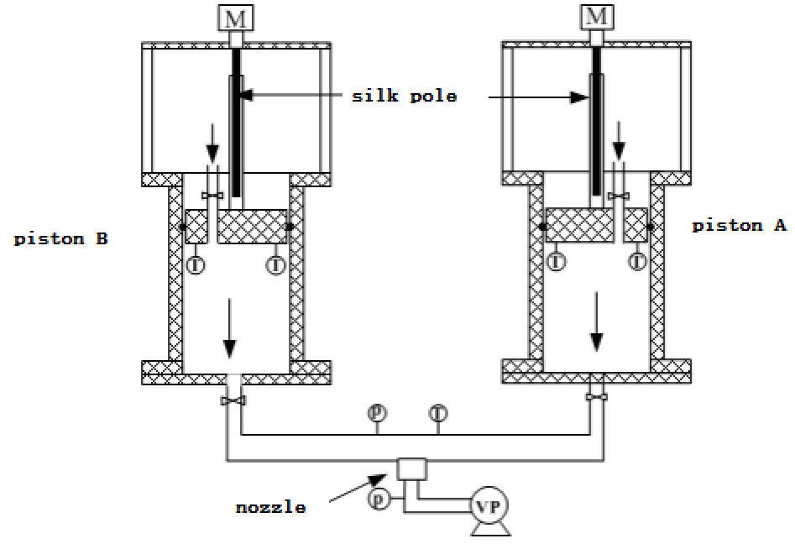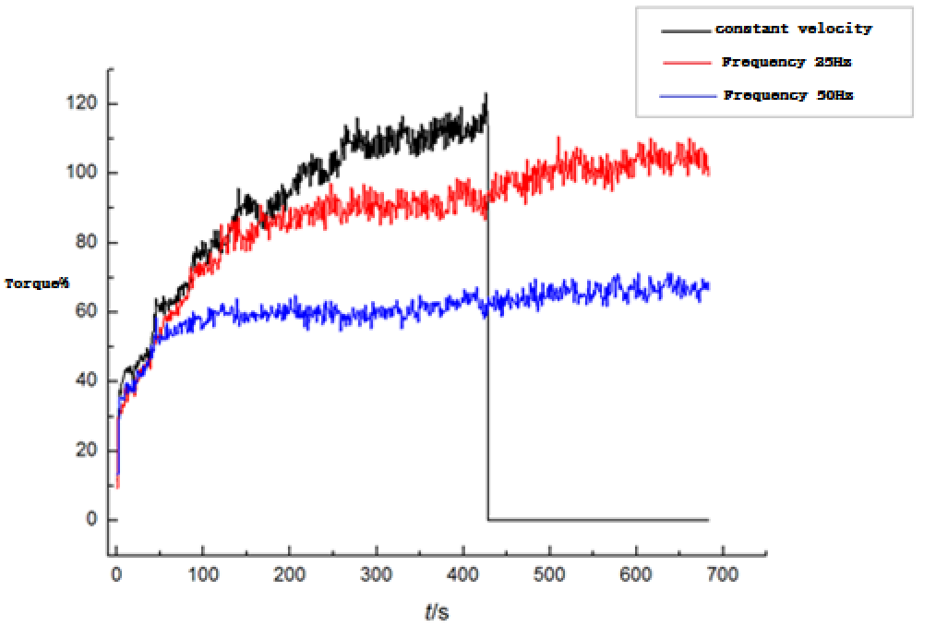
Fig.1 Schematic diagram of the gas prover Fig.2 The torque curves at different frequency

