Laboratory inter-comparison measurements

- Means of proving traceability in liquid flow metering

**R. Engel*)**

*Consulting Engineer and independent researcher,* [*drrengel@t-online.de, Braunschweig*](mailto:drrengel@t-online.de,Braunschweig)*, Germany*

Traceability in liquid flow – or in fluid flow in general – means component traceability through the measurement quantities mass or volume, fluid density, fluid temperature as well as the period of time of measurement. This is the state of the art and it represents the measurement process in flow calibration, which, generally, relies on the assumption that the whole process is run on steady-state conditions. As it was shown in an earlier publication [1], dynamic effects, i.e. random-like fluctuations in the liquid flowrate, cause an impact on the measurement uncertainty.

Other sources of uncertainty result from the installation conditions of the transfer flowmeters.

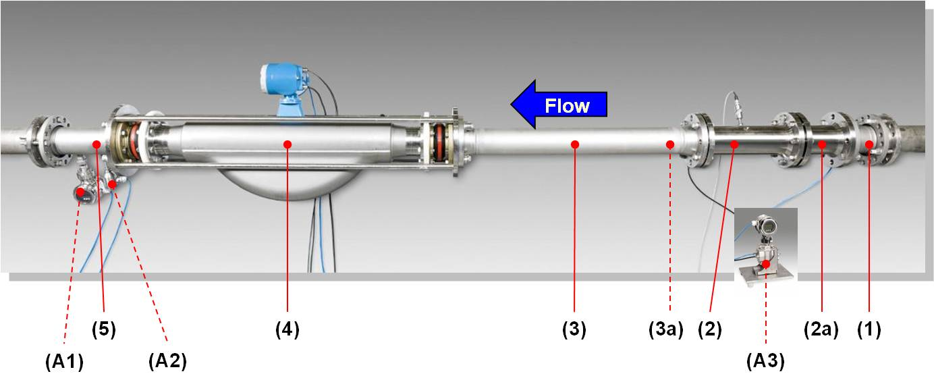

***a)***

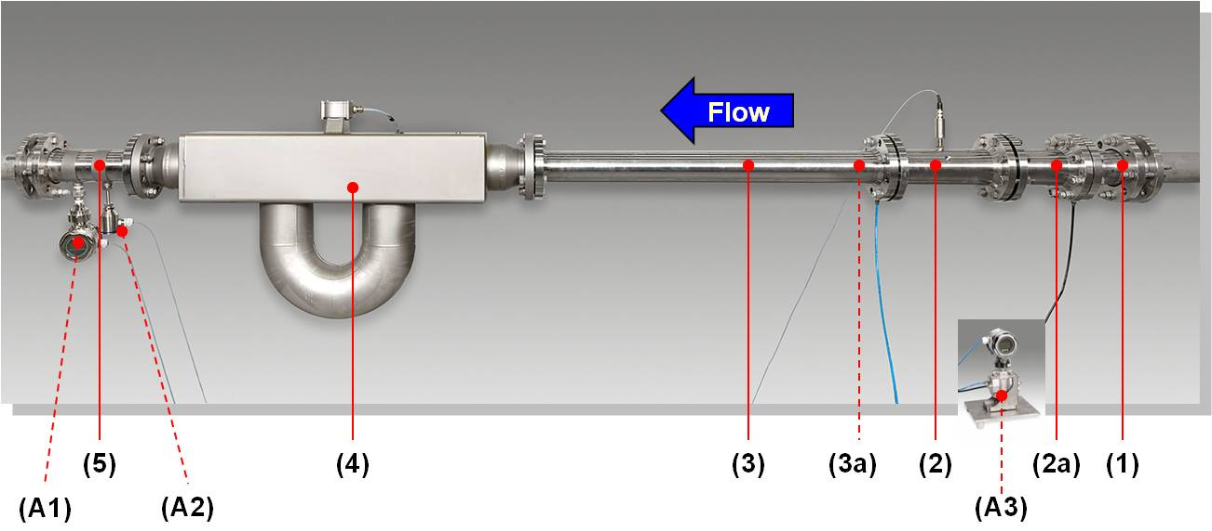

***b)***

***Figure 1:******Sets of comparison transfer flowmeters:***

***-*** *Combination of a Coriolis and a turbine flowmeter*

***a) Sample installation DN100****: applied with Key Comparison* ***CCM.FF-K1.2015***

***b) Sample installation DN80****: applied with SIM Comparison* ***SIM.M.FF-S9***

*(1) Inlet pipe section (adaptable to both ANSI and DIN flange connections)*

*(2) Turbine meter*

*(2a) Tube-bundle flow conditioner dedicated to the turbine*

1. *Connecting pipe section with*

*(3a) Integrated tube-bundle flow conditioner*

*(4) Coriolis flowmeter*

*(5) Outlet pipe section (adaptable to both ANSI and DIN flange connections)*

***Auxiliary devices:***

*(A1) Pressure transmitter*

*(A2) Temperature transmitter*

*(A3) Differential pressure transmitter*

Thus, different sources of uncertainty in the traceability measurement chain have to be distinguished:

- Effects of reproducibility due to meter installation conditions;

- Drift of the characteristics of the transfer meters (during measurement and, especially, during shipment);

- Repeatability of the measurement conditions, which, of course, are superimposed by the parameter drift effect in the flowmeter(s).

The paper will present solutions in hardware and software and, as well as, procedures and techniques which aim at solving the above-mentioned requirements:

- Combination of a pair of transfer flowmeters which rely on different physical operating principles (**Figure 1**);

- Meter characterization of the transfer meters prior to the comparison measurements with respect to their operating behavior due to varying fluid temperatures and gage pressure;

- Auxiliary electronic devices (including special-purpose software) which monitor the measurement conditions during the calibration in the test facility of the participating laboratories in an inter-laboratory comparison;

- Analysing recorded and logged data with respect to the time responses of the process quantities during calibration (See: **Figure 2**);

- Calculation of the dynamic effect contributions to the measurement uncertainty budgets of the calibration measurements;

- Taking into account effects of redundancy based on the different operating principles of two transfer meters in order to separate and isolate uncertainty effects originating both from the transfer meters and the test facility.

**

***Figure 2:*** *Principle of signal acquisition during the comparison measurements*

The approaches and the techniques presented in the paper – and practiced for the first times in a WGFF Key Comparison [2] and SIM supplementary comparison [3] for water flow - , on principle, can be utilized beneficially in any comparison, regardless whether liquid or gaseous fluids are subject of measurement or testing

**References:**

[1] R. Engel, H.-J. Baade: *Quantifying impacts on the measurement uncertainty in flow caliebration arising from dynamic flow effects*, Flow Measurement and Instrumentation, 44(2015), pp 51-60

[2] R. Engel: *Technical Protocol for Key Comparison* ***CCM.FF-K1.2015, 2015***, April

[3] R. Engel: *Technical Protocol for flow-laboratory inter-comparison* ***SIM.M.FF-S9***, 2016. March

*) The author has worked with PTB (Germany’s NMI) as researcher and Head of Working Group “Traceability in Liquid Flow Measurement” until December 2015