Numerical Simulation for the Straight Pipeline after a Sonic Nozzle and Its Influence on the Discharge Coefficient

**HAN Ke1, LUO Dong 2, SHEN Yuming3**

*1* *University of Shanghai for Science and Technology, hanke_happy@126.com, Shanghai, China*

*2* *University of Shanghai for Science and Technology, Shanghai, China*

*3* *University of Shanghai for Science and Technology, Shanghai, China*

*E-mail: ym-shen@usst.edu.cn*

# Abstract

By establishing models, the numerical simulations for the outlet and the straight pipeline after sonic nozzles with throat diameters of 10 mm and 0.96 mm were carried out by means of the CFD software respectively. The comparison of simulation results and empirical values and experimental tests are relatively consistent. According to the simulation results, pressure changes strongly from the nozzle outlet; with the straight pipeline length increasing, the critical back pressure ratio increases firstly then decreases; when the back pressure ratio is less than 0.507 and 0.449, the pressure in the pipeline appears fluctuations, and the pressure fluctuations reach 54.12% at the nozzle outlet.

# 1. Introduction

The sonic nozzle, usually seen as a flow benchmark, is integrated into a gas flow standard device. In recent years, research conducted by either national or foreign scholars mostly focus on the simulative analysis on the nozzle’s internal flow field. Examples include Y. M Choi et al, who researched the critical back pressure ratio of the sonic nozzle at low Reynolds numbers[1]; Arnberg B T researched the discharge coefficient[2] of the sonic venture nozzle at the critical flow; K. A Park studied the effects of inlet shapes of critical venture nozzles on discharge coefficients[3]; C. H. L researched the influence of diffuser angle on discharge coefficient of sonic nozzles for flow-rate measurements[4]; and Yakum Zhao studied it when influenced by the roughness of the internal wall of the nozzle[5]. However, their researches seldom touch on the influence of a nozzle outlet and its internal flow field for the straight pipeline on the discharge coefficient. And in application, an empirical value is always used in setting the nozzle’s back pressure ratio as there is a lack of instructive descriptions on setting.

The research of this article takes nozzle with circular throat which is in compliance with ISO 9300 as an objective, the numerical simulations for the outlet and the straight pipeline after sonic nozzles with throat diameters of 10 mm and 0.96 mm were carried out by means of the CFD software respectively. The comparison of simulation results and empirical values and experimental tests are relatively consistent. According to the simulation results, pressure changes strongly from the nozzle outlet; with the straight pipeline length increasing, the critical back pressure ratio increases firstly then decreases. For the sonic nozzle with throat diameters of 10 mm, with the 5D (D is the pipe diameter, D=5d) length of the straight pipeline after a sonic nozzle, the nozzle throat will keep critical flow when the back pressure ratio is less than or equal to 0.849, and the straight pipeline length has little influence on the discharge coefficient within a certain range; but when the back pressure ratio is less than 0.507, the pressure in the pipeline appears fluctuations. For the sonic nozzle with throat diameters of 0.96 mm, the pressure trends in the pipeline has little to do with the straight pipeline length, and slowly rises to the back pressure after the 3D from the nozzle outlet; when the back pressure ratio is less than 0.449, the pressure in the pipeline also appears fluctuations. The pressure fluctuations reach 54.12% at the nozzle outlet.

# 2. Empirical values Analysis

*2.1 Governing Equations*

If the sonic nozzle and the straight pipeline are simplified as a symmetrical two-dimensional model, and it is the ideal gas that is compressible with steady flow, the continuity equation in column coordinate specific form is as follows:

 (1)

When mass force is neglected, the Navier-Stokes equations group for viscous compressible fluid in column coordinate specific form is as follows:



 (2)

In the above equations,



 (3)



Considering a variable gas density, it is necessary to add an energy equation to the Navier-Stokes equations:

 (4)

In the above equation,  is isentropic gas index.

*2.2 Formula for Sonic Nozzle*

The mass flow of the one-dimensional isentropic ideal gas passing through the sonic nozzle is referred to as, the actual mass flow is, and the discharge coefficient  is defined as:

 (5)

The ideal mass flow measured by the sonic nozzle is given by:

 (6)

In the above equation,  is the stagnation pressure,  is the stagnation density,  is the isentropic index, and  is the area at the nozzle throat.

The mass flow resulted from numerical simulation is referred to as, which are subject to different back pressure ratios.  is resulted from Equation (6),  and  are substituted into Equation (5) to calculate ,  is the simulative value of the discharge coefficient.

The discharge coefficient equation [6] of the sonic nozzle throat referred in ISO9300-2500 is applied to calculate, the empirical values value of the discharge coefficient.

 (7)

 (8)

In the above equation, Re is Reynolds number. The characteristic size “d” is equal to the diameter of the nozzle throat, and  is the stagnation viscosity of the fluid. The equations (5), (6), (7) and (8) are integrated to calculate.

The experimental value of the discharge coefficient  is measured by gas flow standard device.

# 3. Numerical Simulation

*3.1 Modeling*

Studies show that the upstream piping section of the nozzle has little effect on the discharge coefficient, so in this article, the sonic nozzle upstream piping section is not included in the computational domain, in stead, this article only applies simulation for the straight pipe. Takes sonic nozzles with circular throat which is in compliance with ISO 9300 as simulation objective, for two kinds of sonic nozzle with throat diameter of 10 mm and 0.96mm, convergent part with a curvature radius equal to 2d, diffusion angle of 3°, diffusion length of 1d and 2.54d, build two-dimensional model when the length of straight pipeline is 3D, 5D, 6D, 7D respectively, and the model is mesh graphed by using ICEM CFD. Considering a smaller amount of computation and a higher quality in a “structural mesh graph” to achieve convergence of computing, the article applies two-dimensional structural mesh graph. And considering the symmetry of a sonic nozzle, only half of the model needs to be mesh graphed. The mesh graph of sonic nozzle with throat diameter of 10 mm and straight pipeline is shown in Figure 1, and the total number of grid points is approximately 20,000.

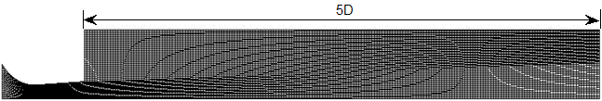

Figure 1: Mesh graph of the straight pipeline after a sonic nozzle.

*3.2 Simulative Computation*

Rotationally symmetric two-dimensional model is applied while gravity is disregarded, the flow media is compressible ideal gas; the calculation applies  turbulence model and energy equation; the stagnation pressure at the inlet is set at 101.325kPa; the temperature is 300 K; and the back pressure ratios at the outlet of the straight pipe after a nozzle are 0.037, 0.371, 0.449, 0.507, 0.573, 0.638, 0.750, 0.799, 0.830,0.838, 0.849, 0.868, and 0.888; the adiabatic and the non-slip conditions are applied to the sonic nozzle wall, the simulation results are shown in Figure 2,3,and 4.

According to the velocity contours, the gas velocity is very low at the nozzle inlet, after a slow increase in convergence section of the sonic nozzle, it increases sharply near the throat; Mach number reaches 1 at the throat, and the velocity continues to increase in divergent section, it reaches supersonic; the velocity begin to decrease near the nozzle outlet. Figure 2 (a) shows that the velocity appears separation and keeps subsonic in the straight pipeline after sonic nozzle with throat diameter of 0.96mm, and the velocity doesn’t change obviously; Figure 2 (b) shows that the velocity changes very unsteadily in the straight pipeline after sonic nozzle with throat diameter of 10 mm, it appears shock wave near the axis of the sonic nozzle.

According to the static pressure contours, static pressure is the stagnation pressure of 101.325kPa at the nozzle inlet, it gradually reduces in convergence section of the sonic nozzle and continues to decrease in divergent section and then slowly rises, pressure changes strongly at the nozzle outlet. Figure 3 (a) shows that the static pressure changes smoothly in the straight pipeline after sonic nozzle with throat diameter of 0.96mm, and the static pressure gradient is very small; however, when the back pressure ratio β is less than 0.449, the static pressure in the straight pipeline after sonic nozzle begins to fluctuate, as shown in Figure 4 (a), the static pressure maximum fluctuations reaches 54.12% at the outlet of sonic nozzle. For sonic nozzle with throat diameter of 10 mm, as shown in Figure 3 (b), the static pressure varies very erratically in the straight pipeline after sonic nozzle, and there are a lot of vortex, when the straight pipeline length is 5D, static pressure in the straight pipeline changes smoothly, and when the back pressure ratio β is less than or equal to 0.830, the nozzle throat keeps critical conditions, the static pressure variation curve along the sonic nozzle and the straight pipeline axis is shown in Figure 4 (b); when the back pressure ratio β is less than 0.507, the static pressure in the straight pipeline also begins to fluctuate, the static pressure variation curve is similar to Figure 4 (a), the simulation results of 0.96mm.

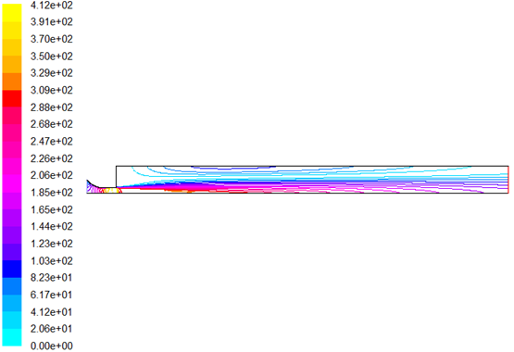

**Figure 2 (a):** Sonic nozzle throat d=0.96mm.

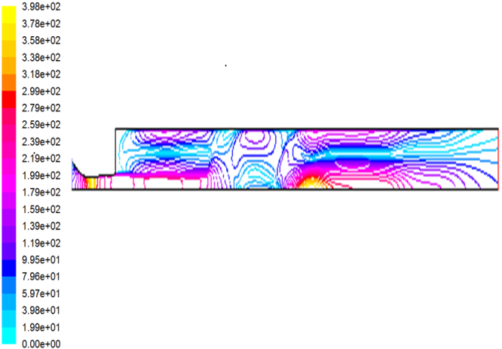

**Figure 2 (b):** Sonic nozzle throat d=10mm.

**Figure 2:** Thevelocity contours of sonic nozzle and straight pipeline.

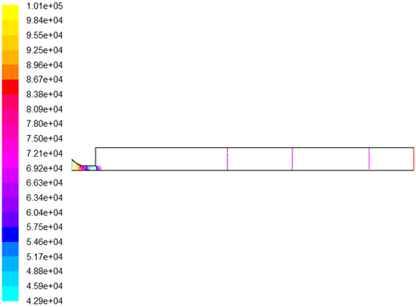

**Figure 3 (a):** Sonic nozzle throat d=0.96mm.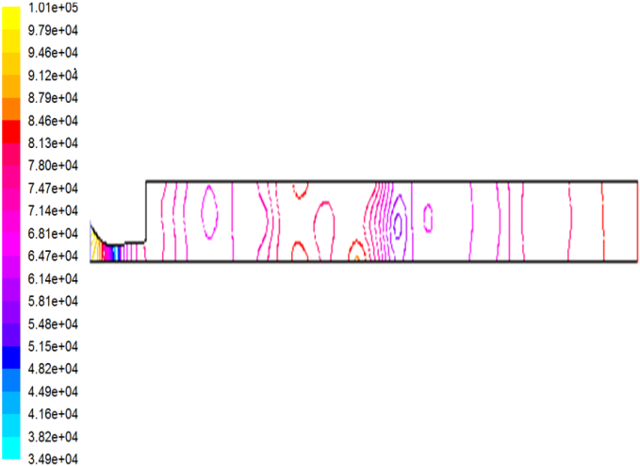





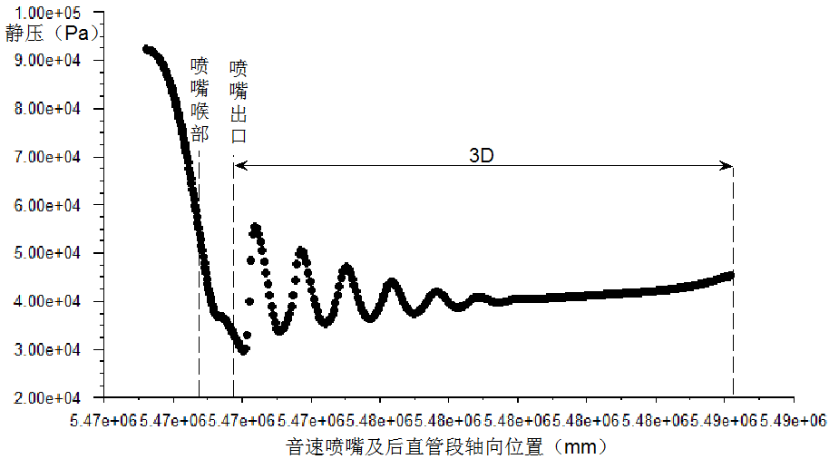



**Figure 3 (b):** Sonic nozzle throat d=10mm.

**Figure 3:** Thestatic pressure contours of sonic nozzle and straight pipeline.



**Figure 4 (a):** Sonic nozzle throat d=0.96mm, back pressure ratio β=0.449

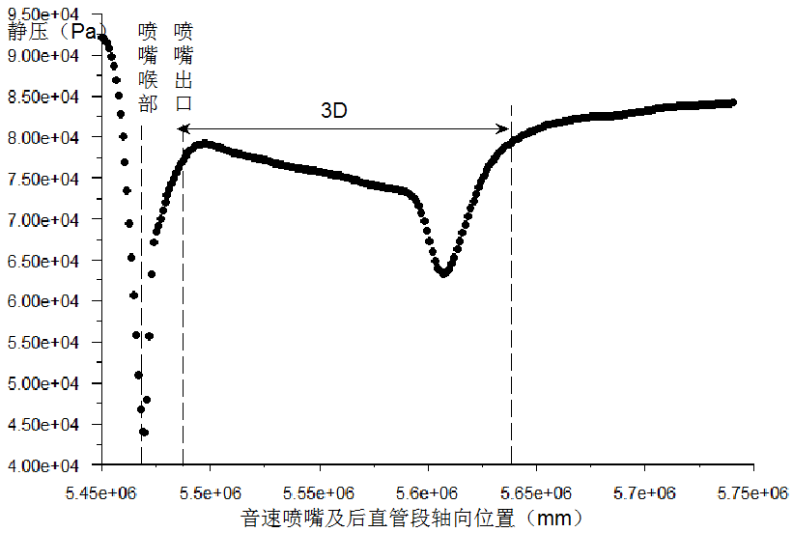

**Figure 4 (b):** Sonic nozzle throat d=10mm, back pressure ratio β=0.830

**Figure 4:** The static pressure variation curves along the sonic nozzle and the straight pipeline axis

According to the simulation results, the static pressure changes relatively steadily in the straight pipeline after sonic nozzle with throat diameter of 0.96mm than throat diameter of 10 mm, and the computation is easier to achieve convergence.

*3.3 Critical Back Pressure Ratio*

With different straight pipeline lengths, the simulation results of critical back pressure ratios that correspond to two kinds of sonic nozzle are shown in table 1.

**Table 1:** Two kinds of sonic nozzle corresponding critical back pressure ratios.

|  |  |  |
| --- | --- | --- |
| **the Length of Straight Pipeline** | **Critical Back Pressure Ratio** β | |
| **d=10 mm** | **d=0.96 mm** |
| 3D | 0.813 | 0.755 |
| 5D | 0.830 | 0.758 |
| 6D | 0.692 | 0.661 |
| 7D | 0.824 | 0.635 |

As is shown in the Table 1, critical back pressure ratios corresponding sonic nozzle with throat diameter of 10 mm is greater than throat diameter of 0.96 mm as a whole. The cause of this result is the influence of the boundary layer, large throat diameter nozzle has less influence on boundary layer than small throat diameter nozzle, thus, the pressure loss is lower; Table 1 also shows that with the straight pipeline length increasing, the critical back pressure ratio increases firstly then decreases, when the straight pipeline length is about 6D, the critical pressure ratio will have a peak value.

*3.4 Comparison between Discharge Coefficients*

The simulative value, empirical value and experimental value of two kinds of sonic nozzles are shown in Table 2:

**Table 2:** Comparison between the simulative value, empirical value and experimental value of the discharge coefficients.

|  |  |  |
| --- | --- | --- |
| **Discharge Coefficients** | **d=10 mm** | **d=0.96 mm** |
| Simulative Value | 0.98279 | 0.96618 |
| Empirical Value | 0.99347 | 0.96936 |
| Experimental Value | 0.98199 | 0.96195 |
| Relative Deviation of Simulative Value and Empirical Value (%) | 1.068 | 0.318 |
| Relative Deviation of Simulative Value and Experimental Value (%) | 0.08 | 0.423 |

Experimental values of the discharge coefficient  in Table 2 are measured by gas standard device according to the reference [7]. Data can be found from Table 2, for sonic nozzle with throat diameter of 10 mm, the experimental value of the discharge coefficient is greater than the throat diameter of 0.96 mm, so do the empirical value and experimental value; and the relative deviation of simulative value and experimental value is smaller. Also, for the two kinds of sonic nozzle, the relative deviation of simulative value and empirical value is less than 1.1% respectively, and the simulation value of sonic nozzle with throat diameter of 0.96 mm is more close to empirical value.

In the numerical simulation, the turbulence model is applied, which takes into account gas viscosity, due to the effect of gas viscosity, there is boundary layer on the inside wall of the nozzle, the presence of the boundary layer makes discharge coefficient reduced.

# 4. Conclusion

The research of this article takes nozzle with circular throat which is in compliance with ISO 9300 as an objective, the numerical simulations for the outlet and the straight pipeline after sonic nozzles with throat diameters of 10 mm and 0.96 mm were carried out by means of the CFD software respectively. The comparison of simulation results and empirical values and experimental tests are relatively consistent. According to the simulation results, pressure changes strongly from the nozzle outlet; the critical back pressure ratio increases firstly then decreases with the straight pipeline length increasing. For the sonic nozzle with throat diameters of 10 mm, with the 5D length of the straight pipeline after a sonic nozzle, the nozzle throat will keep critical flow when the back pressure ratio is less than or equal to 0.849, and the straight pipeline length has little influence on the discharge coefficient within a certain range; but when the back pressure ratio is less than 0.507, the pressure in the pipeline appears fluctuations. For the sonic nozzle with throat diameters of 0.96 mm, the pressure trends in the pipeline has little to do with the straight pipeline length, and slowly rises to the back pressure after the 3D length from the nozzle outlet; when the back pressure ratio is less than 0.449, the pressure in the pipeline also appears fluctuations. The pressure fluctuations reach 54.12% at the nozzle outlet. Therefore, in application, for the two kinds of sonic nozzles, the location of pressure outlet is suggested to be 3D~5D over the location of nozzle outlet; the nozzle back pressure ratio should be no less than 0.449~0.507 when the stagnation pressure is at 101.325kPa.

# References

1. K.A Park, Y.M Choi, H.M Choi, The evaluation of critical pressure ratios of sonic nozzles at low Reynolds numbers, *Flow Measurement and Instrumentation*, 12(1):37-41, 2001.
2. Arnberg B T, et al, Discharge coefficient corrections for circular-arc Venturi flowmeters at critical flow, *Journal of Fluids Engineering, Transactions of the ASME*, 96(2):111-123, 1974.
3. KA. Park, Effects of inlet shapes of critical venture nozzles on discharge coefficients, *Flow Measurement and Instrumentation*, 6(1):15-19, 1995.
4. C.H. Li, X.F. Peng, C. Wang, Influence of diffuser angle on discharge coefficient of sonic nozzles for flow-rate measurements, *Flow Measurement and Instrumentation*, 21(4):531-537, 2010.
5. Chao Wang, Hongbing Ding, Yakun Zhao, Influence of wall roughness on discharge coefficient of sonic nozzles, *Flow Measurement and Instrumentation*, 35:55-62, 2014.
6. ISO9300-2005(E): *Measurement of gas flow by means of critical flow Venturi nozzles*, 2005.
7. Jinlong Meng, Studies on Numerical Simulation of Sonic Nozzle in Micro Gas Flow Standard Device, China Jiliang University, 2013.
8. J.A. Cruz-Maya, F. Sánchez-Silva, P. Quinto-Diez, A new correlation to determine the discharge coefficient of a critical Venturi nozzle with turbulent boundary layer, *Flow Measurement and Instrumentation*, 17(5):258-266, 2014.
9. Lizhong Huang, Gas Flow Standard Device Applying Sonic Nozzle, *China Testing Technology*, 97(9):35-45, 2005.
10. Heming Hu, Chunhui Li, Chi Wang, Numerical Analysis on Sonic Nozzle Flow Characteristics and Critical Back Pressure Ratio Measurement, *Proceedings of National Flow Measurement Forum*, 2010.
11. Lichen Wang, Yun Zhu, Ha Zheng,Simulative Analysis on Fluent-based Critical Flow Venturi Nozzle’s Internal Flow Field, *Sci-Tech and Engineering*, 34(13):10392-10396, 2013.