Experimental Investigation of Cavitating Herschel Venturi-Tube Configuration

S. Brinkhorst¹, E. von Lavante¹, D. Güler¹, G. Wendt²

¹Chair of Fluidmechanics, University of Duisburg-Essen, Duisburg, Germany
²Head of Department “Liquid Flow”, Physikalisch-Technische Bundesanstalt PTB, Braunschweig, Germany
E-mail (corresponding author): Sven.Brinkhorst@uni-due.de

Abstract

The flow in cavitating Venturi nozzles (CV) is a long time subject of experimental as well as numerical investigations. If the pressure decreases due to the local acceleration to the respective vapour pressure, a chocked flow condition similar to the well-known critical flow Venturi-nozzles (CFVN) develops. For the purpose of gaining further insight into the chocked flow condition with respect to liquid flow measurement, high-speed camera investigations of a transparent Herschel Venturi-tube configuration were performed. Together with pressure and flow rate measurements, they demonstrated the overall stable flow behaviour under chocked conditions. With additional numerical investigations, phenomena during the onset of the chocked condition were clarified. Furthermore, a simple correlation for the calculation of the actual flow rate during chocked condition, as well as a temperature correction is proposed.

1. Introduction

Hydraulically cavitating Herschel Venturi-tubes are investigated as a practical and easy realization of traceability requirements, in particular with respect to the general guarantee of uniformity and comparability of measurements.
Cavitation, popular for unwanted effects like erosion and efficiency drop, is in liquid nozzles the cause of a choked flow condition similar to the one in critical flow Venturi-nozzles known from gas metering.
Due to their simple geometry, nozzles are widely established in both numerical and experimental investigations regarding hydraulic cavitation. Back in the 1930’s Ackeret has already performed experiments with cavitating nozzles indicating the analogy between CVs and CFVNs [1]. Numachi et al. investigated different Venturi-tubes and nozzles, used as differential-pressure flow rate measuring devices, regarding the influence of cavitation on the discharge coefficient [2, 3].
Recently, there have been some investigations focusing on the benefits of the chocked flow condition, caused due to cavitation, for liquid flow metering applications. Ghassemi et al. [4] showed the general possibility of the application of CVs as liquid flow meters, while Abdulaziz [5] gained further insights in the cavitation process by using an optical flow visualization method. Rudolf et al. [6] characterized the cavitation regimes of a Herschel-tube experimentally on the basis of the measured loss coefficient, showing a unique behaviour during chocked flow condition. The above mentioned investigations were supplemented by the already published numerical investigations of the authors, revealing the superiority of Herschel-tube geometries in contrast to typical CFVN geometries [7, 8].
The experimental investigations presented in this paper support the so far only numerical investigations of the authors. Furthermore, the measurements and high speed investigations clarified some phenomena during the onset of the chocked condition and enabled the calculation of the chocked flow rate based on simple, frictionless relations via the introduction of a correction factor.

2. Basic Theory

According to Bernoulli, the pressure of an incompressible, isentropic fluid will drop as the flow accelerates. This stays valid up until the pressure drops to the respective vapour pressure. A further pressure drop is not possible. Instead, a phase change takes place, resulting in the formation of vapour. The form of the vapour clouds, as well as their dynamics, is highly dependent on fluid, flow and geometric parameters. For the investigated Herschel-tubes, the resulting cavitation pattern is usually a so called sheet cavitation [9]. The sheet cavity develops along the throat walls, while the core flow remains liquid.

3. Experimental Setup

Figure 1 shows a schematic representation of the used “experimentation and water meter test rig”, the EWZP of the German national metrology institute, the Physikalisch-Technische Bundesanstalt (PTB). The differential pressure was measured between nozzle inlet and outlet (ΔP). Additionally, the static pressure was measured at the inlet (P1). Besides pressure, the water temperature in front of the nozzle was measured, as well as the volumetric flow rate using a magnetic flow meter (Q). For the measurements, the stagnation pressure at the nozzle inlet could be controlled by the rotational speed of the pump in combination with the valve position. The dimensions of the investigated Herschel Venturi-tube are presented in Figure 2. For visual inspection of the cavitation, the Herschel-tube was manufactured out of acrylic glass.

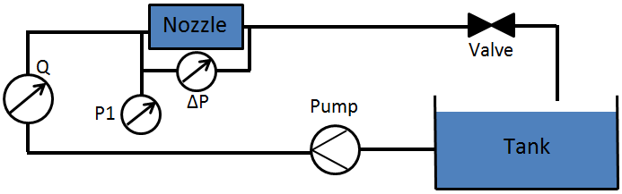

Figure 1: Schematic representation of the test rig.

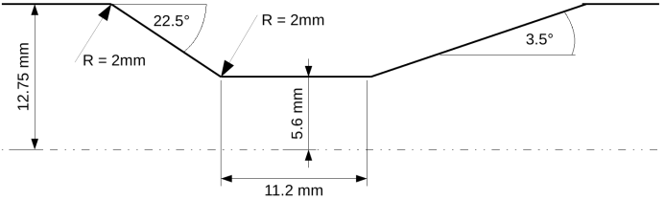

Figure 2: Schematic representation of the investigated Herschel Venturi-tube.

For the visualization of vapour cavity patterns, two cameras were used, a Samsung NX300M, as well as a FASTCAM SA-Z 2100K for high speed recording of up to 140 000 fps.
The measurements were carried out in the following manner: first, the valve, positioned an appropriate distance behind the nozzle, was opened completely and the rotation rate of the pump was set. Thus, the measurement started with full cavitation under chocked conditions. Afterwards, the valve was incrementally closed, with an appropriate amount of time for each pressure ratio to reach static conditions before the measurements were recorded.

4. Experimental Results

4.1 Flow Rate
In Figure 3, the measured volumetric flow rates of the MID were plotted against the pressure ratio p₂/P₀₁. With p₂ denoting the static pressure at the outlet of the nozzle, obtained by subtracting the measured differential pressure from the measured static pressure at the inlet. P₀₁ denotes the total pressure at the nozzle inlet, obtained by adding the dynamic pressure, calculated from the measured flow rate, to the measured static pressure. Q_{max} denotes the maximum measured flow rate during chocked condition.
As can be seen in Figure 3, for all measured flow rates the chocked condition sets in at a pressure ratio of p₂/P₀₁ ≈ 0.875-0.885. During the chocked condition, a further decrease of the outlet pressure did not increase the flow rate any more. For pressure ratios higher than 0.88, the measured flow rates uniformly tend to zero.

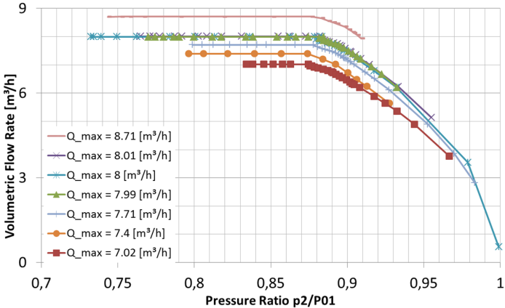

Figure 3: Measured volumetric flow rate of the MID as a function of the ratio of static pressure at the outlet and total pressure at the inlet.

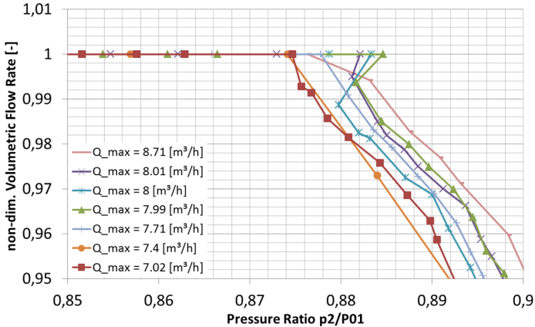

Figure 4: Measured, non-dimensional volumetric flow rate of the MID as a function of the pressure ratio; close-up.

In Figure 4, the measured volumetric flow rates were presented in a non-dimensional form, obtained by dividing the measured curves by their respective maximum flow rates. In the non-dimensional form, the curves fell together in the chocked condition. Only for the non-chocked condition, the curves deviated, with a clear tendency of higher flow rates with increasing Q_{max}. In the close up view between p₂/P₀₁ = 0.85-0.9, for some curves a sudden “jump” into the chocked condition became visible. The loose term “jump” denotes the behaviour of some curves exhibiting an increase of the pressure ratio instead of a further decrease, while the chocked condition sets in.
The reason, why not all curves exhibit this jump is maybe because of a too coarse resolution of the pressure variation during the measurements. Considering the fact, that only those curves with Q_{max} ≈ 8 m³/h exhibit this behaviour, it could also be something unique to those boundary conditions. Based on the measurement curve Q_{max} = 7.99 m³/h, the authors want to explain this sudden jump into the chocked condition.
For that purpose, Figure 5 presents the measurement curve for Q_{max} = 7.99 m³/h, including a numbering of certain measured pressure ratios. Measurement point 1 marked the visible cavitation inception. The first tiny cavitation bubbles were indicated by the arrows, shown in the close-up of the cylindrical throat section of the Herschel-tube in Figure 6. The picture was captured with a shutter speed of 1/180 s, thus representing kind of an instantaneous picture. The pictures of Figure 7 and 8 were captured with a shutter speed of 3 s, thus representing time-averaged vapour cavities.

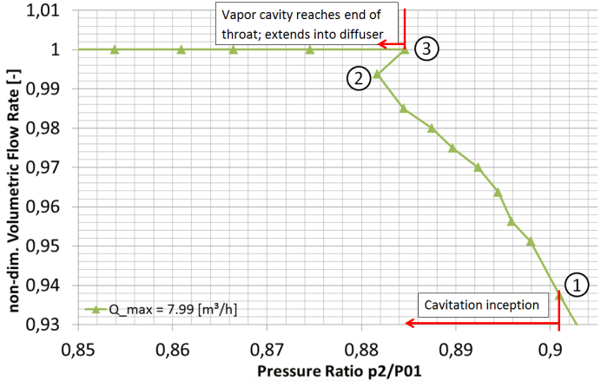

Figure 5: Measured, non-dimensional volumetric flow rate for the measurement curve Q_{max} = 7.99 m³/h.
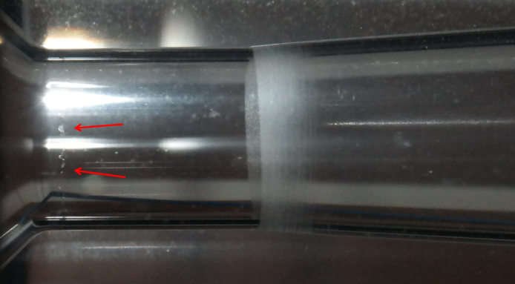

Figure 6: Measurement Point 1; cylindrical throat section of the Herschel-tube, flow direction from right to left; captured with Samsung NX300M, using a shutter speed of 1/180 s.
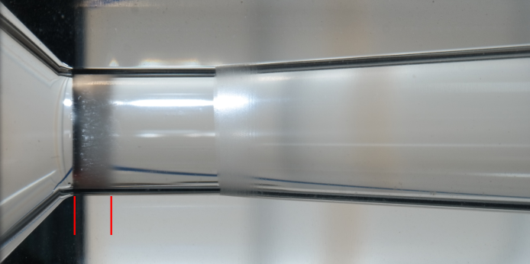

Figure 7: Measurement Point 2; cylindrical throat section of the Herschel-tube, flow direction from right to left; captured with Samsung NX300M, using a shutter speed of 3 s.
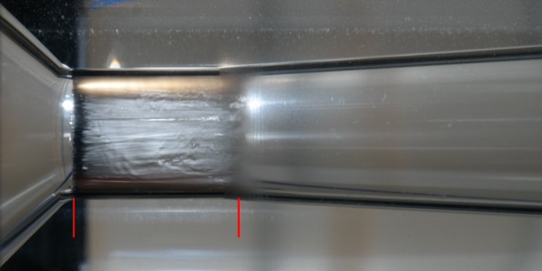

Figure 8: Measurement Point 3; cylindrical throat section of the Herschel-tube, flow direction from right to left; captured with Samsung NX300M, using a shutter speed of 3 s.
Up until measurement point 2, the vapour cavity extended approximately to one third of the cylindrical throat section, shown in Figure 7. But in the next measurement point 3, the vapour cavity suddenly extended to the end of the cylindrical throat and even slightly into the diffuser section, shown in Figure 8. The sudden extension of the vapour cloud goes hand in hand with the onset of the chocked flow condition, as can be seen in Figure 5.

In Figure 9, the maximum length of the vapour cavity L_{cav} was plotted against the pressure ratio p₂/P₀₁ for three different cases. L_{cav} was made dimensionless by dividing it by the throat diameter d_{th}. For the two different measurement curves, Q_{max} = 7.99 m³/h and Q_{max} = 8.01 m³/h, L_{cav} was obtained by evaluating photos with a long exposure time. Furthermore, the results of a numerical 3D simulation of the same geometry were plotted, exhibiting the same phenomenon. For the sake of brevity, details regarding the numerical part can be found in [7, 8].

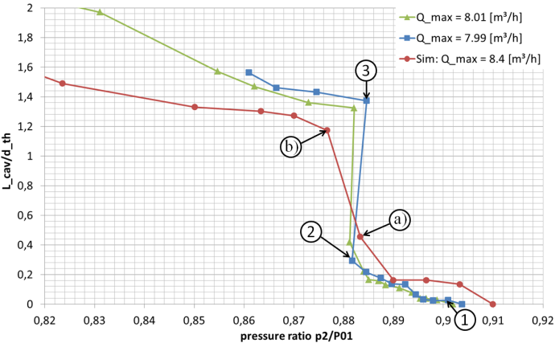

Figure 9: Maximum length of the vapour cavity L_{cav}, non-dimension-alised by the throat diameter d_{th} and plotted against the pressure ratio p₂/P₀₁.

As can be seen in Figure 9, all three curves show a similar behaviour, especially regarding the sudden expansion of the vapour cavity. The numbered measurement points of the curve Q_{max} = 7.99 m³/h were the same as those of Figure 5, again visualizing the sudden expansion of the vapour cavity.
As a reason for the sudden expansion of the cavity, the numerical investigations revealed an unstable, complex pressure field with alternating regions of lower and higher pressure within the throat section. Figure 10 represents the pressure contours of two simulated pressure ratios, denoted in Figure 9 as a) and b). Each half shows an instantaneous pressure contour on a plane going through the centre line of the Herschel-tube.
The two pressure ratios shown in Figure 10 represent the situation before and after the sudden expansion of the vapour cavity. In the upper half of Figure 10 a), an alternating distribution of lower and higher pressures is visible. The lowest pressure is within the vapour bubble, behind it, the pressure rises due to the re-entrant jet. At the transition to the diffuser, the pressure drops again before it continually increases in the diffuser section.
After the sudden expansion of the vapour cavity, the pressure distribution was simplified to the low pressure region within the cavity and the increasing pressure in the diffuser. In that way, the sudden expansion was probably the result of a stabilization of the highly complex pressure field that occured just before the expansion.

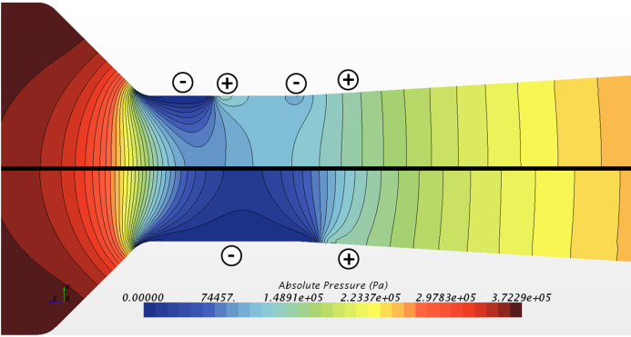

Figure 10: Pressure contours of the numerically investigated Herschel tube for pressure ratios a) (upper) and b) (lower) of Figure 9; + and – denote regions of higher and lower pressure.

For measurement purposes it would be of advantage to be able to calculate the maximum flow rate in the chocked condition. Therefore, a correction factor was introduced into the continuity equation:

$\dot{m}=ρ_{l}V_{th,∞}A_{th}C_{cav}$. (1)

With ρ_{l} being the liquid density, V_{th,∞} the throat velocity based on an inviscid approach, A_{th} the throat cross section and C_{cav} the correction factor. For cavitating nozzle flows, it is often assumed that the throat pressure drops to the respective vapour pressure p_{v}. Using this assumption, the inviscid throat velocity can be calculated using the Bernoulli equation:

$V_{th,∞}=\sqrt{\frac{2(P_{01}-p_{v})}{ρ_{l}}}$. (2)

Using Equation (1), C_{cav} was estimated to 0.8693, based on a comparison with the measurement curve Q_{max} = 8.01 m³/h. As it turned out, the estimated value resulted in quite accurate predictions for all measured curves under chocked conditions, indicated in Table 1.

Table 1: Measured (MID) and calculated (Eq. 1) mass flow rates for the chocked condition for several measurement curves.
Measurement curves (m³/h) | ${\dot{m}}_{max}$ (MID) (kg/s) | ${\dot{m}}_{max}$ (Eq. 1) (kg/s) | Deviation (%)
Q_{max} = 8.71 | 2.4132 | 2.4164 | 0.133
Q_{max} = 8.01 | 2.22055 | 2.22056 | 0.00045
Q_{max} = 8.00 | 2.2178 | 2.2172 | 0.027
Q_{max} = 7.99 | 2.2150 | 2.2242 | 0.415
Q_{max} = 7.71 | 2.1374 | 2.1365 | 0.042
Q_{max} = 7.40 | 2.0514 | 2.0490 | 0.117
Q_{max} = 7.02 | 1.9461 | 1.9466 | 0.026

Although the presented correction factor provided quite accurate predictions for the experimentally investigated chocked mass flow rates, the authors do not assume that the constant factor proves to be unconditionally valid. Rather it is assumed, that the correction factor is a function of geometry parameters as well as fluid parameters such as the stagnation pressure and the density of the fluid. A comparison with the measured fluid temperatures displayed a correlation within the correction factor. In fact, adjusting the correction factor based on the density ratio reduced the deviation for most of the predicted chocked mass flow rates, seen in Table 2. In that sense, the correction factor should be a function of the temperature via a density ratio:

$C_{cav}=C_{cav}^{*}∙{ρ_{l}}/{ρ_{l,ref}}$. (3)

With ρ_{l} being the fluid density at the respective fluid temperature, ρ_{l,ref} the density of measurement curve Q_{max} = 8.01 m³/h with a temperature of 21.4 °C, thus ρ_{ref} = 997.906 kg/m³ and $C_{cav}^{*}$ being equal to to the estimated 0.8693.

Table 2: Measured temperatures for the chocked condition for several measurement curves, as well as the respective density ratios based on ρ_{ref} = 997.906 kg/m³.
Measurement curves (m³/h) | $T$ (°C) | $ρ/{ρ_{ref}}$ | New Deviation (%)
Q_{max} = 8.71 | 24.4 | 0.999291 | 0.0617
Q_{max} = 8.01 | 21.4 | 1 | 0.00045
Q_{max} = 8.00 | 21.0 | 1.000088 | 0.0182
Q_{max} = 7.99 | 24.0 | 0.999391 | 0.354
Q_{max} = 7.71 | 22.2 | 0.999820 | 0.060
Q_{max} = 7.40 | 20.7 | 1.000157 | 0.101
Q_{max} = 7.02 | 20.8 | 1.000131 | 0.039

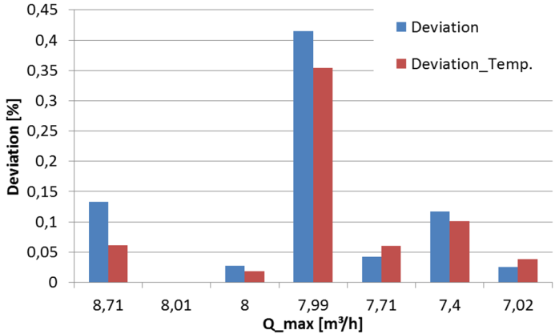

Figure 11: Comparison of the deviation of the predicted mass flow rate with and without temperature influence.

Using the correlation of Equation (3), the deviations between the measured and via Equation (1) calculated mass flow rates dropped for most of the measurement curves, as indicated in Figure 11. Only for Q_{max} = 7.71 m³/h and Q_{max} = 7.02 m³/h the deviations slightly increased, the reasons being unknown.
However, for providing a more accurate correlation for the mentioned influences on C_{cav}, a larger amount of experimental research has to be carried out.

4.2 High speed camera investigations
Using the FASTCAM SA-Z 2100K System, high speed observations of the cavitation cloud with up to 140 000 fps were carried out. Due to the extremely short exposure time, special treatment for the illumination was necessary, resulting in over 20 000 lm of additional luminous power.
In Figure 12, a typical cloud cavitation pattern of the investigated Herschel-tube, for Q_{max} = 9.09 m³/h is shown at 50 000 fps. The cavitation typically began at the junction of the nozzle and the cylindrical throat section and extended along the wall into the diffuser section. As the Herschel-tube had a round cross section, so did the evolving cavity. Thus, the pictures always show a plain view on the forward 180°-section of the cylindrical liquid-vapour-interface. Due to the extreme short exposure time, several properties of the evolving cavity became obvious. First, the cavitation inception seemed to be distributed circumferential unevenly. Secondly, in the vapour closure region a highly irregular distribution of separated bubbles could be seen. Furthermore, chaotic, wave-like structures could be seen on the liquid-vapour-interface. And finally, the bright light reflections on the liquid-vapour-interface clearly supported the recently published cloud cavitation scheme by Stanley et al. [9]. According to it, between most of the cavitation cloud and the wall a thin liquid film exists, shown in Figure 13. Only due to this liquid film it is possible to see the deformations on the water-vapour-interface between cavity and wall.

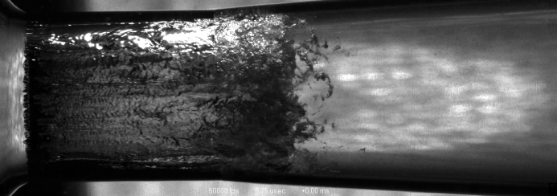

Figure 12: Example of the cloud cavitation appearing at the beginning of the cylindrical throat section of the Herschel-tube and extending into the diffuser section; 50 000 fps, σ_{p} = 7.21, Q_{max} = 9.09 m³/h; Video Link.

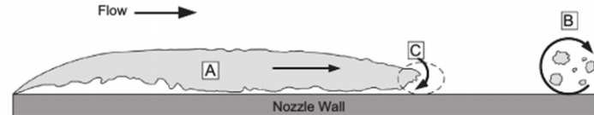

Figure 13: Cloud cavitation scheme by Stanley et al. [9]; with A denoting the fixed vapour cavity, B denoting separated bubbles and C denoting the re-entrant jet.

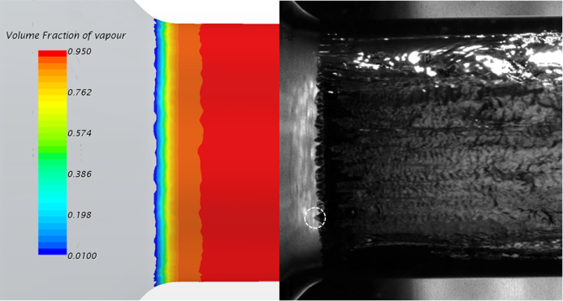

Figure 14: Comparison of numerically predicted and actual cavitation inception at the beginning of the cylindrical throat section; flow direction from left to right.

In Figure 14, a comparison of the cavitation inception at the junction of the nozzle and the cylindrical throat section is shown. Vapour at the wall was represented in the numerically predicted case by several iso-surfaces of the vapour volume fraction. In the simulations, as well as in the high speed picture on the right side, captured with 50 000 fps, the cavitation sets in rather irregular. The finger-like structures, clearly visible in the high speed picture, mark the cavitation inception and were always slightly wandering back and forth in circumferential direction. This was except for the marked spot on the right side, showing no movement but a rather sharp structure, probably caused by a surface irregularity.
a)
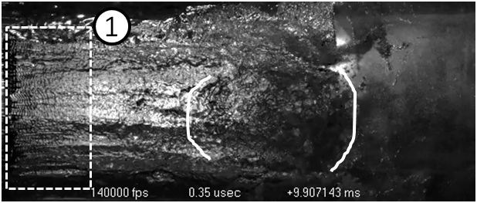
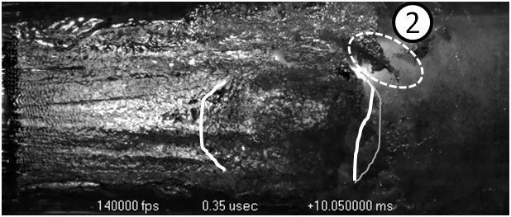
c)
b)
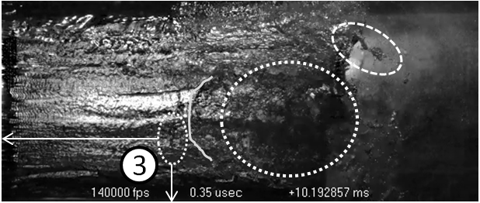
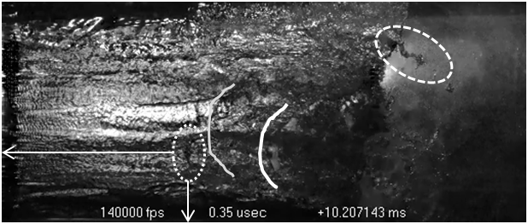
d)
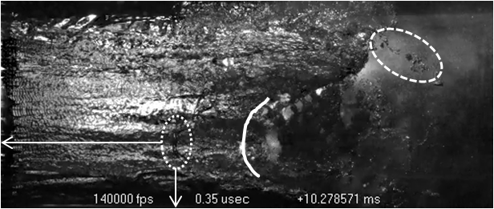
e)

Figure 15: Cloud cavitation in the cylindrical throat section of the Herschel-tube; 140 000 fps, σ_{p} = 7.21, Q_{max} = 9.09 m³/h, Time intervals: a)-b): 20/140 ms, b)-c): 20/140 ms, c)-d): 2/140 ms, d)-e): 10/140 ms; Video Link.

In Figure 15, a compilation of five pictures, captured with 140 000 fps but having different time intervals, was shown. The pictures featured several interesting phenomena, such as a far wavier interface structure at the beginning of the cavitation cloud. This was marked in Figure 15 a) by the square numbered with 1. Additionally, vapour cavities within the bracketed area of Figure 15 a) will collapse due to a re-entrant jet in the following pictures. In Figure 15 b) the collapse progress had slowly set in, with the closure region within the bracket already moving upstream. On the upper side of the nozzle, a tornado-like vortex structure was drawing surrounding bubbles into its core region, denoted with Number 2. As the vortex structure slowly disappeared, the vapour bubbles collapse, seen in Figure 15 e). Until Figure 15 d), the re-entrant jet has pushed the vapour cavity back by about 1/3 of its previous length. Also, a sharp interface was obvious at the end of the cavity, denoted by the white bracket in Figures 15 d) and e). This sharp interface represented a so-called condensation shock [10]. The interesting thing was though, that the cavitation cloud only broke up in a circumferential very narrow region and not everywhere simultaneously. This was proven by the still visible vapour clouds above and below the condensation shock, as well as in the background of Figure 15 e). Due to this, the upstream movement of the re-entrant jet, besides being circumferentially very narrow, was additionally slowed down by the still downstream flowing neighbouring flow.
This was one of the reasons why the cloud cavitation in the investigated Herschel-tube was very stable and steady with only minor overall movements, resulting in a very stable flow rate during the chocked condition.

5. Conclusion

The paper presents to a large part experimental investigations and to some smaller extend numerical simulation data regarding the highly stable flow rate during the chocked flow condition in cavitating Herschel Venturi-tubes. Together with numerical simulations, the experiments yielded further insight into the onset of the chocked flow condition, especially into the prior sudden expansion of the vapour cavity that could be related to a complex alternating pressure field in the nozzle throat right before the sudden expansion.

References

- J. Ackeret, “Experimentelle und theoretische Untersuchungen über Hohlraumbildung (Kavitation) im Wasser”, Technische Mechanik und Thermodynamik, 1, 1930.
- F. Numachi, R. Kobayashi, S. Kamiyama, “Effect of Cavitation on the Accuracy of Herschel-Type Venturi Tubes”, J. Basic Eng., 84, 351-360, 1962.
- F. Numachi, R. Kobayashi, “Einfluß der Kavitation auf die Durchflußzahl der Venturidüse”, Forsch. Ing.-Wes., 30, 86-93, 1964.
- H. Ghassemi, H. F. Fasih, “Application of small size cavitating venturi as flow controller and flow meter”, Flow Measurement and Instrumentation, 22, 406-412, 2011.
- A.M. Abdulaziz, “Performance and image analysis of a cavitating process in a small type venturi”, Experimental Thermal and Fluid Science, 53, 40-48, 2014.
- P. Rudolf et al., “Characterization of the cavitating flow in converging-diverging nozzle based on experimental investigations”, EPJ Web of Conferences, 67, 2014.
- S. Brinkhorst, E. von Lavante, G. Wendt, “Numerical investigation of cavitating Herschel Venturi-Tubes applied to liquid flow metering”, Flow Measurement and Instrumentation, 43, 23-33, 2015.
- S. Brinkhorst, E. von Lavante, G. Wendt, “Numerical Investigation of Effects of Geometry on Cavitation in Herschel Venturi-Tubes applied to Liquid Flow Metering”, in ISFFM #9, 2015.
- C. Stanley, T. Barber, G. Rosengarten, “Re-entrant jet mechanism for periodic cavitation shedding in a cylindrical orifice”, Int. J. of Heat and Fluid Flow, 50, 169-176, 2014.
- P. Tomov et al., “Experimental and numerical investigation of two physical mechanisms influencing the cloud cavitation shedding dynamics”, in HAL Id: hal-01284006, 2016.

