Recent Innovations in the field of traceable calibration of liquid milli-flow rates with liquids other than water

H. Bissig, M. Tschannen and M. de Huu

Federal Institute of Metrology METAS, Lindenweg 50, 3003 Bern-Wabern, Switzerland
E-mail (corresponding author): hugo.bissig@metas.ch

Abstract

Milli-, micro- and nano-flow calibrations are important in several areas of pharmaceutical, flow chemistry and health care applications where volumetric dosage or delivery at given flow rates are crucial for the process. After developing a facility for the micro-flow range, METAS has developed a facility to extend its international traceability for flow rates up to 100 ml/min with an uncertainty of 0.07 %. The flow generators are homemade syringe pumps which allow measurements with liquids other than water in the range from 100 ml/min down to 100 nl/min. Traceability is guaranteed through the calibration of the generated flow rates of the syringe pumps by means of the dynamic gravimetric method where a liquid of well-known density and a well-controlled evaporation rate is used. Up to now, water has been used to perform these calibrations. The possibility to replace the water by oil with traceable properties is investigated with respect to its applicability. As the syringe pump is a volumetric flow generator, it can be operated with any liquid acting as a transfer standard to perform calibrations of flow meters. The design of the milli-flow facility will be discussed as well as first measurement results of flow generators using other liquids than water.

1. Introduction

Milli-, micro- and nano-flow calibrations are important in several areas of pharmaceutical, flow chemistry and health care applications where volumetric dosage or delivery at given flow rates are crucial for the process. Calibration is required to achieve high flow rate accuracy or to verify the repeatability and the reproducibility. Currently, validated traceability in the micro flow range in Europe goes down to flow rates of 100 nl/min [1]. Therefore, traceable calibrations in Europe are guaranteed for flow rates of several orders of magnitude up to several thousands of m³/h. Nevertheless, most of the calibration facilities are operated with water and are not designed to be operated with any other liquid than water. A minority of laboratories offers the calibration also for oil products [2, 3, 4].

After developing a facility for the micro-flow range [5, 6], METAS has developed a facility to extend its international traceability for flow rates up to 100 ml/min with an uncertainty of 0.07 %. More important is the fact that for the whole flow rate range from 100 nl/min to 100 ml/min METAS has developed flow generators that can be operated with other liquids than water. The flow generators are homemade syringe pumps where the volume flow rates can be calibrated by means of the dynamic gravimetric method using water as liquid [5]. These syringe pumps can then be operated with any other liquids as the volume flow rate is traceable to the SI units. To guarantee traceable calibrations of mass flow rates, the density of the used liquid has to be determined by means of traceable density measurements in order to calculate the mass flow rate based on the measured volume flow rate.

2. Design of the milli-flow facility

The milli-flow facility is designed to cover the flow rate range from 0.2 ml/min up to 100 ml/min with an uncertainty of 0.07 % (coverage factor 95 %).

2.1 Working principle
The flow generator, a homemade syringe pump, is filled with water and the water is pressed at the desired flow rate through the DUT and collected in the beaker on the balance, as shown in Figure 1. More details can be seen in Figure 2, where a picture of the actual facility is shown.

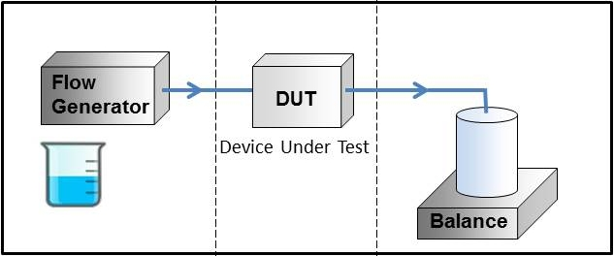
Figure 1: Working principle of the milli-flow facility. The flow generator presses the water through the DUT in the beaker on the balance, where it is collected.

The installation is filled with degased ultrapure water. To hamper growth of bacteria and algae, 50 mg of Sodium azide is mixed with 2 liters of ultrapure water, which is not hazardous for the environment in this concentration.

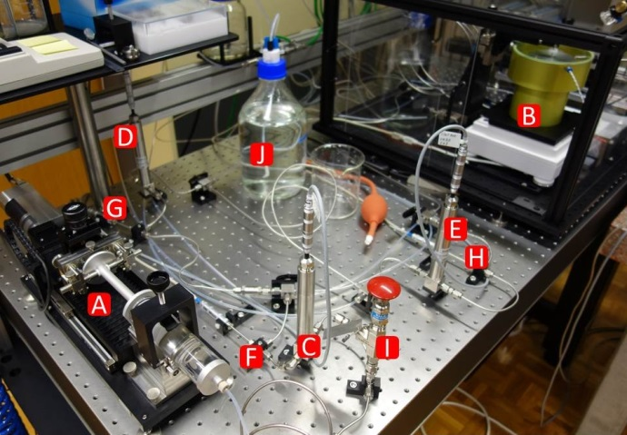
Figure 2: Milli-flow facility. (A) syringe pump, (B) beaker on balance, (C, D, E) pressure sensors, (F, G, H) temperature sensors, (I) pressure security valve, (J) water reservoir.

An important issue is to avoid any air entrapment each time a DUT is connected to the facility. The calibration procedure has to make sure that the air inside the DUT is flushed out. Close to the connections of the DUT, a purging system with CO₂ is installed, where the DUT is first flushed with CO₂ and then flushed with water, where the CO₂ and the water are directed to the piping for waste. Thus, the DUT is full of water and no air is remaining in the piping.

2.2 Homemade syringe pump
The syringe pump consists of a high precision linear stage with a fixed linear measuring system, mounting parts to fix syringes in front of the table and mounting parts to fix and move the plunger of the syringe in order to generate the flow rate. The position of the linear stage is determined by counting the pulses sent by the linear measuring system by means of an FPGA. For each additional pulse in any direction, a time stamp of the FPGA is recorded and a pair with the position and the timestamp is formed. This pair of values is then read from the main software and the real time position can be recorded. The real time speed is then determined by a linear fit of the position as a function of time. Multiplying the speed with the cross section of the syringe gives the volume flow rate.

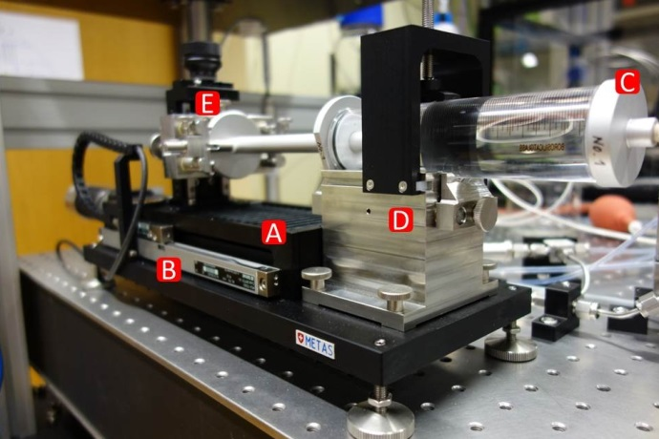
Figure 3: Homemade syringe pump. (A) high precision linear stage, (B) linear measuring system, (C) syringe, (D) mounting syringe body, (E) mounting and positioning for syringe plunger.
2.3 Evaporation and continuous water bridge
To limit the contribution of the evaporation of the water on the measurement, the evaporation rate in the beaker has to be kept low during the measurement. To control this process, the conventional method of adding water in an evaporation trap in the weighing zone (blue colored water in Figure 4, D) to saturate the air with humidity is applied. To avoid any condensation on the outlet needle the degree of humidity is regulated by two small holes at the top of the weighing zone housing, which are connected to tubing acting as humidity exchanger (Figure 4, G). Additionally, a special measurement beaker is built, as shown in the detailed cross-section in Figure 4 (B). The outlet needle is in general positioned 200 μm to 50 μm above the glass filter (Figure 4, C) depending on the diameter of the outlet needle (1 mm to 0.3 mm). At low flow rates, the water enters the measurement beaker and the capillary force in the glass filters sucks the water in before any droplet can be formed at the surface. The water finds its way through the glass filter and continues in the bulk of water at the bottom of the beaker. If the flow rate is higher, the water jet hits the surface of the glass filter and the water flows down at the surface of the glass filter. In both cases the forces due to the water bridge are constant in time and they do not influence the measurement. With this setup, a stable evaporation rate of (3.5 ± 0.5) nl/min for water is achieved and hardly contributes to the uncertainty.

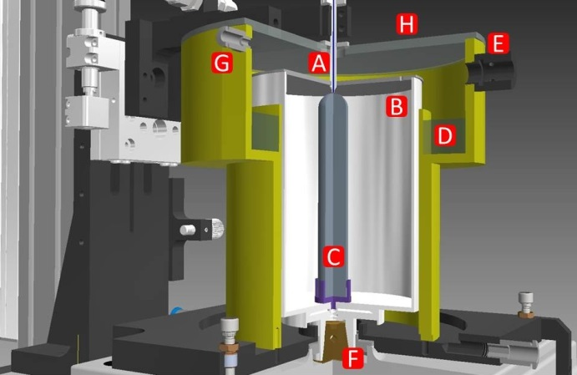
Figure 4: Weighing zone on the balance. (A) outlet needle, (B) beaker with cover, (C) glass filter, (D) water in evaporation trap, (E) mount for T and rH sensor, (F) balance, (G) tubing for humidity exchanger.

3. Dynamic gravimetric method

The measurements are performed by means of the dynamic gravimetric flying start-stop method. This means that the desired flow rate is set and the data acquisition is only started once the flow rate has reached a steady state. Therefore, the measurement beaker is continuously filled with water and the weighing data are continuously collected by a real time system (RT), which communicates with the balance at 10 Hz. The weight value is directly paired with the time stamp of the RT. The other sensor values such as water pressure upstream and downstream of the DUT, the water temperature at various positions and the ambient conditions are recorded as well.

3.1 Determination of flow rate
The collected weighing data are then fitted by means of a least square linear fit. Flow rate determination is best explained using an example. A fixed time window of 10 seconds is chosen for the determination of the instantaneous flow rate, shown in Figure 5 as green and orange portion on the black curve showing the weighing value. The resulting mass flow rates are then converted to volume flow rates including all corrections (evaporation, buoyancy, etc.) and are shown in Figure 6 as green and orange triangle with their uncertainties. The time stamp of the determined volume flow rate of each fixed time window is the center time of these data. This guarantees that any strong change in the flow rate is detected at the occurring time independently of the chosen fixed time window. By increasing the starting time of this fixed time window by time steps corresponding to the acquisition rate of 10 Hz the moving average of the flow rate in time can be followed. Applying this to the collected weighing data shown in Figure 5 (black line), the evolution in time of the volume flow rate is obtained, as shown in Figure 6 (black line).

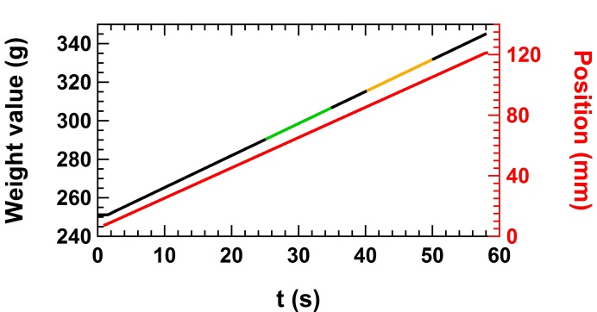
Figure 5: Increase of mass on the balance (black line) and increase of the position of the linear measuring system (red line) as a function of time. Two fixed time window of 10 seconds are shown in green and orange on the black line.

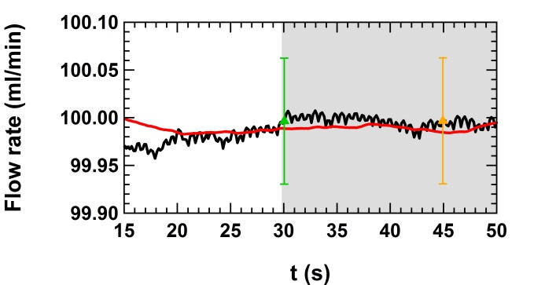
Figure 6: The determined volume flow rate of the balance (black line) and of the syringe pump (red line) as a function of time. The green and the orange triangles are the determined volume flow rates corresponding to the data in the fixed time windows (green and orange) in Figure 5. The background in gray illustrates the time window where the flow rate is considered to be in steady state after the stabilization time.

The same procedure applies to the data of the linear measuring system, where the identical fixed time window is chosen. The change of the position in time shown in Figure 5 (red line) leads to the evolution in the flow rate shown in Figure 6 (red line), where the speed of the syringe pump is multiplied by the cross section of the syringe to obtain the volume flow rate. The cross section is the nominal value from the manufacturer’s datasheet. The background in gray in Figure 6 illustrates the time window, where the flow rate is considered to be in steady state after a stabilization time. Once the stabilization time is reached, the deviation of the flow rate of the syringe pump with respect to the flow rate determined by the dynamic gravimetric method can be calculated. Otherwise a systematic error on the deviation can be introduced, which is only dependent on the stabilization of the flow rate of the facility and not on the DUT itself.

3.2 buoyancy correction online
Another issue of the dynamic measurement is the continuously filling of the measurement beaker with water [5]. Therefore the buoyancy correction f_{buoyancy} for the increasing water volume in the measurement beaker depends on the evolution in time of the air density and the water density in the beaker. To take any unforeseen changes in the densities into account, the buoyancy correction factor is calculated for each single fixed fit window and directly applied to the mass flow rate Q_{w} obtained from the real weight values (not the conventional weighing values), as shown in the simplified Equation (1).

$Q_{m}(t)=\left({Q_{w}\left(t\right) ∙ f}_{buoyancy}(t)-{\dot{m}}_{evap}\right)$ (1)

${\dot{m}}_{evap}$ is the evaporation rate of the water from the beaker on the balance.

4. Repeatability and reproducibility of the milli-flow facility

In Figure 7, respectively Figure 8, first measurement results with the milli-flow syringe pump using a syringe of 100 ml volume, respectively 10 ml volume, are shown. Symbols with the same color represent the repeatability measurements where the syringe was mounted and calibrated several times. Symbols with different color represent the reproducibility measurements as the syringe was mounted for a first calibration and then removed from the mounting block and remounted several days later for a second calibration. The repeatability and the reproducibility measurements are consistent and prove the suitability for changing the syringes on the mounting in order to change the flow rate range, which is limited to the speed range of the linear stage and the diameter of the syringe.

The mean values of the 3 calibrations for each flow rate with the two different syringes are shown in Figure 9. The consistent deviations over the full flow rate range for each syringe mounted on the syringe pump indicate that several calibration points are sufficient for the calibration of the corresponding syringe. The average of the deviations leads to a single calibration factor of the syringe for the full flow rate range.
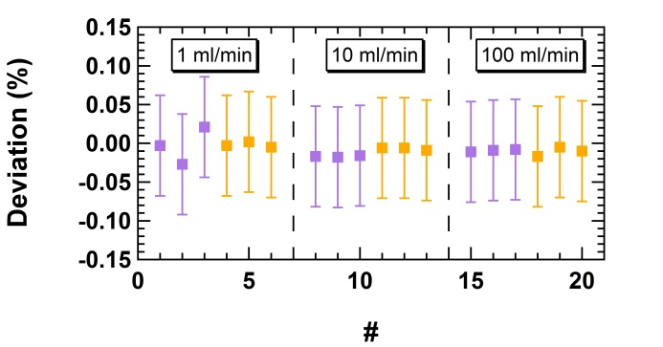
Figure 7: Calibration of the milli-flow syringe pump using a 100 ml syringe. The purple and orange squares represent repeatability measurements whereas the different color codes represent reproducibility measurements.

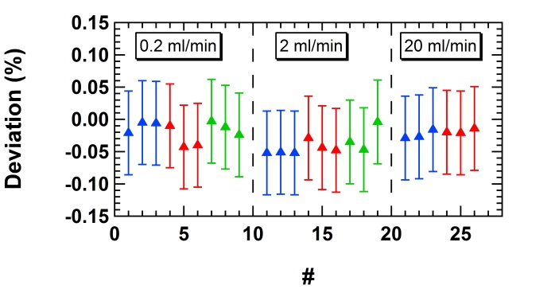
Figure 8: Calibration of the milli-flow syringe pump using a 10 ml syringe. The blue, red and green triangles represent repeatability measurements whereas the different color codes represent reproducibility measurements.

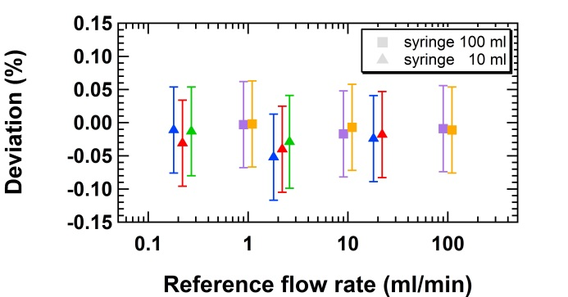
Figure 9: Mean values of the deviations shown in Figure 7 and 8 for the syringes of 100 ml (colored squares) and 10 ml volume (colored triangles).

5. Repeatability of the micro-flow syringe pump

For flow rates below 0.2 ml/min, METAS has built the same syringe pump with a lower speed range called micro-flow syringe pump to cover the flow rate range from 100 nl/min to 5 ml/min, which is already covered by the micro-flow facility [5]. The first measurements with the micro-flow syringe pump using syringes of 50 ml, 10 ml and 1 ml on the micro-flow facility are shown in Figure 10. Rather consistent deviations are found over the full flow rate range for each syringe mounted on the syringe pump. Also in the case of this micro-flow syringe pump the average of the deviations leads to a single calibration factor of the syringe for the full flow rate range.

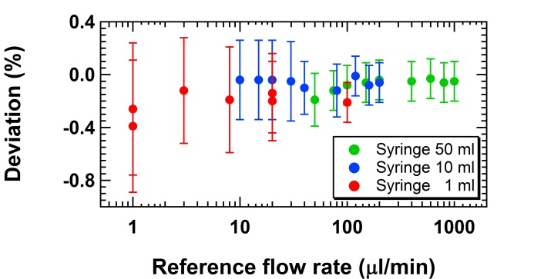
Figure 10: First measurements with the micro-flow syringe pump using syringes of 50 ml, 10 ml and 1 ml volume on the micro-flow facility.

6. Calibration using reference oils

As the volume flow rates of the milli-flow syringe pump are now calibrated with water and traceable to the SI units, it can be operated with any other liquids. In order to confirm this, additional calibrations are performed using three reference oils with traceable densities and viscosities of 16 mPa s, 33 mPa s and 120 mPa s at 22 °C by means of the dynamic gravimetric method, as shown in Figure 11. Due to the higher viscosities of the oils the pressure drop in the piping and in the DUT are much higher compared to the case where water is used as calibration liquid. Therefore the first calibration measurements with oil are performed without a DUT.

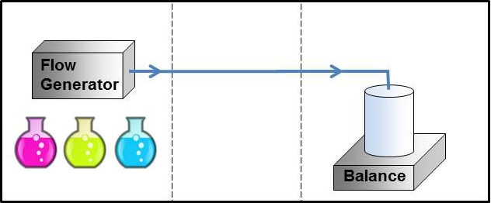
Figure 11: Calibration of the milli-flow syringe pump with other liquids by means of the dynamic gravimetric method.

The calibration results using the three reference oils are consistent with the results where water is used as calibration liquid, as can be seen in Figure 12. A slight viscosity dependent trend can be observed and needs further investigation. It is worthwhile to mention at this point that the reference oils could not be degassed properly prior to the measurements in contrast to the degassing procedure of the water. However, the effect of entrapped air in the oil on the calibration results is not yet known by the authors.

These consistent calibration results allow to use the syringe pump as a transfer standard and to perform the measurements according to the scheme shown in Figure 13, where the liquid is pressed with the flow generator through the DUT and into the waste. The additional contributions to the overall measurement uncertainty for the transfer standard are currently under investigation.

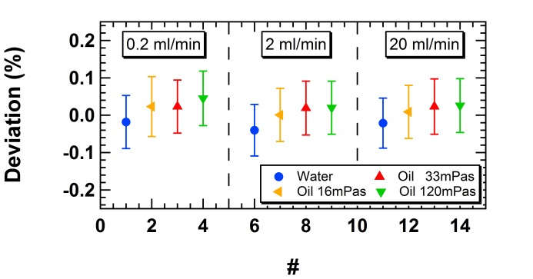
Figure 12: Calibration of the milli-flow syringe pump with a syringe of 10 ml volume and other liquids by means of the dynamic gravimetric method.

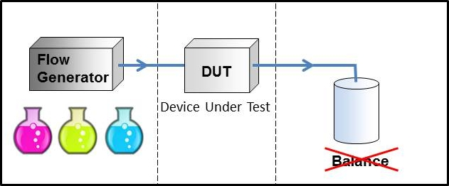
Figure 13: Working principle of the calibrated milli-flow syringe pump without collecting the liquid on the balance. The flow generator pumps any liquid through the DUT and into waste.

7. Validation of the milli-flow facility

To validate the milli-flow facility a comparison between the milli-flow facility and the micro-flow facility has been performed. The milli-flow syringe pump is first calibrated on the milli-flow balance and then also on the micro-flow balance. The measurements were performed with the syringe of 10 ml volume at the flow rate of 1 ml/min, which is the maximum flow rate covered by the micro-flow facility. The results are shown in Figure 14, where the blue triangles are the measurements on the milli-flow balance and the green circles are the measurements on the micro-flow balance. The solid symbols are the single measurements and the empty symbols are the corresponding mean values. The results are very consistent.

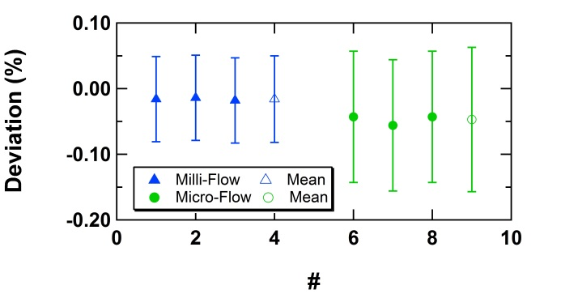
Figure 14: Validation of the milli-flow facility by means of a comparison of the milli-flow syringe pump at flow rate 1 ml/min on the balance of the milli-flow facility (solid blue triangles) and on the balance of the micro-flow facility (solid green circles). The empty symbols represent the mean values of the 3 measurements shown in solid symbols.

Additionally, an international comparison EURAMET P1379 in the flow rate range from 0.5 kg/h (8.3 ml/min) to 10 kg/h (166 ml/min) is scheduled in September 2016 to validate the milli-flow facility. Once the stated uncertainties are validated and internationally recognized METAS will apply for the publication of the calibration and measurement capabilities (CMC) at the BIPM in December 2016.

7. Conclusion

METAS has developed a milli-flow facility for flow rates from 0.2 ml/min to 100 ml/min with an uncertainty of 0.07 %. The flow generator is a homemade syringe pump which allows measurements with liquids other than water. Moreover, a micro-flow syringe pump has been built for the flow rate range from 100 nl/min to 5 ml/min. Traceability is guaranteed through the calibration of the generated flow rates of the syringe pumps by means of the dynamic gravimetric method where a liquid of traceable density and a well-controlled evaporation rate is used. As the syringe pump is a volumetric flow generator, it can be operated with any liquid acting as a transfer standard to perform calibrations of flow meters.

METAS is currently building homemade syringes to increase the volume of the syringe body from 100 ml to 200 ml. This will allow the generation of a higher flow rate of the order of 200 ml/min.

Validation measurements with several reference mineral oils have shown the feasibility of the calibrations with liquids other than water and the direct calibration of the syringe pump by means of the dynamic gravimetric method using mineral oil instead of water.

With the successful validation of the facility by means of the international comparison EURAMET P1379 METAS will apply for the publication of CMC’s at the BIPM by the end of 2016.

References

- BIPM, the BIPM key comparison database, internal NMI service identifier 5135-CH11, http://kcdb.bipm.org/appendixC/
- Cheong K-H, Doihara R., Shimada T. and Terao Y., “Expansion of Calibration Flow Range of Small Liquid Hydrocarbon Flow Facility at NMIJ”, in proceedings of ISFFM, 2015.
- BIPM, the BIPM key comparison database, internal NMI service identifier UK1, http://kcdb.bipm.org/appendixC/
- Euroloop: test facility for high pressure and high flow gas and liquid meters, http://nmi-euroloop.nl/
- Bissig H., Tschannen M. and de Huu M., “Micro-flow facility for traceability in steady and pulsating flow”, Flow Meas. and Instrum., 44, 34-42, 2015.
- Bissig H., Petter H.T., Lucas P et al., “Primary standards for measuring flow rates from 100 nl/min to 1 ml/min – gravimetric principle”, Biomed Eng – Biomed Tech, 60(4), 301-316, 2015.

