Should Reynolds Number Correction and Linearization of Flow Meters be Standardized

T. Cousins
CEESI

Abstract

Flowmeters are without exception controlled in their performance by Reynolds number. For example for many years it was considered that Positive Displacement meter performance was only viscosity related, but now it is accepted that the real criteria is Reynolds number. The same is true of turbine meters. Modern meters such as USMs and Coriolis meters have for years hidden the fact that Reynolds number has an influence on meter calibration and performance by using sophisticated computational techniques, and presenting the user with a “black box” output. Unfortunately, this approach hides from the user a number of important issues that can affect the meter performance.
The usual method of accounting for the performance changes is by linearization, also called data fitting of the calibration curve. Obviously to obtain a good fit it is essential that the base upon which the curve fit is achieved must be stable, accessible and easy to determine. For flow meters the base is Reynolds number, which generally is a difficult parameter to determine, particularly in real time. The variables required to determine Reynolds number are flow rate, viscosity, either kinematic or absolute and density. Often these are not available and so surrogates are used. So, for example, multi-path liquid USMs often use flow profile as the surrogate on the basis that there is a relationship between a fully developed profile and Reynolds number, a very fragile relationship relying on the installed quality of the flow profile in the meter.
API are now beginning to recognize the issue in some new standard updates, such as the new standard for allocation metering. But it is piecemeal and there is a good argument to have a separate standard dealing with the complete issue of data fitting of flow meters to ensure a commonality of methods, criteria, metering integrity and uncertainty calculation.
The paper considers the effect on different meters, the methods available and the potential problems resulting from linearizing meters. It considers the need for correct calibration, understanding of the operation of the meters and how a standard could be developed to alleviate the current issues resulting from the mis-application of data fitting. Also discussed is the issue of taking the fit further and into the realms of extrapolation

- Introduction

The flow measurement world seems to have lost the concept of Reynolds number in dealing with fluid machines such as flowmeters. For example, at one stage it was even claimed that, because they were mass meters, Coriolis meters did not obey the laws of fluid mechanics and were not affected by Reynolds number. The statement “Coriolis mass flowmeters usually are calibrated on water, because the constants are valid for all other liquids” was used to advertise one Coriolis meter. API standards rarely mention Reynolds number but prefer to use such concepts as “change in viscosity” as a criteria to determine when a meter should be calibrated.
Essentially, all meters are non-linear, the non-linearity being determined by a number or factors which include bearing friction for turbine meters, resolution or timing for USMs, resolution of phase shift for Coriolis meters, zero shifts and temperature and pressure effects. However, the one common nonlinearity for them all is the fluid mechanically induced effect of Reynolds number. This is a feature of the subsonic operation of all fluid machines, of which flow meters are a part. The extent to which the nonlinearity is relevant will depend on the meter performance and operation but more importantly the measurement requirements. For example if the meter is non-linear by 1% over its operational range, and the required uncertainty is only 2%, then there is clearly little incentive to correct the meter. If the requirement is for an uncertainty of 0.3% for example, then depending on the specified range the linearity will need to be corrected to meet the uncertainty. This paper concentrates more on the performance of meters used in custody transfer measurement, where the uncertainty requirements are low and measurement is fundamentally the “cash register” for hydrocarbon measurement.
The paper describes the methods of linearization and shows how fragile these can be if proper care is not taken with the method and correlating values used to linearise the meter. If not corrected properly it can lead to significant meter bias and additional uncertainty, often not clear to the end user of a meter. Having made the point about the problems of data fitting the paper concludes that the only way to clarify the underlying issues is to start including in standards the different methods used describing the methods, pitfalls and limitations to allow the user to identify the potential performance and effect on his metering uncertainty.

- Uncertainty/Systematic Error

This paper is concerned about the highest quality measurement of flow, this is the case of meters used as “cash registers” usually for Custody Transfer or Fiscal Operation.
It is important that we talk about the target we are trying to achieve before discussing the process Reynolds number corrections, and its effect on calibration requirements. Defining the appropriate value of uncertainty to be assigned to such a process is not straight forward. It should be noted, however, that in the current circumstances of low oil prices it is far more important to measure with good uncertainty, because when the margins are low any mis-calculation in oil revenue will have a larger effect on the profitability both proportionately and in absolute terms than in the times when the margins are high. The uncertainty value assigned to a meter for custody transfer is usually assigned by a contract signed prior to the meter installation. It also can be determined by the requirements of the local regulators (weights and measures), so the value can vary. Giving a value is therefore difficult. For example with oil measurement OIML R117 defines it for pipe lines as basically a system uncertainty of 0.3%, and assign the meter uncertainty to be 0.2%. So we can say in general we are talking about metering uncertainties probably in the range 0.15-0.3%, although some manufacturers are claiming better than 0.1%! This is by any standards in measurement terms difficult to achieve consistently, requiring only the smallest error in installation, calculation, leakage, operation or mis-application to go beyond the required uncertainty. If we consider gas measurement the uncertainties are greater, but still within the grand scheme of things they are difficult to achieve and require careful operation and application. The potential error due to Reynolds number is due to the method of correction. It can be treated though as an uncertainty resulting from the systematic non-linearity, particularly if the correction method is fragile. The issues of data fitting due to Reynolds number which results in the calibration requirements discussed in this paper are issues that can without due care and knowledge, take metering well beyond the expected uncertainty.
- Linearisation
A linear flow meter is one whose basic output is directly proportional to the flow we are trying to measure, so for example a 2:1 change in flow results in a 2:1 change in the meter output. However, most meters do not follow this criteria exactly, at some point in their operation they will not be linear. Thus for example they may now be 2.01:1 for a 2:1 change in flow, a 0.5% of range error. A Coriolis meter typically will retain a linear relationship within 0.1% at high Reynolds numbers, but at low Reynolds numbers this can increase to over 1%. If operated within the limits for the 0.1% then for most applications there would be no need for any correction, but outside of those limits it is quite clear that something must be done to correct the meter.

- Reynolds Number
Reynolds number is a key parameter for any liquid fluid machine such as a flow meter. Every flow meter exhibits characteristics related to Reynolds number including, USMs, Coriolis, Positive displacement, turbine and differential pressure meters. The fact that Coriolis meters are mass meters does not make them immune. It is therefore a major factor in determining the performance of meters.
So what is Reynolds number? It is simply a non-dimensional number resulting from the ratio of the fluid internal inertia forces to the fluid internal viscous forces:
R_{D} = Inertia Forces/Viscous Force:
$$= \frac{ρV^{2}L^{2}}{(\frac{μV}{L})L^{2}}=\frac{ρVL}{μ}=\frac{VL}{ϑ}$$

Where: L is a characteristic length (Pipe diameter), V the fluid velocity,ρ is the density, μ is the absolute viscosity and ν is the kinematic viscosity.
This number reflects the fluid dynamic properties of a fluid machine such as a flowmeter and, in particular, it describes the fluid properties of flow in pipes, such as the turbulence levels and basic profile, which heavily influence the operation of flow meters. It is often referred to as dynamic similarity and along with geometric and Kinematic similarity represents the basis for subsonic experimental work from aircraft design through to flow meter and pump operation.

- Reynolds Number Vs Flow rate data fitting
Reynolds number is one of the features that determines the error curve, or the linear performance of a flow meter. Historically, it is often considered just a flowrate or velocity issue. Turbine meters often are corrected on site using a correction Vs flow rate table in a flow computer. Figure 1 shows the performance of a turbine meter calibrated at the CEESI calibration facility, plotted against flow rate. As can be seen at any given flowrate there is a scatter in the data dependent on the viscosity. If the meter is calibrated on site against flowrate and the data fit is based on flowrate, then it can be seen that the meter will need a re-calibration every time the viscosity changes.
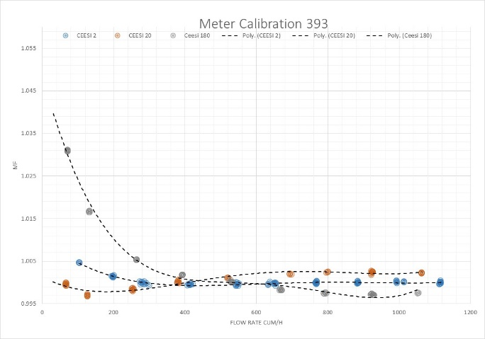
Figure 1 Flowrate Calibration of 8" FH Turbine Meter at CEESI Laboratory
If the meter is calibrated against Reynolds number, figure 2 it can be seen that calibration now follows a continuous curve, except where bearing friction begins to play an increasing role in the meter performance. If now the meter has its data fit, linearization, based on Reynolds number the performance will be fully characterized for changing flow conditions.
The corrections will depend on the viscosity, Reynolds number range, on the meter type and the design. The Helical meter is, for example, much better at dealing with Reynolds number changes than a flat bladed turbine meter but even to achieve the performance shown it has to be linearized.
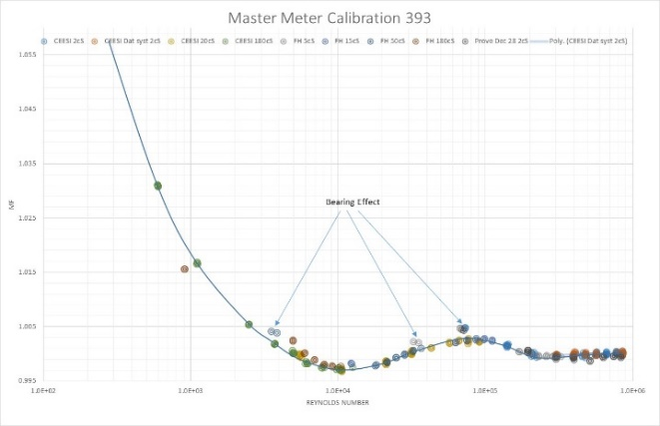Figure 2 Reynolds Number Calibration of 8" FH Turbine Meter at CEESI Laboratory
Figure 3 shows the calibration of a USM over a large Reynolds number range. Again the curve fits well into a Reynolds number curve, except at the point of transition, where a standard USM hits problems due AS with the turbine, if flowrate was used as a base for correcting the meter calibration it would look like scatter at individual flowrates, particularly at the lower Reynolds numbers.
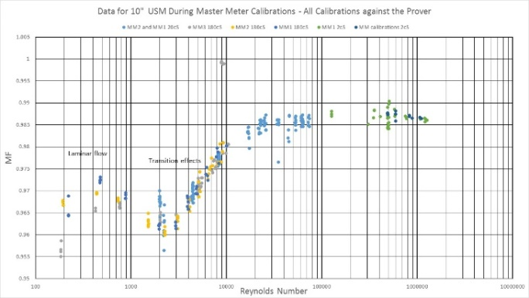
Figure 3 Reynolds Number Calibration of a 10" USM
- Data Fitting (Linearisation) Methods
There are two basic methods of correcting meters for the effect of Reynolds number. The meter can be modified physically so that it behaves in a more linear way, or it can be modified “on the fly” by the use of some algorithm usually carried out in software. In the case of using physical changes this could be either making sure that the basic design, if possible, is linear under all circumstances and the meter needs no modification, or the meter can be calibrated over the operational conditions and then physically modified. In either case, once corrected, the meter will essentially find its own Reynolds number correction, by virtue of the modification, and only such features as the installation would affect the performance. For the algorithm method the meter output needs correction externally usually by software. This implies two things, the meter must follow the Reynolds number curve reproducibly, and the linearization / data curve fit to Reynolds number will only be as good as the viscosity estimation uncertainty allows it to be.
- Data Fitting (Linearisation) By Changing the Physics of the Meter
Good design dictates that a meter’s actual output should follow the theoretical output as closely as possible. In the case of meters designed to track a change of flow rate with a corresponding linear change in output, i.e. linear meters, the meter output should be as linear with the flow rate as practically possible. Unfortunately this is never perfect by virtue of practical aspects of design, for example location of transducer ports in a USM or size constraints on a Coriolis meter. It is obvious, however, that the more basically linear a meter the more stable it will be in operation. Modifying the meter as part of calibration or operation must add uncertainty and instability to the meter. Thus the smaller the required modification the better the reproducibility of meter operation. This is the best method of data fitting!
If the physics of the meter will not allow the development of a linear characteristic then another method needs to be used. The most stable is to modify the meter physically upon calibration. The most common instance of this method is the turbine meter. For a turbine meter this is achieved by modifying the characteristics of the blades, either by “filing” or “bending” them. To do this the meter has to be calibrated over the Reynolds number range that it will be used when in site operation. In figure 4 the original calibration curve is shown by the dotted line. The usual practice is to calibrate the meter at one viscosity and modify the blades to linearise, then to move to the next viscosity until the meter is corrected over the full range.
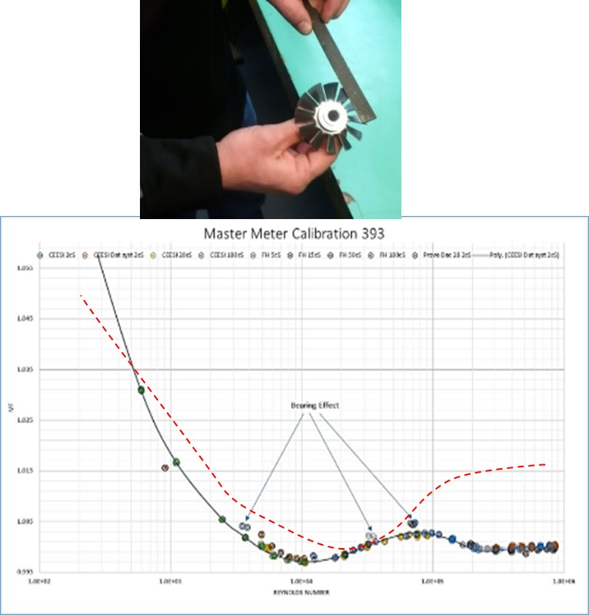
Figure 4 Calibration of Turbine Meter by Aero Dynamic Change
Furthermore, the method modifies the base design by modifying the fluid mechanics of the meter to produce a linearized characteristic that is a function of Reynolds number. Providing that there are no installation issues, and that the meter repeats well with Reynolds number the data fit or linearization will hold regardless of the fluid.
The calibration particularly over a larger range requiring a very tight tolerance may still not meet the full performance requirement and some other form of linearsation is required.
It can be seen the calibration is Reynolds number dependent and requires a knowledge of the Reynolds number to perform further correction. To use flowrate as the base, which is commonly used on flow computers, will not effectively linearize the
It is the second issue of making the curve more linear, the “optimizing” of the curve, where the problem lies with the turbine meter and as we shall see in USMs, Coriolis and differential pressure meters. These corrections have to be made by a combination of electronics, software and a knowledge of the flow properties and their effect on the given meter performance.
- Data Fitting (LINEARISATION) Electronically.
Before we even discuss the concept of electronic data fitting we have to get past the hurdle of accepting that there is an issue that meters need to be corrected. This fits into two categories:
- Meters that are assumed to be linear throughout their range because a theory shows them to be independent of any issues, and it is only when independent testing is carried out that eventually this is found not to be true.
- Using “black boxes” to hide the extent of the non-linearity.
Both concepts can lead to the user, having a false view of the meter performance and at the extreme incurring large biases that are not included in the overall uncertainty budget, and hence affecting the metering balances, and even profitability.
When we have got past this hurdle we have to find a way that is acceptable to linearize meters. It is clear that a USM, for example, does not allow us to “file” off a part of the meter to do this. We have inevitably to resort to some form of external correction, and that is most commonly electronic. This is not necessarily a bad concept but it requires the following issues to be addressed:
- The meter calibration must be stable and reproducible in terms of its calibrated relationship with Reynolds number.
- There must be some effective and reproducible method to determine Reynolds number in real time.
- The method should not be significantly influenced by the installation of the meter.
- The acceptable limits of the meter operation with this linearization must be very clear.
- The correction should be a method that improves the performance of the meter, not a method that makes changes to the meter from a “poor” meter into a “good” meter. In other words the meter physical design should be the best possible and external linearization should then improve the meter.
- The characteristic curve should be determined by the quality of calibration. This should represent the field operation of the meter, and should no extrapolation .

A simple example in terms of stability and reproducibility of the curve is the use of a turbine meter in the region where bearings are having an effect on the performance. This can be seen in figure 5, the calibration of a turbine meter on 2.5cS oil. At the low flows the meter factor changes rapidly as the bearing friction takes hold. The curve becomes steep. The groups of points are nominally repeats, but as can be seen they are generally wider than the repeats at higher Reynolds numbers where the curve is more linear. The repeats and the linearity of the curve are now becoming a combined issue. The meter for very small changes in flowrate are just moving up and down the curve, correction of this curve becomes exceedingly difficult. Further we know that with time this curve will change as the bearings wear and will ultimately change the curve.
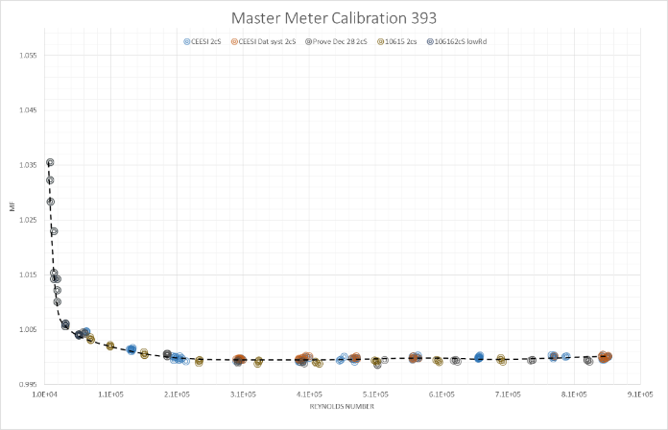
Figure 5 Effect of bearing Friction on Low flow performance of a Turbine Meter CEESI Calibration
- Calibration, Reproducibility and Extrapolation
It must be quite clear that calibration becomes an issue when having to data fit or linearize a meter. The curve has to be determined and, therefore, it would be assumed that the meter needs to be calibrated over its operation Reynolds number range. Many, particularly manufacturers, use only water, even though it is known that their meters have potentially large non- linearity at low Reynolds numbers, figure 6.
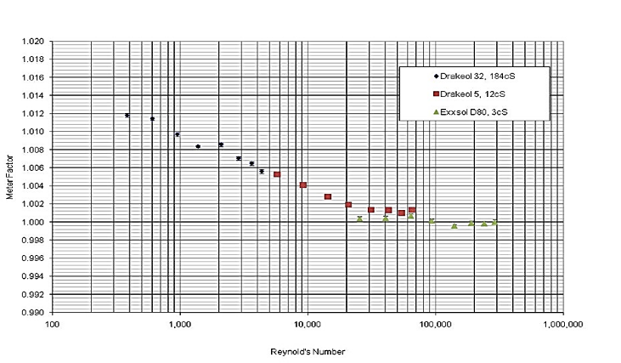
Figure 6 Calibration Curve of a 4" Coriolis Meter
The red dotted line shows the calibration range on water. It can be seen that this comes barely to the point of non-linearity. So how can this be used to determine the curve? Using a 4th order extrapolation based on the water curve results in the green dotted line, obviously wrong. Maybe the curve can be assumed? That may be the case but it then relies on the assumption that all meters follow the same curve. This takes a substantial effort in time and numbers of meters to prove, and will always lead to the possibility of a “rogue” meter going through. Whatever the case there will be an additional uncertainty, and how this is to be estimated will rely on the reproducibility of the meters during manufacture.
- How Can Reynolds Number be Determined
At this stage we must assume that the meter is stable and will always follow the same characteristic curve with Reynolds number. This leaves us with the issue that for electronic correction we need to know the Reynolds number. It is not sufficient when dealing with the levels of uncertainty described previously to use velocity or flowrate. For example a typical oil in the northern US will vary its viscosity between 2:1 and 4:1 dependent on the oil type and temperature, this is a direct change of between 2:1 and 4:1 on the Reynolds number. For the USM shown this would result in a calibration change of between 0.3% and 0.8% if not corrected for Reynolds number. Figure 7 shows the effect of viscosity on a particular Coriolis meter. Choosing to do a prove at a particular flowrate rather than Reynold number could result in a substantial change in the prove if not compensated for the effect of viscosity change.
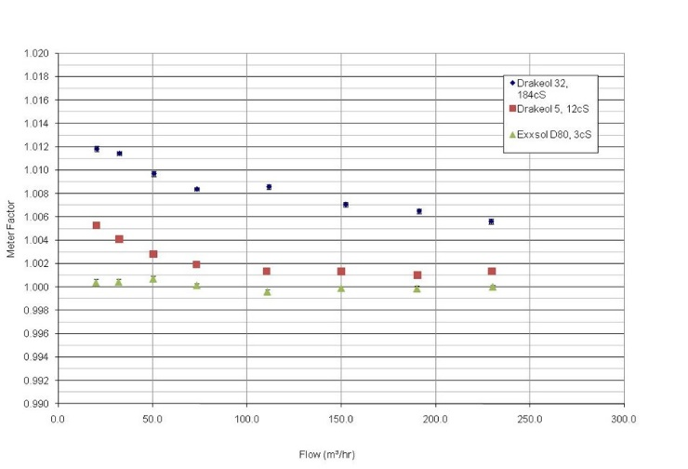
Figure 7 Calibration of a 4" Coriolis Meter Against Flowrate
Again, as shown for the turbine and the USM when plotted against Reynolds number a continuous curve is formed which can then be linearized (data fitted) to correct for the changes.
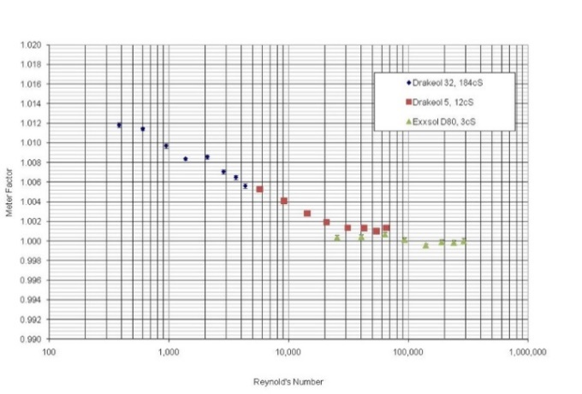
Figure 8 Calibration of a 4" Coriolis Meter against Reynolds Number
It can be seen that the measurement of Reynolds number is critical to the data fit. So how can it be done in such a way as to give the calibration the uncertainty required? Initially, of course, there must be a good base calibration of the meter that will give under controlled conditions a characteristic curve for a given meter. Once this has been achieved Reynolds number has to be determined under site conditions. We need 3 or 4 items to give us Reynolds number:
- Characteristic dimension, in most cases meter diameter. In general, this is relatively accessible.
- Flowrate or velocity. The meter itself will give an uncorrected value which is usually sufficient to perform the correction. (For better correction this can be done as an iteration, by taking the uncorrected flowrate, the viscosity and hence a Reynolds number, re-correcting and going around the loop again, until it converges.)
- Density, often available from sampling or on-line densitometer. Density will not be needed if Kinematic viscosity is available.
- Absolute or Kinematic viscosity, the problem measurement.
How do we measure viscosity on site? The obvious method would be to measure it directly and continuously but sensibly there is only available the tuning fork meter, and adding the output into the system is cumbersome. It can be obtained as part of the sample system but then this will not be a continuous measurement, although it is feasible to put in a value of viscosity and temperature compensate. This is acceptable if the relationship between the viscosity of the fluid and temperature is known.
Recently, a Coriolis meter has been modified to measure viscosity directly using the damping effect on the vibration of the tubes. This is potentially a very effective method. Ultrasonic flow meters use a variety of methods, including the relationship between velocity of sound and viscosity and the effect of Reynolds number on the flow profile. Both of these suffer potential difficulties. The relationship between the viscosity and VOS is empirical and does not hold for all fluids. The use of the concept that the profile changes in relation to Reynolds number is effective as long as the profile is not affected by installation. Both methods are fundamentally fragile and can give very significant errors in the viscosity measurement.
- Standardization
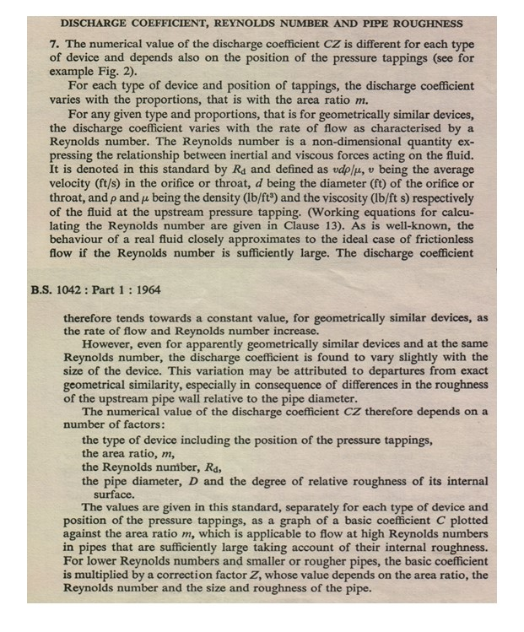
This paper has discussed the effects and implications resulting from the issues of linearization and Reynolds number based correction. But the paper is about the standardization of the linearization and data fitting. It can be seen that it is an important and complex issue and needs to be simplified and brought to a consistent level of understanding. While it is not a new phenomenon, it has become more confused and hidden from the view of users in recent years. It quite clearly affects the performance of meters and consequently the uncertainty. and Yet it is rarely considered. The old differential pressure standards such as BS 1042 as far back as the 1964 edition quite clearly recognizes that Reynolds number must be corrected for and that it carries an extra tolerance, figure 9.
.

Figure 9 BS1042 1964 Section 1 Method -Part 7
More often than not we have to learn from the past to move on to the future. Under the section entitled “Accuracy of Flow Measurement” they say “In estimating the accuracy of a flow measurement the tolerances on C,Z_{R},Z_{D},ε,d and ….. are always to be included since the errors on these quantities are systematic for a given installation” Note that Z_{R} is the Reynolds number correction factor. While the terminology may not be quite as we would use it today the meaning is still very clear. The standard then goes on to give values for tolerances for each meter type, for example for a square edge orifice under the section “Values of Tolerances” we find “b. Tolerance on Reynolds number correction factor X_{Z(R)}. The tolerance on the Reynolds number correction factor is given by X_{Z(R)} = 33(Z_{R}-1) per cent where Z_{R} is the Reynolds number correction factor” Many of the current meters have larger calibration variations with Reynolds number than orifice plates and yet there is rarely any mention of the factor it plays in their operation.
A very similar process could be carried out for all meters. It may be difficult to quantify the uncertainty for such meters as Coriolis, USM etc. because the effects vary for different manufacturers and designs, but the following could easily be included:
- The effect of Reynolds number on the meter.
- The methods of determining Reynolds number.
- A method of determining uncertainty/systematic error.
- The implications of not calibrating the meter correctly.
This would certainly help the user to understand the implications of Reynolds number, whether it is an issue in the application and at least some idea of the error that can result from this measurement. It will also help the user to decide on the relevance of changing Meter factors when proving his meters.
A further issue that should be included in a standard, is the warnings of the possible problems and consequences of using extrapolation, to not only linearize the meter, but also to predict its performance.
- Conclusions

- All meters have at some point in their range a non-linearity associated with Reynolds number.
- In the past this has been recognized but over the years it has become a hidden error or uncertainty, usually by the use of a black box to produce the meter output.
- The corrections and correction methods are often complex and require some understanding by the user to fully realize the implications.
- The inclusion in metering standards of details, the methods and their implications would help greatly in understanding the need for calibration of the meter, proving of the meter and the resultant uncertainty of the installed meter.

- References

- BS 1042: Part 1:1964
- Raymond J. Kalivoda, Jim H. Smith, Nicole L. Gailey, “Dynamic Testing”, NSFMWS, 2013
- Jim Smith, “HELICAL TURBINE METERS FOR LIQUID MEASUREMENT” ISHM 2014 CEESI Technical Library
- T. Cousins “VISCOSITY AND ITS APPLICATION IN LIQUID HYDROCARBON MEASUREMENT” ISHM CLASS 2O13
- T.Cousins, “HOW SAFE IS LINEARISATION OF FLOW METERS?” ISSFM 2011,
- T. Cousins “The Reynolds Number Correction of Liquid Ultrasonic Meters and Coriolis Meters” CEESI/VSL Conference 2014 Lisbon.
- Gregor Brown, Herb Estrada, Don Augenstein, Terry Cousins, “Metering of Liquified Natural Gas Using 8-Path Ultrasonic Meters” Production and Upstream Flow Measurement Workshop, 2008.

