Experiences with use of a gravimetric flow standard in vacuum

**Zdeněk Krajíček1, Dominik Pražák1, Martin Vičar1, Jiří Tesař1, Ladislav Peksa2,**

**Tomáš Gronych2, Martin Jeřáb2**

*1Czech Metrology Institute, Okružní 31, 638 00 Brno, Czech Republic*

*2Charles University, Praha, Czech Republic*

*E-mail (corresponding author): zkrajicek@cmi.cz*

# Abstract

The range of the low gas flow (litres per minute at the standard conditions and lower) are of increasing importance which must be reflected by the national metrology institutes. The Czech national standard of low gas flow is based on a gravimetric flow standard (GFS) principle. Hence this instrument defines the flow as a time function of a loss of gas from a pressure bottle which is continuously weighed. This weighing is performed in ambient air causing that the main source of uncertainty results from the buoyancy correction. A precise determination of this correction is complicated by the instabilities of the atmospheric environment and by a fact that volume of the weighed pressure bottle is dependent both on temperature and internal pressure. By upgrading the experimental set-up of the GFS enabling weighing-procedure in vacuum, it is possible to suppress the problematic buoyancy effects. Moreover it brings another advantage eliminating a water vapour condensation on the pressure bottle due to cooling below dew point for the higher flow rates. This presentation describes the solutions of the practical problems with the mentioned above modification together with the comparison of the old and the new uncertainty budget and the measurement results. The hermetic mode variant and its main applicability is also introduced. In the end, the utilisation of this primary standard for the traceability of a gas concentration transfer-standard with a mixing ratio of 1:17576 is highlighted. *This research is supported by EMRP Project “HIGHGAS: Metrology for High Impact GreenHouse GASes”.*

# 1. Introduction

The gravimetric flow system (GFS) manufactured by DH-Instruments [1,2] is the basis of the primary low gas flow standard of the Czech Metrology Institute (CMI). It consists of a pressure cylinder which rests on a precise electronic balance of 0.1 mg resolution with an automated system for zeroing the balance, and automatic handling of the pressure bottle, see Figure 1. This system is placed upon a vibration damping table. It is also closed in a draft enclosure preventing the effect of air circulation on the pressurized cylinder. It is equipped with a system monitoring the ambient temperature, humidity and pressure conditions. Two pressure regulators are attached to the pressure cylinder, which ensure a constant pressure in the capillary which interconnects the pressurized cylinder with a flow regulation and a device under test. The capillary is of a catenary shape to ensure minimal effect of mass indication by its elastic forces. Also the stabilization of the gas pressure at its input is important in order to minimize the changes of the forces exerted on the capillary walls. Through this capillary, the measured gas flow passes into the temperature stabilization volume and then through a mass flow controller which ensures the stability of the flow into the molbloc system which measures and integrates the flow via its control terminal molbox [3,4]. Finally, the gas leaves into the atmosphere or it can be pumped using the Busch Seco SV1025 vacuum pump. The GFS is joined into one system by a control program which controls individual elements of the standard and calculates the resultant flow with all the necessary corrections (mainly for the balance drift and the changes in buoyancy affecting the bottle).



Figure 1: Schematic of primary low mass flow standard based on the dynamic gravitometric principle (1 – pressurized cylinder with gas, 2 – electronic balance, 3 – catenary-type flexible manifold, 4 – regulation element, 5 – molbloc, 6 – molbox, 7 – system of automatic filling and tarring of pressurized cylinder, 8 – reference weight, 9 – balance ambient measurement conditions, 10 – air pump).

The standard measures and calculates the mass flow from the decrease of mass of a pressurized gas cylinder:

, (1)

where the used symbols have the following meanings:

*t*(*i*) time of the *i*th reading,

*t*(0) time of the initial reading,

*m*(*i*) mass of the bottle in the *i*th reading,

*m*(0) mass of the bottle in the initial reading.

These mass readings are automatically corrected for the buoyancy effect using data from the ambient conditions monitoring system and electronic balance drift by a regular automatic weighing of a precise tare mass. The original working range of this calibration system is from 0.2 to 200 mg/s, i.e. from 10 to 10000 sccm, i.e. standard cm3 per minute, for nitrogen. (Standard volumetric flow reference conditions are 101325 Pa and 0° C.) This is the specification of the manufacturer, but our team managed to prove that this standard can be utilized in the range from 1 to 20000 sccm for nitrogen with only a minor increase of its uncertainty [5].

The authors have determined the uncertainty of the mass flow defined by the standard in a way analogical to that published by the manufacturer in [2]. Their value of the relative uncertainty *U*r [%] (Unless stated otherwise, all uncertainties in this document have coverage factor of *k* = 2, corresponding to an approximately 95 % confidence interval.) depends on the flow rate *Q*m [mg/s] and the depleted mass *m*d [mg] for 1.1-liter pressure cylinder (in the range 1 to 20000 sccm):

 (2)

And for 1.5-liter cylinder it is:

 (3)

For *m*d  7 g is this value lower than 0.11 % of measured value. So this value also serves as recommended limit for minimal depleted mass of gas during one measurement. For the higher depleted masses (cca above 30 g) the specification of the manufacturer gives a little lower uncertainties (in the range 10 to 10000 sccm):

 (4)

Expanded (*k* = 2) relative uncertainties in the CMC rows of the CIPM MRA Key Comparison DataBase are the following:

1 cm3/min - 3 cm3/min: (–0.22248·*Q* + 0.8895) %, where *Q* is in cm3/min.

3 cm3/min - 10000 cm3/min: 0.15 %.

10000 cm3/min - 20000 cm3/min: 0.20 %.

Validation of this primary standard was performed by the successful participation in comparison with gas flow department of CMI, but also three international comparisons. These were EURAMET.MM.FF-S3 [6] in the range 0.1 standard L/min to 25 standard L/min, then a bilateral comparison with Ljubljana University (Slovenia) [7] in the range 0.002 standard L/min to 44 standard L/min and a comparison with DHI-Fluke (USA), LNE (France), NIST (USA) and PTB (Germany) [8] in the range 0.01 standard L/min to 10 standard L/min. These comparisons approved our CMCs, in fact in [8] we declared and confirmed an expanded relative uncertainty 0.1 %.

There is a permanent demand for decreasing the uncertainty of low gas flow standards from the metrology community. The GFS gravimetric standard accuracy depends mainly on the (in)accuracy of buoyancy corrections which are the main contribution to the uncertainty. Placing the gas cylinder, mass handler, and electronic comparator under a vacuum bell jar for weighing in a vacuum, while maintaining the catenary connection to the flow path, decreases these influences to practically zero, and results in a significant decrease of uncertainty of the national standard [9]. However, many technical problems related to weighing in vacuum had to be solved. Even, weighing in atmosphere, hermetically closed, where at constant air density and omitting the effects of buoyancy on the resultant uncertainty are also rapidly eliminated, would be a significant contribution to the decrease of uncertainty. There are also other advantages. The first, the vacuum-type, causes also an automatic increase of the upper range of GFS due to the lack of water vapour, the condensation of which at the weighted pressurized cylinder during a quick cooling of the surface under higher flow, which does not occur in vacuum. The second, the hermetic-type, provides at the same time for a substantial decrease of uncertainties of calibration of atmospheric freon leaks for high ranges, which are also calibrated by means of this device [10,11].

# 2. Applicability of the GFS components in vacuum

The first stage of solution was to find whether individual components of dynamic gravimeter withstand a vacuum. The main examined parts:

a) Electronic balance – this evaluation was critical, since it is the most expensive component of the system. That is why the manufacturer (Mettler Toledo) was asked, whether this type of balance can be used in vacuum. The manufacturer answered that the balance can withstand the vacuum, but its metrological performance can change. We assumed the temperature stability of the 10watt balance as critical. The balance is cooled with an elastic touch into the wall recipient.We found that after pumping the atmosphere, a rapid drop of temperature approximately by 1°C occurs due to the gas expansion during pumping, but after about 10 hours the balance temperature stabilizes at cca 0.5 °C above the original value and increases no more.

b) AMH – automated mass handler - a system of motors, sensors and cams. The manufacturer confirmed a possible functionality in vacuum.

c) LCM – laboratory condition monitor – it need not be in vacuum completely, but its probes should monitor conditions in the vacuum recipient – pressurized cylinder (IR sensor) and electronic balance (Pt100) temperature and pressure in which the system operates. Temperature probes were found to be applicable, but the barometric probe of the LCM can work only from 70 kPa to 130 kPa and does not enable measurement in vacuum. To measure the residual pressure, a different gauge was utilized – a Pirani vacuum gauge or an MKS Baratron. Moreover, the software controlling the gravimeter had a limitation not allowing the system to work outside the ambient pressure range from 70 kPa to 130 kPa. The system indicates non-measurable values in that case. This problem was eliminated in a co-operation with the manufacturer programmer.

d) Pressurized cylinder and flexible connecting capillary – these components withstand the vacuum without any problem. The difference of pressure is roughly 100 kPa and pressurized cylinder maximum filling pressure is 25 MPa, while it is filled only to 15 MPa, so it has a sufficient pressure reserve. Capillary operating pressure is 700 kPa but it can withstand up to 1 MPa, so a pressure reserve is sufficient, too.

# 3. Vacuum recipient for the GFS

We assumed that to demonstrate the gravimeter new parameters, the international comparisons will have to be accomplished, in which it will be necessary to show a very low uncertainty of the standard. These comparisons have always a problem with a transfer standard, which does not exist for such low uncertainties. The only way how to compare it with other primary standard is a transportation of the whole gravimeter into the NMI, and to accomplish a direct comparison of both standards here. That is why we designed the vacuum recipient with an emphasis put on its transportability, see Figure 2. However, the internal dimensions are a little larger than necessary to enable placement of the various equipment.

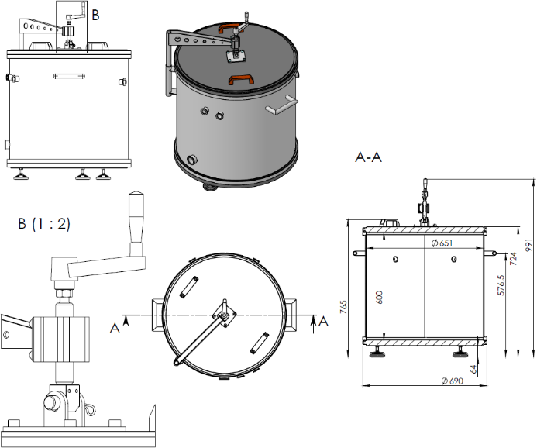

# Figure 2: Vacuum recipient for the GFS.

It is a simple stainless steel cylinder with the rubber sealings at its ends and welded-in vacuum fittings to connect pumping, measuring, electric and pneumatic connections. The cylinder has two strong duralumin lids to prevent their bending due to the atmospheric pressure. The lower lid is furnished with the legs and the upper lid is equipped with a mechanism to lift and turn it. The recipient is pumped in vacuum mode by the conventional dry vacuum pumps.

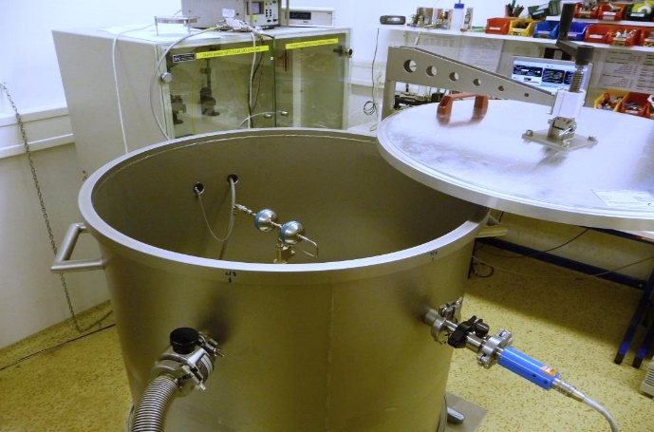

# Figure 3: Open vacuum recipient for the GFS.

# 4. Uncertainty budgets of the GFS

When comparing the initial atmospheric weighing with the work in the special box, then the use of hermetic mode significantly decreases uncertainty of deter-mination of the change in mass of the pressurized cylinder. We have two cylinders. The uncertainty budget for 1.1-liter cylinder is shown in Figure 4, a graph for 1.5-liter cylinder would be practically identical.

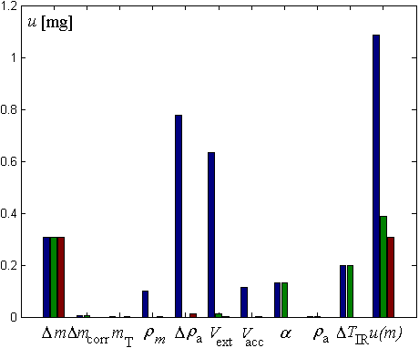

# Figure 4: Uncertainty of the amount of flow for 1.1 liter cylinder in various modes – atmospheric mode – blue, hermetic mode – green, vacuum mode – red. *m*, *m*corr, *m*T – weighing, *m* – mass density,* ***a, **a – atmospheric density, *V*ext, *V*acc – volume,* * – thermal expansion and  *T*IR – temperature measurement influence.

As it is seen, vacuum mode is not such a significant advantage; however another issue must be also accounted for. This is a prevention of water condensation on the cylinder surface during higher flows. However, a decrease of uncertainty of weighing will not reflect into the whole range of applicable flows and especially of amounts of flow, due to the influence of the time measurement uncertainty, see Figure 5. While for the small flows and the smaller depleted amounts, the uncertainty in hermetic mode decreases four times and in the vacuum mode decreases nearly five times, then for the great depleted amounts the manufacturer declares the uncertainty lower by nearly 7 %. However, it should be taken into account that the manufacture’s declaration is one thing and the uncertainty acknowledged by CMC is the other thing. Only a few national metrology laboratories all over the world can provide the conservative uncertainty level of 0.05 % (*k* = 2) from the measured value.

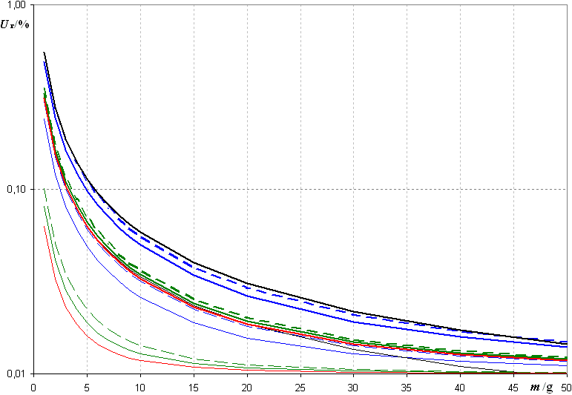

# Figure 5: Comparison of relative uncertainties of flow for various modes – 200 mg/s –thick line, 0.2 mg/s – thin line, DHI specifications – black, atmospheric mode – blue line, hermetic mode – green, vacuum mode – red line, 1.5 liter cylinder - broken line.

The relative uncertainty in the hermetic modefor 1.1-liter pressure cylinder is (in the range 1 to 20000 sccm):

 (5)

And for 1.5-liter cylinder it is:

 (6)

The condition *m*d  7 g now gives the maximum uncertainty 0.09 % of measured value for 20000 sccm flowrate, but usually much lower.

The relative uncertainty in the vacuum modefor both pressure cylinders is:

 (7)

The condition *m*d  7 g now gives the maximum uncertainty 0.08 % of measured value for 20000 sccm flowrate, but usually much lower.

# 5. Results of the comparison of the GFS in the atmospheric and the vacuum modes

The very satisfactory results of an internal comparison of a performance of the GFS in the atmospheric and vacuum modes is via 500 sccm molbloc transfer standard are shown in Table 1.

**Table 1:** The measured difference between vacuum and atmospheric mode in calibration characteristics of the 500 sccm molbloc in % of measured value (MV).

|  |  |  |
| --- | --- | --- |
| **Nominal flow – 500 sccm molbloc** | **Difference in vacuum and atmospheric mode** | **Scatter** |
| **[sccm]** | **[% from MV]** | **[% from MV]** |
| 500 | 0.016 | 0.008 |
| 400 | -0.017 | 0.006 |
| 300 | -0.026 | 0.002 |
| 200 | -0.027 | 0.002 |
| 100 | -0.025 | 0.009 |
| 50 | 0.012 | 0.009 |

Recently, the 0.05 % uncertainty claimed for the operation in the vacuum mode was confirmed by a comparison with LEI (Lithuania), LNE (France), MIKES (Finland) and PTB (Germany) within EURAMET Project 1325 [12] in the range from 5 to 20000 sccm.

# 6. Other utilizations

The CMI plans that this experimental set-up will constitute a traceability hub not only for the low gas flows, but also for the leak artefacts and the production of the precise gas mixtures.

As for the leaks, we aim only to the atmospheric leaks, because the vacuum ones are usually of much lower flow rates than can be measured by this system. However, it seems to be promising for the atmospheric Freon leaks. If we compare the initial atmospheric weighing with the work in the special closable box, the solution is beneficial mainly for the secondary standard freon leaks of large values, which usually have a bulky structure, see Figure 6. However, it is necessary to realize that this solution was intended especially for them, since there exists a better solution for small and compact ones (a Mettler Toledo mass comparator, see [10,11]).

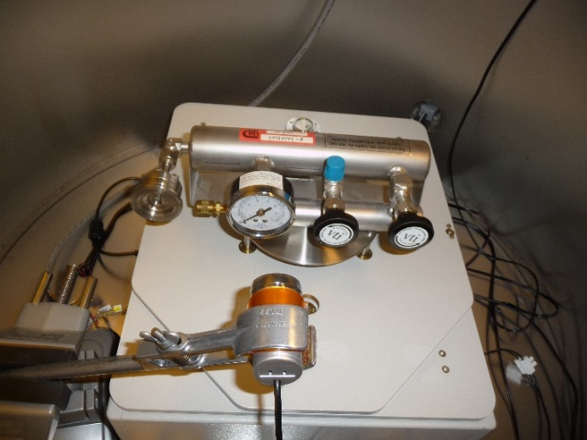

# Figure 6: Standard freon leak in a hermetic box with a camera for reading pressure of freon.

Last, but not least, the GFS system in this set-up also ensures the traceability of the mass flow controllers serving in our gas diluting system with the dilution ratio up to 1 : 17500, see Figure 7.

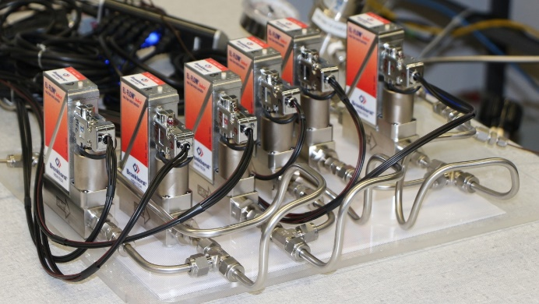

# Figure 7: Gas diluting system of the CMI.

# 7. Conclusion

Modification of the GFS using weighing improved the resultant expanded (*k* = 2) uncertainty of the national standard of low gas flow from 0.1 % to cca 0.05 % due to supressing of all effects of uncertainty depending on the density of cylinder and the uncertainty of density of the ambient air. Also, the condensation of water on the cylinder is quite impossible now even when temperature of the pressure bottle drops below the dew point at the higher flow rates. Measurement accuracy was confirmed in international comparison Euramet.

# References

1. Krajíček Z, Pražák D, Vičar M, Tesař J, Staněk F, “Zajištění metrologie malého průtoku plynů – nový státní etalon dynamické gravitometrie – GFS”, *Metrologie*, **19**, 18–23, 2011. (*in Czech*)
2. Bair M, Rombouts C, Technical Note 6050TN09, http://download.flukecal.com/pub/literature/6050TN09.pdf
3. Krajíček Z, Pražák D, Hajduk T, Tesař J, “Experiences with traceability of molbloc flowmeters to primary gravimetric mass flow standard”, *Metrologie*, **56**, 38–43, 2009.
4. Bair M, Technical Note 2011TN06B, http://download.flukecal.com/pub/literature/2011TN6B.pdf
5. Krajíček Z, *Rozšírenie rozsahu primárného etalónu malého hmotnostného prietoku plynu* (Bratislava, STU), 2013. ISBN 978-80-227-4014-2 (*in Slovak*)
6. Probert C, Johns A I, Metaxiotou Z, “An intercomparison of low gas flow facilities at eleven European laboratories using a Molbloc transfer package: EUROMET.M.FF-S3”, *Metrologia*, **45**, Tech. Suppl. 07012, 2008.
7. Kutin J, Bobovnik G, Bajsič I, *Report: Direct Comparison of the LMPS Gas Flow Reference Standard at ČMI in the Range (2 to 44000) Scm3/min* (Ljubljana: Faculty of Mechanical Engineering), 2012.
8. Rombouts C, Bair M, Barbe J, Wright J D, Kramer R, Krajicek Z, “A Comparison of Primary Gas Flow Standards Spanning the Range from 10 sccm N2 to 10 slm N2”, *Measure*, **9**, 46–54, 2014.
9. Krajíček Z, Vičar M, Pražák D, Tesař J, Hajduk T, Peksa L, Gronych T, Jeřáb M, “Experience with gravimetric flow standard (GFS) in vacuum and hermetic mode”, in *XXI IMEKO World Congress Full Papers Book*, 2015. ISBN 978-80-01-05793-3 (online only - pdf).
10. Pražák D, Zůda J, Tesař J, Peksa L, Vičar M, “Perspectives of atmospheric reference leaks calibration by gravimetric method”, *Measurement*, **46**, 621–627, 2013.
11. Pražák D, Peksa L, Tesař J, Gronych T, Vičar M, “A survey of the principles for primary standards for atmospheric halogenated hydrocarbon-leaks”, *Metrologia*, **52**, R11–R21, 2015.
12. Heinonen M, Högström R, *Comparison report No. M-16D001 – draft* (Espoo: MIKES), 2016.