Development of a calibration process for water meters close to real world conditions

D. Schumann¹, G. Wendt², J. Tränckner³

¹PTB – The National Metrology Institute of Germany, Daniel.Schumann@ptb.de, Braunschweig, Germany
²PTB – The National Metrology Institute of Germany, Gudrun.Wendt@ptb.de, Braunschweig, Germany
³The University of Rostock, Jens.Traenckner@uni-rostock.de, Rostock, Germany
E-mail (corresponding author): Daniel.Schumann@ptb.de

Abstract

A growing awareness of environment as well as consumption is leading to rising and novel requirements for flow metering technology, e.g. higher flow rate ranges, smaller measurement uncertainties and calibration procedures more oriented to the actual requirements of further use. This means a changeover from ideal stationary calibration conditions to realistic measurements and a demand for meters which operate precisely under real working conditions.
As an example, realistic conditions, especially the profiles of real water demand, deviate fundamentally from the existing test procedures of water meters at well-defined, constant and reproducible reference flows as prescribed, for instance, in the existing documents in legal metrology like OIML R49 [1] or ISO 4064 [2]. In the real world, a daily profile of water consumption is characterized by short water tappings, overlays of different tapping events, varying flank increases, leakage and stagnation. The main purpose of the investigations described is to develop both highly realistic calibration procedures for water meters based on real water consumption profiles as well as the physical opportunities to generate them. Based on the analysis of water consumption measurements at more than 300 German households and of several international consumption profiles, realistic flow rates and flow rate sequences can be identified. To simulate such highly variable flow rates, a device-related test setup using cavitating nozzles has been developed. With the test rig, it is possible to generate reproducible dynamic flow rates also under laboratory conditions. The corresponding behaviour of different water meters at the simulated consumption profiles are recorded electronically and are traceable to a gravimetric standard. First results show remarkable differences in the behaviour of the water meters in reference to the different realistic profiles used.

Introduction

The daily practice of potable water consumption differs from person to person and from region to region. It depends on the widely differing consumer habits as well as on the particular external preconditions. In each case, the consumption is characterized by highly changing flow rates in time and quantity and is measured by a variety of different types of water meters, e.g. piston, single-jet, multi-jet, ultrasonic or electromagnetic meters. In many countries, water meters are subject to legal metrological control. The current international documents mostly used in this field are the International Recommendation of OIML R49 “Water meters for cold potable water and hot water” [1] as well as the ISO Standard 4064 “Water meters” [2].
Amongst other things, these recommendations define the technical and metrological requirements for the meters, the test procedures during type evaluation and verification as well as the concrete test conditions. Particularly here, an essential contradiction occurs between the long-lasting stable flow rate required for the tests and the highly dynamic flow rate changes during the water tapping under “real world conditions”.
The purpose of the following research is to identify these real world conditions and to develop procedures fulfilling the current practical demands.
Therefore, the consumption profiles of over 300 households in Germany and several international consumption profiles were used to identify the actual conditions of use of the water meters.
To reproduce such highly variable flow rates a device-related test setup using cavitating nozzles has been developed. The corresponding behaviour of different water meters at the simulated consumption profiles is recorded electronically and traceable to a gravimetric standard.

Identifying real world conditions

Public data
The necessity of developing and implementing more realistic test conditions for water meters is based on a large variety of the real conditions of the water meters’ practical use. Figure 1 [3] provides a worldwide overview of the actual total water withdrawal per country and year, whereupon the relation between water needs of several sectors (industry, agriculture and public consumption) differs considerably. The mean daily potable water consumption (without industry and agriculture) per capita ranges from 25 litres in India over 122 litres in Germany, 295 litres in the United States up to 500 litres in Dubai [4].
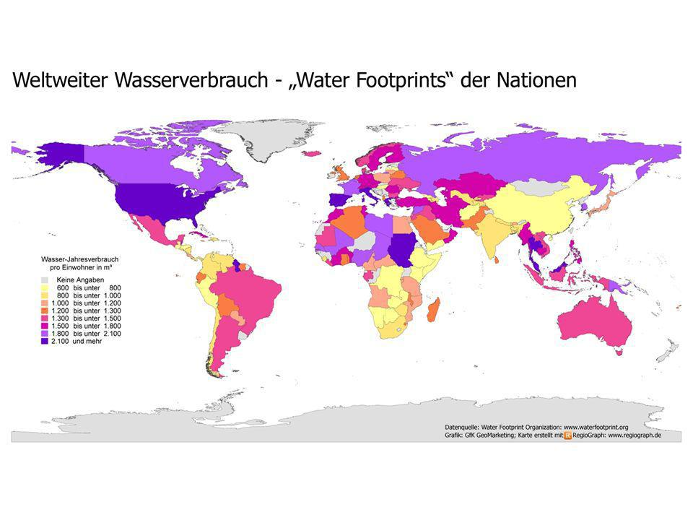
No data
600 – 800
800 – 1000
1000 – 1200
1200 – 1300
1300 – 1500
1500 – 1800
1800 – 2100
> 2100
Figure 1: Total water withdrawal worldwide per year and per capita in m³ (including all sectors such as industry, agriculture and public water consumption) [3]

A further analysis of these data shows that for instance in Germany the mean water consumption per household splits up into seven main parts (Table 1). These types of use show an average consumption for German households, but they can be transferred to other countries – with varying portions of the total consumption.
The consumption profile of a household is characterised by a multitude of single tappings as well as tappings of different quantities and duration. Based on data recorded during a research project [5], it can be concluded that the smaller the population of a house or a flat, the higher the variance of consumption due to individual withdrawals.

Table 1: Composition of water consumption in Germany 2013 [7]
Type of use | Part of total consumption [%]
Bath, shower, personal hygiene | 36
Toilet | 27
Laundry | 12
Cleaning, car care, garden | 6
Dishes | 6
Food and drink | 4
Small trade | 9

The daily consumption curve of a multi-family house, which is shown in Figure 2, is just an example of water withdrawal at the household level. Keeping in mind that these consumption curves are measured with regular water meters, which are tested and approved through [1] and [2], the current real condition differs fundamentally from test conditions required in the existing regulations.
The analysis of the consumption curves in [5] does not only provide information about the “simple” water withdrawal of the inhabitants, but also shows essential aspects of peoples’ behaviour. Figure 3 represents the probability density function (PDF) of the consumption of a multi-family house over 8 weeks. A daily analysis of these data shows that the trend of this function recurs each weekday during the whole time of recording the water consumption. Furthermore, it follows approximately the same pattern. It should be mentioned that the time periods of no flow which represent the highest part during the observation period are not included in Figure 3 and Figure 4.
The reported curves are characterised by multiple single peaks in the lower flow part and two major peaks between 500 l/h and 1200 l/h. Keep in mind that in these households water meters of the size Q₃=4 m³/h (formerly Q_{n} 2.5) are used. The respective test flow rates of Q₁ at 25 l/h, Q₂ at 40 l/h and a nominal flowrate Q₃ at 4000 l/h (red lines in Figure 3 and Figure 4) lie completely outside of the actual flowrate range.

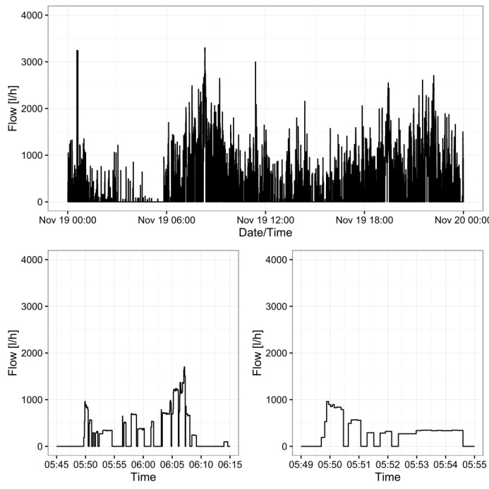
Figure 2: Real consumption profile of a multi-family house over 24 h (above), 30 min (on the left) and 6 min (on the right) [5]

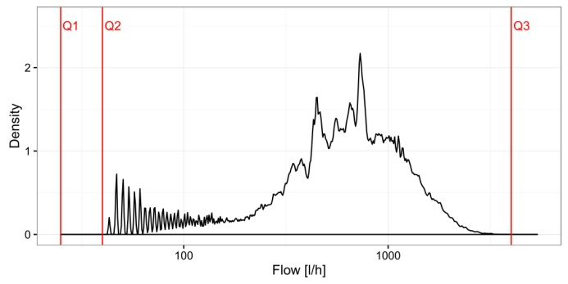
Figure 3: Probability density function (PDF) for a multi-family house over 8 weeks

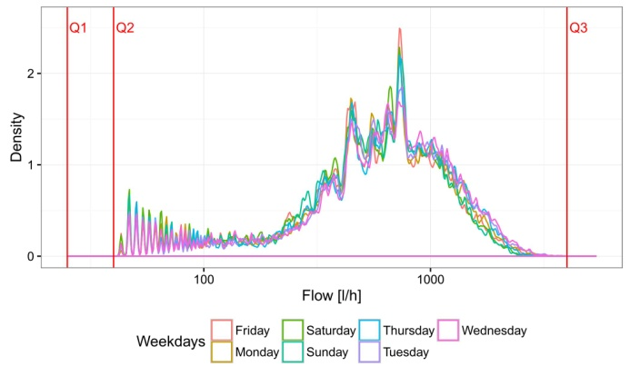
Figure 4: PDF for a multi-family house classified by weekdays

Therefore, an analysis of public data - as was done to a great extent in the study [5] - demonstrates that the requirements of the current test practice of water meters clearly contradict the real consumption conditions of potable water in two points:
- rapid changing flow rates regarding time and quantity versus constant flow rates and long-lasting measurement times during the tests
- immense differences between the consumption and the test flow rates

Overrun test results
The first focus concerning the development of more realistic test procedures was directed to the identification of the impact of mainly temporary withdrawals and small volumes on different types of water meters. For this, multi-jet and single-jet as well as piston and electromagnetic meters of different sizes and accuracy classes were subject to the measuring program shown in Table 2.
Table 2: Measuring program for the overrun tests
Flow [l/h] | Measuring time [sec]
300 | 2; 5; 10; 20; 30
600
900
1500
2500
5000

The water meters were tested in a gravimetric test rig at the Physikalisch Technische Bundesanstalt (PTB) in Braunschweig. The overall expanded uncertainty (k=2) is smaller than 0.05 %, which was determined in accordance with the “Guide to the Expression of Uncertainty in Measurement” [6]. The displays of the water meters under test were electronically recorded and analysed. As an example, the results of a Q_{n} 2.5 multi-jet water meter are displayed in Figure 5.

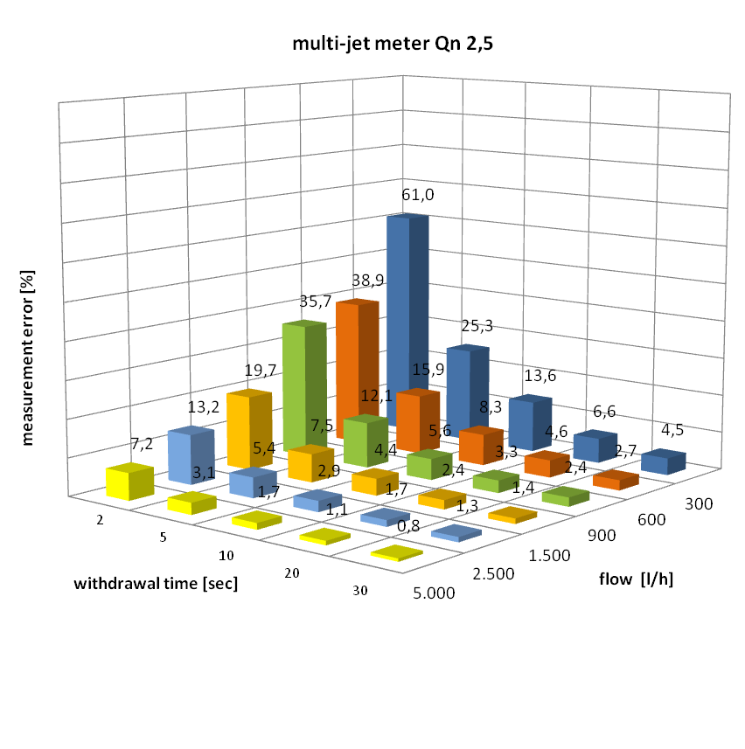
Figure 5: Example of the overrun measuring results for a multi-jet water meter Q_{n} 2.5

The highest measurement error of 61 % occurred during a two-second flow of 300 l/h. The graph also illustrates that the longer the withdrawal time, the lower the measurement errors. When using single-jet meters for the measurement program, error deviations up to 170 % occurred under these conditions. For all investigations the error deviations were always positive.
At this point, it should be clearly emphasised that such large measurement errors are achieved in very extreme withdrawal situations. From the consumers’ point of view, further analyses have shown that the overall errors for an ordinary consumption profile during a whole day still lie within the maximum permissible errors in service. Nevertheless, the test results showed an urgent demand for a critical analysis of the current test procedures as stated in the prevailing documents.

Practical implementation of dynamic testing conditions

Development of a new type of a test rig operating with cavitating nozzles
Up to now, all test procedures and test facilities in the field of quantity and flow rate measurement of flowing fluids are solely focused on the realisation of highly stable and reproducible flows without any disturbances or other influences. This approach does not only concern the primary standards of the national metrology institutes, it is common and usual practice. The discrepancies between test and real world conditions of the water meters can be qualitatively transferred to a lot of other applications in fluid measurement; for instance in the automotive industry (measurement of instantaneous fuel consumption), in chemical, pharmaceutical and food industries (process controlling and quality insurance) or in oil production (amongst other things, also for danger prevention), with the same adverse effects. Therefore, the development of test facilities enabling the realisation of highly dynamic, reproducible and traceable flows is of growing interest.

Based on the excellent experience with the critical nozzle in gas measurement, PTB’s department “Liquid Flow” started comprehensive research activities with so-called cavitating nozzles. The first step was the development of a special test rig using a set of six toroidal Venturi nozzles manufactured in accordance with the corresponding ISO standard 9300 for gas measurement [8]. Figure 6 and Figure 7 show the prototype of the test rig and the initially used nozzles, respectively.

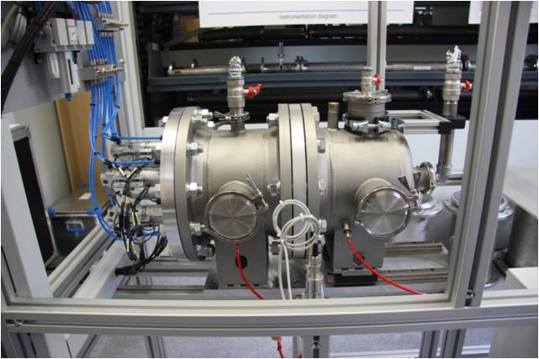
Figure 6: Test rig with six optionally shiftable cavitating nozzles

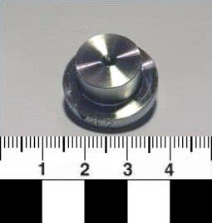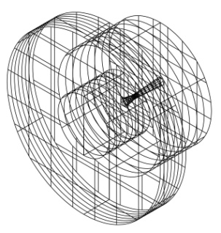
Flow
Figure 7: Initially used cavitating nozzles of toroidal shape

3.2 Realisation of reproducibly changing flow rates
The developed test rig is equipped with six nozzles realizing flow rates between 100 l/h and 5400 l/h. The corresponding diameters lie between 1 mm and 8 mm. Using different nozzle combinations, flow rates between 100 l/h and 10 m³/h can be realised in discrete steps of 100 l/h of any order. Instantaneous flow rate changes are possible due toof a very fast opening and closing of the nozzle holes, respectively by pneumatically driven pistons.
Figure 8 shows two “theoretical” flow rate profiles (sequence A: stepwise sloping, and sequence B: alternating); Figure 9 (sequence C) reproduces the real consumption profile of Figure 2.

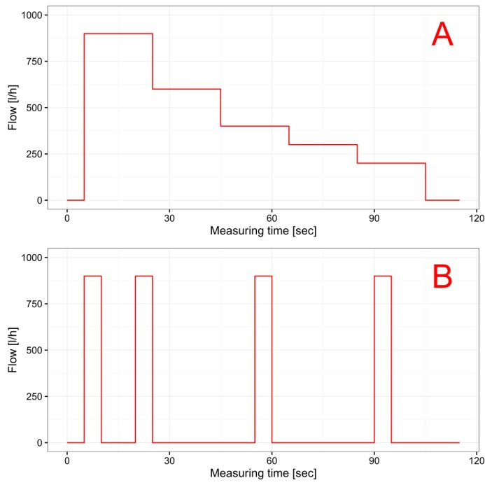
Figure 8: Theoretical flow sequences A and B representing stepwise sloping and alternating consumption profiles

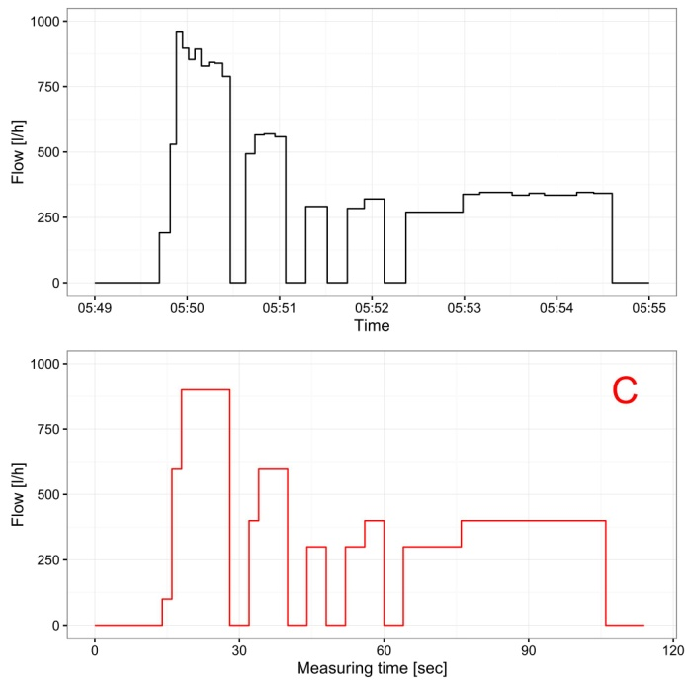
Figure 9: Real flow sequence C representing reproducing an actuallymeasured consumption profile according to Figure 2

3.3 Test results
Up to now, numerous profiles have been investigated. Besides the study of the cavitating nozzles themselves, also the behaviour of different types of water meters being exposed to several consumption profiles has been analysed. Especially the different reactions of particular meter types has been of greatest interest. Figure 10 presents, as an example, the reaction of an electromagnetic flow meter with high frequency output which follows the changing flow rates nearly without any delay.

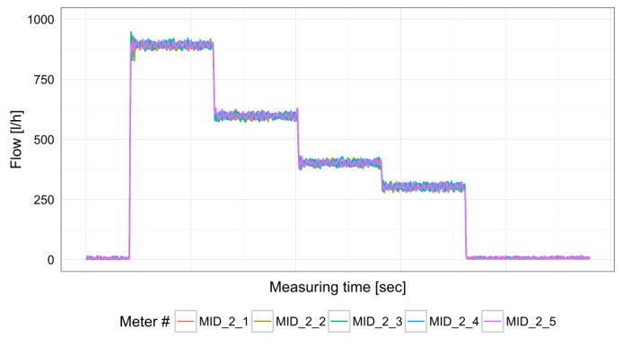
Figure 10: Test results of an electromagnetic flow meter with high frequency output at sequence A

Figure 11 shows the results of an ultrasonic flow meter developed to be used as a utility volume meter and to apply for consumption measurement in households (i.e. it is not configured for instantaneous flow rate measurements). Nevertheless, it also follows the flow rate changes relatively fast and gives stable flow rate indications at the plateaus.

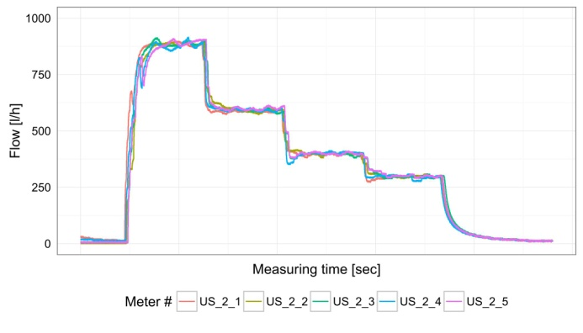
Figure 11: Test results of ultrasonic water meter at sequence B

Based on long-lasting studies of the flow rate stability achieved by the cavitating nozzles, reproducibilities of these flow rates of 0.1 % and better could be verified.

3.3 Further steps
In cooperation with the University of Duisburg-Essen, comprehensive investigations of the theoretical background of cavitating flows through nozzles have been started. The reason is that only Venturi nozzles of toroidal shape have been in use so far. The PTB was particularly interested in special investigations concerning the possibilities of an optimisation of the nozzles’ inner contour for their application under cavitating flow conditions. As a result of these activities, it was proposed to change the toroidal nozzle type to a Herschel Venturi tube.
In addition to the simulation at the University of Duisburg-Essen, an acrylic glass nozzle was prepared and with the help of a high speed camera, the flow conditions inside the nozzle were recorded. The details of these investigations are presented in [9] and [10].

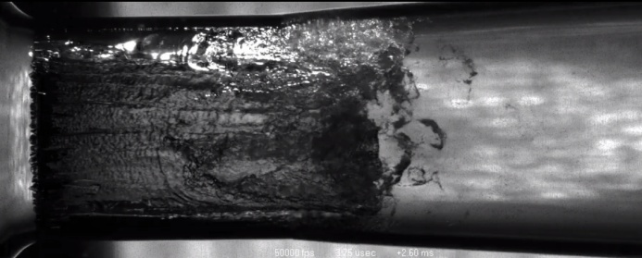
Flow
Figure 12: High speed recording of an acrylic glass nozzle (see also [9])

All the investigations carried out at PTB and at the University of Duisburg-Essen validate the applicability of cavitating nozzles to realise highly reproducible flow rates also under rapidly changing flow conditions.

Conclusion

The paper presents the essential divisiveness between the practical conditions of the use of water meters and the requirements in the current international regulations for water meter testing. While real conditions are characterised by highly dynamic and rapidly changing flow conditions, the regulations enact stable and reproducible flow conditions on fixed flow rates far away from the real consumption mainly occurring in practical use.
The identification of the real world conditions of water consumption is one of the reasons requiring the development of novel test facilities and test procedures for utility water meters. Therefore, it is necessary to analyse the existing consumption profiles, to define and investigate representative profiles for typical applications and to show the influences on different profiles to different types of water meters.
On the other hand, it is necessary to develop and to establish a new generation of test rigs. First investigations with cavitating toroidal and Herschel Venturi nozzles validate the applicability of these methods for creating highly reproducible dynamic flow conditions.
The combination of real world data of water consumption and of baseline and experimental investigations and simulations is a promising blend to establish a novel test process for waters meter under conditions that are closer to their realistic use and are better able to ensure reliable measurements.

References

- OIML R 49, Water meters for cold potable water and hot water, 2013
- ISO 4064, Water meters for cold potable water and hot water, 2014
- Water Footprint Organisation, Total water withdrawal worldwide per year and per capita in m³, http://www.waterfootprint.org
- OECD (2010), "Wasserverbrauch", in Die OECD in Zahlen und Fakten 2010: Wirtschaft, Umwelt, Gesellschaft, OECD Publishing, Paris.
- A. Korth, T. Martin (2016): “Aktualisierung von Verbrauchsganglinien für Haushalte, öffentliche Gebäude und Kleingewerbe sowie Entwicklung eines Modells zur Simulation des Wasserbedarfs”, DVGW-Forschungsvorhaben W-10-01-11, not published
- Internationale Organisation für Normung (1995): Guide to the expression of uncertainty in measurement. 1. ed., corr. and reprinted. Genève.
- BDEW Wasserstatistik, https://www.bdew.de/internet.nsf/id/bdew-jahresstatistik-de
- ISO 9300, Measurement of gas flow by means of critical flow Venturi nozzles, 2005
- S. Brinkhorst, E. von Lavante, D. Güler, G. Wendt, “Experimental Investigation of Cavitating Herschel Venturi-Tube Configuration“, in FLOMEKO 2016, Sydney, 2016, submitted
- S. Brinkhorst, E. von Lavante, G. Wendt, (2015): “Numerical investigation of cavitating Herschel Venturi-Tubes applied to liquid ﬂow metering”. In: Flow Measurement and Instrumentation 43, S. 23–33. DOI: 10.1016/j.ﬂowmeasinst.2015.03.004

