Bilateral Comparison between NMISA and VTT-MIKES – Part of the NMISA Flow Laboratory Journey to Accreditation

**D. Jonker1, R. Högström2, M. W. Dlamini1**

*1NMISA – National Metrology Institute of South Africa, Private Bag X34 Lynnwood Ridge 0040, Pretoria, South Africa*

*2VTT Technical Research Centre Ltd., Centre for Metrology MIKES, Espoo, Finland*

*E-mail (corresponding author):* [*djonker@nmisa.org*](mailto:djonker@nmisa.org)*, Pretoria, South Africa*

# Abstract

The NMISA Flow laboratory is in the process of obtaining ISO/IEC 17025 accreditation. The laboratory is compelled to perform the majority of gas flow calibrations in South Africa, due to severely limited accredited gas flow calibration capacity in industry. This is resulting in unacceptable long lead times.

The laboratory is equipped with a positive displacement piston prover as the highest-level standard. Traceability is obtained by sending this secondary standard to overseas National Metrology Institutes for calibration. The necessity of sending the reference standard overseas for regular re-calibration in order to maintain sufficient confidence in the reliability of the results, means an absence of about two months from the laboratory, creating a further impact on the calibration lead times. Intermediate measurement checks are performed with flow cells overlapping in different flow ranges to prove reliability of the measurement results and compliance to the requirements of ISO\IEC 17025. A bilateral comparison was performed with the VTT-MIKES Flow laboratory to validate the mass flow controller calibration method of NMISA, as well as to assess metrologist competence. VTT-MIKES acted as the pilot laboratory.

To address the long lead times, a set of laminar flow elements covering the flow range 0.5 mL/min to 50 000 mL/min, was purchased as another reference standard. Two reference standards in the laboratory will eliminate the situation of a two months absence of reference standards from the laboratory and will increase the calibration capacity of the laboratory.

This paper gives an overview of the NMISA Flow laboratory, the progress made towards ISO\IEC 17025 accreditation and discusses the bilateral comparison; artefacts used, method employed, and measurement results. Future developments planned for the laboratory are also discussed.

# 1. Introduction

NMISA, the National Metrology Institute of South Africa, is mandated to provide measurement traceability to the South African industry. The majority of gas flow calibrations for the South African industry are currently performed by the NMISA gas flow laboratory and one other ISO/IEC 17025 accredited laboratory. This limited accredited gas flow calibration capacity in industry results in long calibration lead times.

A first priority for the NMISA gas flow laboratory was to obtain ISO/IEC 17025 accreditation. The gas flow laboratory of VTT-MIKES agreed to act as the reference laboratory for a bilateral comparison using four mass flow controllers as comparison artefacts.

A second priority was to obtain a second secondary reference standard. Using secondary standards as reference standards in the laboratory, therefore importing traceability from other overseas National Metrology Institutes (NMIs), necessitates the calibration of the standards at an overseas NMI. This results in a reference standard’s absence from the laboratory for approximately two months. Having two reference standards in the laboratory solves this problem.

# 2. The NMISA gas flow laboratory

The gas flow laboratory is part of the Flow Section in the Physical Metrology group. Gas flow (volume gas flow) calibration services are offered in the flow range 5.0 mL/min to 50 000 mL/min. Nitrogen gas is used as the calibration medium. Environmental conditions are monitored by a barometer and temperature- and humidity loggers. Typical instruments received for calibration include mass flow controllers, mass flow meters, bubble flow meters and rotameters.

The gas flow laboratory is equipped with two secondary reference gas flow standards as highest-level standards, a Bios ML-800 positive displacement piston prover and Fluke molbloc-L laminar flow elements (LFE). As the laboratory is not equipped with a primary gas flow standard, the secondary reference standards are calibrated by overseas National Metrology Institutes with relevant calibration and measurement capabilities (CMCs) in the BIPM key comparison database (KCDB). Traceability to international standards is therefore imported from these NMIs.

# 3. Road to accreditation

The first step was the implementation of a quality system in the laboratory which adheres to the overall NMISA Total Quality Management System based on the requirements of the ISO/IEC 17025 standard.

Secondly a laboratory comparison had to be performed with an overseas National Metrology Institute (NMI) over the required flow range (5.0 mL/min to   
50 000 mL/min) to support the laboratory’s proposed calibration and measurement capabilities (CMCs).

Thirdly the metrologists had to register with the NLA (National Laboratory Association) MetCert personnel certification scheme as metrologists or at the South African Council for Natural Scientific Professions (SACNSP) as scientists. This is a requirement implemented by SANAS (South African National Accreditation System). Registration at one of these two registration bodies is compulsory to be approved as a Technical Signatory by SANAS.

The NMISA gas flow laboratory implemented the required quality system, participated in a bilateral comparison with VTT-MIKES and the metrologists were registered as metrologists through the MetCert scheme. The gas flow laboratory underwent an initial assessment by SANAS on 22 & 23 March 2016. An international expert was employed as technical assessor. The laboratory received a positive recommendation for accreditation pending the successful clearance of the non-conformances identified.

# 4. MIKES – NMISA bilateral comparison

*4.1 Comparison arrangements*

Four MKS mass flow controllers (50 mL/min, 500 mL/min, 5 000 mL/min, 50 000 mL/min) were used as comparison artefacts. Measurements were first performed by NMISA. The four mass flow controllers were then sent to the VTT-MIKES flow laboratory for calibration. After VTT-MIKES had completed the calibration, the mass flow controllers were returned to NMISA for a second calibration. VTT-MIKES acted as the reference laboratory (pilot), compiling the comparison report and generating the calibration certificates.

Measurements were performed at the following nominal points:

MFC(1): 5 mL/min, 12.5 mL/min, 25 mL/min,   
37.5 mL/min and 50 mL/min

MFC(2): 50 mL/min, 125 mL/min, 250 mL/min,   
375 mL/min and 500 mL/min

MFC(3): 500 mL/min, 1 250 mL/min, 2 500 mL/min,   
3 750 mL/min and 5 000 mL/min

MFC(4): 5 000 mL/min, 12 500 mL/min, 25 000 mL/min, 37 500 mL/min and 50 000 mL/min

Measurement results were reported at the standard conditions of 0 °C and 101.325 kPa. Nitrogen (purity of at least 99.999%) was used as the calibration gas and the mass flow controllers’ inlet pressure was set to  
1.7 bar(g). Measurement uncertainty calculations were performed for each measurement.

A specific excel spreadsheet was provided by the pilot laboratory for the reporting of the results. Calibration certificates were generated for the calibrations. A description and pictures of the calibration system had to be submitted to the pilot laboratory as well as the NMISA gas flow laboratory’s traceability information.

NMISA submitted their two sets of measurement results simultaneously after the second calibration was completed. VTT-MIKES compiled the comparison report thereafter.

*4.2 Measurements performed at VTT-MIKES*

Calibrations below 30 000 mL/min were performed using the LFE (laminar flow element) calibration system and for calibrations above 30 000 mL/min, the DWS2 primary standard was used. The LFE calibration system is calibrated against the DWS1 primary standard to establish traceability to SI units.

The two primary standards, DWS1 and DWS2, are primary gravimetric standards for gas mass flow which are traceable to SI units through measurements of mass and time.

At each measurement point four one minute measurements were performed.

*4.3 Measurements performed at NMISA*

NMISA performed two sets of measurements, one before and one after VTT-MIKES’ measurements. The mass flow controllers were calibrated against the Bios ML-800 reference gas flow standard. The mass flow controllers were connected in line with the Bios.

A nitrogen gas cylinder was connected to the inlet of the flow bench with its outlet connected to the inlet of the mass flow controller. The outlet of the mass flow controller supplied the reference standard with the flow medium.

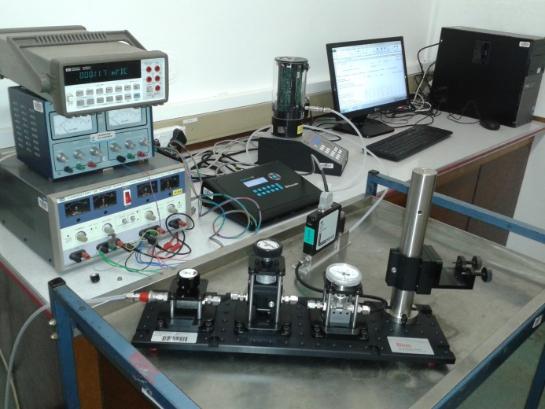

Figure 1: NMISA calibration system.

Ten consequtive readings from the reference standard were acquired at each measuring point.

# 5. Method for analysing the results

At each measurement point, the relative calibration correction ( ) was determined as:



(1)



,

where and are the actual volumetric flow determined by the laboratory and the corresponding reading of the instrument, respectively. The difference between the reference laboratory and the participating laboratory (*DNMISA*) was determined as:



(2)



where was calculated as the uncertainty weighted mean of NMISA1 and NMISA2 measurements according to [2].



The uncertainty of the difference was calculated as:

, (3)

The drift *udrift* was determined as the largest difference between the weighted mean of the NMISA measurements and one single measurement assuming a rectangular probability distribution:

 (4)

*5.1 Significance of the observed differences*

To analyse the significance of the differences calculated with equation (2), normalized error values (*E*n) were calculated by dividing the difference with its expanded uncertainty (*k*=2)

, (5)



If -1 < *E*n < 1, the estimate for the difference is smaller than its expanded uncertainty. In this case, there is no statistically significant difference between the results obtained by the reference laboratory and the participating laboratory.

*5.2 Drift of the transfer standards*

The drift of the transfer standards during this comparison was studied by comparing the results of the measurement sets at NMISA to each other. Figure 2 shows the relative calibration corrections for both measurement sets.

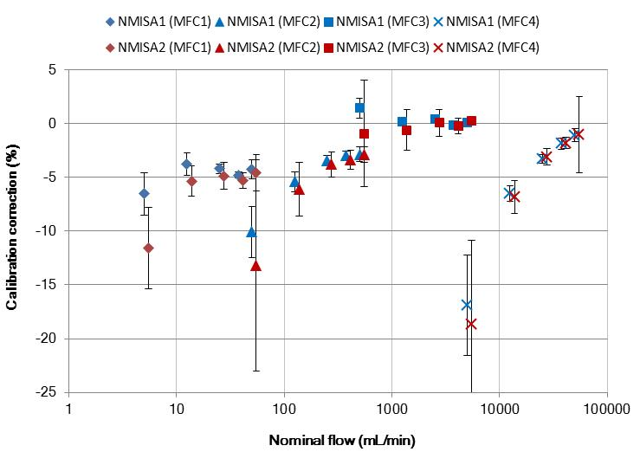

**Figure 2:** Calibration corrections determined in NMISA1 and NMISA2 for transfer standards MFC(1), MFC(2), MFC(3), MFC(4). Error bars show the estimated expanded uncertainty (*k* = 2).

NOTE: x-axis values are adjusted in order to avoid overlap of symbols.

The drift was generally less than the measurement uncertainty for all transfer standards and therefore no corrections were made to the results. Instead, the drift was included in the uncertainty of the NMISA results [1]. The differences in the uncertainties for the NMISA1 and NMISA2 measurements were due to poor reproducibility between the two sets of measurements.

# 6. Comparison results

Results of the laboratories are shown in table 1 and figures 3 to 6. The uncertainty due to drift of the transfer standards is included in the NMISA results.

**Table 1:** Final results of the comparison for MFC 1 to MFC 4.

Expanded uncertainties are given using a coverage factor of 2.



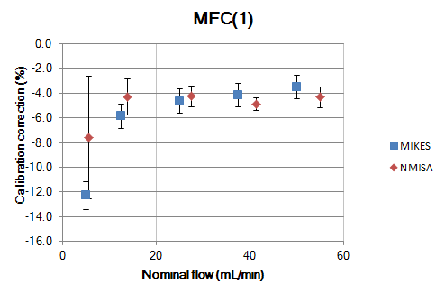

**Figure 3:** Comparison results with transfer standard MFC(1). Error bars show the estimated expanded uncertainty (*k*=2).

NOTE: x-axis values are adjusted in order to avoid overlap of symbols.

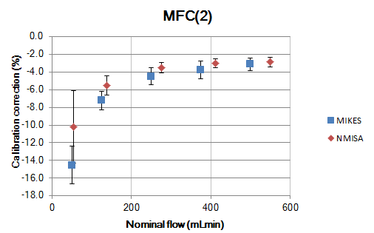

**Figure 4:** Comparison results with transfer standard MFC(2). Error bars show the estimated expanded uncertainty (*k*=2).

NOTE: x-axis values are adjusted in order to avoid overlap of symbols.

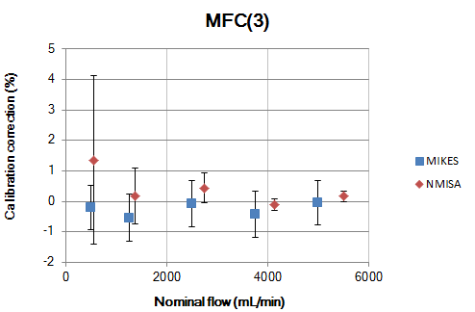

**Figure 5:** Comparison results with transfer standard MFC(3). Error bars show the estimated expanded uncertainty (k=2).

NOTE: x-axis values are adjusted in order to avoid overlap of symbols.

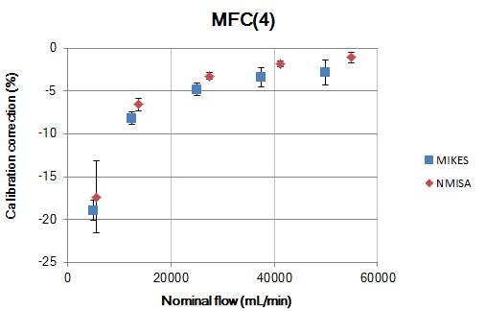

**Figure 6:** Comparison results with transfer standard MFC(4). Error bars show the estimated expanded uncertainty (*k*=2).

NOTE: x-axis values are adjusted in order to avoid overlap of symbols.

# 7. Discussion of the comparison results

The results of NMISA mainly agreed with the VTT-MIKES results for transfer standards MFC(1)-(3) in the volume flow range 5 mL/min to 5 000 mL/min. All normalized error values were within -1 ≤ *E*n ≤ 1, except for measurement point 125 mL/min with MFC(2). The observed discrepancy was probably due to the poor repeatability and stability of the MFCs when operated at low set point values. This is supported by the fact that the difference between laboratories was smaller at   
50 mL/min, 500 mL/min and 5000 mL/min for measurements performed with a MFC at set point of 100 % instead of 10 %.

A disagreement between the NMISA and VTT-MIKES results was found at flow rates from 12 500 mL/min to 50 000 mL/min, where *E*n values were above one. This discrepancy cannot be explained by the transfer standard, as it was found to perform well in this flow range. A systematic difference of about -1.6 % was found in this flow range, which suggests that there might be an underestimated systematic error component affecting the results of NMISA [1].

# 8. Follow-up measurements to investigate discrepancies

Measurements were repeated for the 50 000 mL/min mass flow controller (MFC(4)) using the LFE calibration system as reference standard. The measurements were performed according to the comparison protocol.

A nitrogen gas cylinder supplied gas through the reference LFE and the flow bench to the mass flow controller. The nitrogen gas was connected to the inlet of the LFE. The outlet of the LFE was connected to the inlet of the flow bench; the flow bench’s outlet was connected to the inlet of the mass flow controller. The outlet of the mass flow controller was open to atmosphere.

The results are shown in figure 7.

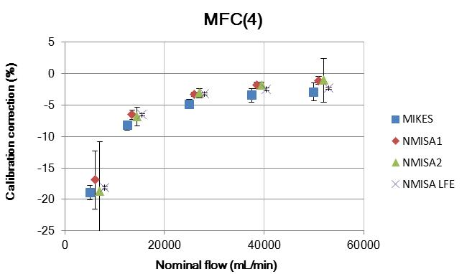

**Figure 7:** Measurement results for transfer standard MFC(4) including the measurements performed with the LFE. Error bars show the estimated expanded uncertainty (*k*=2).

NOTE: x-axis values are adjusted in order to avoid overlap of symbols.

The measurements performed with the LFE as reference standard were consistent with the results performed with the BIOS. Based on these findings, it seems that the BIOS performance is not the reason for the discrepancy observed in the comparison.

A possible reason for the observed discrepancies is the reproducibility and short-term stability of the transfer standard MFC(4). Due to the different reference standards used by NMISA and MIKES, the calibration cycles were different in terms of repetitions per calibration point and length of calibration cycle. Also the laboratory temperature deviated by 4 °C. This might have resulted in a different response of the mass flow controller.

**9. Conclusion**

To further investigate the discrepancies found at flow rates above 12 500 mL/min:

a) Direct comparison measurements between the Bios ML-800 and Fluke laminar flow element reference standards should be performed and the results analysed.

b) Measurement uncertainties will be investigated. Currently the main sources of uncertainty taken into consideration are the measurement uncertainty of the reference standard, repeatability and instrument resolution. It seems not to be adequate enough. Measurement uncertainty sources like reference standard stability, temperature and pressure influences will be investigated and included in the uncertainty budget.

c) Opportunities for NMISA to participate in further gas flow inter-laboratory comparisons should be investigated; inter-comparisons using high accuracy transfer standards, such as piston provers or LFEs.

# References

1. Comparison report, M-15D013.
2. Cox M. G., “The evaluation of key comparison data.” Metrologia 39. 589-595 (2002).