Low-speed Jerking Motion of the Reciprocating Double-pistons Gas Prover

Zhipeng Xu, Jun Zhou, Jiayin Dai, Dailiang Xie
Zhejiang Provincial Key Laboratory of Flow Measurement Technology,
China Jiliang University, Hangzhou 310018, China
E-mail: xuzhipeng@cjlu.edu.cn

Abstract

Piston prover is widely used as gas flow standard for its advantages like high accuracy, flow stability, good repeatability, and so on. In our former research on the reciprocating double-piston gas prover, obviously low-speed jerking motion was found when the flow rate was less than 0.064 m³/h. Sometimes the prover even stopped working due to overloaded torque of server motors. To solve this problem, the mechanism of the low-speed jerking was carefully analyzed. And the simple solution of stacking a high frequency saw-tooth wave into the constant speed of the piston was proposed. As a result, the mechanical structure could be avoided amending since there were only some changes within the control program. Detailed experiments had been carried out for the calibration of the venture nozzle whose flow rate was about 0.04 m³/h. And the results showed that the torque of servo motors has been reduced from about 120% of their nominal torque to only 60% when a 50Hz wave has been stacked. While both the pressure and the temperature fluctuations were limited in a small range.
Keywords: Gas flow rate, flow standard, piston prover, servo motor, low-speed lerking

1. Introduction

Low-speed jerking motion is an inconsecutive phenomenon caused by friction. Low-speed jerking motion was firstly raised in the 1930s by F.Bowden et al. [¹]. Overseas and domestic scholars have done a lot of research on characteristics and causes of low-speed jerking motion. Bowden and Tabor gave an idea called “micro-welding bridge” which means both contact faces are welded together because of normal pressure[²]. Stolarski took cementation caused by microcosmic plasticity contact for reasons of generation of low-speed jerking motion[³]. Mokhtar tended to attribute it to the fluctuation of static friction coefficient, dynamic friction coefficient and friction[⁴]. Capone thought that friction between two sliding faces lead to periodic oscillation[⁵]. LU et al. established physical model of stick-slip and analyzed relation among stiffness, dampness, mass, difference of static and kinetic coefficient of friction[⁶]. WAN et al. from NUDT proposed that comprehensive analysis on low-speed jerking motion dependent on not only considering friction coefficient but also whether considering fluctuation of normal pressure which caused by slide speed or geometry shape of surface[⁷].

In our former research, a reciprocating double-piston gas prover as gas flow standard was proposed[8]. In the double-piston gas prover, screw rod transforms rotation driven by servo motors into rectilinear motion of pistons. In order to improve accuracy, stabilizing gas pressure in piston cylinder and pipe is crucial. When calibrating flow rate of more than 0.1 m³/h, servo motors are in high speed and will counteract most of the friction force from mechanical components. However, situation is different in lower flow rate. Due to low speed from servo motors, pistons impacted by force of friction from mechanical components will have unstable velocity which is a non-linear curve on a v-t coordinate system.

2. Structure & Principle

2.1 Operational Principle

The general structure of the prover is illustrated in Figure 1. It is mainly composed of two identical piston systems: Piston A and Piston B. Each piston system mainly consists of a cylinder, a piston, two guides, a ball screw, two air inlet/outlet valves, a temperature sensor, a pressure sensor, and a servo motor. The diameter of the two pistons is 300 mm and the effective stroke is 425 mm. Thus the available capacity of the reciprocating double pistons is 60 L and the maximum flow rate of the prover is 8 m³/h.

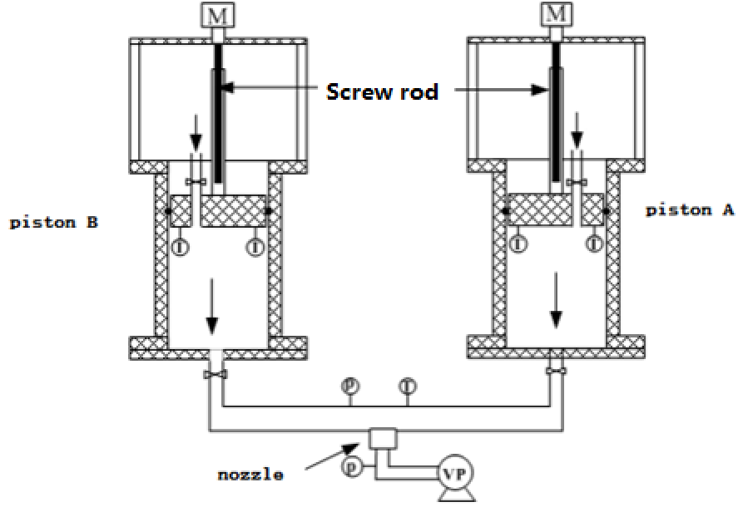
Figure 1. Structure of the Reciprocating Double-pistons Prover

A PLC controller was employed to control the rotation speed, direction of servo motors, at the meantime, screw rod transform rotation of servo motors into rectilinear motion of pistons. The whole process nozzles of calibrating could be separated into two stages:

1) Calibration stage:
When critical back pressure ratio is achieved after open vacuum pump, the inlet valve will be closed and servo motors will be activated to push piston move downward, which will make flow discharge through piston cylinder, pipe, and vacuum pump. The rotation speed of servo motors is set based on flow rate of the nozzle for stabilizing targeted critical back pressure ratio. At last, the C_{d} of nozzle can be figured out with records of tim, distance, pressure, temperature, humidity etc..

2) Back Stage:
After calibration stage, servo motors will rotate in negative direction to drive the pistons to move upward to original position. Meanwhile, the outlet valve will be closed and the inlet valve will be open in advance.

2.2 Calculation Principle

Mass flow rate from pistons:

··· ··· (1)

Where, q_{m} is the flow rate generated by the prover. V is volume of piston discharged from top to bottom. ρ is density of air and it is necessary to multiply αi as correction factor due to humidity. t is duration of piston’s motion.

Meantime, the mass flow rate from the critical flow nozzle could be derived by Equation (2) :
(2)
Where d is nominal diameter of the nozzle, C_{d} is the discharge coefficient, C* is the critical flow function, β is correction factor due to CO₂ in the air, p₀ is stagnation pressure of the critical nozzle, T₀ is stagnation temperature.

Mass flow from the prover and the critical flow nozzle must comply with the following Equation:

··· (3)

According to Equations 1-3,C_{d} can be derived as:

···· · (4)

3. Low-speed jerking motion

Due to non-linear force of friction, although the input is even, the output will be saltatory. In this device, it will occur in this way: due to the non-linear friction force between pistons and cylinders, pistons’ movement is in saltatory speed although rotation speed from servo motors is stable.

3.1 Force analysis
For the sake of analysis, single piston structure can be simplified as follows:

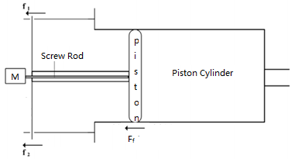
Figure 2. Simplified structure of a single piston

By considering friction coefficient, damping, elasticity modulus, the following Equation can be derived:

(5)

Where, m is the mass of the piston, β is the damping coefficient of the screw rod, v is the product of rotation speed and the lead of the screw rod, S is displacement of the piston, k is rigidity.

With the original value of S′=0, S″=Δf/m, when t=0, we have:

· (6)

In Equation (6), ,,

After differential operation on Equation (6):

······ (7)

3.2 Motor Characteristics
Torque of the motor can be expressed as:

······ (8)

Where, T_{em}: is the torque of the servo motor, T_{f} is friction torque; J: is the inertia Moment, b is Damping coefficient of the transmission shaft, ω is rotation speed of the transmission shaft.

Under uniform motion, velocity of the piston and needed torque are shown in Figure 3.

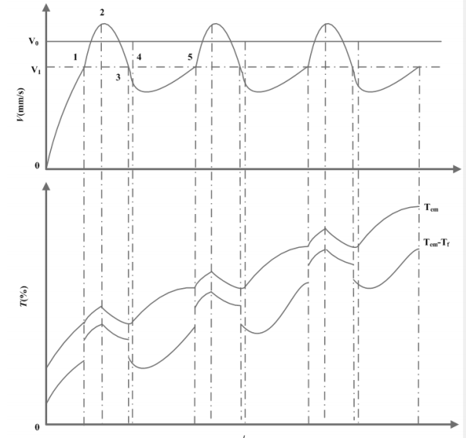
Figure 2. Curve of speed and torque

Stage 0-1: Servo motor’s torque is rising while the rotation speed rises from 0 to V₁.

Stage 1-2: Due to saltus of kinetic friction force, motor’s torque changes accordingly. But the speed hasn’t arrived at V₀, torque and acceleration will continue to rise after arriving at V₀ because of the response delay.

Stage 2-3-4: Velocity and torque start to decline when servo motors start to respond. Kinetic friction force jumps again when the velocity arrives at V₃. Accordingly, the velocity declines in higher negative acceleration. When the velocity arrives at V₄, the torque begins to rise to conquer kinetic friction force.

Stage 4-5: Along with rising torque, rotation speed starts to rise again to V₅, and the circulation restarts from 1-2stage.

In the circulation, torque will rise constantly. Eventually, servo motors will power off when torque exceed their maximum rated value.

4. Experiments

Typically, there are three some solutions to solve the low-speed jerking problem: 1) Amend the mechanical structure to complement damping; 2) Improve the lubrication to reduce the coefficient of friction; 3) Increase the power the servo motors to increase the input torque.

But the mechanical structure needs to be amended in all these three solutions. It will cost a lot on both time and money. However, a possible solution is to stack high-frequency periodical flutter signal into the constant speed of the piston, which is similar to the control of electro-magnet. Since the control algorithm of the PLC is not so flexible as PC or some other controllers, the saw-tooth wave was chosen as the stacked signal to simplify the programming. The experiments with different amplitude and frequency had been carried out to check influence of stacked signal, and the results are as follows.

4.1 Comparison 1
The first comparison is shown in Figure 4, where the curve I is the torque of the servo motor while the piston moves at the constant speed of 0.15mm/s. It can be seen that the torque continued arising from the start point and finally caused the servo motor to stop after the torque reached at about 120% the nominal torque of the servo motor. In curve II, a saw-tooth wave whose amplitude was 0.5 mm/s and frequency was 25 Hz was stack into the constant speed, and the compound speed cure is as shown in Figure 5. It can be seen that the torque had dropped a lot to about 100%, and the servo motor did not stop during the calibration. While the maximum pressure fluctuation is about 30 Pa which is allowed for the calibration.

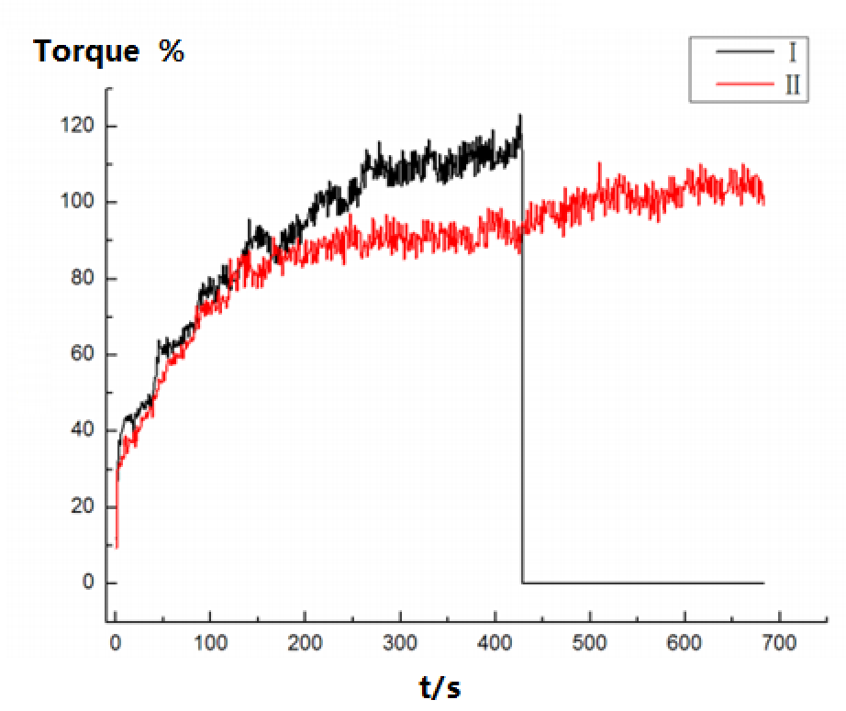
Figure 3. Curves I and II

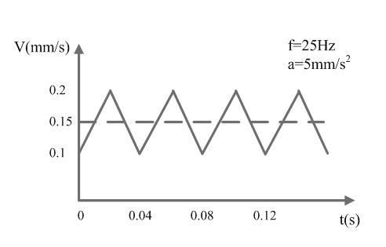
Figure 5. Actual speed curve of the piston

4.2 Comparison 2
In Figure 6, there is another saw-tooth curve stacked into the constant speed where the amplitude is enlarged to 0.1 mm/s. The torque curve is as shown in curve III. We can see that the torque continued dropping to only about 70% of the nominal value. Hence, the magnifying of the speed is helpful for the low-speed jerking of the piston.

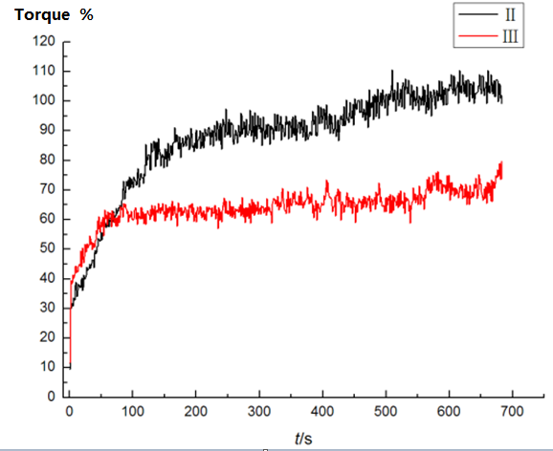
Figure 6. Curves II and III

4.3 Comparison 3
Then the frequency of the saw-tooth curve was changed to 50 Hz, and the amplitude was remained at 0.05 mm/s. The torque curve was shown as curve IV in Figure 7, and the maximum value is about 60% of the nominal torque. We can see that the drop of torque is even more than curve III.

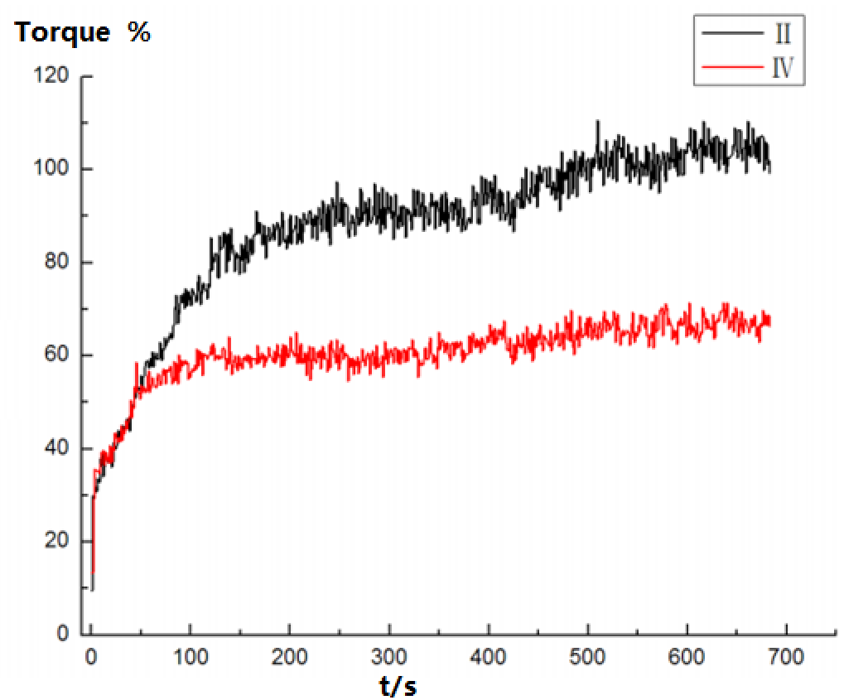
Figure 7. Curve II and IV

5. Conclusion

Low-speed jerking of piston prover is mainly caused by friction between piston and the cylinder. And the response delay of the actuator like the servo motor will also lead to the increase of friction. The simple solution of stacking saw-tooth wave into constant speed of the piston works well and can decrease the motor torque a lot. Both improving the amplitude and the frequency of the saw-tooth wave could reduce the torque, and the pressure fluctuation inside the cylinder is in a small range which is acceptable for the calibration of critical flow nozzle.
By applying the stacking flutter, the low-speed jerking problem was overcome. And the lowest calibration flow rate of the reciprocating double-pistons prover was expanded from 0.064 m³/h to about 0.04 m³/h. But detailed mechanism of low-speed jerking needs to be carefully analyzed and further experiments will be carried out to investigate the influence of speed change on the uncertainty of the prover.

Acknowledgments
This work is supported by the National Natural Science Foundation of China (No.51305419)

References

- F.PhilipBowden, D.Tabor. An Introduction to Tribology. Beijing: China Machine Press 1982.
- Stolarski TA. Analysis of the resistance to motion in a sliding contact. Wear, 1994(171): 203-209.
- Mokhtar MOA,Younes YK,Mahdy THEL,et al.A theoretical and experimental study on the dynamics of sliding bodies with dry conformal contacts.Wear,1998 (218):172-178.
- Giuseppe,Vincenzo,Sergio,et al.Influence of the variation between static and kinetic friction on stick-slip instability.Wear,1993(161):121-126.
- Lu ZeSheng,Cao DongHai. Simulation Analysis for Physical Model of Stick-Slip.Chinese Journal of Mechanical Engineering.2004(11):107-112.
- Qiu JianQi. Research on Torque Ripple Attenuation Techniques for PM Brushless DC motors [D]. 2002:57-65.
- Song De-jie. Realization of Ultra-Low Running of AC Servo Motor [D]. Small & Special Electrical Machines, 2009(8): 19-20.
- Zhi-Peng Xu, Jia-Yin Dai, Hui-Yun Chen, Dai-Liang Xie. Development of a Reciprocating Double-Pistons Gas Prover. Flow Measurement and Instrumentation. 2014, 38: 116-120.

