**The Development and Performance of a Low Uncertainty Flexible Multi-Viscosity Calibration Facility**

**W.R. Johansen, T. Cousins, D. Flournoy and J. Reiner**

*ColoradoEngineering Experiment Station, Inc.*

*bjohansen@CEESI.com*

# Abstract

Flow measurement for custody transfer is required to be very accurate. The accuracy of custody transfer flow measurement is directly affected by the calibration of the custody transfer flow meter. Custody transfer flow meters may be calibrated onsite or they may be calibrated at an offsite calibration facility. In either case it is very important to have a characterization of the meter performance over the Reynolds number range the meter is to be used. The characterization of meter performance will vary from meter to meter even though the manufacturer is careful to maintain control of the meter geometry. This means that every custody transfer meter should be calibrated over its entire operating Reynolds number range to achieve the most accurate flow measurement possible. This paper describes the development and performance of a low uncertainty multi-viscosity hydrocarbon liquid calibration facility.

**1. Introduction**

The variations in orifice meter performance with Reynolds number have been observed and studied for over 100 years. Other differential pressure meters like cone meters and wedge meters also exhibit variations in performance that are Reynolds number dependent. More recently, it has been shown that turbine meters, ultrasonic meters and coriolis meters have calibration curves controlled by Reynolds number. The calibration of all of these meters at the application Reynolds numbers will result in the best accuracy or lowest uncertainty. There are few independent commercial facilities that offer calibrations over wide Reynolds number ranges.

Water calibrations are typically provided by manufacturers for most meter types. The water calibrations are attractive to manufacturers for several reasons:

* Water calibration facilities are relatively inexpensive to build and operate
* Customers often do not appreciate the fact that water calibrations do not represent the meter performance on-site.
* Multi-viscosity calibration systems are expensive to build. The combined expense of a flow meter and multi-viscosity calibration can make a manufacturer’s product less competitive.

An illustration of the Reynolds number effect on a differential meter is shown in Figure 1. The data in Figure 1 show the results of testing a wedge meter over a large pipe Reynolds number range with hydrocarbon calibration fluids. Data were taken using three viscosity calibration fluids with viscosities ranging from 2 to 200 cSt. Miller[1] states that the flow coefficient of a wedge meter is constant over a wide pipe Reynolds number range. The belief that the flow coefficient is constant has resulted in wedge meters being used for viscous fluid flow measurement with a single flow coefficient developed from water calibration data. Water data taken on the wedge flow meter over a flowrate range of 20 to 2000 gpm would cover a pipe Reynolds number range of 7,000 to 700,000. If the meter were used at pipe Reynolds number of 1000 based on a water calibration errors of up to 2% would be possible.

**Figure 1. Wedge Meter Calibration Data**

If a meter is not calibrated correctly the customer will probably not be aware of the additional uncertainty due to improper meter characterization. The errors in flow measurement may never be detected. Even meters that undergo on-site proving can provide incorrect and confusing flow measurement results due to improper characterization. The initial calibration and adjustment of the meter needs to be performed as close to the operating Reynolds number range as possible. If the initial calibration and adjustment are performed at Reynolds numbers that are different from the operating Reynolds numbers then an extrapolation is required. The behaviour of the meter at the proper Reynolds number range may be vastly different than at the calibrated Reynolds numbers. This situation is illustrated in Figure 2. The data in Figure 2 are from the calibration of an ultrasonic flow meter. Four different calibration fluids were used resulting in a calibration that covered a pipe Reynolds number range of 300 to nearly 500,000. The laminar, turbulent and transitional boundary layer flow regimes can be seen very clearly in the data. If an initial adjustment of the meter had been performed using data from a Reynolds number quite different than the application Reynolds number large errors in flow measurement could result even if this meter were proved on-site. On-site proving cannot be performed over wide flowrate ranges so a meter factor developed at one flowrate will not be correct at another flowrate if the initial characterization of the meter is not performed properly.

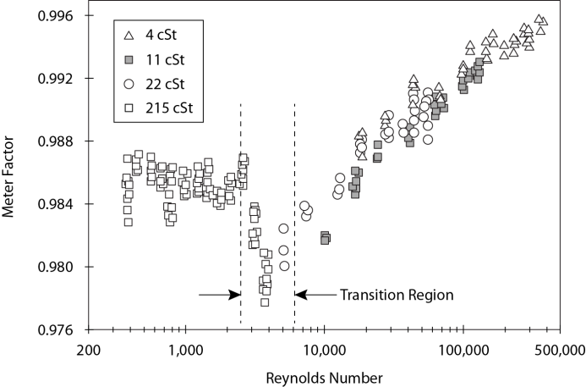

**Figure 2. Variations in Ultrasonic Meter Performance Over a Wide Reynolds Number Range**

**Figure 3. Volumetric Correlation of Turbine Calibration Data**

Figures 3 and 4 show calibration data taken on a turbine meter. The calibration was performed with three different calibration fluids over the volumetric flowrate range of the turbine. The data clearly correlate well with pipe Reynolds number as can be seen in Figure 4. If this turbine was used with a meter factor developed at a different Reynolds than the application Reynolds number the uncertainty of the flow measurement would be much higher than if the turbine was properly calibrated.

**Figure 4. Reynolds Number Correlation of Turbine Calibration Data**

**2. Calibration System Design Goals**

The following design goals were established prior to designing the calibration system:

* Wide volumetric flowrate range
* Large Reynolds number range
* Low uncertainty
* Ability to control temperature
* Versatile data collection system

*2.1 Wide Volumetric Flowrate Range*

A wide volumetric flowrate range will be achieved by using secondary standards or master meters. Provers will be used to calibrate a single turbine or other type of master meter. Multiple master meters will then be run alone or in parallel to achieve the highest possible flowrates.

Hydrocarbon calibration fluids will be used as the calibration medium. At very high volumetric flowrates high differential pressures across system components, particularly flow conditioners, may result in pressures decreasing to the saturation pressure of the fluid at the flowing temperature. The system design will include a pressurization bottle. The bottle will use air or bottled gas to pressurize the system to a pressure high enough that will ensure no cavitation of the calibration fluid will occur. The pressure bottle will also provide for the thermal expansion or contraction of the fluid during operation.

*2.1 Large Reynolds Number Range*

The Reynolds number range of the system will be expanded by using multiple calibration fluids and possibly by operating the system over a wide range of temperatures. Calibration fluids with viscosities ranging from 2 cSt to 200 cSt are commonly used. The use of multiple fluids will expand the Reynolds number range by two orders of magnitude. The design of the system will include storage capacity for a custom calibration fluid. The custom calibration can be developed by mixing the existing calibration fluids or, if a viscosity outside the range of the existing fluids is desired, by obtaining a special fluid.

The ability to flow at specific temperatures will also provide a mechanism for targeting specific viscosities. For a hydrocarbon liquid a 17 degree C temperature rise will result in a viscosity change of approximately 25%. If the performance of a meter will not be adversely affected by temperature changes during the calibration then temperature control may provide another method of increasing the Reynolds number range of the system.

*2.3 Low Uncertainty*

The uncertainty of the calibration facility is determined by first looking at the uncertainty required for custody transfer flow measurement. The uncertainty of custody transfer flow measurement is usually specified in a contract signed prior to the installation of the custody transfer flow meters. Local regulators and industry standards also provide guidance. OIML R-117 [2] states a maximum permissible error of 0.3% for liquid system measurement and a maximum permissible error of 0.2% for the flow meter error. A test uncertainty ratio (TUR) is used to describe the ratio of the test uncertainty to the calibration system uncertainty. TUR values ranging from 10:1 to 4:1 have been commonly used in the past. If a calibrated meter uncertainty of 0.15% to 0.3% is used and a TUR of 5:1 applied then the target uncertainty is 0.03% to 0.06%.

*2.4 Ability to Control Temperature*

Controlling temperature during a calibration is essential as variations in temperature can adversely affect the performance of many types of flow meters. The data shown in Figure 2 illustrates how poor temperature control can affect the performance of an ultrasonic flow meter. The variations in meter performance at the low pipe Reynolds numbers are a good indication of poor temperature control.

The uncertainty of the calibration system is also affected by temperature control. Kegel et al [3] examined the relationship between temperature changes in the system trapped volumes and the overall system uncertainty. An estimate of temperature change in the trapped volume is required to calculate the uncertainty associated with the trapped volume. Although the contribution of the trapped volume uncertainty to the overall system uncertainty is low the estimated uncertainty of the system may be reduced in time if the control of temperature is better than the estimate in the uncertainty analysis.

*2.5 Versatile Data Collection System*

Most custody transfer meters are expected to produce pulse outputs but the data acquisition system will also accommodate analog, differential and serial output meters. Valves, filters and other piping components can also be tested. The system should be able to accommodate up to 5 meters under test at one time.

The calibration system is also intended to be used for research and development and as a platform for special testing to benefit industry. Testing of this nature often requires many measurements of pressure, temperature and other system parameters. The data acquisition system should support unlimited parameter measurements.

**3. Calibration System Construction**

Two calibration systems were built, a high flow system and a low flow system. The two systems can be operated independently, each flowing different fluids, or they can be connected. There is some overlap between the two systems which will allow comparison of meter performance.

The high flow system is based on a DN500 (20”) bi-directional pipe prover built by Weamco Metric. The flowrate range of the DN500 (20”) bi-directional prover is 20 to 1300 cubic meters per hour. Flowrates up to 3000 cubic meters per hour are achieved by placing three DN200 (8”) Faure Herman turbines in parallel and bypassing the DN500 (20”) bi-directional prover. Three test sections are available with isolation valves between 750 mm (30”) headers. The test section line sizes are DN200 (8”), DN300(12”) and DN400(16”). Flow through the system is provided by 2 250 HP pumps.

The low flow system is based on an FMD-060 displacement prover. The flowrate range of the low flow system is 2 to 600 cubic meters per hour. A single DN150 (6”) test section is available. The system can be operated with the prover in line or bypassed. Master meter sizes are 1”, 2”, 4” and 6”. Flow through the system is provided by a single 150 HP pump.

The calibration fluids and nominal viscosities are listed in the table below.

Table 1. Calibration Fluids

|  |  |
| --- | --- |
| **Calibration Fluid** | **Nominal Viscosity** |
| Exxsol D80 | 2 cSt |
| Drakeol 5 | 17 cSt |
| Drakeol 32 | 200 cSt |

A schematic of the high flow calibration system is shown in Figure 5. The flow from the pumps passes through a heat exchanger before passing through the test sections and master meter runs. The flow then passes through the DN500 (20”) bi-directional prover or it can bypass the prover before returning to the pump suction header. The test sections are mounted between 750 mm (30”) headers that are 15 meters apart. The large header diameters and long test sections ensure well developed and symmetric velocity profiles are present at the meter under test. Figure 6 shows some details of the temperature control in the high flow calibration system. A chiller shown in the bottom right of Figure 6 is used to cool a water/glycol mixture. The water/glycol circulation system includes a large storage tank to dampen temperature variations in the chill water supply. The chill water circulating through the chill water system is available to flow through a mixing valve and into the heat exchanger shown in the bottom left of Figure 6.



**Figure 5. System Schematic**

**Figure 6. System Temperature Control**

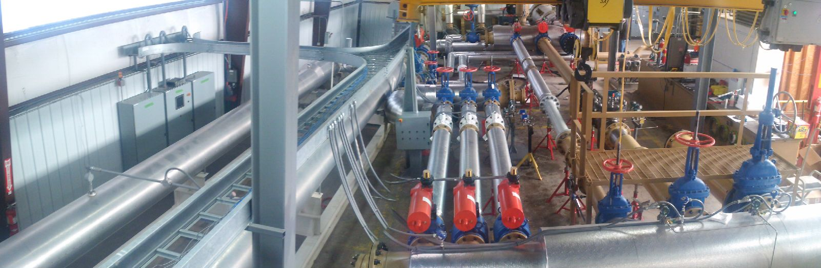

**Figure 7. Master Meter Piping**

Figure 7 shows the master meter runs in the high flow system. 20 nominal diameters of straight piping upstream of the master meters ensures no installation effects will be present in the master meter performance.

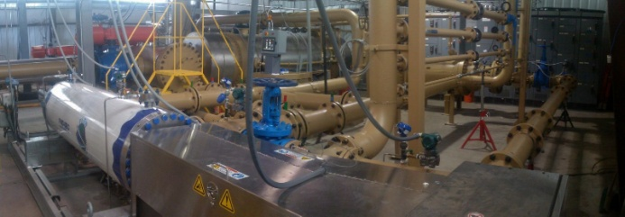

**Figure 8. Small Volume Prover System**

Figure 8 shows the FMD-060 installed in the low flow system.

**4. Calibration System Testing**

The testing of the completed calibration systems included:

* Comparison of CEESI and Faure Herman calibration data on the DN200 (8”) master meters
* Comparison of calibration data on the master meters taken with the DN500 (20”) bi-directional prover and the FMD-060
* Develop complete calibration curves on the 3 DN200 (8”) Faure Herman turbines using all 3 calibration fluids
* Evaluate the temperature control

The data shown in Figure 9 are calibration data on master meter 393 using the DN500 (20”) bi-directional prover, the FMD-060 Small Volume prover and at the master meter manufacturer’s facility using a 5 cS calibration fluid. The data show good agreement between all three data sets and verify that no installation effects were introduced by the new facility piping.

**Figure 9. Small Volume Prover Test Data**

The data shown in Figure 10 is a comparison of the calibration of master meter 393, the DN200 (8”) Faure Herman turbine by the DN500 (20”) Ball prover and the Small Volume prover. The calibration facility allows the two provers to be operated in series with the master meters. The accredited standard uncertainty Ubp of the ball prover is 0.024%, the accredited standard uncertainty of the Faure Herman turbine, Ufh is 0.05% and the proposed standard uncertainty, Usvp, of the small volume prover is 0.015%. The combined standard uncertainty Uc =(Ubp2+Ufh2+Usvp2)1/2. The error bands on the graph are shown based on the values obtained from the proving using the ball prover. As can be seen the two calibrations are well inside the combined uncertainty bands.

**Figure 10. DN500 (20”) Prover and FMD-060 Prover Comparison**

Figures 11 and 12 show calibration data on Master Meters 394 and 395. The manufacturer data were taken using 4 different viscosity calibration fluids. CEESI data were taken using 3 different viscosity calibration fluids using the DN500 (20”) bi-directional prover. The level of agreement between the manufacturer’s data and the CEESI data indicate no installation effects have been introduced.

**Figure 11. Master Meter 394 Calibration Data**

**Figure 12. Master Meter 395 Calibration Data**

Figures 13 and 14 show the piping setup and data resulting from filter testing performed for a filter manufacturer. Two basket strainers were installed in the calibration system. The differential pressure and flowrate through the strainers were measured for the manufacturer.

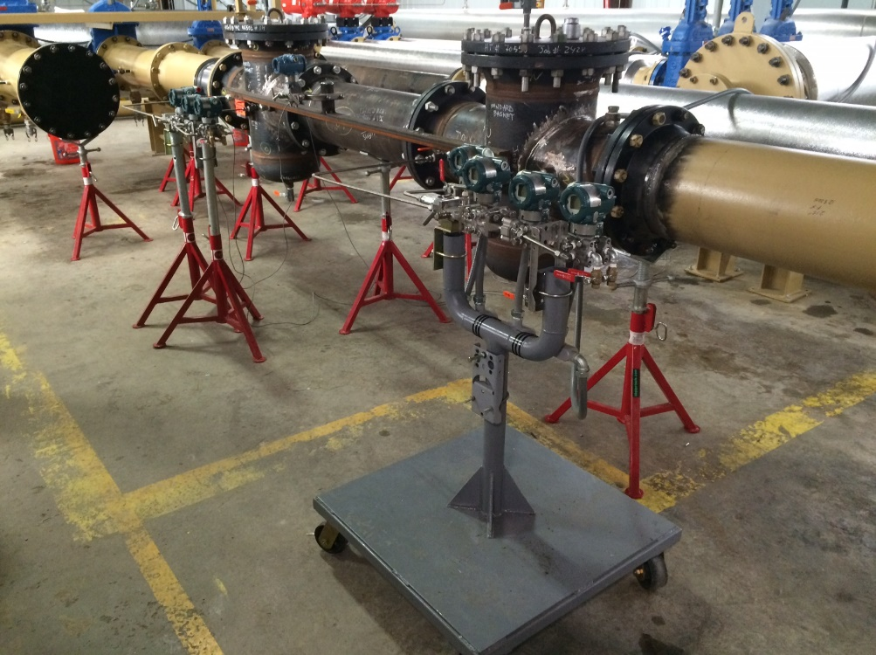

**Figure 13. Strainer Testing Setup**

**Figure 14. Strainer Test Results**

Figure 15 shows data taken over a two hour time period at flowrates varying from 200 to 50 cubic meters per hour while calibrating a master meter. The temperature control system has been shown to be working quite well.

**Figure 15. System Temperature Data**

**5. Conclusions**

Accurate flow measurement is dependent on the proper calibration of the flow meter. The performance of nearly every flow meter changes with Reynolds number. A calibration system that utilizes multiple calibration fluids with different viscosities was built to provide low uncertainty calibrations of custody transfer flow meters. This paper discussed the design, construction and testing of the calibration system. Test results of the completed system were presented. Testing showed the master meter calibration data were in good agreement with manufacturer calibration data. Two provers installed in separate systems were found to produce calibration data with good agreement. The temperature control system functions well eliminating a problem found in other liquid hydrocarbon calibration systems. The data acquisitions system is quite versatile and will support flowmeter calibration work as well as product research and development.

# References

[1] Miller R.W., *Flow Measurement Engineering Handbook 3rd Ed.,* McGraw-Hill 1996.

[2] OIML R-117: Dynamic Measuring Systems for Liquids Other Than Water, 2007, International Organization of Legal Metrology

[3] Kegel, T., Cousins T., Reiner, Uncertainty Analysis of a Multi-Viscosity Oil Calibration Facility, Flomeko 2016, Sydney, Australia