Towards the Improvement of a Blow-Down Type High Pressure Air Flow Calibration Rig

**Wen-Bin Wang1, Fong-Ruey Yang1, Bodo Mickan2 and Chun-Min Su1**

*1* *Center for Measurement Standards, Industrial Technology Research Institute, Taiwan*

*2* *Physikalisch-Technische Bundesanstalt, German*

*1E-mail:wenbin@itri.org.tw*

# Abstract

A blow-down type high pressure air flow calibration rig has been established at Center for Measurement Standards (CMS) in Taiwan since 1996. The facility consists of a primary standard which adopts the gravimetric method and a secondary standard which utilizes master meter method using sonic nozzles, having a capacity of flow from 15 m3/h to 12000 m3/h under standard condition and pressure from 1 bar to 60 bar. During flowmeter calibration, the air pressure in the upstream storage tank drops continuously due to the blow-down design, leading to the corresponding temperature drop. Measures have been taken to improve the facility’s performance and reduce the thermal effect during flowmeter calibration. The original sonic nozzle bank was replaced by a new sonic nozzle array consisting of seven nozzles which can be operated independently. The throat diameters of the new nozzles range from 2.312 mm to 11.56 mm, having nominal flow rates of 3 m3/h to 75 m3/h, and the three largest nozzles have to be operated simultaneously to achieve the maximum flow rate. Two additional sonic nozzles were installed downstream of the nozzle array as the check meters.

Calibration of the new nozzles by the primary, gyroscope weighing system shows that the nozzles operate across laminar to turbulent regimes, and the transition takes place at the Reynolds number around 106. Positive dependence of transition point on the nozzle diameter was also observed. Consistency among the standard nozzles, applicability of combining the nozzles in parallel, long-term stability and calibration capability were confirmed by flow measurement tests as well intra comparison with a bell prover. An unofficial bilateral comparison with PTB through a 6” turbine meter was conducted to verify the capability of the modified calibration rig. The En values across the tested flow range were all less than unity, suggesting that the measurement results are equivalent and CMS’s uncertainty claim of 0.19 % is adequate. Further improvement of the facility by installing two additional heat exchangers to recover the heat loss during calibration process is underway.

# 1. Introduction

The ITRI/CMS had finished the high pressure gas flow calibration system (HP) in 1996, as shown in Figure 1. This system is the only primary high-pressure air flow calibration system in Taiwan. It has been over 20 years since the debut of service. The flowrate range is (15 to 12000) m3/h (@1 bar), and the flow measurement expanded uncertainty is 0.19 %.



Figure 1: High pressure air calibration system overview.

This HP system used sonic nozzles (SN) as transfer standard to calibrate a meter under test (MUT). The SN is used as a transfer standard by the flow measurement laboratories of many countries, because it has simple structure, stable, and traceable convenience. The SN of this system can be traced to the primary weighing system directly, and the calibration period of standard SN is two years. The weighing tank and gyroscopic weighing system are shown in Figure 2. The volume of weighing tank is 2 m3, and the biggest design pressure is 50 bar.

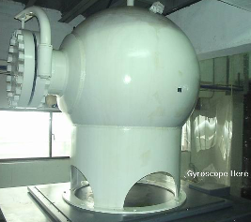

Figure 2: Weight tank of the high pressure air calibration system.

Upon calibrating SN using weighing system, a diverter is used to control the fluid entering into the weighing tank. Meantime, a timer is used to collect the filling time. The Gyroscopic Weighing System is used to weigh the mass of gas entering the weighing tank by a static way. The filling time and the accumulated mass are used for calculation of mass flow rate. The temperature and pressure are measured to determine the density of air passing through the nozzle and the volume flow rate is obtained.

The SN used for the system has the nozzle array design originally, as shown in Figure 3. Seven independent SNs are assembled on a board, upstream of which is a buffer tank made out of a 10 inch pipe, and the pneumatic cylinder is used to connect the upstream switching rod of nozzle, to control the switching of nozzle. This nozzle array has already been used for over 20 years. Because of long-term use, the surface of nozzle was worn, and a lot of scratches were appeared in the junction of rod and cylinder. The leaking problem was occurred due to poor sealing. Thus, replacing the standard nozzles are necessary, and a project has been proposed to support this work.

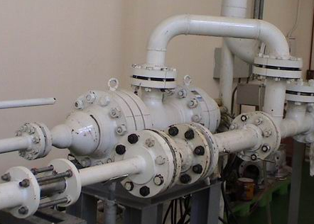

Figure 3: Original compact array nozzle of HP system.

# 2. System Design of New Sonic Nozzle

When the new SNs is planned to replace the original SNs, the shortcomings of compact nozzle are considered as follows.

* Compact nozzle has large inventory volume, leading to higher uncertainty upon calibrating by the weighing system.
* The leakage of compact nozzle is unable to be tested for individual nozzle, so it is unable to guarantee the calibration result of system.
* The upstream pipe diameter of nozzle is 10 inches. Its internal temperature has gradient in such big buffer tank. So, the measured temperature of fixed position might be different from the actual temperatures at the nozzle’s upstream position.

After considering the shortcomings of SN array design, it is determined to design new SN with independent nozzle configuration. The system design is shown in Figure 4. There are valves at upstream and downstream of each nozzle to carry out the on-off control, and there are independent temperature and pressure measurements.

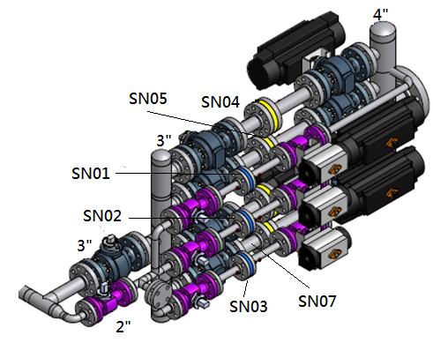

Figure 4: New single nozzle design.

In the new system, 7 nozzles has been upgraded altogether, and the throat diameters for 7 nozzles are tabulated in Table 1. Upon designing, the D/d (upstream pipe diameter/throat diameter of nozzle) is greater than 4.5, which complies with ISO 9300 standard, which requires that the value be larger than 4.

**Table 1:** 7 transfer SN’s diameter and D/d.

|  |  |  |  |
| --- | --- | --- | --- |
| Nozzle throat diameter d  (mm) | Nominal nozzle flow rate  (m3/h) | Upstream diameter D  (mm) | D/d |
| 2.307 | 3 | 26.6 | 11.5 |
| 3.271 | 6 | 26.6 | 8.1 |
| 4.219 | 10 | 26.6 | 6.3 |
| 6.679 | 25 | 52.5 | 7.9 |
| 9.439 | 50 | 52.5 | 5.6 |
| 11.560 | 75 | 52.5 | 4.5 |
| 11.556 | 75 | 52.5 | 4.5 |

This system designs all nozzles to be used in parallel. Because of the restriction for the number of pressure gauge, maximum 3 sets of nozzles can be opened in parallel simultaneously. If three largest nozzles (50 m3/h, 75 m3/h and 75 m3/h) are opened simultaneously, the summed flowrate will be 200 m3/h. The maximum operation pressure of this system is 60 bar, so the maximum flowrate of this system is 12000 m3/h (@1bar).

In order to assure the system functioning normally, two checking SNs are designed for the system. The diameters of checking nozzles are 6.674 mm and 14.924 mm. A standard nozzle is corresponded to a checking nozzle upon using. As shown in Table 2, the maximum choke ratio of standard nozzle is 0.6, and this choke ratio can assure the choke condition for all SNs.

**Table 2:** The combination of check nozzles and standard nozzles

|  |  |  |
| --- | --- | --- |
| Standard nozzle d1  (mm) | Check nozzle d2 (mm) | Choke ratio A1/A2 |
| 2.307 | 6.674 | 0.12 |
| 3.271 | 6.674 | 0.24 |
| 4.219 | 6.674 | 0.4 |
| 6.679 | 14.924 | 0.2 |
| 9.439 | 14.924 | 0.4 |
| 11.56 | 14.924 | 0.6 |
| 11.556 | 14.924 | 0.6 |

After finishing the design, the schematic of whole system and photograph of the standard and check SNs are shown in Figure 5 and Figure 6, respectively.

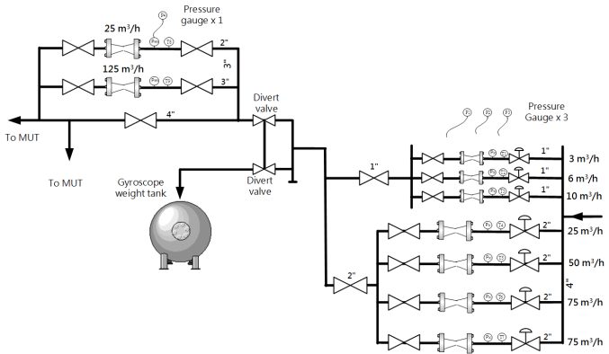

Figure 5: The design of new sonic nozzle system.

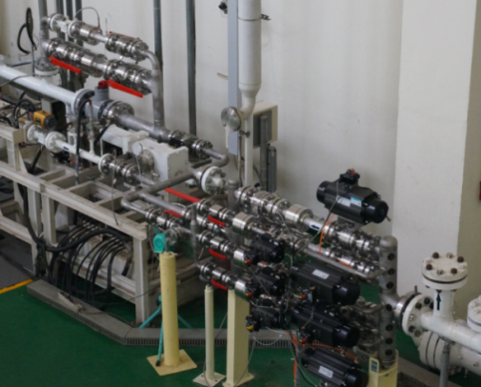

Figure 6: New standard and check SNs.

# 3. Sonic Nozzle Calibration Result

After finishing the replacement of old standard SNs, the weighing system is used to calibrate 7 brand-new SNs. The calibration results are shown in Figure 7. From the calibration results, it is known that a transient point will be appeared for Cd value when the nozzle is under certain Reynolds Number. After the transient point, the Cd values will reduce by about 0.2 % - 0.3 %. The Reynolds Number of transient point depends on the size of nozzle. When the throat diameter of nozzle is larger, the Reynolds Number of transient point will be larger, vice versa.

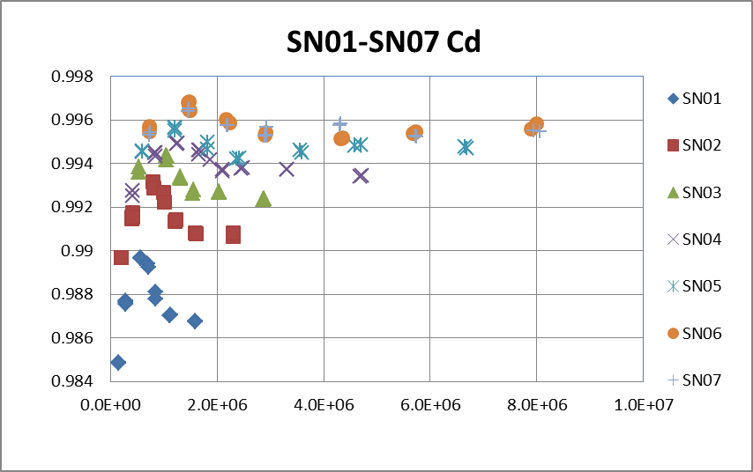

*Reynolds Number*

Cd

Figure 7: The calibration result of New SNs.

When the SN is used as transfer standard to calibrate MUT, the Reynolds Number and Cd value shall be regressed for use, because the calibration range of nozzle used in this system includes the transient point. So, the Reynolds Number of transient point is used as the boundary line for the regression of two ranges. According to ISO 9300, the regression equation of lower range is $Cd=a1×{Re}^{-0.5}+b1×{Re}^{-1}+c1$. After the Reynolds Number is larger than that of transient point, the Cd value drops quickly first and then resumes to flat gradually. So in order to cover all calibration points within the curve, the regression equation of higher range is $Cd=a2×Re+b2×{Re}^{0.5}+c2×{Re}^{-0.5}+d2×{Re}^{-1}+e2$. All the regression coefficients are shown in Table 3. According to this regression model, the difference between the calculated Cd value and actual Cd value is less than 0.02 %.

**Table 3:** The regression coefficient of SNs.

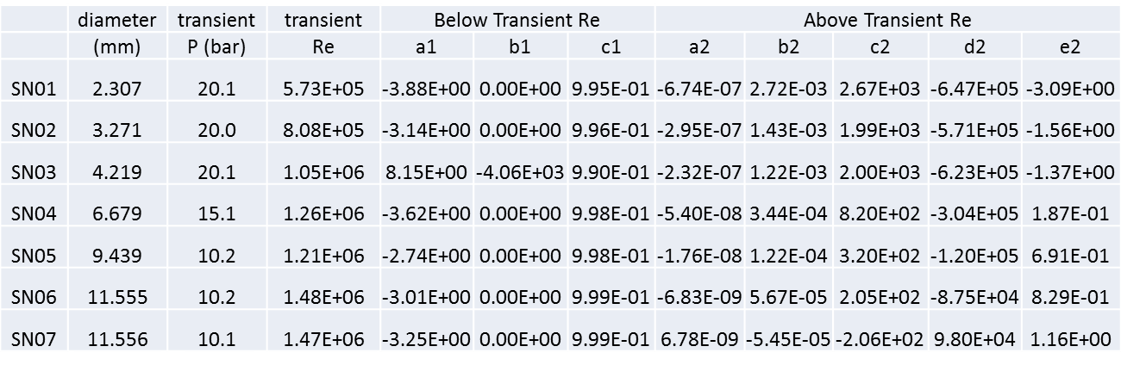

A nozzle (SN04) is used as an example. The regression result of lower range is shown in Figure 8. The regression result of higher range is shown in Figure 9. The differences between the calculated Cd value and actual Cd value in the two regions are both less than 0.02 %.

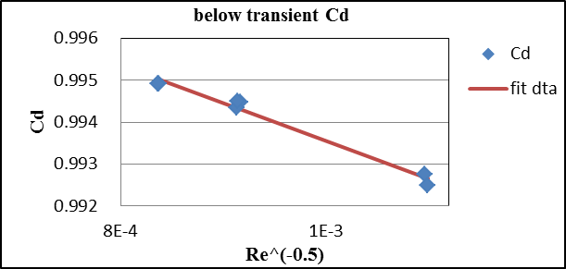

Figure 8: The regression of SN below transient Re.

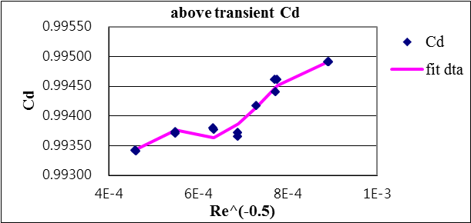

Figure 9: The regression of SN04 above transient Re.

# 4. System Assurance Program

After finishing the calibration of standard SNs by weighing system, the system carries on a series of tests to confirm the status of system. The confirmation procedures include the following items.

* Consistency of the calibration results among the nozzles.
* The confirmation for the use of standard nozzle in parallel.
* The confirmation for the nozzle’s long-term stability.
* If the calibration result is within uncertainty range declared by the system.

*4.1 Mutual consistency of nozzle*

There are 7 standard SNs in the system. Upon calibrating the flowmeter, different nozzle and pressure combination can obtain the same flowrate. So upon confirming the mutual consistency of nozzle, an elster 6” trz2 G650 turbine flowmeter was installed at the downstream of standard nozzle as MUT. The flowmeter is calibrated at the flowrates of (200, 400, 800 and 1000) m3/h. Different upstream nozzle pressure was used for different nozzle to carry out the test. The test results, relative deviations, E (%), are shown in Table 4. From the calibration results, it is found that the difference among different standard nozzles is about 0.05 %. This result proves that the calibration results of different nozzles have very good consistency.

**Table 4:** Relative deviation E (%) of the 6” turbine meter calibrated by different SNs.

|  |  |  |  |  |  |  |
| --- | --- | --- | --- | --- | --- | --- |
| Flowrate \ SN used | SN02 | SN03 | SN04 | SN05 | SN06 | SN07 |
| 200 m3/h | 0.04 | 0.06 |  |  |  |  |
| 400 m3/h |  | -0.16 | -0.13 | -0.13 | -0.14 | -0.13 |
| 800 m3/h |  |  | -0.34 | -0.34 | -0.32 | -0.33 |
| 1000 m3/h |  |  | -0.41 | -0.37 | -0.37 | -0.36 |

*4.2 The confirmation for the use of nozzle in parallel*

Because the weighing system is limited by the calibration capacity, so the weighing system is used to calibrate a single sonic nozzle only, but when the sonic nozzles are used to calibrate the flowmeter, they can be connected in parallel to increase the calibration capacity. Maximum 3 sets of sonic nozzles can be used in parallel in this system, and the total flowrate will be the sum of all nozzles connected in parallel. It is necessary to be confirmed if the nozzles can be connected in parallel.

The feasibility test of parallel calibration is conducted by the weighting method. An itron 2” S1-Flow G100 rotary meter was installed at the upstream of the standard SN. Upon testing, the gas passes through the rotary flowmeter first, and then enters the weighing tank through the standard nozzle. After finishing the calibration, the difference is calculated and compared with that of parallel SN. The results are shown in Table 5. The relative deviation E (%) is calculated by two methods. One standard flow rate is calculated from the sum of SN’s flow rate, and the other is from using weighting method directly. The results reveal that the difference is within 0.03 %. This result proves that the use of nozzles in parallel is feasible.

**Table 5:** nozzle in parallel Calibration Result.

|  |  |  |  |  |
| --- | --- | --- | --- | --- |
| Pressure  (bar) | Nozzle combination | Actual flow rate  (m3/h) | Against nozzle result  E (%) | Weighing  method result  E (%) |
| 55.7 | SN5+SN6 | 124.6 | 0.23 | 0.22 |
| 40.5 | SN5+SN6 | 123.5 | 0.26 | 0.29 |
| 25.1 | SN5+SN6 | 123.6 | 0.31 | 0.32 |
| 10.2 | SN5+SN6 | 123.2 | 0.17 | 0.18 |
| 5.3 | SN5+SN6 | 123.3 | 0.16 | 0.19 |
| 10.3 | SN4+SN6 | 99.3 | 0.16 | 0.18 |
| 55.2 | SN4+SN6 | 100.5 | 0.17 | 0.18 |

*4.3 The stability of nozzle in long-term use*

The original system uses the turbine flowmeter (4 inch Instroment SM-RI-X) as the check standard. Though the turbine flowmeter has very good repeatability (0.1 %), there is performance uncertainty after long-term use due to the different lubricating and bearing’s condition. Because SN does not have any moving part, the long-term repeatability is believed to be better. Therefore, SN is selected to be used as the check standard for the system. For the design of system checking, 2 SNs are used to check all 7 standard SNs. The design of the check SNs is shown in Table 2. The long-term checking results for standard SN5 in recent 10 months are shown in Figure 10. When standard SN1 and SN2 are used to calibrate check SN, the range of E (%) is within ± 0.03%, and the range of E (%) of other standard SNs calibrating check SNs is within ± 0.02 %. This proves that the stability of the whole system has been improved greatly.

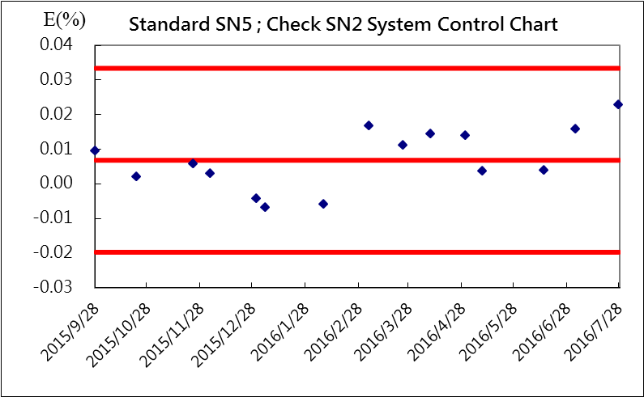

Figure 10: The long-term stability control chart of SN5.

*4.4 The confirmation for the calibration result of system*

After finishing the upgrade of standard SNs, the system uncertainty evaluation has been conducted and the expanded uncertainty of the system is evaluated to be about 0.19 %. But it is necessary to verify if the actual calibration result complies with the uncertainty of this system. The confirmation method is to carry out comparisons with other gas flow calibration systems. Because the turn down ratio of this system is about 1000 times, the bell prover of CMS/ITRI is used to carry out the intra comparison at low flowrate range, and an unofficial bilateral comparison with PTB, Germany is conducted at high flowrate range, which are described as follows.

*Intra comparison with CMS/ITRI bell prover:*

There is a bell prover calibration system in this laboratory, as shown in Figure 11. The bell volume of this system is 600 liters. The bell prover has been in operation for over 20 years and has participated in several international comparisons with good results. The calibration flowrate range of this bell prover is (20 to 1000) L/min, and the expanded uncertainty is 0.11 %.

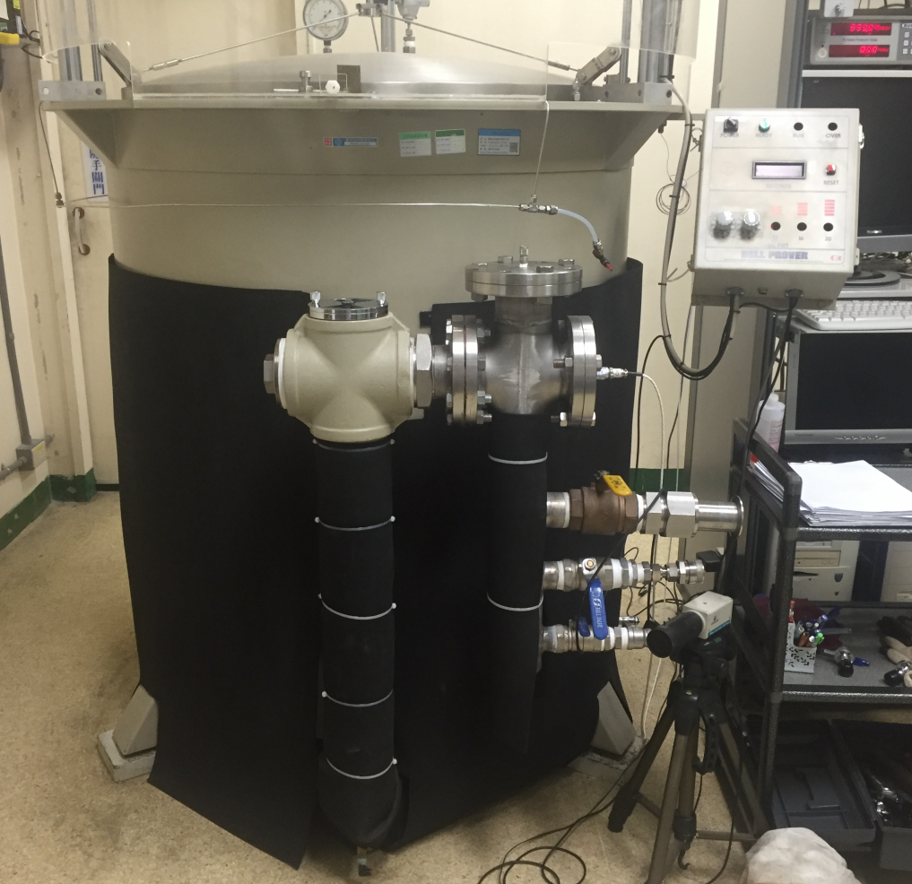

Figure 11: A bell prover system in CMS/ITRI.

Because the overlapping flowrate range between the bell prover HP systems is limited, the intra comparison was conducted only in the flowrate range of (15 to 60) m3/h. Only the smallest nozzle (SN1) of the HP system can be used for the comparison. Upon comparing, after SN1 standard nozzle is calibrated by the bell prover, then this SN1 is installed to the high-pressure gas system for calibration by the weighing method. The calibration results are shown in Figure 12. From the results, it is known that the difference between the bell prover and high-pressure gas system is less than 0.02 %. The comparison results reveal that two systems receive very good consistency under (15 to 60) m3/h flowrate range.

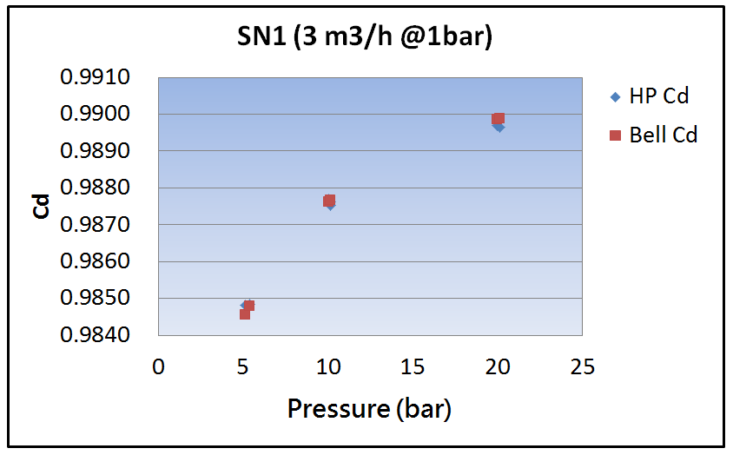

Figure 12: Inter-comparison result between bell system and HP.

*Carry out bilateral comparison with PTB, Germany*

After finishing the improvement of system, there is an opportunity to carry out an unofficial bilateral comparison with PTB, Germany. At this time, the 6 inch Elster TRZ2 G650 turbine meter is used. The flow conditioner and a straight pipe with length of 10D are installed at upstream, and a straight pipe with length of 3D is installed at downstream of flowmeter, as shown in Figure 13. The comparison flowrate range is (80 to 1000) m3/h. The pressure is 1 bar and 10 bar. The expanded uncertainty for PTB calibration of this turbine flowmeter is from 0.18 % at low flowrate to 0.14 % at high flowrate.

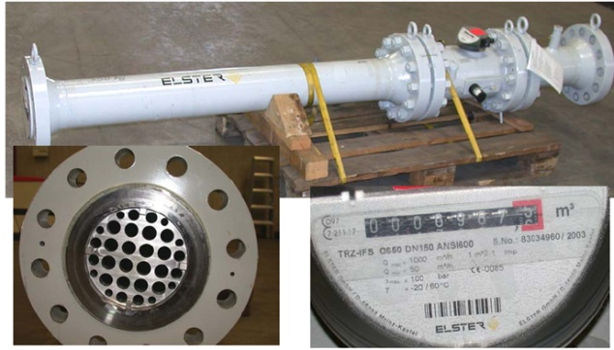

Figure 13: The meter used between CMS HP and PTB comparison.

The stability of the meter is approved up to now by a larger series of recalibrations at PTB with and natural gas as well, see figure 14.

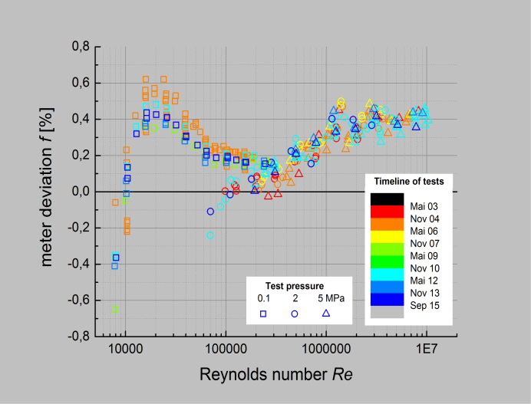

Figure 14: The history of recalibrations for the turbine meter 83034940 at PTB with air (0.1 MPa) and natural gas (2 rsp. 5 MPa).

The meter 83034940 was already used in the key comparison[4] in the year 2005. At this time, the key comparisons for high pressure gas were separated between natural gas (CCM.FF-K5a) and air/nitrogen (CCM.FF-K5b). In 2007[6] an extended model for the meter deviation depending on Reynolds number, flow rate and density was established to enable the direct comparison of facilities utelizing different gases, mainly natural gas, air and nitrogen.

The new approach for this bilateral comparison was here that PTB provides all parameters of the extended model based only on their own calibration capabilities in advances before the comparison (and not afterwords using all comparison results as done in[6]). Hence, PTB was determining the complete parameter set of this meter based on the calibrations with air (0.1 MPa) and natural gas (2 and 5 MPa). The comparison PTB-ITRI at 1 MPa with air is therefore also a trial for the planned repetition of the CCM.FF-K5.

The calibration results, relative deviation E(%), of this system and PTB for a turbine flowmeter is shown in Figure15. Through this comparison, it can be seen that there is difference of fixed direction for the comparison results. Their difference range is about 0.07% to 0.19%. This information can be regarded as our reference, as the basis for continuous system improvement.

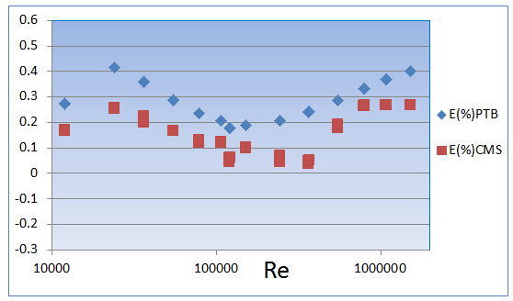

Figure 15: The comparison’s E(%) between CMS and PTB.

The En values of comparison results are shown in Figure 16. It is known that the En is less than 1 for all Reynolds number. It proves that 0.19 % of uncertainty declared by this system can be achieved.

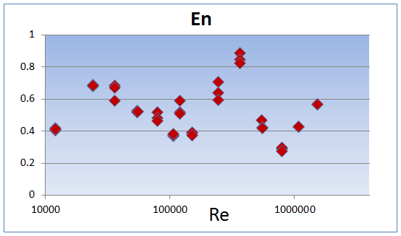

Figure 16: The comparison’s En value between CMS and PTB.

# 5. Conclusion and Future Work

The CMS/ITRI high pressure air calibration system had completed system improvement by replacing the transfer standard SNs. The system expanded uncertainty, 019%, had been validated through a series of confirmation and system comparison.

Because there is gas tank volume limitation of blow down system, so that the temperature of calibrated gas will drop with respect the pressure drop of gas tank. In addition, after the gas passes through the sonic nozzle, the gas temperature will drop greatly, so there will be temperature gradient between the standard sonic nozzle and the flowmeter under calibration. These two temperature effects have great influence on the performance of system. In order to improve the stability of temperature, the system improvement of this system is carrying on. The heat exchangers will be added at upstream and downstream of standard sonic nozzles. It is hoped to improve the stability of gas temperature through two sets of heat exchangers at the calibration process.

The comparison results with En values always below 1 for the tested pressure range from 0.1 MPa to 1 MPa are satisfying and indicate that the the calibration capability of ITRI and the determination of the error curve for the meters by PTB utelizing an extended meter model are reliable and provides good base to proceed with the arrangements of a repeated CCM.FF-K5.

# References

1. ISO 9300: *Measurement of gas flow by means of critical flow Venturi nozzles*, 2005.
2. Kuo, C.-Y., Ho, Y.-L., Dietz T., Wang, W.-B., Yang, F.-R., Su, C.-M. and Shaw, J.-H., “Calibration of Ultrasonic Flow Meter Using Blow-down Type High Pressure Gas Flow Standard”, *8th ISFFM* ,2012.
3. Carter, M., Johansen, W., and Britton, C., "Performance of a Gas Flow Meter Calibration System Utilizing Critical Flow Venturi Standards", *15th FLOMEKO Flow Measurement Conference,* 2010.
4. D. Dopheide, B. Mickan, R. Kramer, H-J Hotze, “*Final Report on the CIPM Key Comparisons for Compressed Air and Nitrogen*”, 2005.
5. Ching-Yi Kuo, Jiunn-Haur Shaw and Chun-Min Su , “Study of Thermal Effect on Calibration of an Ultrasonic Flow Meter”, *16th FLOMEKO Flow Measurement Conference,* 2013.

[6] B. Mickan, R. Kramer, D. Dopheide; “The Linking of the CIPM Key Comparisons CCM.FF-KC5a (for Natural Gas) and CCM.FF-KC5b (Compressed Air/Nitrogen) using Model Based Analysis of the data”; *14th International Conference on Flow Measurement, FLOMEKO' 2007; Johannesburg, South Africa*, Sept. 14 -17, 2007.