**Investigation on Error Model of Turbine Flowmeters Based on the Reynolds Number**

**Han Zhang1, 2, Chunhui Li2, Peijuan Cao1, 3**

*1* *Beijing Jiaotong University,* [*zhanghan@nim.ac.cn*](mailto:zhanghan@nim.ac.cn)*, Beijing, P. R. China*

*2 National Institute of Metrology, Beijing, P. R. China*

*3 Tianjin University, Tianjin, P. R. China*

*E-mail (corresponding author): lich@nim.ac.cn*

# Abstract

The meter error is an important index of flow characteristics for the turbine flowmeters, associated with flow rate and gas pressure. The model for meter error is the key link to decrease the fitting uncertainty faced by the non-fixed usage of turbine flowmeters. 4 sets of turbine flowmeters (Dn 100) were selected as master meters applied in measurement high pressure (up to 2.5MPa) gas flow is developed at NIM by the method of close loop standard facility. The investigation were carried out by the 4 sets of turbine flowmeters and the results showed that: the curve of meter error mainly shows a certain rule with the Reynolds number at different pressures but might be obviously spread at low flow rate but low pressure. Starting from the fact of the physical model that for a constant flow rate all forces (torques) are in equilibrium, the error model of turbine flowmeters (named NIM-2015) was presented. It can reflect the characteristics of the curve of meter error. With comparison with the uncertainty based on the NIM-2014 model, the uncertainty based on the NIM-2015 model of the 4 turbine flowmeters for the non fixed point usage could be lower than 1% (*k*=2). To prove the model the consistency of the turbine flowmeters was verified and the result suggests that the model is reasonable.

# 1. Introduction

Turbine flowmeters are widely used to measure the gas fluids flow as well as liquid fluids. The average volume flow obtained by measuring both the amount of time and pulse, which is based on the fact that the angular velocity of rotation of turbine flowmeters is proportional to the fluid flow velocity. Since the birth of turbine flowmeters, continued investigation was done, mainly in itself and the method of signal processing and itself.

The PTB’s[1] study shows that the change of gas pressure has a significant effect on the mechanical performance of turbine flowmeters and impact its characteristics. The error of turbine flowmeters is not only related to the Reynolds number, but also to the fluid density. The NIST ‘s[2] variable viscosity experiment by changing the mixing ratio of the fluid medium found that as the Reynolds number increases, the influence of fluid viscosity on the error of turbine flowmeters is gradually reduced to negligible. The NIM’sexperimental study found that the error of turbine flowmeters can change more than 0.4% under the same flow point of different pressure.

Actually, the flow of turbine flowmeters calibrated is not the same as the actual flow when it was used. The turbine flowmeters are calibrated at fixed point and used at non-fixed point by the method of curve fitting neglecting the influence of the pressure change, which directly increase the measurement uncertainty. So, the model for meter error is the key link to decrease the measurement uncertainty faced by the non-fixed usage of turbine flowmeters. Hence, the paper will be focus on the NIM-2015 model on the base of the physical model considering the influence of pressure change.

# 2. The error model of turbine flowmeters

*2.1 NIM-2014 model*

In view of the meter factor of turbine flowmeters *(K)* are typically not a constant, the flow characteristics for the turbine flowmeters are often characterized by the meter error of turbine flowmeters (*E*). When the flow rate is stable, all forces (torques) of the turbine flowmeters mainly include the fluid friction forces related to the boundary layer caused by the viscous fluid and bearing friction forces related to the relative motion of lubrication, which are the main sources of the meter error[3].

Based on the physical model that for a constant flow rate all forces (torques) are in equilibrium, the NIM-2014 model of the turbine flowmeters was presented.

 (1)

The parameters *A* 、*B* 、*C 、D* and *E* are constants and can be determined out of the experiment at different pressures. The eq.1 express the meter error as a sum of two main parts: meter error caused by flow and meter error caused by bearing. Compared to the negative effect of the bearing, the driving effect of the fluid flow on the turbine flowmeter is more dominant. So the positive power terms express the effect of fluid and the negative power terms express the effect of bearing in eq.1 . In order to balance the above two parts, a constantis introduced in the equation.

In 2013, the 4 sets of turbine flowmeters used as the master meters of the high pressure closed loop gas flow standard facility in NIM were calibrated in PTB at 0.1 MPa air and 2.5 MPa natural gas. Considering the uncertainty in the measurement of each flow point, we used the eq.1 to fit the calibration results (in Fig.1 the example for D2# turbine flowmeter).

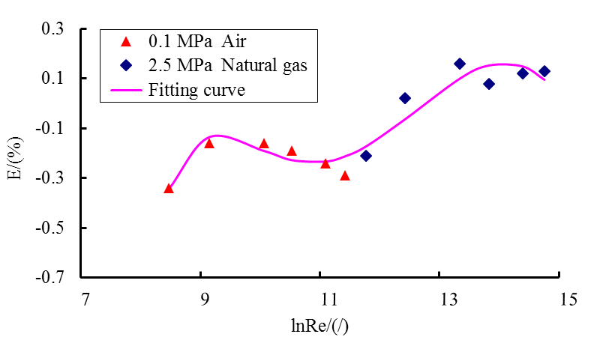

**Figure 1 :** The calibration results in PTB at 0.1 MPa air and 2.5 MPa natural gas and the fitting curve calculated with NIM-2014 model eq.1 of D2# turbine flowmeter

In Fig.1, one can see that the fitting curve of D2# turbine flowmeter is in good agreement with the calibration results. The uncertainty of curve fitting with NIM-2014 model eq.1 is 0.06% ~ 0.07%. This shows that the characteristics of the turbine flowmeter can be evaluated by the method of curve fitting based on the Reynolds number. In 2014, the calibration of one Dn 100 turbine flowmeter with the 4 sets of turbine flowmeters which were based on the NIM-2014 model was carried out by the high pressure standard facility in NIM. The results are shown in Fig.2.

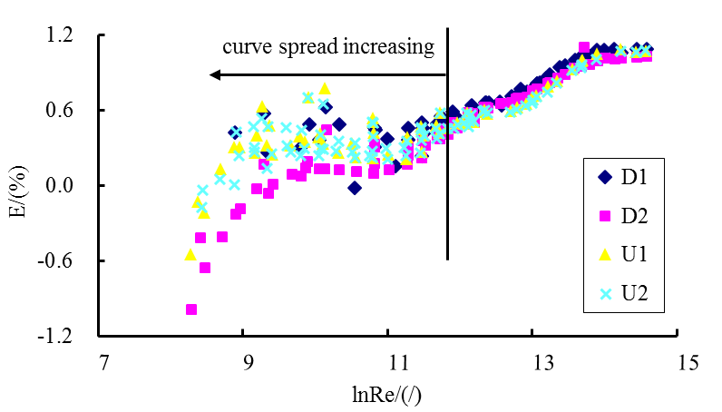

**Figure 2 :** The result for the calibration of one Dn 100 turbine flowmeter with 4 sets of turbine flowmeters based on the NIM-2014 model

In Fig.2 the consistency of the results for the same Dn 100 turbine flowmeter calibrated by the 4 sets of turbine flowmeters decrease and the spread increase obviously When the Reynolds number is lower than 100000, ln(Re)<11.5. Hence, the estimation for the difference of the calibration results is:

 (2)

The parameters *Ei* and *Ej* are the separated calibration results for the 4 sets of master meters. is the difference between the two calibration results. One can see from the Fig. 2 that the difference all over 0.5%. The maximum difference which is between D2# and U1# reached about 0.75%. The uncertainty of the difference can be described as follows:

 (3)

The parameters *Ui* and *Uj* are the separated uncertainty of the 4 sets of turbine flowmeters based on the NIM-2014 model as master meters in the non-fixed point usage;is the uncertainty of the difference of the 4 sets of calibration results. Considering the uncertainty of the master meters in the fixed point usage 0.21% and the uncertainty of the curve fitting based on the NIM-2014 model, the maximum uncertainty  is 0.53%. Meanwhile, the maximum uncertainty of 4 sets of turbine flowmeters based on the NIM-2014 model as master meters in the non-fixed point usage is 0.36%, which is far large than the uncertainty of their fixed point usage. So, we concluded that the NIM-2014 model cannot completely reflect the characteristics of the error curve of turbine flowmeters.

*2.2 The experimental for the turbine flowmeters calibrated in original position*

Due to the spread of the calibration results mainly appear and increase at ln(Re) < 11.5, We defined the Reynolds number at this time as the critical Reynolds number. We built up the high pressure sonic nozzles standard facility to get the possibility to perform the recalibration tests of the turbine flowmeters under 0.5 MPa、80 m3/h. In view of the change from the installation position to the reinstallation position may affect the performance of the turbine flowmeter, the high pressure standard facility designed the sonic nozzle bank consisting of 16 sonic nozzles closely adhered to the downstream of the turbine flowmeters to ensure that they are recalibrated in the original position. The experimental setup for the turbine flowmeters recalibrated in original position is shown in Fig.3.

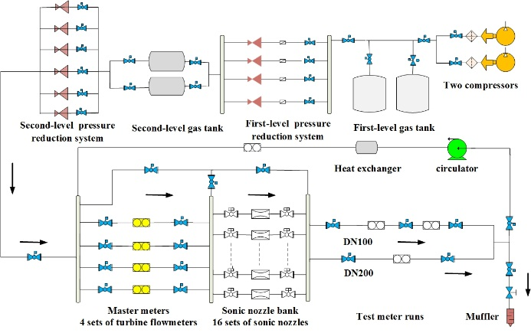

**Figure 3 :** The experimental for the turbine flowmeters recalibrated in original position

*2.3 NIM-2015 model*

The calibration curves by the sonic nozzlesin original position are shown in Fig.4 (the example for D1# turbine flowmeter, original result was the calibration result in PTB in 2013).

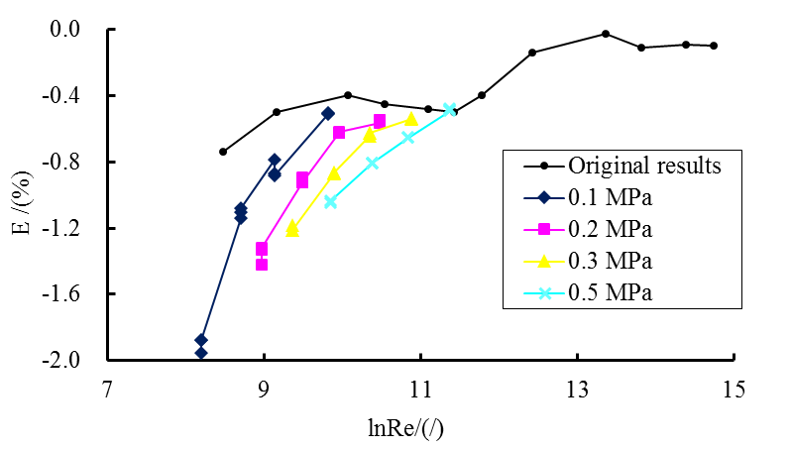

**Figure 4 :** The calibration results for D1# in original position

The spread of the calibration curves appear under the critical Reynolds number and the spread degree changes inversely with the increase in pressure and flow. This shows that the meter error is not only related to the Reynolds number, which prove that the NIM-2014 model also has some shortcomings

The bearing friction torque and the fluid friction forces influence the turbine flowmeter and each plays the dominant role at different working condition. In Fig.2, the spread of the calibration curves occurs mainly under the critical Reynolds number, which means that the meter error is not only related to the Reynolds number, but also to the pressure and flow change. The fluid friction forces is related to the velocity gradient in the boundary layer and the influence of fluid friction increases with the increase in the fluid velocity. When the fluid flow rate multiply towards infinity, the rotor of the turbine flowmeter rotation to reach the limit and the fluid frictional forces plays an absolute leading role compared to the bearing friction forces. When the flow velocity is close to starting flow at the same pressure, the bearing friction forces plays an absolute leading role compared to the the fluid friction forces. Hence, there must be a velocity point in the middle of the flow velocity extreme point to make the two forces in the balanced position. At this time, the Reynolds number is the critical Reynolds number defined in the above.

The bearing friction forces plays a leading role under the critical Reynolds number, and the dominant degree decreases with the increase of the Reynolds number. For gas fluid, the change of pressure is mainly influenced the change of gas density, which is closely related to the volume flow. However, the density of the gas fluid is not equal at the same Reynolds number for the different pressure. Although the relative flow of lubricant inside the bearing is laminar, the effect of the bearing friction forces is not consistent at different pressure. So, the effect of the bearing friction forces not only related to the Reynolds number, but also to the density of the gas fluid and volume flow. Based on Mickan et al. [3~5], the term of the effect of the bearing friction forces in NIM-2014 model was introduced a new term which is related to the density of gas fluid and the volume flow used to reflect the influence of the bearing friction forces of the pressure change. We named the new model as the NIM-2015 model, which can be described as follows:

 (4)

The parameters  is constant and can be determined out of the experiment at different pressures. The parameters is the density of the gas fluid and is the volume flow. Unlike the NIM-2014 model, the negative power terms and the newly added term are used to reflect the influence of the bearing friction forces. Here, the calibration results and fitting results based on the equation 1 and equation 4, are shown in Fig.5 (the example for D1# turbine flowmeter.

.

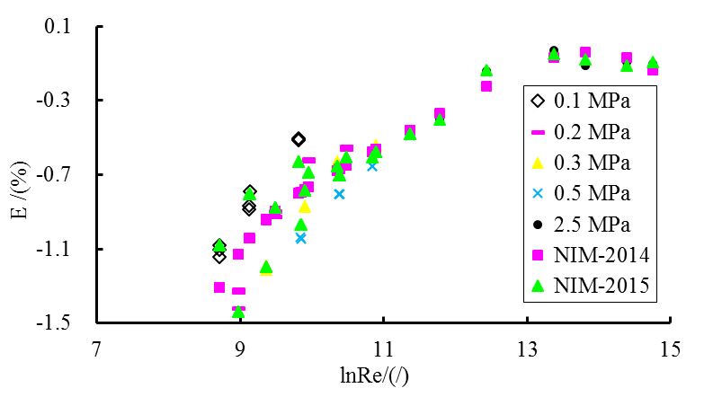

**Figure 5 :** The calibration results and fitting results for D1#

In Fig.5 the fitting results based on the NIM-2014 model shows that the Reynolds number and the meter error are corresponding one by one. The fitting results based on the NIM-2015 model are not only to the Reynolds number which reflect the spread characteristics of the turbine flowmeter to some degree. Therefore, the NIM-2015 model completely reflect the spread phenomenon of the error curve, which is compared to the NIM-2014 model.

*2.4 the uncertainty of the curve fitting based on the error model of the turbine flowmeter*

It is possible to express the uncertainty of the non-fixed point usage of the turbine flowmeter as a sum of two main parts: the uncertainty of the fixed point usageand the uncertainty caused by the curve fitting based on the error model .

 (4)

The parameters  is coverage factor. The uncertainty of the fixed point usage of the turbine flowmeters is 0.21%. we are more concerned about the uncertainty caused by the fitting curve based on the NIM-2014 model and the NIM-2015 model. The deviation  between the fitting results  based on the error model and the calibration results can be described as follows:

 (5)

the uncertainty of the fitting curve  can be described as follows:

 (6)

The parameters  is the number of the flow points and is the number of the constants in the equation. Hence, the uncertainty of the turbine flowmeters at the non-fixed point based on the NIM-2014 model and the NIM-2015 model as follows ( which can be calculated based on the equation 4、equation 5、equation 6 ):

**Table 1:** the uncertainty of the turbine flowmeters at the non-point based on the NIM-2014 model and the NIM-2015 model

|  |  |  |  |  |  |
| --- | --- | --- | --- | --- | --- |
| **Meter** | **U(E)**  **(%)** | **NIM-2014** | | **NIM-2015** | |
| **U(F)** | **U(Ec)** | **U(F)** | **U(F)** |
| **(%)** | **(%)** | **(%)** | **(%)** |
| D1# | 0.21 | 0.34 | 0.40 | 0.14 | 0.25 |
| D2# | 0.21 | 0.28 | 0.35 | 0.10 | 0.23 |
| U1# | 0.21 | 0.32 | 0.38 | 0.08 | 0.22 |
| U2# | 0.21 | 0.36 | 0.42 | 0.12 | 0.24 |

As we can see from the table 1 that the uncertainty of the flowmeters at the non-fixed point based on the NIM-2015 model can be decreased from 0.35% ~ 0.42% to 0.22% ~0.25% compared to based on the NIM-2014 model, which shows the obvious advantages of the NIM-2015 model.

# 3. The verification of the NIM-2015 model

If the NIM-2015 model is more appropriate compared to the NIM-2014 model, the consistency of the turbine flowmeters based on the NIM-2015 model should be very good. The 4 sets of turbine flowmeters based on the NIM-2014 model and the NIM-2015 model respectively calibrated a Dn 100 turbine flowmeter. The consistency of the turbine flowmeters evaluated by the value of  . The value of  represents three kinds of results:

* -11, the results show that the consistency of the 4 meters is good, and the calibration results are consistent.
* -1.2-1 or 11.2, warning area, we need to check the calibration results of the 4 meters.
* 1.2 or -1.2, the results show that the consistency of the 4 meters is poor, and the calibration results are not consistent.

 (7)

The parameters  is the calibration results of the referenced meter;  is the calibration results of the non-referenced meter;  is the uncertainty of the referenced meter at the non-fixed point usage;  is the uncertainty of the non-referenced meter at the non-fixed point usage.

Experiments were carried out at the 0.1 MPa、0.2 MPa、0.5 MPa、1 MPa、1.5 MPa and 2.5 MPa pressures and 20 m3/h、32 m3/h、40 m3/h、50 m3/h、65 m3/h、80 m3/h and 100 m3/h flow points. At the above experimental point, each experimental point repeated as measured three times and the results based on the NIM-2014 model and NIM-2015 model as follows:

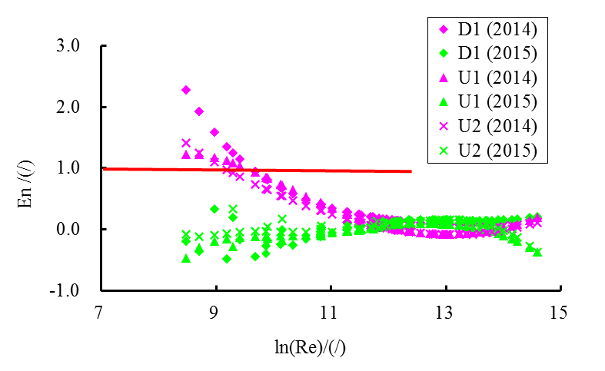

**Figure 6 :** The consistency of the 4 sets of turbine flowmeters based on the NIM-2014 model and NIM-2015 model

In Fig.6 we can see that the value of  based on the NIM-2015 model are significantly better in the 141 measurements of the 4 meters under the critical Reynolds number. The value of the  D1#、U1# and U2# separate has fifteen times、fifteen times and eight times which were over 1 and all occurred under the critical Reynolds number. The verification results show that the consistency of the 4 meters based on the NIM-2015 model is good and the NIM-2015 model can completely reflect the characteristics of the error curve of the turbine flowmeter compared to the NIM-2014 model.

# 4. Conclusion

The characteristics of turbine flowmeter can be evaluated by the method of curve fitting based on Reynolds number.

Based on the physical model, the NIM-2015 model was presented. Compared to the NIM-2014 model, the NIM-2015 model can completely reflect the characteristics of the error curve of the turbine flowmete and the uncertainty of the turbine flowmeters at the non-fixed point based on the NIM-2015 model can be decreased from 0.35% ~ 0.42% to 0.22% ~0.25%.

The NIM-2015 model shows that the critical Reynolds number is existed in the error curve of turbine flowmeter. The bearing friction forces plays a leading role under the critical Reynolds number, and the dominant degree decreases with the increase of the Reynolds number. Under the critical Reynolds number, the spread of the calibration curves appears and the spread degree changes inversely with the increase in pressure and flow.

# References

1. B.Mickan, R.Kramer, D.Dopheide. The linking of the CIPM key comparisons CCM.FF-KC5a (for natural gas) and CCM.FF-KC5b (compressed air/nitrogen) using model based analysis of the data. 14th International Flow Measurement Conference on Flow Measurement, South Africa, September. 2007.
2. Jodie G P, John D W, Aaron N J, Michael R M. Extended Lee model for the turbine meter & calibrations with surrogate fluids[J]. Flow Measurement and Instrumentation, 2012, (24).
3. Baker R C, Turbine flowmeters: II. Theoretical and experimental published information[J]. Flow measurements and instrumentation, 1993, 4(3).
4. Thompson R E, Grey J. Turbine flowmeter performance model[J]. American Society of Mechanical Engineers, 1970, (12).
5. B.Mickan, R.Kramer, D.Xie. Reliable determination of bearing friction in turbine meters and the relation to the calibration curve. 2012. 16th International Flow Measurement Conference on Flow Measurement, Paris, September. 2013.