Extended data analysis of bilateral comparisons with air and natural gas up to 5 MPa
Bodo Mickan¹, Jean-Pierre Vallet², Chunhui Li³ and John Wright⁴

¹ Physikalisch-Technische Bundesanstalt (PTB), Germany
² CESAME EXADEBIT S.A., France
³ National Institute of Metrology (NIM), China
⁴ National Institute for Standards and Technology (NIST), USA

¹ E-mail:bodo.mickan@ptb.de

Abstract

In 2015, the PTB, LNE-LADG, NIM and NIST performed informal bilateral comparisons using six critical venturi nozzles (CFVN). The goal of the comparisons was to prove the equivalence of reference standards for gas flow using pressurized air and natural gas at pressures from 0.1 MPa to 5 MPa.
The approach represents the results reported by participants using functions based on physical understanding of the transfer standards. The paper documents the full equivalence of all traceabilities involved in these comparisons. The comparison database includes not only measurement sets of 2015 but also measurements done by PTB in other years with the same nozzles. Hence, qualitative statements on the long term reproducibility could inform the analysis on multilateral equivalence of the participants. Linked bilateral comparisons can effectively expose discrepant labs and perhaps give insight on the long term drift of primary standards.
The evaluation of the data utilized a function for the discharge coefficient c_{D} of critical nozzles as a function of the Reynolds number and real gas characteristics. The fitting function covers both laminar and turbulent boundary layer operating ranges of a nozzle with a single equation. The summary of all results of this comparison series shows that the proposed c_{D} function can represent single measurement values with a precision on the order of 0.1 %.

Introduction

In the past 15 years, the National Metrology Institutes (NMIs) and Designated Institutes (DIs) made big efforts to establish a system of intercomparisons to support the quality of calibration results under the Mutual Recognition Arrangement (MRA) organised within the Bureau International des Poids et Mesures (BIPM, www. bipm.org).

Besides high level key comparisons, many NMIs or DIs in the field of fluid flow continue to do informal comparisons, performed bilaterally and efficiently at a less sophisticated technical level. These comparisons can provide a database to make the calibration capabilities evident.

The comparisons discussed herein were organised ad-hoc in 2015 between 1) PTB and LNE-LADG, 2) PTB and NIM, and 3) NIM and NIST using a total of six critical nozzles. A special characteristic of the database generated within this series of measurement is the wide range of pressure (0.1 MPa to 5 MPa) and the different gas species (air and natural gas) used for the calibrations. Furthermore, PTB could provide datasets of calibrations for five of the nozzles performed in previous years and based on consistent traceability to a the same primary standards.

Hence, a large database was available and it was the central challenge to make use of all these data to determine the degrees of equivalence between the participants. Hereby, it was necessary to introduce new approaches based on the application of functions to represent the values of c_{D} reported by the NMIs.

Overview of the transfer standards and the NMIs

The transfer standards for the comparison measurements were critical nozzles of different throat diameters. Both types of nozzles defined by the ISO 9300 [1], toroidal and cylindrical) have been applied. Only the nozzles were transported among the labs to keep the comparisons simple, less risky regarding damage or loss of equipment, and less expensive. Consequently, all auxiliary equipment (pressure, temperature, and composition sensors) necessary for the complete determination of the discharge coefficient c_{D} were provided by each participating laboratory. Each participant included the uncertainty of the auxiliary instruments in their uncertainty of the reported c_{D} values. Table 1 and Figure 1 give an overview to the six nozzles and the mass flow range covered. From these data, it is apparent that at approximately 100 kg/h, there is indirect linkage from NIST through NIM and PTB to LNE-LADG via three or more CFVNs. Our goal is to advance the analysis of this bilateral comparison database.

Table 2 lists the NMIs and their primary standards that are relevant for the comparisons discussed here. All NMIs have already established CMCs in the BIPM database, but CMC revisions are in process:
- NIM has increased the operating pressure to 2.5 MPa [3].
- LNE has completely re-built their pVTt system and is using air [6].
- PTB offers direct calibrations of customer devices with their primary standard for high pressure natural gas.

It is one intention of this paper to provide evidence regarding these ongoing changes of the related CMC entries.

Table 1: Nozzles used in the comparisons.
CFVN | d [mm] | Form | NIST | NIM | PTB | LNE
NIST 2.5 mm | 2.5 | toroid | X | X
HD-17b | 2.156 | toroid |  | X | X
HD-9b | 4.9452 | toroid |  | X | X
HD-5b | 6.9882 | toroid |  | X | X
TF65 | 10.007 | cylind. |  |  | X | X
TF200 | 17.396 | cylind. |  |  | X | X

Figure 1: Ranges of mass flow rate covered by the different nozzles within the comparison campaigns.

Table 2: List of the NMIs and their primary standards.
NMI | Gas used | Prim. standard | Ref. | p_{max} [MPa]
NIST | Air | pVTt | [2] | 0.7
NIM | Air | pVTt | [3] | 2.5
PTB | Air  Natural gas | Bell prover*  piston prover** | [4]  [5] | 0.8  5.6
LNE | Air | pVTt | [6] | 4
* Working standards were used for the calibrations in all measurements with air above 100 kPa.
** Working standards were used for the calibrations in all measurements with natural gas before 2015.

On the uncertainties in comparisons and the degree of equivalence

The Working Group for Fluid Flow (WGFF) in the Consultative Committee for Mass and Related Quantities at the BIPM, released a guideline [7] for CMC and Calibration Report Uncertainties in 2013. According to the role of the BIPM, the statement about the uncertainty in a CMC entry in the BIPM database has to include the repeatability u_{repeat,BED} of a best existing device under test (BED) beside the base uncertainty of the laboratory’s reference standard:
(1)
The transfer standard (TS) used in an intercomparison will have a different repeatability performance u_{repeat,TS} than the laboratory’s best existing device. Consequently, the uncertainty reported by a laboratory u_{Lab,reported} in a comparison is given by:
(2)
In practice, transfer standards have a certain long term stability u_{TS,stab} which is not represented by the u_{repeat,TS} and has to be determined by repeated calibrations covering a long period. The value u_{Lab,applied} finally used for the calculation of the degree of equivalence is considering therefore this additional contribution to the uncertainty:
. (3)

The (bilateral) degree of equivalence is the central outcome of the comparisons and is expressed here as the normalized difference between the values reported by two laboratories:
, (4)
where the combined uncertainty of both participants is the normalization factor using the expansion factor k so that we get the 95% coverage interval. The critical level for abs(E_{N}) is therefore 1. Exceeding the level of 1 indicates the non-equivalence of the calibration results.

In the past, some effort was necessary to make sure that all participants performed their measurements under very similar working conditions. Specifically the operating pressure, flow, and fluid composition or properties had to be similar for all participants because the indication performance of our transfer standards has dependency on these operating conditions. Hence, the comparisons were evaluated in a so-called point-to-point (P2P) manner, meaning that only values were compared which were generated at very similar operating conditions for all participants. The database generated within the series of measurements documented in this paper does not fulfill the requirements for such a P2P evaluation. We have chosen therefore to pursue an approach that determines functions that represent the data of the participating labs.

Least squared best fit functions (LSF) are practical solutions, but require the consideration of the following topics to avoid misinterpretation of the results:
- Correlation among data measured with common traceability (data out of one lab),
- Bias effects due to imbalances regarding number of data provided by the labs (the results can be biased towards the larger datasets),
- Choice of the fit function. The structure of the fit function shall have sufficient complexity to cover the characteristics of the true relationship (a demonstrated physical model) but shall also provide results based on a sufficient statistical significance.
- Extrapolation to very different conditions of flow and composition increases uncertainty.

Our approach here was to use a function which shall represent the general behavior of the dependency of our measurand, the discharge coefficient c_{D} of a critical nozzle as a function of the Reynolds number Re. This first approximation c_{D,base} $=f\left(Re\right)$ is determined by means of a weighted LSF with data from all available labs for each nozzle. The uncertainties u_{Lab,reported} were used for the weights but we did not consider any correlation among the data (LSF with uncorrelated data). As a consequence, the result for c_{D,base} is definitely biased in multiple ways and the related uncertainty of the fit result is strongly underestimated. Therefore, a more sophisticated approach is needed before using this function to produce a comparison reference value.

But we can make use of c_{D,base} to remove a common base line from all single measurement values:
(5)
In a second step, the remaining single data Δc_{D,Lab} are approximated again by means of a LSF:
(6)

The complexity of functions being necessary to represent the Δc_{D,Lab} is dramatically reduced when the first estimation c_{D,base} is quite close to the real behavior of c_{D}(Re). For this database, it was possible to apply polynomials of first order in most cases and only in a few cases higher order (the maximum was third order in one case).

The LSF processing of the data provides finally the parameters for the fitted function and the variance-covariance matrix of these parameters. With this we generated the values of the fitted curve Δc_{D,fit,Lab}(Re) and the related uncertainty to this value u_{conf,fit}(Re) for a new set of Reynolds number in the Reynolds range covered by two laboratories. At each “new” Reynolds number we applied then the conventional approach for the P2P determination of the degree of equivalence Equation (9). We did not perform extrapolation beyond the range of Reynolds number provided by a participating laboratory.

Please note that the outcome of LSF for the uncertainty of the fitted value at confidence level u_{conf,fit}(Re) has similar meaning as the standard uncertainty of the mean which is background for the u_{repeat,TS} reported by the lab. Furthermore, we assume that critical nozzles are very stable artifacts and it is not necessary to include a value for u_{TS,stab} for the short duration of these comparisons. Hence, we assumed the following simplifying relations for all evaluations documented here:
(7)
(8)

The bilateral degree of equivalence is finally:
(9)

Definition of c_{D} $=f\left(Re\right)$ covering wide Reynolds range

The discharge coefficient c_{D} depends mainly on the Reynolds number of the flow through the nozzle. Looking to the characteristics of this dependency we have to distinguish two main cases, when the boundary layer of the flow inside the nozzle is laminar (c_{D,lam}) and when boundary layers is turbulent (c_{D,turb}):
, (10)
with
The parameter a represent the impact of the inclination of the isotache lines at the nozzle throat [9] to the discharge coefficient c_{D} and b_{lam} as well as b_{turb} indicate the dependency of c_{D} on Reynolds number in the case of laminar boundary layers or turbulent respectively (for discussion regarding the exponent 0.139 for turbulent boundary layers please refer e.g. to [10]).

It is a common approach to bridge the laminar and turbulent boundary layer transition with one function for the whole Reynolds range by means of a transition function given by the two terms s_{a} and s_{e}. Note that. The parameter Re_{tr} defines the middle point of the transition and k_{u} the “sharpness” of the transition (the larger k_{u}, the more “sudden” the transition occurs).

Equation defines our base function for c_{D} for a particular nozzle versus all Reynolds numbers which we call in the following, c_{D,base}. We will use the database from the participating labs to determine the free parameters in Equation (10) for each nozzle. In many cases, the fitted values for some of the free parameters (and particularly b_{turb}) are more difficult and less reliable because of a lack of comparison data in the turbulent regime. Also, the sensitivity to the parameter k_{u} is weak. Therefore some reduction of the independent parameters is applied:
- the parameter k_{u} is fixed arbitrarily to the value
k_{u} = 5.5 for all nozzles, and
- we introduce a fixed relationship between b_{lam} and b_{turb}.
Based on previous theoretical and numerical studies [10], the following fixed relation between the parameters b_{lam} and b_{turb} can be used:
, (11)
removing b_{turb} from the list of parameters to be determined for each nozzle.

The measurements from our bilateral comparisons cover air and natural gas up to a pressure of 5 MPa. Therefore real gas effects are significant and an inclusion of gas characteristics as a function of composition and pressure is necessary. For the parameter b_{lam} we made use of the theoretical work of Geropp [11]. Geropp showed that the parameter b_{lam} has dependencies on the isentropic exponent κ, the Prandtl-number Pr, the difference of the wall temperature to ideal condition ΔT_{Wall}, and the radius of curvature of the nozzle inlet near the throat R_{throat}. Explicit equations for these dependencies are found in reference [11]:
. (12)
Up to now, we have no detailed knowledge about ΔT_{Wall} therefore we are ignoring the influence of heat transfer on b_{lam} and assume always ΔT_{Wall} = 0.

To utilize the relation given by Equation (12) for our application, we use a parameter b_{lam,0} which is assumed to be valid for the specific gas parameters κ = 1.4 and Pr = 1. This yields:
. (13)
Hence, for a certain value of b_{lam,0} we can apply the related b_{lam} specific for each gas and each pressure when we calculate c_{D,base}.

For the parameter a, representing the impact of the inclination of the isotach lines, we apply a similar approach. The parameter a also depends on the isentropic exponent κ and the radius of curvature at nozzle throat R_{throat}:
. (14)
An explicit equation for this dependency is given e.g. by [9].

Analogous to the approach for b_{lam}, we use a parameter a₀ assumed to be valid for κ = 1.4 and which is related to the actual parameter for a specific, actual κ according to:
, (15)
with

Hence, the determination of the function c_{D,base} for one nozzle needs now the determination of three parameters {a₀, b_{lam,0}, Re_{tr}} instead of the original five.

The characteristics of our definition of c_{D,base} have important consequences for our purpose here. The relationships of Equation (13) and Equation (15) introduce systematic dependency on the fluid parameters isentropic exponent κ and the Prandtl number Pr. These parameters differ significantly for different gases as well as for different pressures of the same gas (because of real gas effects). An illustration is given for the nozzles investigated here in Figure 7 to Figure 11. The c_{D,base} in these graphs is calculated using the same a₀ and b_{lam,0} for both air and natural gas (NG). But at the high Reynolds numbers, i.e. at the higher pressures, the difference for c_{D,base} between air and natural gas is approximately 0.075% which is of the same order as the expanded uncertainty of the single values. It would definitely distort the results for comparisons using air and natural gas if we ignored this behaviour.

Results for the Degree of Equivalence E_{N}

All data sets of our nozzles have been treated with the principles given above in sections 3 and 4. The related database from the six nozzles can be seen in graphical form in the Appendix, Figure 7 to Figure 11.

Figure 2 and Figure 3 below illustrate the Δc_{D} values for one of the six nozzles (HD-9b) and the final E_{N} curves. The E_{N} curves (Figure 3) have been determined with data sets that are pair-wise independent regarding their traceability; so e.g. NIM (2015 air) with PTB (2015 air) but also with PTB (2015 NG) and with PTB (2006 air). To avoid introducing uncertainty due to extrapolation, the E_{N} values are calculated only for the range of Reynolds numbers were the data sets overlaps.

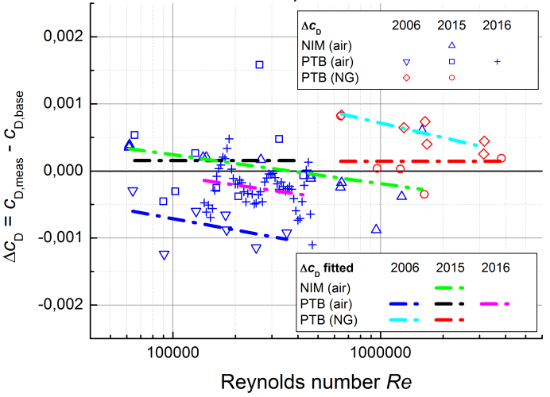
Figure 2: Differences Δc_{D} of single c_{D} values against the c_{D,base} function for the nozzle HD-9b. The Δc_{D} for each measurement series are approximated by a polynomial Δc_{D,fit}. Please refer to Figure 9 in the Appendix for plot of c_{D,meas} and c_{D,base}.

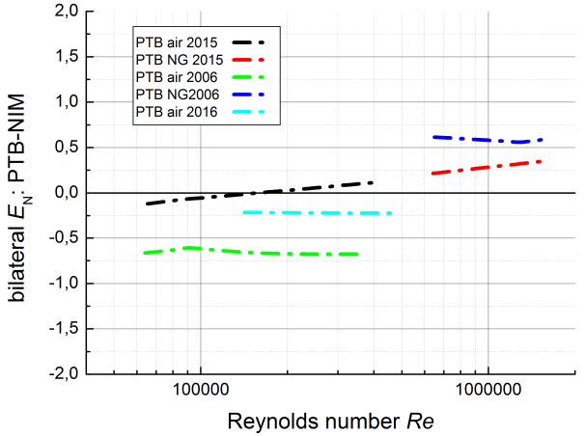
Figure 3: Bilateral E_{N} PTB – NIM using nozzle HD-9b. E_{N} is calculated according to Equation (9).

The E_{N} curves in Figure 3 for the bilateral equivalence between PTB and NIM are all significantly within ±1 and vary approximately ±0.5 against an average. This indicates the overall stability of the measurment process including the reference standards of participants and the transfer standard over all the years from 2006 to 2016!

Figure 4 shows the E_{N} curves for all the the data for all nozzles. To maintain readability, the curves are distiguished by colour based on the bilateral comparison pairs.

All E_{N} are within ±1 and the pair-wise equivalence between PTB/NIM, PTB/LNE, and NIM/NIST is evident.

After the calculation of the E_{N} curves and the approval of bilateral equivalence we can ask about the multilateral equivalence. The multilateral equivalence is here evaluated qualitatively using the fact that the bilateral comparisons are establishing a chain between NIST-NIM-PTB-LNE in which NIM and PTB can be used as the link between the other two participants.

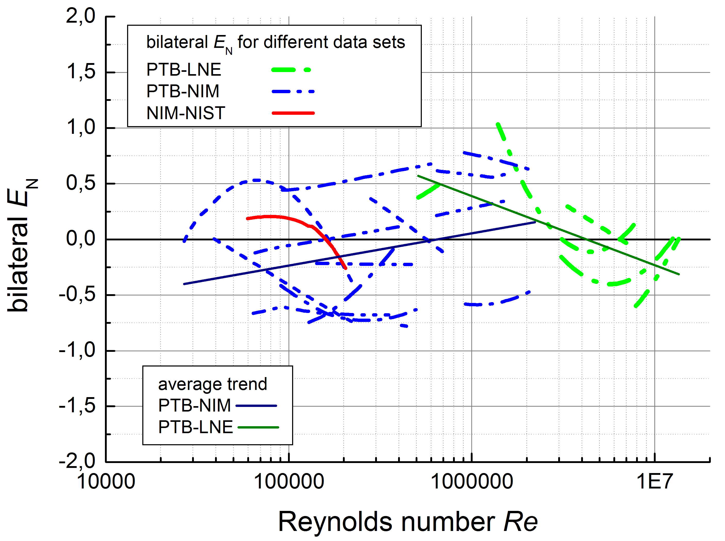
Figure 4: Bilateral E_{N} PTB-LNE, PTB-NIM and NIM-NIST for all nozzles and all datasets.

Looking to Figure 4, we can conclude first that there is only a slight trend in E_{N} with respect to Reynolds number for all compared data sets between NIM and PTB. Secondly, considering the data PTB-LNE, we can see a trend starting from about +0.6 going down to -0.3. Both trends are getting rather close together in the overlapping range. Hence, we can conclude that also for NIM-LNE we can expect equivalence in the operation range where both NIM and LNE can provide calibrations.

For NIST-NIM we had only one data set and the line of E_{N} for this case is also reasonably close to the overall trend line for NIM-PTB.

Evaluation of all single c_{D} values using c_{D,base}

In the following, we will use the overall function c_{D,base} in sense of a comparison reference value although, we are formally are not allowed to name it so as already mentioned above in section 3. Hence, we will talk about the normalised differences Δc_{D}/U_{Lab,reported} (Figure 6) which have the same philosophy behind them but may slightly differ from the exact values for E_{N}. But we can assume that the difference is small and probably Δc_{D}/U_{Lab,reported} will be overestimated because an existing bias is increasing the values for at least one of the participants.

Figure 5 shows the relative differences Δc_{D,rel} against the c_{D,base} functions for all measurements. It can be seen that the majority of the values for Δc_{D,rel} are approximately in a range of 0.1%. There are only a few values between 60 kg/h and 200 kg/h that exceed this limit significantly (up to +0.3%).
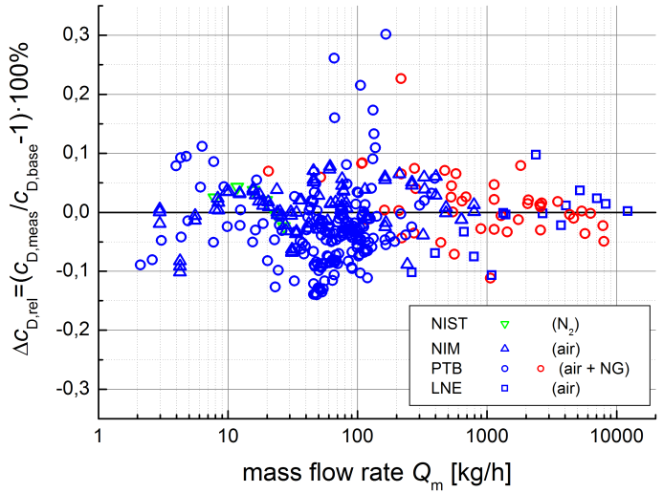
Figure 5: Differences Δc_{D} of single c_{D} values (relative in %) against the c_{D,base} functions for all nozzles and all measurement series.

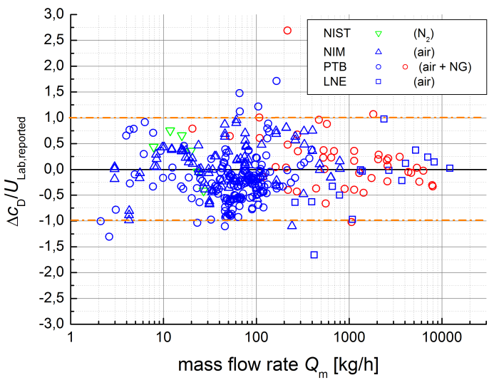
Figure 6: Normalised differences Δc_{D}/U_{Lab,reported} as shown in Figure 5 using the related uncertainties reported by the laboratories (k = 2) for all nozzles and all measurement series.

The normalised differences Δc_{D}/U_{Lab,reported} are shown in Figure 6. The overall histogram statistics for these data are shown in Figure 12 in the appendix and indicate that 95 % of the values are within ±1.

Additionally we can conclude that the functionality behind c_{D,base} is sufficient to represent a single experimental datum at the level of 0.1 % because otherwise the normalised difference is highly unlikely to give abs(E_{N}) values in the manner shown here.

Conclusions

First of all, we conclude from these comparisons that there is equivalence between all the measurement capabilities involved. These results support of the following improved CMCs: 1) LNE with their new pVTt-facility [6] with pressure up to 4 MPa and uncertainties of U_{base} ≥ 0.1%, 2) NIM with their pVTt [3] up to 2.5 MPa and U_{base} = 0.08% and 3) PTB’s capability to calibrate sonic nozzles with their High Pressure Piston Prover with U_{base} = 0.072%.

The usage of functions was successfully introduced into the evaluation of the comparison database. This approach was necessary because the database did not allow the application of the conventional approach of point-to-point evaluation. The procedure to first subtract a base line (c_{D,base}) from the reported results is very helpful; it reduces the complexity for the representations of data of each laboratory.

It has to be emphasized hereby that the additional contributions of uncertainties caused by the transfer standard to the final values of E_{N} because the value for the uncertainty of the fit u_{conf,fit} is replacing the repeatability u_{repeat,TS}. In practise, u_{conf,fit} is smaller than the repeatability at one point due to the higher degree of freedom and is also representing some parts of the u_{TS,stab}. This is an important advantage of this approach for future comparisons because it is enhancing the quality of the intercomparisons regarding the possibility to assess the CMCs based on the comparison results (see for this [13]).

Last but not least, the application of a generalised function to represent the database of discharge coefficients was demonstrated and with the set of overall results it was shown that this function can reflect the experimental data at a precision level of 0.1%. Furthermore, the function includes additional real gas effects on the boundary layer that were used to correct significant differences (up to 0.075 %) between application with air and natural gas at high pressures (2 MPa to 5 MPa).

References
[1] International Standards Organization, Measurement of Gas Flow by Means of Critical Flow Venturi Nozzles, ISO 9300:2005(E).
[2] J. D. Wright and A. N. Johnson, NIST Lowers Gas Flow Uncertainties to 0.025 % or Less, NCSL International Measure, 5, pp. 30 to 39, March, 2010.
[3] C. Li, L. Cui, C. Wang: The new pVTt facility in NIM, Proceedings of the 13th Int. Conference on Flow Measurement FLOMEKO 2013, Paris, France 2013.
[4] B. Mickan, R. Kramer, and M. Strunck, Highest Precision for Gas Meter Calibration Worldwide: The High Pressure Gas Calibration Facility pigsarTM with Optimized Uncertainty, 7th ISFFM, Anchorage, Alaska, 2009.
[5] B. Mickan, R. Kramer: Experiences with sonic nozzles used for different gases and wide range of pressure and temperature conditions, Proceedings of 7th International Symposium on Fluid Flow Measurement, Anchorage, Alaska, 2009.

[6] J. P. Vallet, G. Miault, C. Windenberger, P. Manrot, P. Kervevan, The conception and the construction of a new High Pressure Primary Facility for Gas, Proceedings of 8th International Symposium on Fluid Flow Measurement, Colorado Springs, Colorado, 2012.
[7] WGFF Guidelines for CMC and Calibration Report Uncertainties, http://www.bipm.org/utils/en/pdf/ccm-wgff-guidelines.pdf, 2013.
[8] M. G. Cox, P. M. Harris: The evaluation of key comparison data using key comparison reference curves, Metrologia 49, 437–445, 2012.
[9] I. M. Hall, Transonic Flow in Two-Dimensional and Axially-Symmetric Nozzles, Quarterly Journal of Mechanics and Applied Mathematics, Vol. XV, Pt. 4, pp. 487-508, 1962.
[10] B. Mickan, R. Kramer, D. Dopheide: Determination of Discharge Coefficient of Critical Nozzles Based on their Geometry and the Theory of Laminar and Turbulent Boundary Layers; 6th ISFFM, Queretaro, Mexico, 2006.
[11] Geropp, D., Laminare Grenzschichten in Überschalldüsen, Deutsche Luft- und Raumfahrt, Forschungsbericht 01 TM 8603-AK/PA 1, 1987.
[12] J.P. Vallet, C. Windenberger, F. Vulovic, and R. Bourd, Improvement of Thermodynamic Calculations Used for the Flow Rate of Sonic Nozzles, Proceedings of the 10th Int. Conference on Flow Measurement FLOMEKO 2000, Salvador, Brasil, 2000.
[13] J. D. Wright, B. Toman, B. Mickan G. Wübbeler, O. Bodnar, C. Elster, Pass / Fail / Inconclusive Criteria for Inter Laboratory Comparisons, Proceedings of 9th International Symposium on Fluid Flow Measurement, Arlington, Virginia, 2015.

In Memoriam of Jean-Pierre Vallet

With great sorrow, we received the message that our friend and colleague Jean-Pierre Vallet passed away on July 5, 2015. Jean-Pierre was a kind and generous friend to many of us and his death is a big loss for the flow community.

Critical flow nozzles and their application in flow metering was one of his central topics over all the years, always encouraging cooperative research on his favorite flow meter. Besides advancing technical issues, he also had tremendous abilities to identify strategic needs and to pursue them with long lasting energy.

But in all these long years of his active participation in our community, it was not only his ambition to bring forward our topics in fluid flow that impressed us, but even more, his great joie de vivre, ability to enjoy life itself with a deep sense for real friendship and good lifestyle. With this, we will keep him always in our memory as a great example of a fulfilled life.

Appendix: Graphical presentation of all measurement results

Results of c_{D} values determined by the participants and the c_{D,base} function (see section 4) based on a LSF are given in Figure 7 to Figure 11. We refrain from showing the error bars for the single measurement values to keep the graphs readable.

Figure 12 shows the histogram statistics for data in Figure 6.

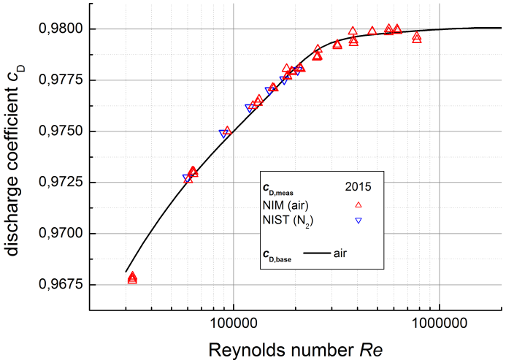
Figure 7: Data for nozzle NIST 2.5 mm.

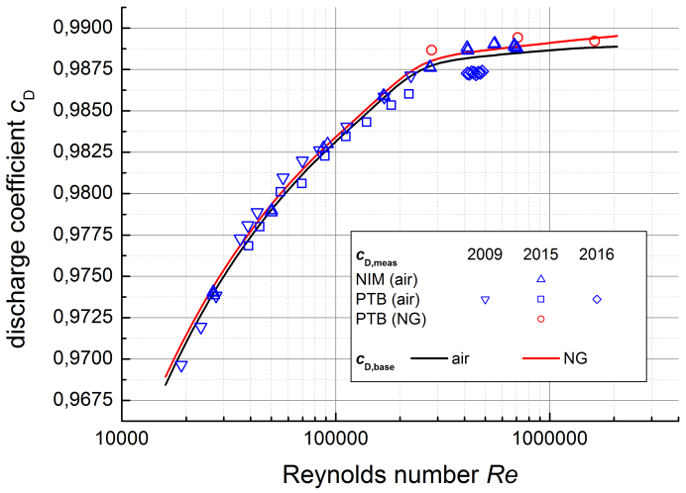
Figure 8: Data for nozzle HD-17b.

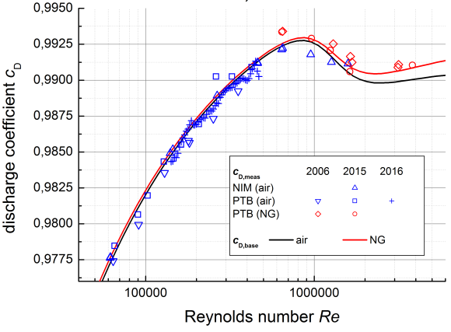
Figure 9: Data for nozzle HD-9b.

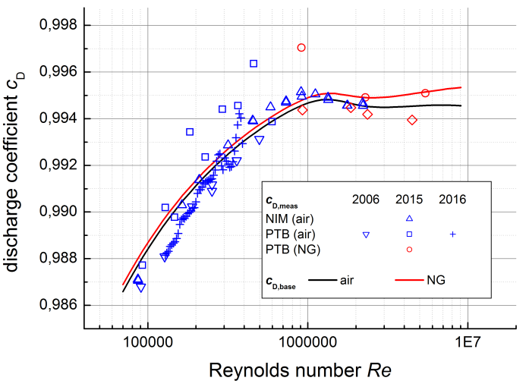
Figure 10: Data for nozzle HD-5b.

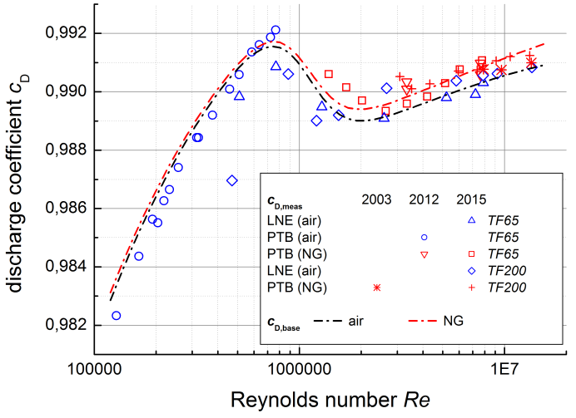
Figure 11: Data for nozzles TF65 and TF200. Please note that only one parameter triplet {a₀, b_{lam,0}, Re_{tr}} has been applied for both nozzles.

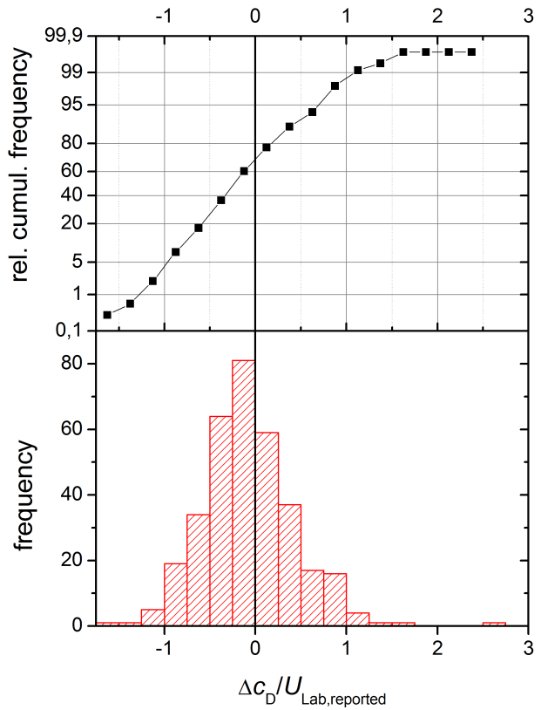
Figure 12: Histogram statistics on the data shown in Figure 6.

LNE-LADG is the Laboratoire National de Métrologie et d’Essai, Laboratoire Associé de Débitmétrie Gazeuse. CESAME EXADEBIT is designated institute of LNE-LADG.
Correlation among data can be included in application of LSF in principle [8] if we would have the prior information about the structure and level of correlations. But this approach needs the prior analysis of the uncertainty budgets in accordance to this.
This should not be confused with the influence of real gas characteristics which is taken into account by the critical flow factor C*, see e.g. [12].
The trend lines in Figure 4 are given only for orientation because we have not quantified the uncertainties of these average lines.
These values belong to the measurements with nozzle HD-5b at PTB in 2015. This is the only case where we have to assume instability of the nozzle itself because the values both of the independent measurement series with air and natural gas show these changes and higher scatter than usual. We could not detect the physical reason; during the repeated measurements in 2016 all values were consistent again.
This is in very good consistency with the precondition that the evaluation have been done at a level of 95% confidence for the uncertainties. Also the distribution of the data is similar to the expectation of a random process with a Gaussian distribution.

