Impact of swirl on flow measurement in stacks –

CFD modelling

J. Geršl¹, S. Knotek¹, Z. Belligoli², R. Dwight²,
R. Robinson³

¹Czech Metrology Institute, Okružní 31, 63800 Brno, Czech Republic
²TU Delft, Delft, The Netherlands
³National Physical Laboratory, Teddington, UK
E-mail: jgersl@cmi.cz

Abstract

In this paper we investigate a swirling flow in stacks which is generated by various shapes of supplying pipe. We determine errors of flow rate measurement when the method with S-type Pitot tubes measuring gas speed in a grid of points is used. This research is motivated by increasing legal requirements for uncertainty in emission monitoring.
The considered supplying pipes are – a straight pipe, pipe with single 90° elbow and pipe with double out-of-plane 90° elbow. The considered range of Reynolds numbers is 3.10⁵ to 3.10⁶. The flow in stacks is investigated by means of CFD modelling using the OpenFOAM software. We show that the error of flow rate oscillates with changing height of the sampling plane in the stack. This is caused by a velocity profile which is turned by the swirl. The span of the error oscillation can reach 3 % in the considered cases. Additional flow rate error caused by a neglected correction of the velocity indication of the S-type Pitot tube due to the presence of the swirl can reach 5 % in the considered cases.
This research is a part of a bigger project “Metrology to underpin future regulation of industrial emissions” (IMPRESS) within the frame of the European Metrology Research Programme (EMRP).

1. Introduction

Measurement of flow rate in stacks is important component for determining of amount of emissions released to the atmosphere. Current regulation documents (e.g. EU Industrial Emissions Directive) are introducing lower emission limit values bringing new requirements for accuracy of the emission measurement methods. One of the most common methods for flow rate measurement in stacks is using S-type Pitot tubes for determining gas speed in a grid of points inside a stack [1, 2, 3]. This method is sensitive to orientation of the meter with respect to the gas flow direction and therefore also to a swirl which appears in the stacks.
The aim of this paper is to investigate the flow in certain typical stack configurations, to determine the swirl characteristics for various shapes of the supplying pipe and various Reynolds numbers (flow rates) of the gas flow and to estimate the related errors in flow rate measurements using the above mentioned method. The stack geometries considered consist of a vertical pipe with T-junction of a supplying pipe. The supplying pipe is either straight or with 90° elbow or with double out-of-plane 90° elbow. The considered range of Reynolds numbers is 3.10⁵ to 3.10⁶ – typical for the stack flow.
The method used for this investigation is CFD modelling using OpenFOAM software validated by experimental data. The determination of errors of the flow rate measurement with Pitot tubes is based on

known experimental data on indication of S-type Pitot tubes exposed to air streams of various directions [4, 5, 6, 7].

2. Flow measurement in stacks

Various methods of flow measurement in stacks are described e.g. in [1]. Here we focus on one of them which is widely used - the method based on measurement of velocities in a predefined grid of points inside the stack with use of an S-type Pitot tube.

2.1 Flow measurement using velocities in a grid
This method uses a grid of points in a plane perpendicular to the stack axis where each point “covers” the same area. Exact point distribution and minimal number of points for a given stack diameter are prescribed in [2]. Typically the points are distributed along two lines in several circles with radius given by the same area requirement. A point distribution with two lines and three circles is shown in Figure 1.
We denote $v_{zα}$ the velocity component along the stack axis (z-axis) measured in the point $α$ with $α=1,…, N$ where $N$ is the total number of measurement points. The measured flow rate is then determined as

$$Q_{M}=\frac{A}{N}\sum_{α=1}^{N}{v_{zα}} (1)$$
where $A$ is the area of the stack cross section.

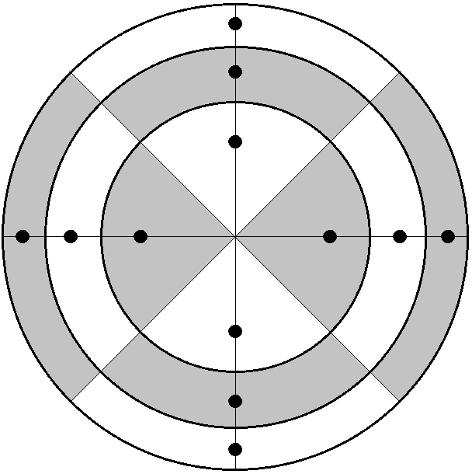

Figure 1: Flow rate measurement grid – all the grey and white fields have the same area. The points lie on circles which cut the fields into halves with the same area.

2.2 Angle dependence of the S-type Pitot tubes
Pressure difference on a Pitot tube depends on the mutual orientation of the air velocity vector and the Pitot tube which is defined by the yaw and pitch angles. The orientation of the S-type Pitot tube is given by its tangent vector $\vec{t}$ and measurement direction vector $\vec{z}$ as shown in the Figure 2.
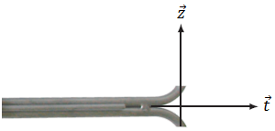

Figure 2: Vectors defining orientation of the S-type Pitot tube.

The pitch angle is then defined as the angle between the velocity vector and the vector $\vec{t}$ minus 90°. The yaw angle is defined as the angle between the vector $\vec{z}$ and projection of the velocity vector to the normal plane of $\vec{t}$. The yaw angle is positive when the velocity vector is pointing to the $\vec{z}×\vec{t}$ direction.
During a calibration in a wind tunnel the Pitot tube can be turned with respect to the main flow direction and a dependence of the calibration factor $C(β,γ)$ on the yaw angle $β$ and the pitch angle $γ$ can be determined from the equation

$$v_{ }=C\left(β,γ\right)\sqrt{\frac{2∆p\left(β,γ\right)}{ρ}} (2)$$

where $v$ is the reference velocity in the wind tunnel, $ρ$ is the air density in the wind tunnel and $∆p(β,γ)$ is the differential pressure on the Pitot tube turned by the angles $β$ and $γ$. The velocity component in the $\vec{z}$ direction is then given as

$${v_{z}=v.\cos{β.\cos{γ}}}_{ }$$
$$=C\left(β,γ\right).\cos{β.\cos{γ}}\sqrt{\frac{2∆p\left(β,γ\right)}{ρ}} (3)$$

If the S-type Pitot tube is installed in a stack and well aligned such that the $\vec{z}$ vector of the tube lies in the stack axis the calibration factor $C\left(β,γ\right).\cos{β.\cos{γ}}$ should be used to determine the $v_{zα}$ value in case of a swirling flow in the stack. If the swirl is neglected and the calibration factor $C\left(0,0\right)$ is used instead the resulting relative percentual error of the velocity measurement is given as

$$E= \left(\frac{C\left(0,0\right)}{C\left(β,γ\right).\cos{β.\cos{γ}}}-1\right).100 (4)$$

The yaw and pitch angle dependence of the S-type Pitot tubes has been investigated by several authors in the past [4, 5, 6, 7]. For the purpose of this paper we use data published in [4] in Figure 4-12 of this reference. We restrict the range of yaw angles to (-25°, 25°) and pitch angles to (-10°, 10°) and fit the experimental data for the error (4) by second order polynomial. The resulting formula is

$$E=\left(a_{1}γ^{2}+a_{2}γ+a_{3}\right)β^{2}+c_{1}γ^{2}+c_{2}γ (5)$$

where $E$ is the error in percents, $γ$ and $β$ are the pitch and yaw angles in degrees and $a_{1}=1.4×{10}^{-5}$, $a_{2}=4.5×{10}^{-4}$, $a_{3}=0.024$, $c_{1}=5.9×{10}^{-3}$ and $c_{2}=0.13$. The formula (5) is specific for the instrument reported in [4]. Different instrument can have significantly different error. E.g. one of the Pitot tubes reported in [5] has errors which are more than double.

In the following text we denote $Q_{Mz}$ the flow rate determined by the grid “integration” (1) where we suppose that the measured velocities $v_{zα}$ are exactly the z-components of the velocity, i.e. the error of the flow rate $Q_{Mz}$ comes only from the approximate integration and not from the inaccurate velocity measurement in particular points.
On the other hand we denote $Q_{Mi}$ the flow rate determined by the Equation (1) where we suppose that the measured velocities $v_{zα}$ have an error (4) due to the neglected yaw and pitch angles. In this case the error of $Q_{Mi}$ comes both from the approximate integration and from the velocity measurement error.
If we denote $Q$ the real flow rate in the stack we can define the relative percentual errors as

$$E_{z}=\frac{Q_{Mz}-Q}{Q}.100 (6)$$
$$E_{i}=\frac{Q_{Mi}-Q}{Q}.100 (7)$$

The aim of the rest of the paper is to determine the errors (6) and (7) for certain typical stack configurations by means of the CFD modelling.

3. CFD modelling of flow in stacks

The flow in stacks is modelled by the OpenFOAM software. The cluster of CMI is used for computations.

3.1 The studied cases
In our investigation we consider a stack with circular cross section of diameter 1.5 m and length of 18 m from bottom to the outlet. In the height of 1.5 m to 3 m from the bottom a supplying pipe is connected. The supplying pipe can have various shapes but its cross section is always circular with 1.5 m diameter – same as the stack. The connection is a 90° T-junction. Three shapes of the supplying pipe are considered each of them generating a different swirl pattern – the first is a straight pipe (Figure 3), the second is a pipe with a single 90° elbow (Figure 4) and the third is a pipe with double 90° out of plain elbow (Figure 5).

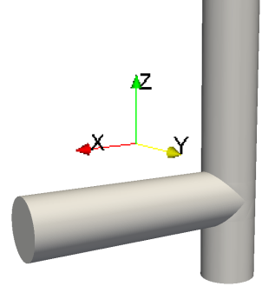 | 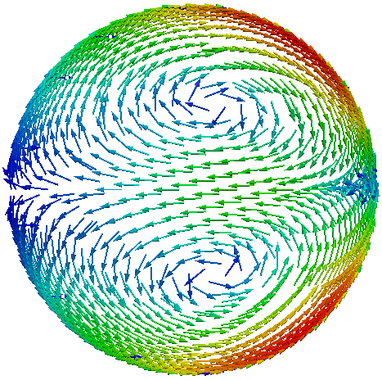

Figure 3: The straight supplying pipe. The length of the pipe is 5 m from the inlet to the stack wall. This pipe generates two counter-rotating swirls in the stack.

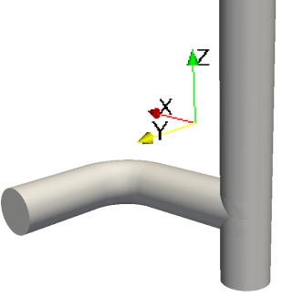 | 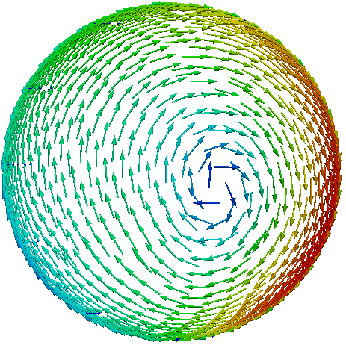

Figure 4: The supplying pipe with single 90° elbow. Radius of the elbow is 1.5 m. Length of the straight parts upstream and downstream of the elbow is 3 m. This pipe generates a single clockwise (view from the stack outlet) swirl in the stack.

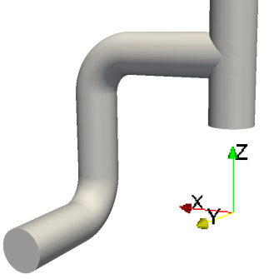 | 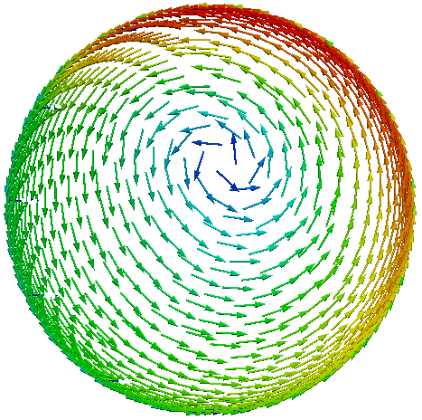

Figure 5: The supplying pipe with double 90° out of plain elbow. Radius of both of the elbows is 1.5 m. Length of the straight parts upstream, downstream and in between the elbows is 3 m. This pipe generates a single counter-clockwise (view from the stack outlet) swirl in the stack.
For each of the three shapes of the supplying pipe we study three cases with different inlet velocity value. The considered velocity fields at the inlet to the supplying pipe are homogeneous with magnitude of 3 m/s, 10 m/s and 30 m/s.
The considered gas flowing in the stack is air at a temperature of around 20 °C and kinematic viscosity of ν = 15 mm²s⁻¹. Thermal effects influencing the flow are not taken into account.

3.2 Validation of the CFD model
Several turbulence models were tested and compared with experimental data in order to find the model best matching the reality. The experimental data were obtained from the reference [8] where a flow of air inside a T-shape channel is measured by PIV. The channel has rectangular cross section with dimensions 20 cm x 40 cm and consists of two straight parts with length 3.3 m (supplying pipe) and 6.9 m (stack) connected in a 90° T-junction which starts 0.5 m above the stack bottom. The velocity of air at the inlet is 9.85 m/s. The corresponding Reynolds number is 175 000 which is slightly below the smallest Reynolds number of 300 000 considered in the above cases.
The geometry of [8] was created in OpenFOAM and four RANS type turbulence models were tested, namely kEpsilon, kOmega SST, v2f and LRR. The kEpsilon and LRR models were evaluated as giving the best match with the experimental data and the kEpsilon model was selected for further computations. However, there is a space for improvement and therefore it is planned to test also the LES turbulence models in future to achieve even better correspondence.

3.3 Model settings and mesh
The flow is computed as a stationary viscous turbulent flow without thermal effects using the simpleFoam solver of the OpenFOAM. As stated above the kEpsilon turbulence model is used.
Boundary conditions for velocity at inlet are described above, at walls the zero velocity is used and at outlet the zero normal gradient is prescribed. Pressure is fixed at the outlet and zero normal gradient is prescribed at inlet and at the wall. The values of the turbulence fields $k$ and $ε$ are fixed at the inlet and correspond to the turbulence intensity of 5 %. At the wall the wall-functions are applied and at the outlet the zero normal gradient condition is prescribed.
The computation mesh is a structured mesh created by the blockMesh tool of the OpenFOAM. Several mesh densities have been tested to achieve a mesh-converged solution. The parameters of the final meshes are summarised in the Table 1.

Table 1: Parameters of the meshes.
supplying pipe | number of cells | y+ for 10 m/s | cell size at the wall | cell size in the centre
straight | 16M | 20 | 0.6 mm | 1.8 cm
single elbow | 30M | 20 | 0.6 mm | 1.5 cm
double elbow | 37M | 20 | 0.6 mm | 1.5 cm

The final mesh in the pipe cross section for the single and double elbows is shown in the Figure 6. Detail of the T-junction with the structured mesh created in blockMesh is shown in the Figure 7.

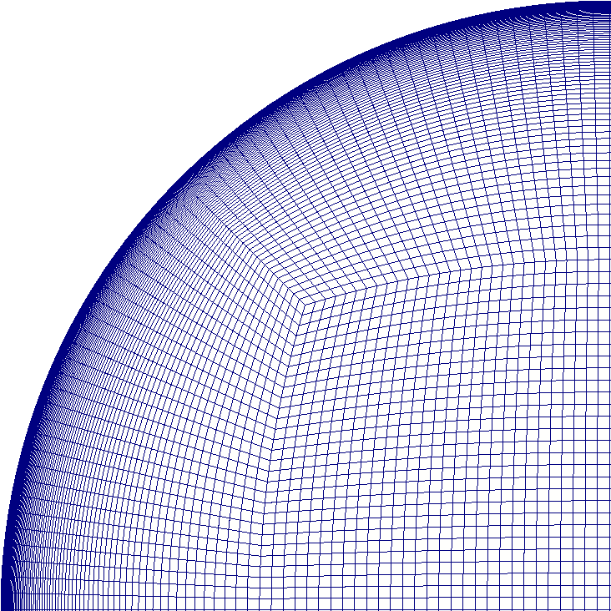

Figure 6: Mesh in the pipe cross section.

Figure 7: Mesh in the T-junction created in blockMesh.

The results for the single and double elbows presented below are taken from solutions with residua of velocity and turbulence fields converged to order of 10⁻⁶ and residua of pressure converged to order of 10⁻⁴. For the straight supplying pipe the residua are a little bit higher – 10⁻⁵ to 10⁻⁶ for velocity and turbulence fields and 10⁻³ for the pressure.

4. Results

The output of the CFD computation is a velocity field inside the stack. To calculate the measured flow rate $Q_{M}$ given by the Equation (1) we need to get the velocity components in the measurement grid. The minimal number of the measurement lines prescribed in [2] and in an older standard [3] is two. The minimal number of points in one line for the circular stack of the diameter 1.5 m is 4 according to [2] and 6 according to [3]. In the following analysis we use 6 points in one line and therefore the measurement grid looks exactly like in the Figure 1. The measurement lines are parallel with the x and y axes (see Figures 3-5) and we consider the measurement ports positions such that the vector $\vec{t}$ of the Pitot tube points in the negative sense of the x-axis (port above the T-junction) and the positive sense of the y-axis (port 90° clockwise from the T-junction when viewed from the stack outlet). Results for the height of the sampling plane in the range of (9 to 18) m above the stack bottom (or (6 to 15) m above the upper part of the T-junction) are investigated.
To calculate the measured flow rate $Q_{Mz}$ which is unbiased by the inaccurate measurement of velocity we need to get the axial velocity components $v_{zα}$ in the measurement grid. To calculate the measured flow rate $Q_{Mi}$ which is biased by the inaccurate measurement of velocity due to the neglected swirl we need to get also the yaw and pitch angles in the measurement grid.
Example of the computed yaw and pitch angles along the sampling lines 7 m above the upper point of the T-junction and inlet velocity of 3 m/s is shown in the Figure 8 (the origin of the x, y coordinates is in the stack axis).

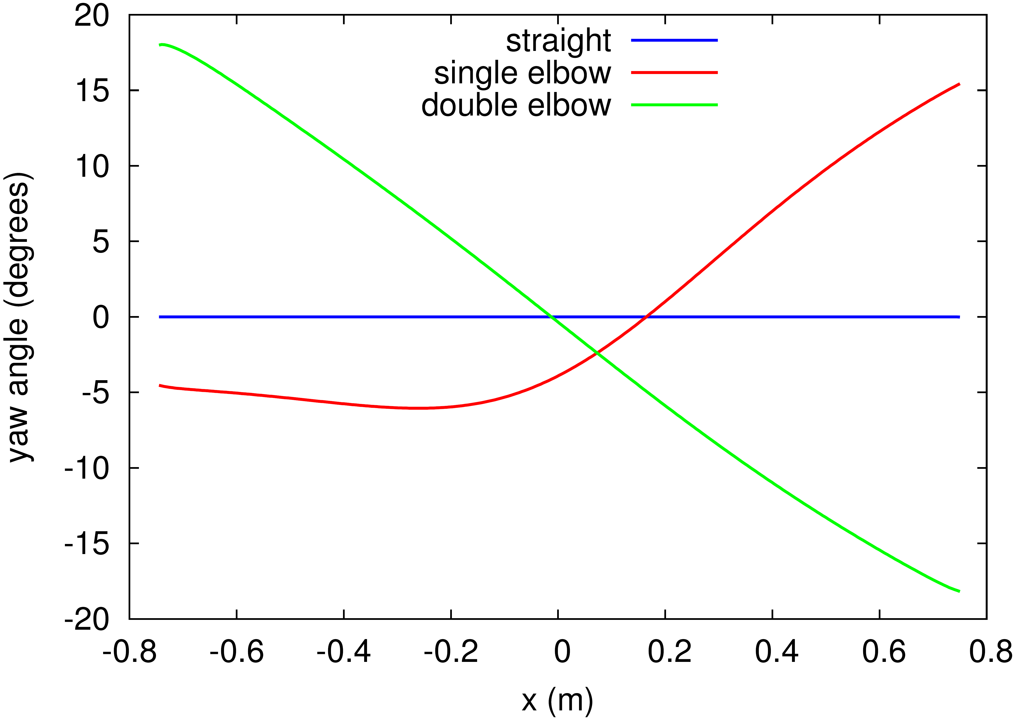
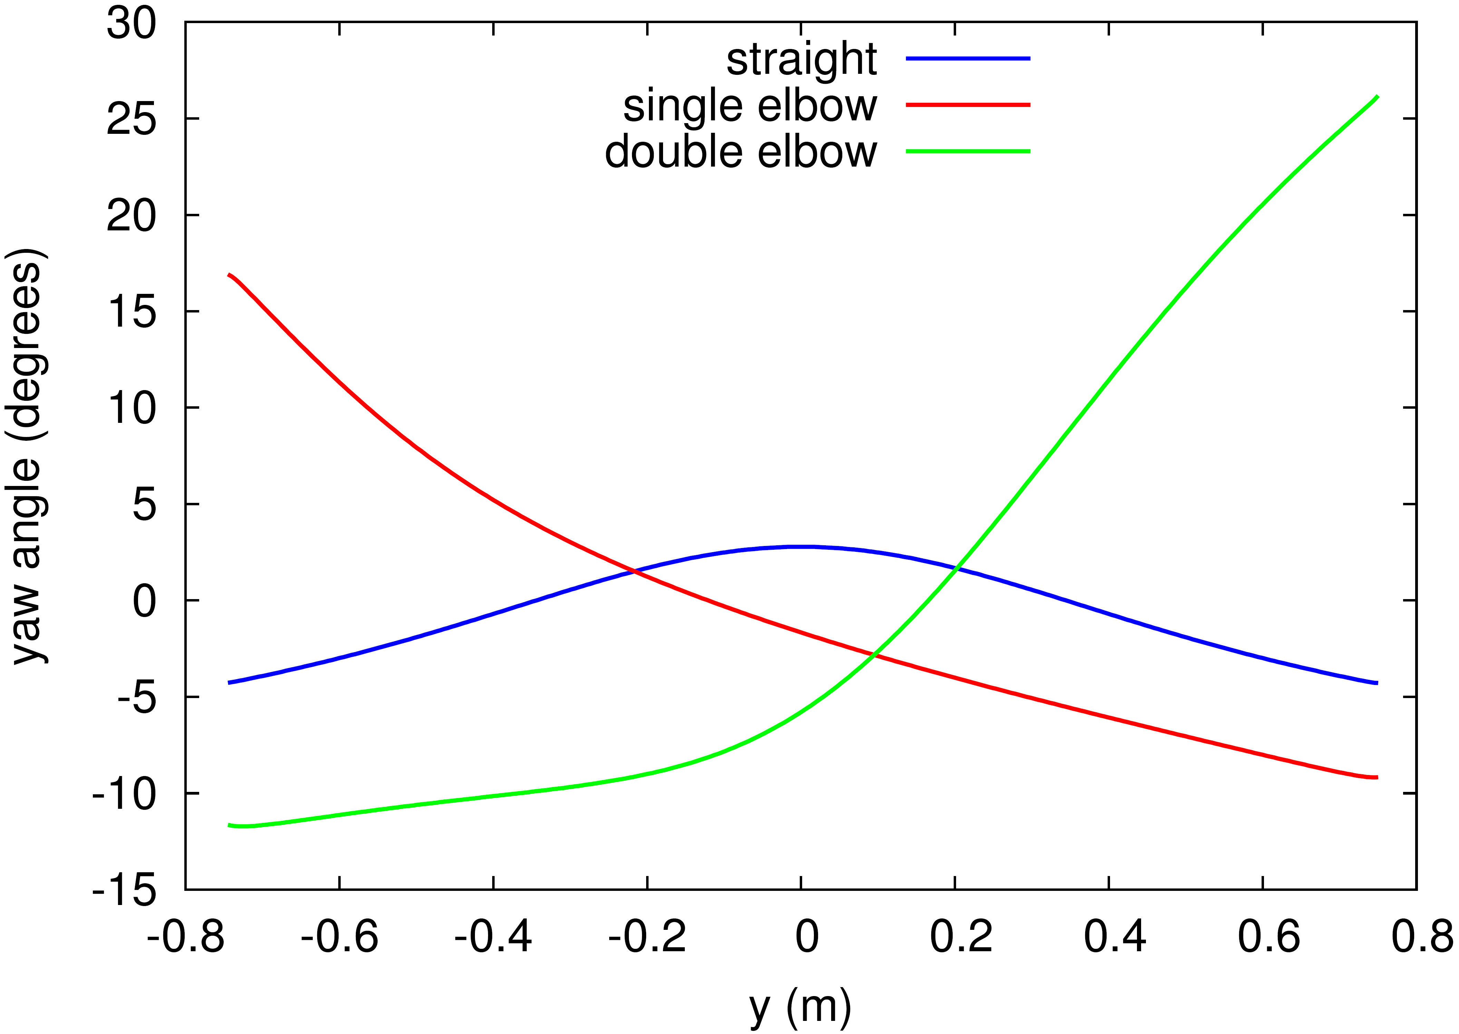
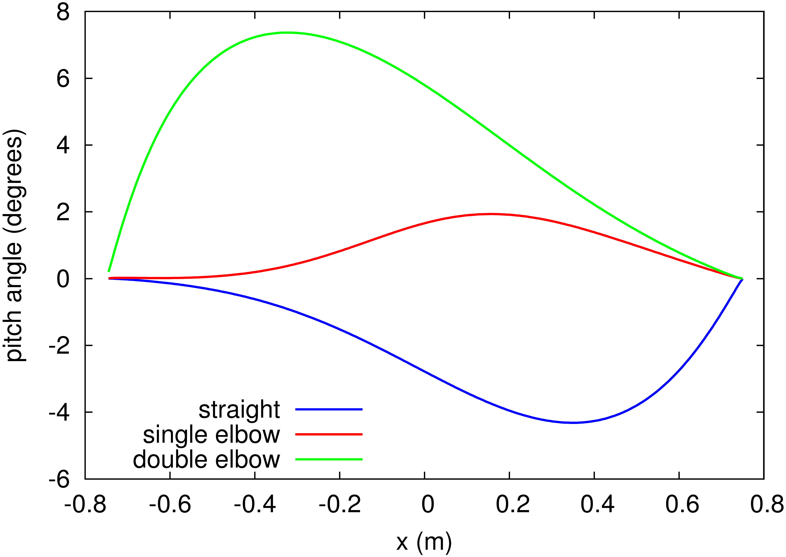
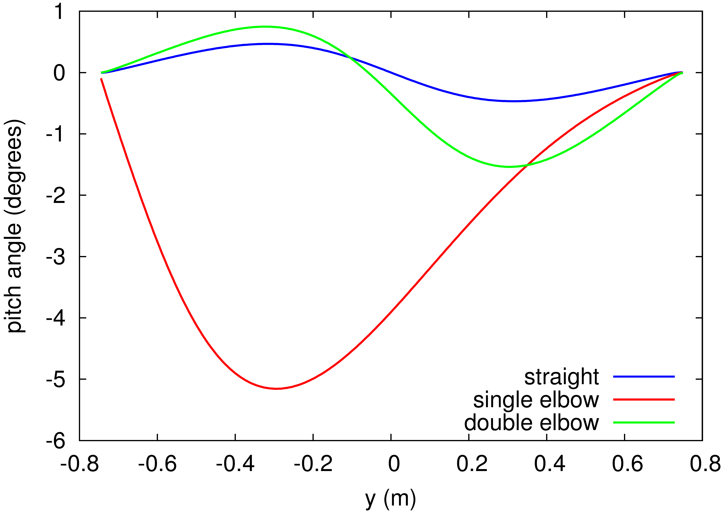

Figure 8: The yaw and pitch angles along the x and y sampling lines 7 m above the upper point of the T-junction for inlet velocity of 3 m/s.

With increasing inlet velocity the maximal yaw and pitch angles are decreasing in almost all cases and the trends remain unchanged.

2.1 The flow rate error E_{z}
In this section we show results for the error (6), i.e. the error of flow rate which is caused only by the fact that the measurement grid has a finite density and therefore it gives only an approximation of the exact flow rate formula which is given by an integral of $v_{z}$ over the stack cross section. The error of velocity measurement in the grid points do not enter the error $E_{z}$. The flow rate $Q_{Mz}$ entering the formula (6) is given by the formula (1) where $v_{zα}$ are directly the computed axial velocity components in the grid points. The real flow rate $Q$ is given simply as $Q=v.A$ where $v$ is the inlet velocity and $A$ is the area of the stack cross section.
The Figure 9 shows how this error depends on the height of the sampling plane in the stack for various shapes of the supplying pipe and various inlet velocities.
In case of the supplying pipes with single and double elbow which generate a single swirl in the stack we can observe a periodic behaviour. This behaviour is caused by a velocity profile in the stack which rotates together with the swirl. The velocity profile of $v_{z}$ in the stack cross section is not axially symmetric and therefore the error $E_{z}$ depends on the orientation of the sampling lines with respect to the velocity profile. Since the profile is turned with changing height by the swirl also the error changes with the height and repeats when the profile is

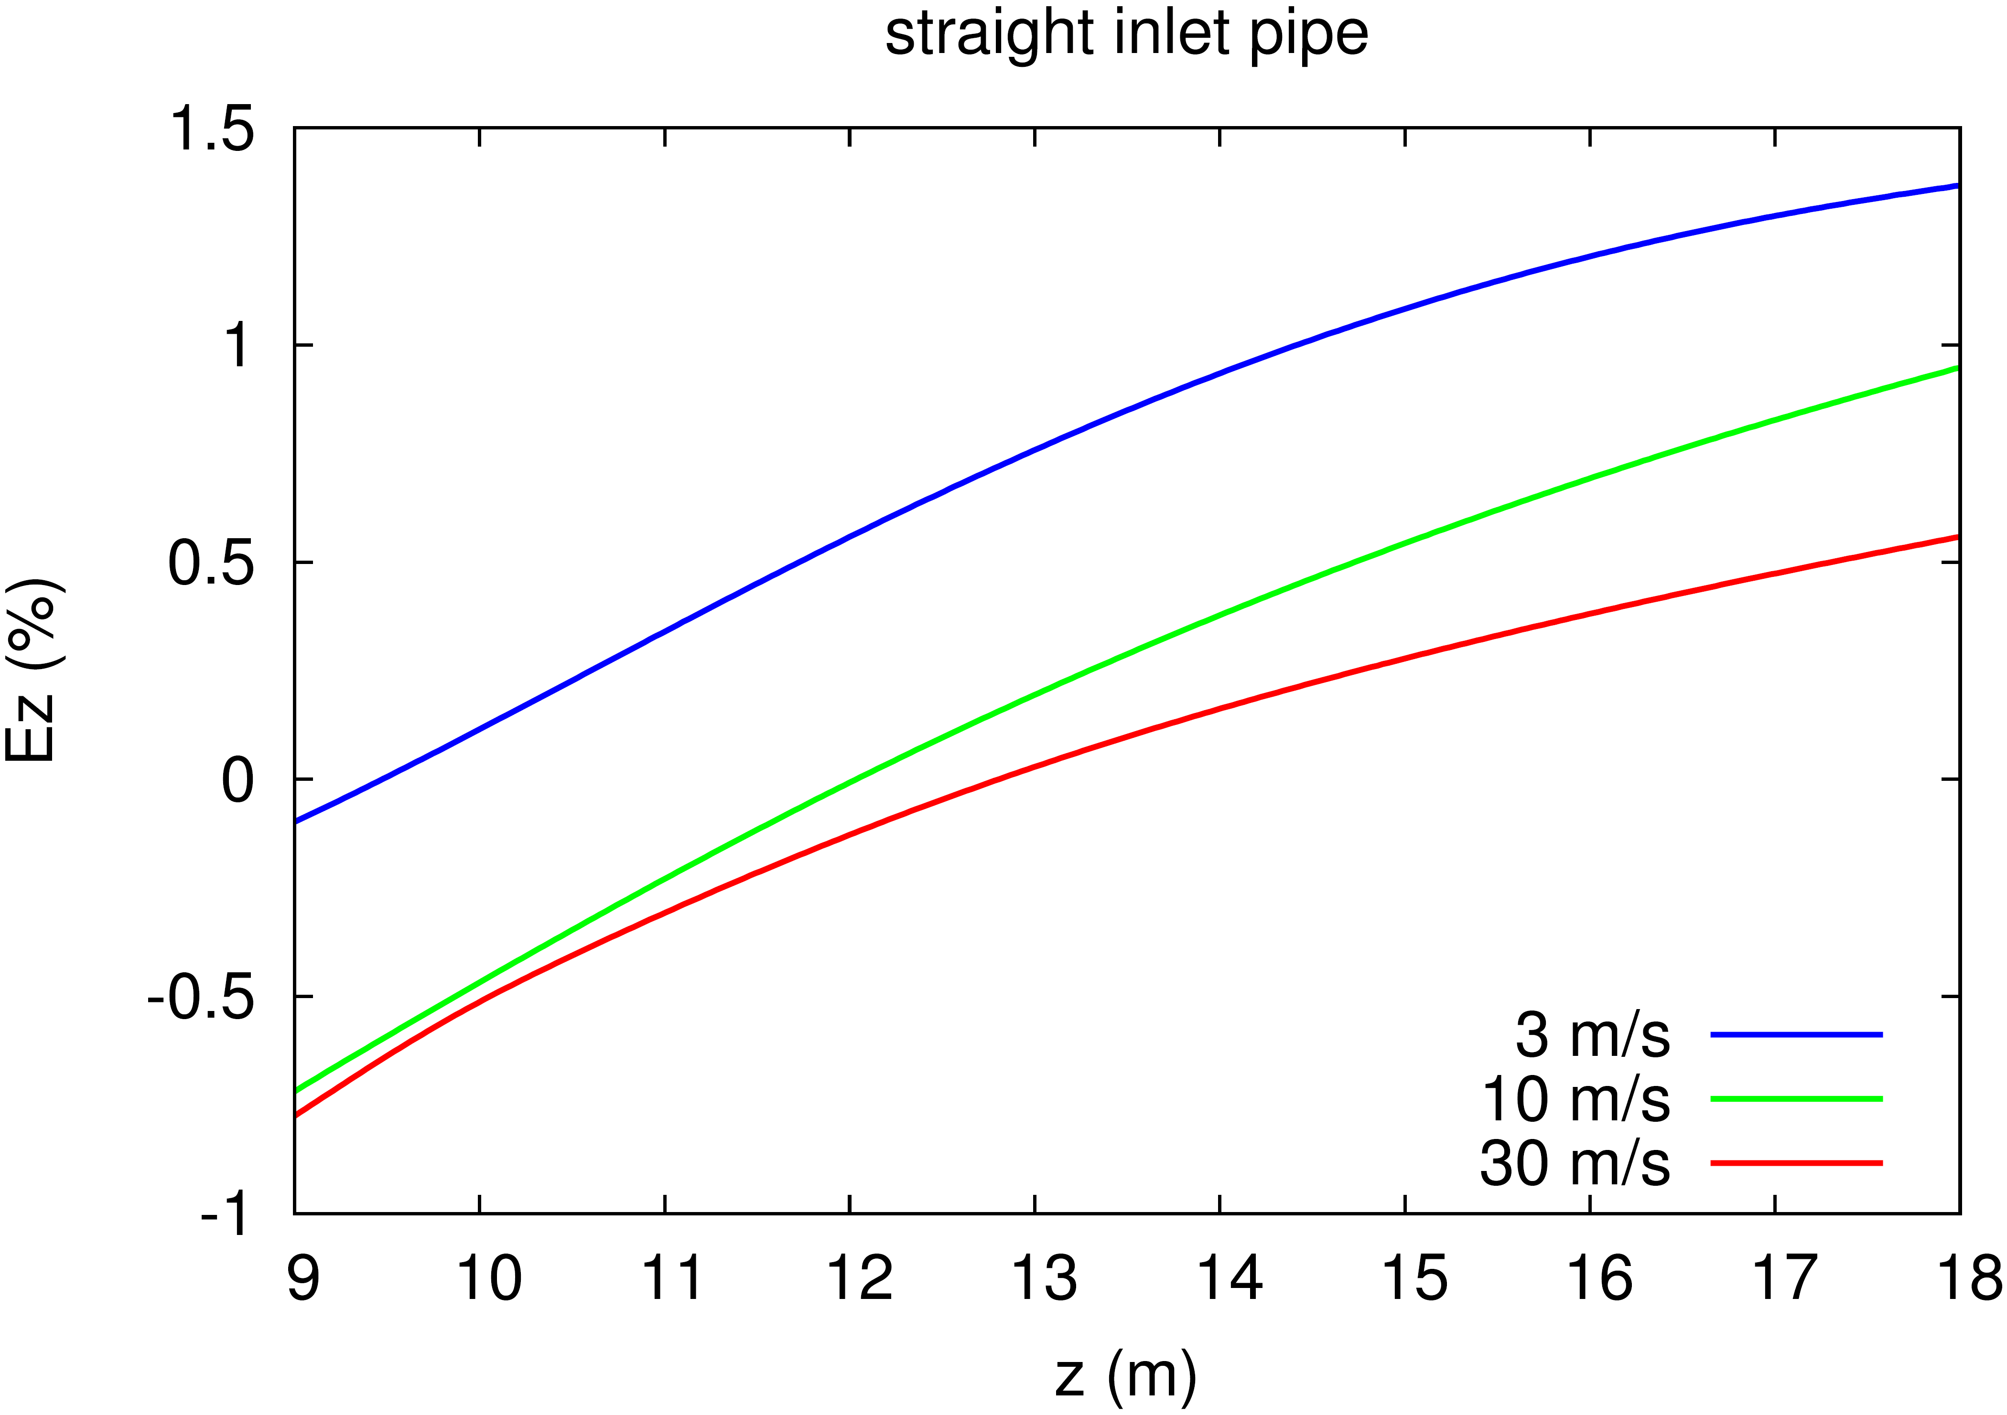
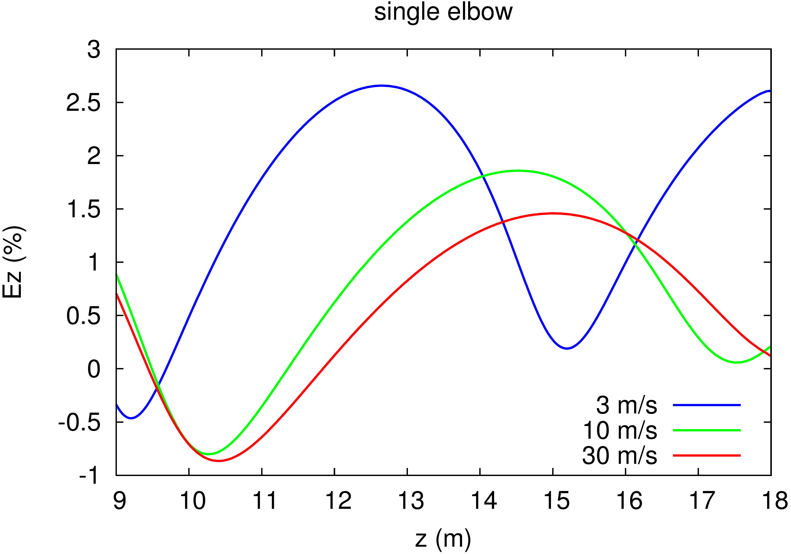
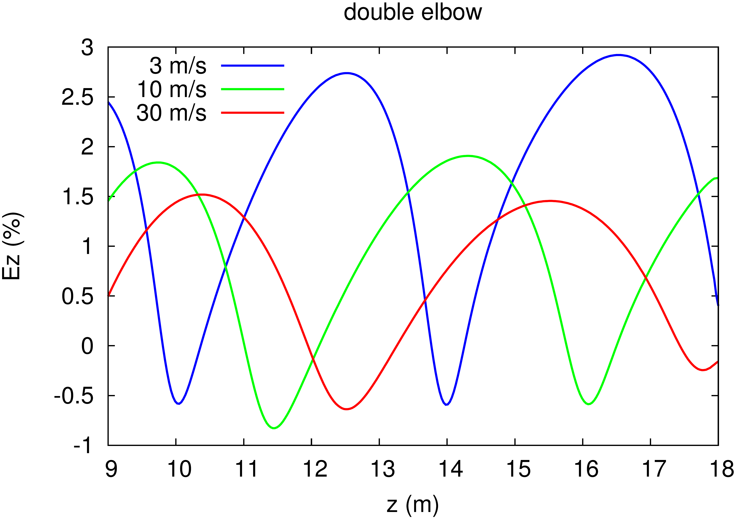

Figure 9: The error of flow rate due to the approximate integration in the measurement grid and its dependence on the height of the sampling plane in the stack.

turned by 90° since the sampling grid has the 90° rotation symmetry.
This explanation is supported by Figure 10 where we plot the axial velocity $v_{z}$ in the four outermost points of the grid and its dependence on the height in the stack for the double elbow and inlet velocity 3 m/s. We see that rotating the observation point by 90° counter-clockwise (view from the stack outlet) the curve is shifted by approx. 4 m higher. This corresponds to rotation of the velocity profile of 90° counter-clockwise per 4 m.
Similar behaviour was observed for a water flow behind a double elbow in [9].

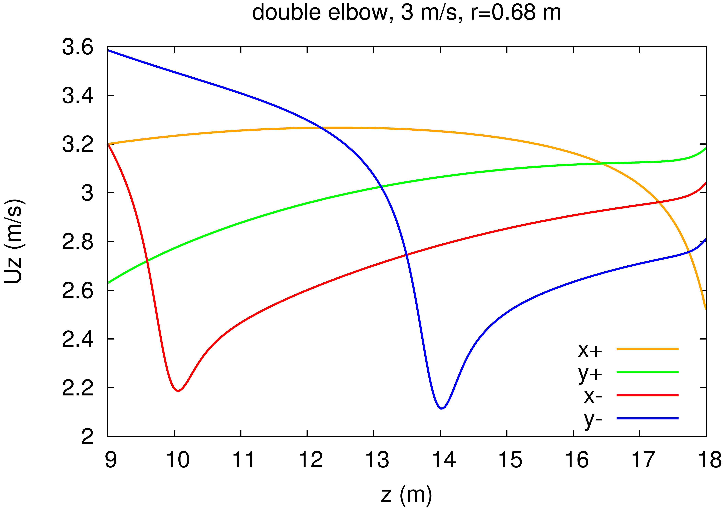

Figure 10: The axial velocity component in the four points of the measuring grid with the largest radius and its dependence on the height in the stack for double elbow and inlet velocity 3 m/s.

2.2 The flow rate error E_{i}
Next we calculate the error (7), i.e. the error caused by both approximate integration and biased velocity measurement in the grid points due to the neglected swirl. In this case the flow rate $Q_{Mi}$ is calculated according to the formula (1) where the velocities $v_{zα}$ are the computed axial velocity components modified by the error (5) which is determined from the yaw and pitch angles in the grid points, i.e. the velocities $v_{zα}$ are the velocity values which would be measured by the S-type Pitot tube neglecting the swirl.
The Figure 11 shows the difference $E_{i}-E_{z}$ and its dependence on the height in the stack for the investigated geometries and velocities.

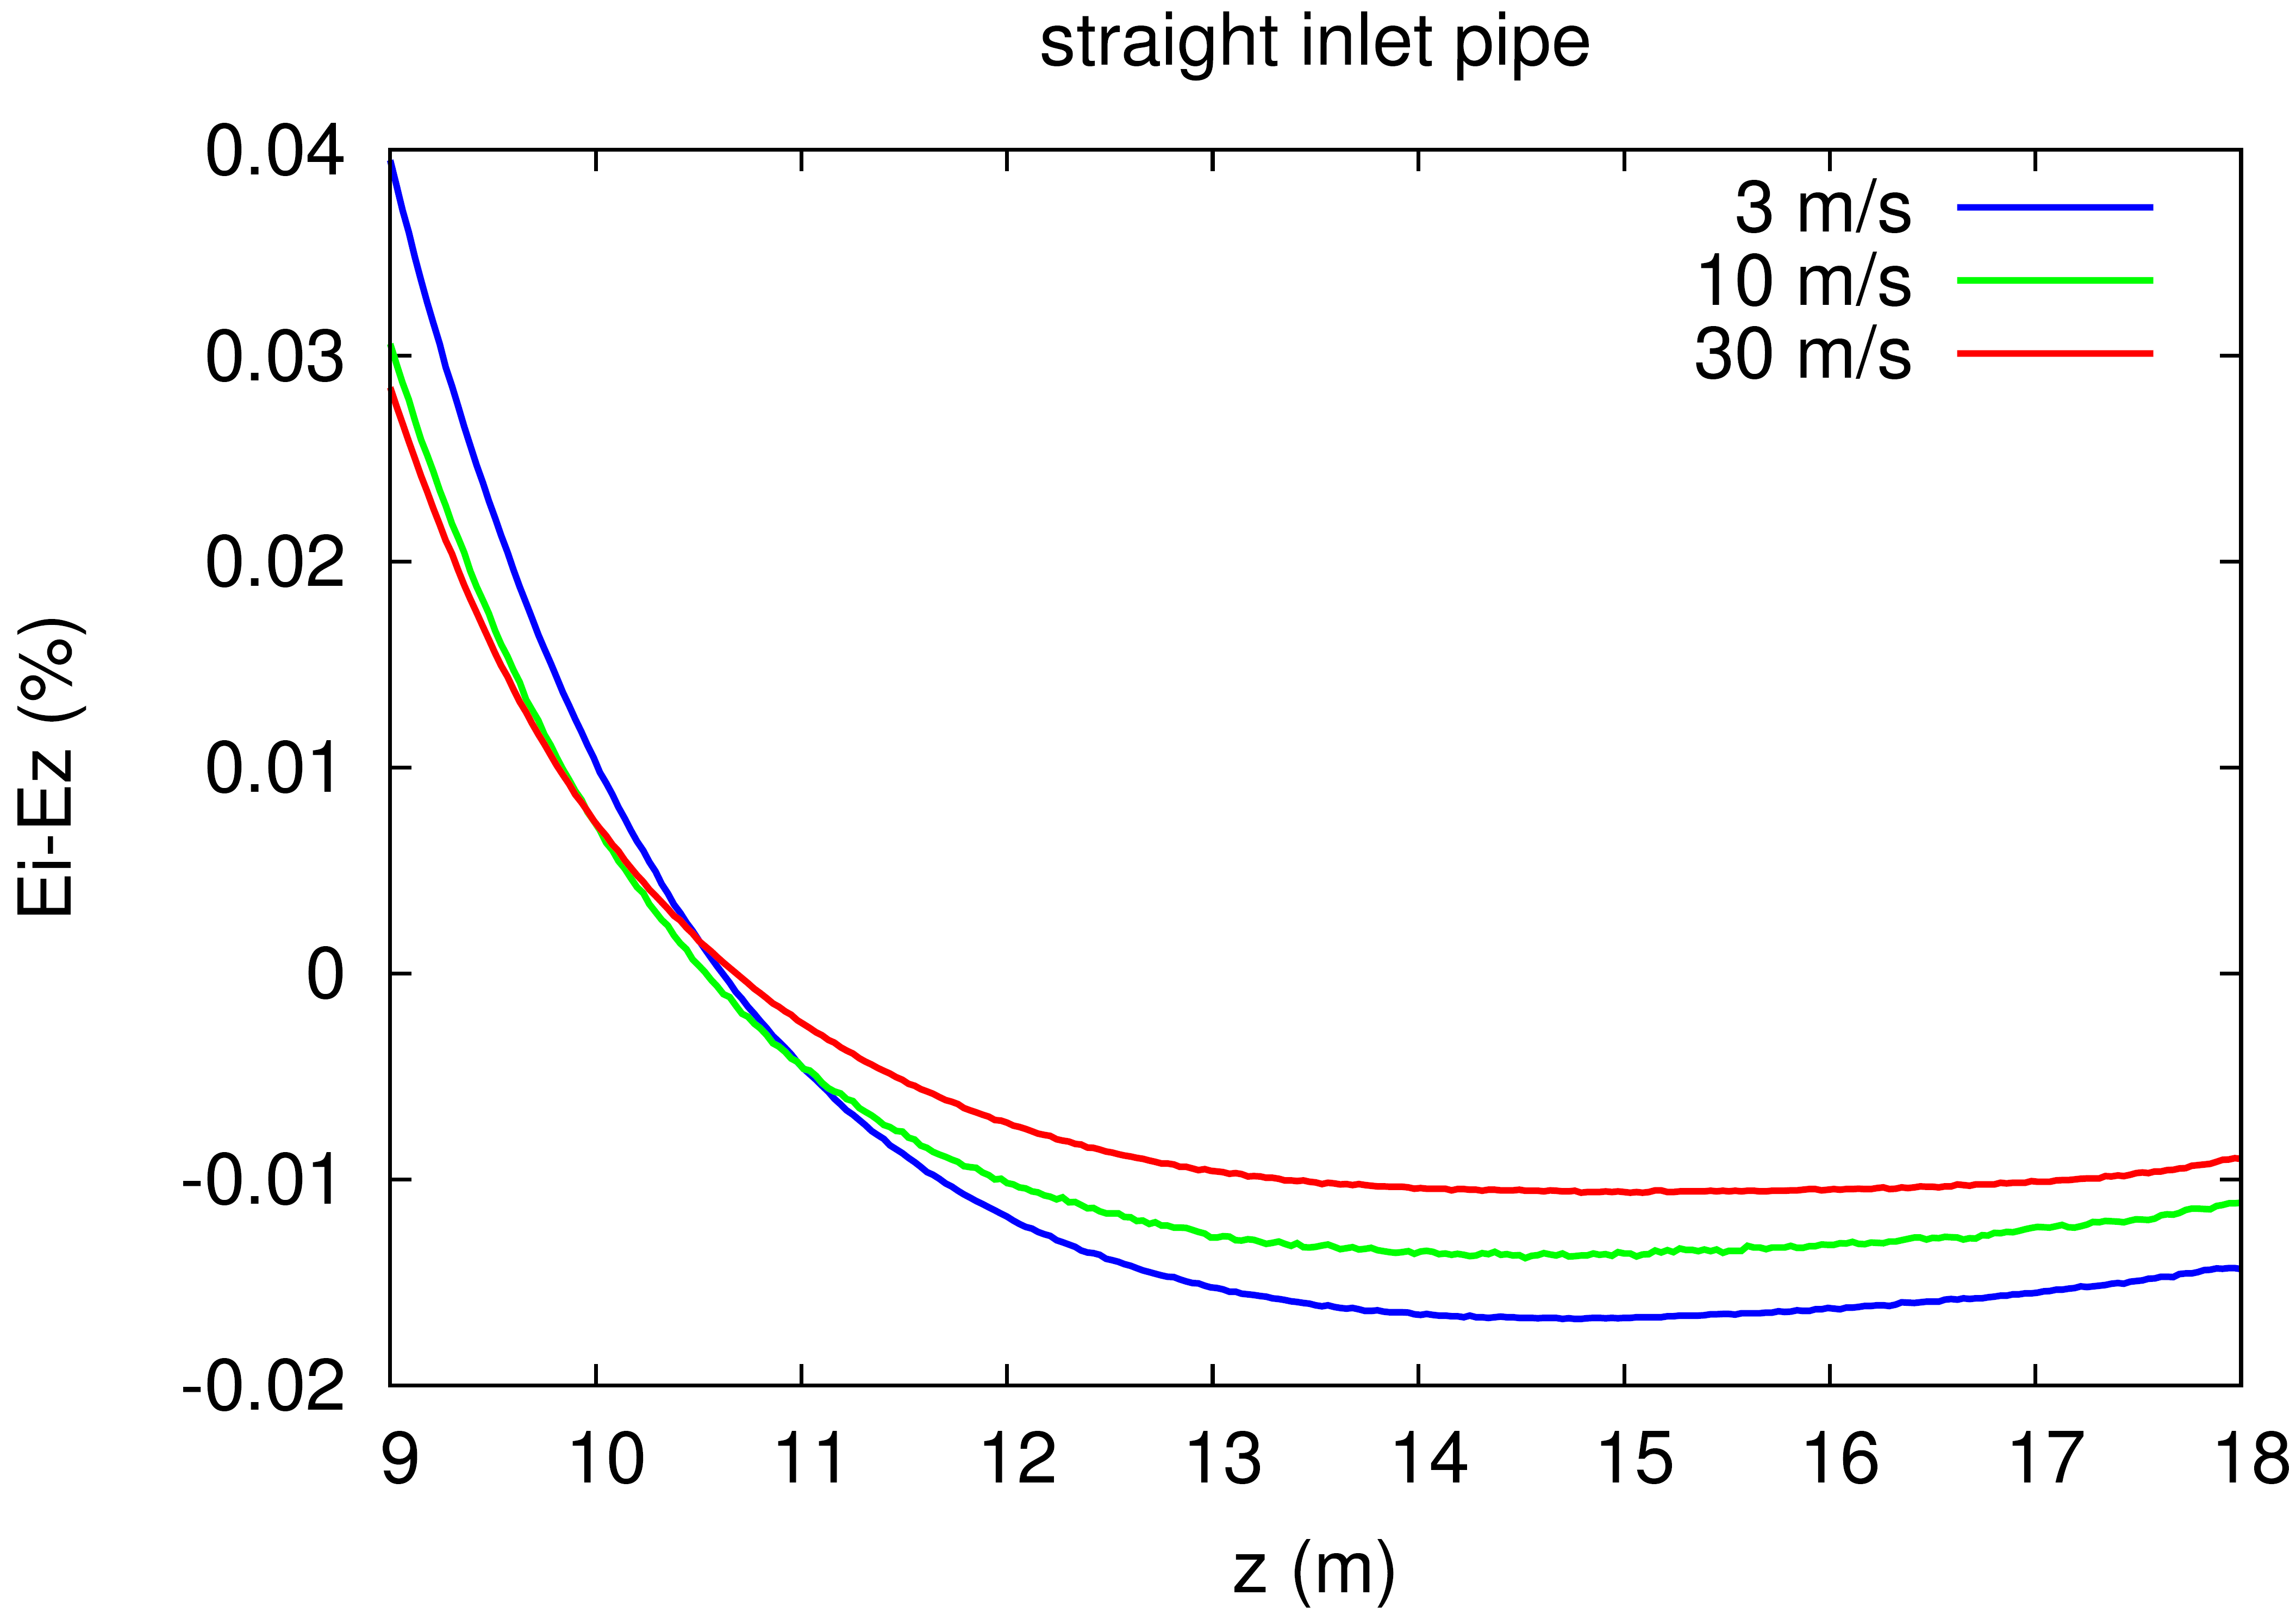
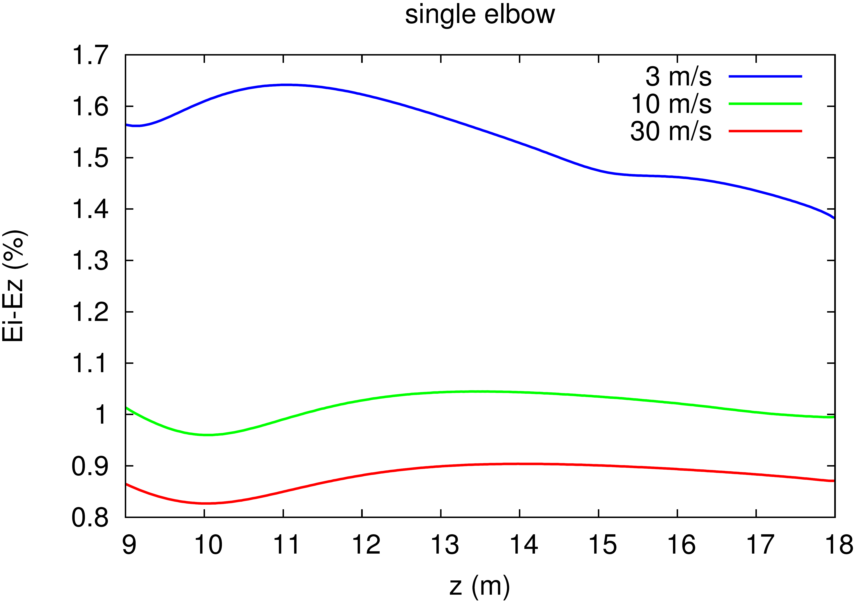
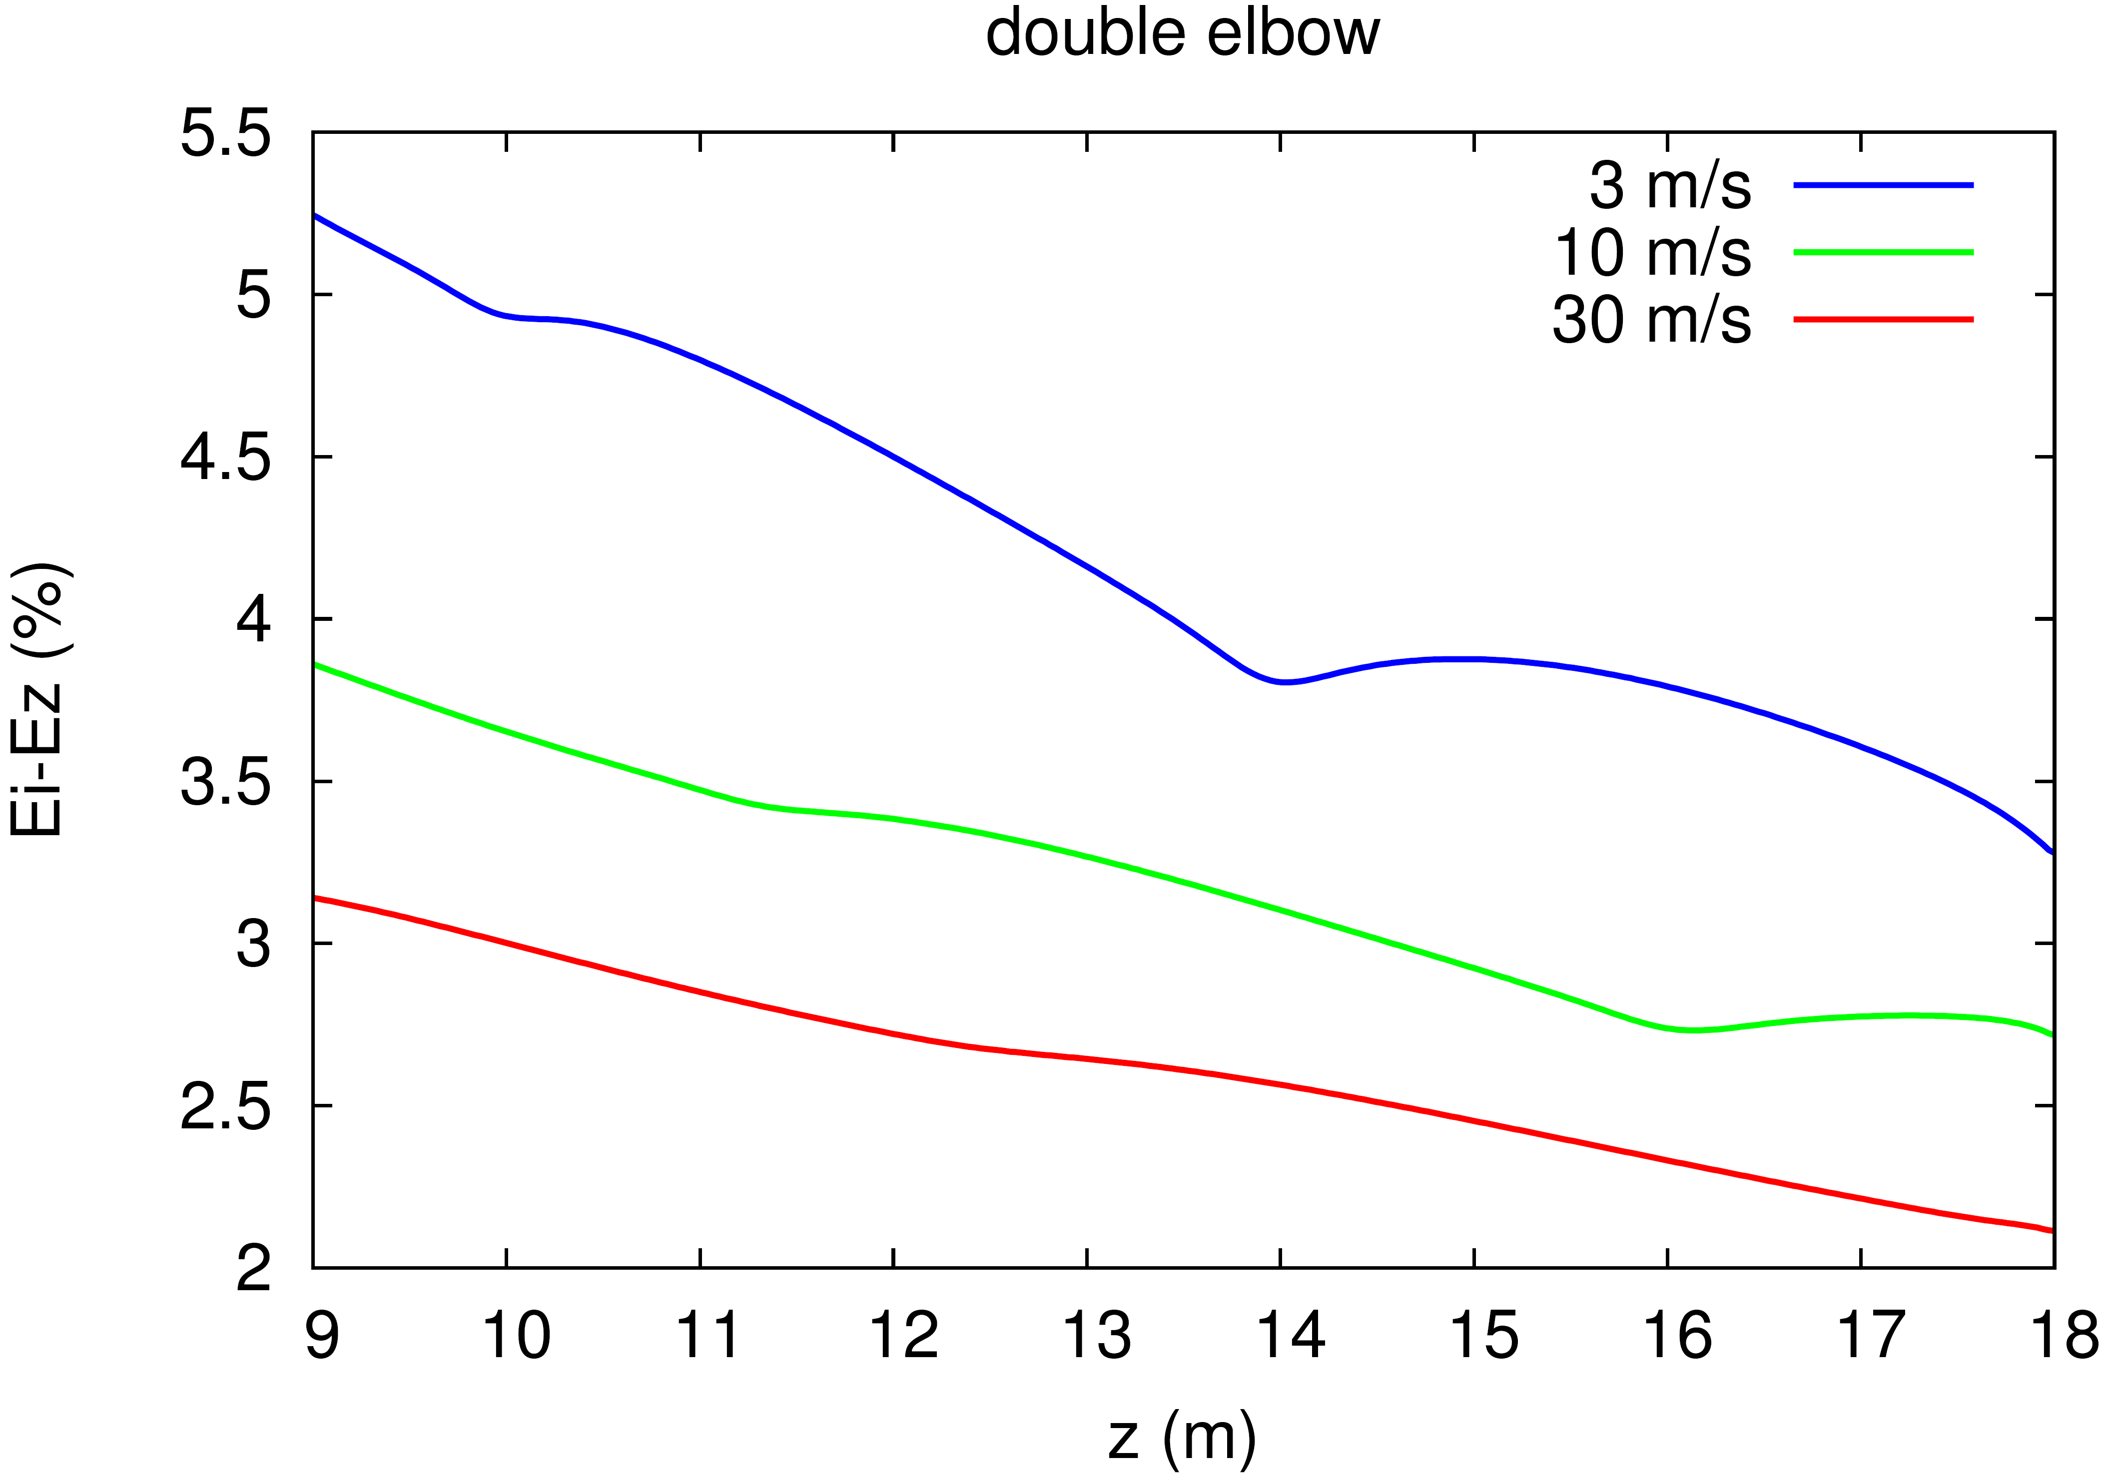

Figure 11: The additional error of flow rate given by error of the velocity measurement due to neglecting the swirl in the stack and its dependence on the height of the sampling plane in the stack.

5. Conclusion

It was found out that in the cases of stacks with supplying pipe containing elbow(s) where the single swirl is generated, the error of flow rate metering due to the finite density of the grid points is oscillating with the height of the sampling plane in the stack. This is caused by a velocity profile in the stack which is turning together with the swirl. The difference of the minimal and maximal error in the oscillation can reach 3 % in the studied cases. It means that special attention should be paid to the height and orientation of the sampling ports in stacks in order to achieve the minimal error.
It was observed that the amplitude of the error oscillation decreases with increasing flow rate and that the length of one period increases with increasing flow rate corresponding to the fact that the swirl velocity grows slower than the axial velocity.
The additional error caused by neglecting the shift of the Pitot tube due to the swirling flow is highest for the double elbow supplying pipe and it can reach values around 5 % in the studied cases. This error is decreasing with growing flow rate in all the studied cases.

Acknowledgement
The research has received funding from the European
Metrology Research Programme (EMRP). The EMRP is jointly funded by the EMRP participating countries within Euramet and the European Union.

References

[1] ISO 16911-1: Stationary source emissions -- Manual and automatic determination of velocity and volume flow rate in ducts -- Part 1: Manual reference method, 2013.

[2] EN 15259: Air quality -- Measurement of stationary source emissions -- Requirements for measurement sections and sites and for the measurement objective, plan and report, 2007.

[3] ISO 10780: Stationary source emissions -- Measurement of velocity and volume flowrate of gas streams in ducts, 1994.
[4] Muzio M J, Martz T D, McRanie R D, Norfleet S K, Flue Gas Flow Rate Measurement Errors (EPRI TR-106698s), 1996.
[5] Williams J C, DeJarnette F R, A Study on the Accuracy of Type-S Pitot Tubes (EPA-600/4-77-030), 1977.
[6] Shinder I I, Khromchenko V B, Moldover M R, “NIST’s New 3D Airspeed Calibration Rig Addresses Turbulent Flow Measurement Challenges”, in Proceedings of ISFFM, 2015.
[7] Kang W et al., “Experimental and numerical investigations of the factors affecting the S-type Pitot tube coefficients”, Flow Meas Instrum, 44, pp 11-18, 2015.
[8] Szmyd J et al., “Experimental and numerical analysis of the air flow in T-shape channel flow”, Arch. Min. Sci., 58, pp 333–348, 2013.
[9] Weissenbrunner A et al., “Simulation-based determination of systematic errors of flow meters due to uncertain inflow conditions”, Flow Meas Instrum, 2016, doi:10.1016/j.flowmeasinst.2016.07.011

