Development Process and Third Party Test Results of a Coriolis Mass Flow Meter with Superior Density Performance

A. Rieder¹, H. Zhu¹, M. Wiesmann¹

¹Endress+Hauser Flowtec AG, Am Lohmühlbach 12, 85356 Freising, Germany
alfred.rieder@flowtec.endress.com

Abstract

Coriolis metering in general is in favour over older mechanical based technologies such as orifice, positive displacement and turbine metering. Additionally to mass flow this multi-variable process sensors also determine density, temperature and some even viscosity. A new type of Coriolis mass flow meter is presented which combines the tremendous technological progresses of the recent years. Among other highlights like new lows for both zero point and the pressure drop which equates to highest usable flow range and drastic improvements in measurement performance on applications where entrained gas is present the focus of this paper is on fluid density measurement. The exceptional density measurement performance under real world process conditions is ideally suited to serve the highly demanding application of volumetric custody transfer in the Oil & Gas Industry and also high end concentration measurement in Food & Beverage Industry. It will be explained how all aspects of the meter design have been optimized to ensure robust density performance in the field. These include tube shape, excellent temperature measurement, as well as the most advanced compensation techniques for the effects of temperature, pressure, flow and viscosity. During design process FEM and CFD simulation have been heavily used. This results in a superior out of the box density measurement performance. The meter has been tested internally across fluid temperature, ambient temperature and pressure as well as various installation conditions. Finally the meter was third party tested at 25°C with tubes hanging downwards and verified to be within the stated ±0.2 kg/m³ specification on a broad range of densities and viscosities.

1. Introduction

Coriolis metering in general is in favour over older mechanical based technologies such as orifice, positive displacement and turbine metering. Additionally to mass flow this multi-variable process sensors also determine density, temperature and some even viscosity. Precise density measurement performance under real world process conditions is the basis for the highly demanding applications of volumetric custody transfer and meter proving in the Oil & Gas Industry as well as high end concentration measurement in Food & Beverage Industry. This because volume flow is equal to mass flow divided by density and concentration is a function of density. After a brief introduction in to meter properties and working principle a detailed overview of sensitivities and accuracies is given. It will be explained how all aspects of the meter design have been optimized to ensure robust density performance in the field.

2. Flow meter

In Figure 1 the design of Endress+Hauser Proline 300 Promass Q is shown. The light weight, compact and drainable Coriolis mass flow meter is offered with all industry standard process connections in four different line sizes from 1” to 4”. Process temperature and pressure ranges are -196…205°C and 0…100 bar respectively. Transmitters with a variety of standard outputs and communication protocols are available.

The internal structure is depicted in Figure 2. Two parallel and bent measuring tubes are connected via flow splitters to the process line. Coupling elements at the inlet and outlet of the meter define the oscillation length of the working mode. Equivalent to a tuning fork, both tubes vibrate in opposite directions so the system is balanced and energy is conserved in the oscillator, shown in Figure 3. Via an electrodynamic driver at the tube center and two electrodynamic sensors at the tube inlet and outlet the transmitter control algorithm generates a harmonic tube vibration at resonance frequency and constant amplitude, thereby compensating tube damping.

The working principle of Coriolis mass flow meters has been described in many publications, e.g. [1]. Tube resonance frequency $f_{r}$ depends on tube stiffness, tube mass and fluid mass load. Fluid density reading $ρ$ is derived from measured raw resonance frequency $f_{r}$ by

$f=f_{r}(p,v,γ)$ (1)

$ρ_{r}=C_{0}(T_{m})+C_{1}\left(T_{m}, T_{h}\right) f^{-2}$ (2)

$ρ=ρ_{r}(η,c)$ (3)

where $f$, $p$, $v$ and $γ$ are compensated frequency, process pressure, flow velocity and orientation angle. $ρ_{r}$, $T_{m}$, $T_{h}$, $C_{0}$ and $C_{1}$ are raw density, mean measuring tube temperature, housing temperature and two calibration constants. And $η$ respectively $c$ is fluid viscosity and fluid speed of sound.

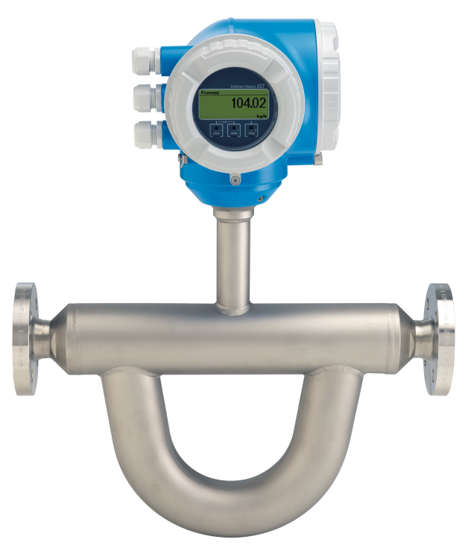
Figure 1: Design of Endress+Hauser Proline 300 Promass Q.

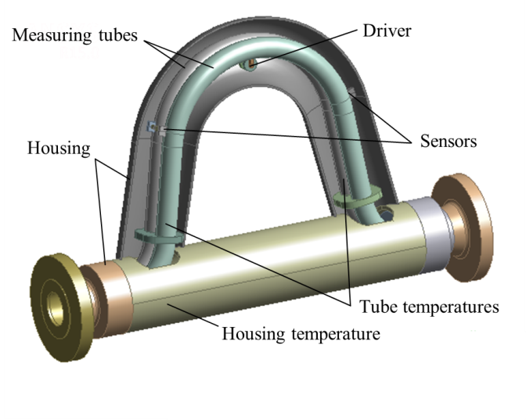
Figure 2: Internal construction of Promass Q.
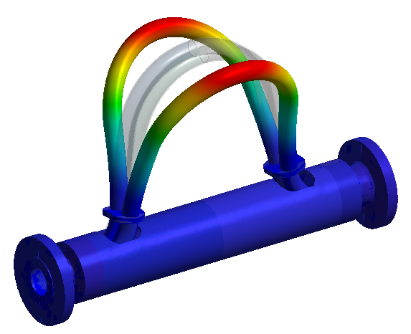
Figure 3: Magnified displacement of balanced working mode calculated by FEM analysis.

3. Sensitivities and accuracies

During the development process FEM and CFD analysis in symbiosis with experimental approach has been used to optimize sensor design and compensation algorithms. Sensitivities to process variables, fluid properties as well as environmental and installation effects have been minimized to increase density accuracy.

3.1 Process influences

3.1.1 Fluid temperature
Due to the direct contact, tube temperature $T_{m}$ in principle follows fluid temperature. Accurate tube temperature measurement is the dominant factor for good density measurement because this temperature is used to compensate the dependency of Young's Modulus respectively stiffness on temperature for measuring tubes. PT1000s sensors are used to minimize drifts caused by connecting cables. In the meter design phase CFD modelling has been used to study convection effects and finally determine the best possible location and fixation technique for two RTDs, shown in Figure 2. The introduction of both inlet and outlet tube temperature sensors gives a mean tube temperature if the temperature distribution along measuring tube is inhomogeneous due to certain reasons, e.g. a very low flow speed or environmental temperature gradients. In addition, it provides a redundancy measurement and greater reliability. Figure 4 shows measured density deviation which is within ±0.2 kg/m³ from 20°C up to 150°C. And Figure 5 gives specified respectively maximum expected absolute density deviation across process temperature.

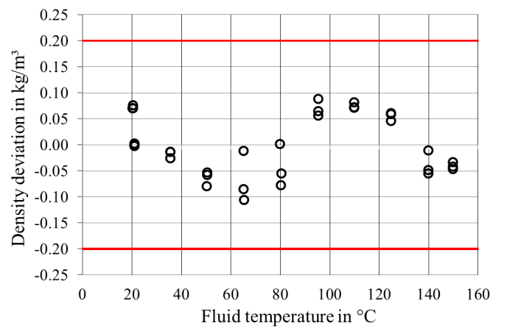
Figure 4: Measured density deviation across varying water temperature within ±0.2 kg/m³ at constant ambient temperature 25°C.
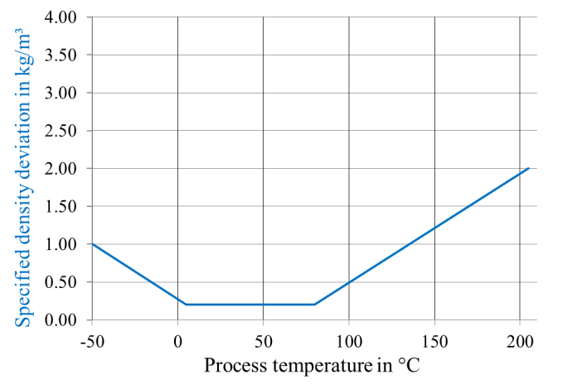
Figure 5: Specified density deviation across varying process temperature.

3.1.2 Process pressure
Tube shape and the location and size of special braces that are located on the measuring tube was carefully optimized by FEM simulation and thoroughly tested to have as low sensitivity to pressure $p$ as possible. The small residual effect that is left behind has been found to be very repeatable also another critical aspect. It’s obviously ideal to reduce pressure effect to as low as possible but the effect that is left behind can easily be compensated for if it is repeatable and linear, as shown in Figure 6. This innovation was achieved through the use of hydro formed tubes. This process guarantees roundness of tubes and a very repeatable process in manufacturing. For on-line compensation pressure can be manually given by the operator or read in from an external pressure sensor. Figure 6 shows specified pressure sensitivity of typically -0.015 kg/m³/bar and density deviation after compensation by external pressure input. From 0 up to 100 bar measured density deviation is linear and within ±0.2 kg/m³.
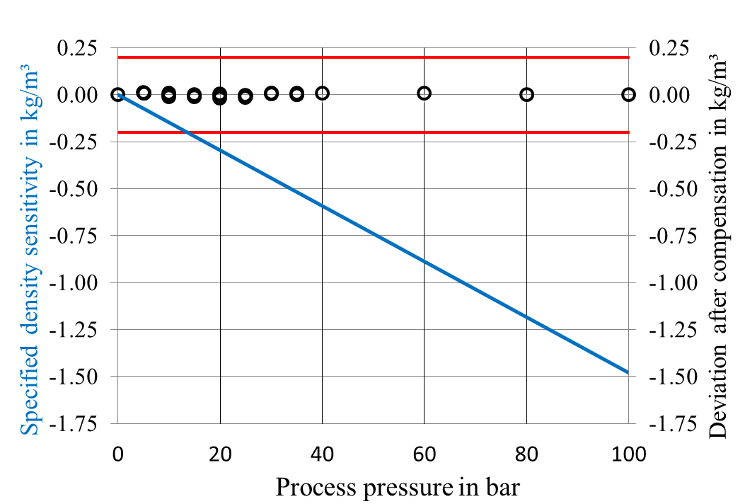
Figure 6: Specified density deviation and density deviation after compensation across varying process pressure with water at room temperature.

3.1.3 Flow velocity
To reach this high level of density accuracy at least a minimum flow velocity $v$ is recommended to guarantee a homogeneous sample in the measuring tube. At high mass flow rates another effect of flow velocity $v$ has to be taken into account. At bent tube sections flowing material generates centrifugal forces, stiffening the tube and increasing tube frequency. As flow velocity $v$ can be derived from measured mass flow internal compensation is possible.

3.2 Fluid properties

3.2.1 Fluid density
To preserve linearity across density $ρ$ of a homogeneous measuring tube attachments have to be placed carefully. Test results in Figure 7 obtained at UKAS-accredited laboratory of H&D Fitzgerald Ltd. verify, that this design step was successfully supported by FEM analysis [2]. For 11 different fluids at 25°C, starting from air at 1.38 kg/m³ across different hydro carbons, ethanol in water, water, dextrose in water, dimethyl-phthalate up to tetrachloroethylene at 1612 kg/m³ density deviation stays within ±0.2 kg/m³. Several meters of all line sizes have been tested giving similar results as well. More details concerning uncertainties of measurement with the calibrants can be found in the certificates.

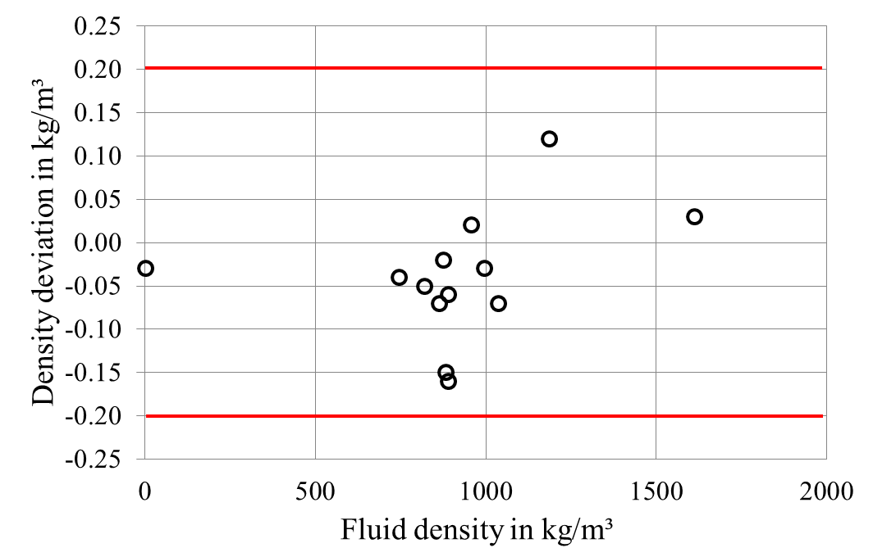
Figure 7: Measured density deviation across varying fluid density at 25°C in accordance with H&D Fitzgerald Ltd. certificate number 15215 & nn15217R stays within ±0.2 kg/m³ [2].

3.2.2 Fluid viscosity
Measurement of accurate density for viscous fluids is a challenge as viscous fluids transfer shear forces, so more fluid material is accelerated near the tube wall during tube oscillation. The result is a higher density reading than actual. Using a patented technique fluid viscosity $η$ is estimated by measuring tube damping and this information helps to compensate for this effect. Figure 8 shows test results obtained at UKAS-accredited laboratory of H&D Fitzgerald Ltd. Up to 2885 mPa∙s density deviation stays within ±0.2 kg/m³. Several meters of all line sizes have been tested with equivalent results. More details concerning uncertainties of measurement with the calibrants can be found in the certificates.

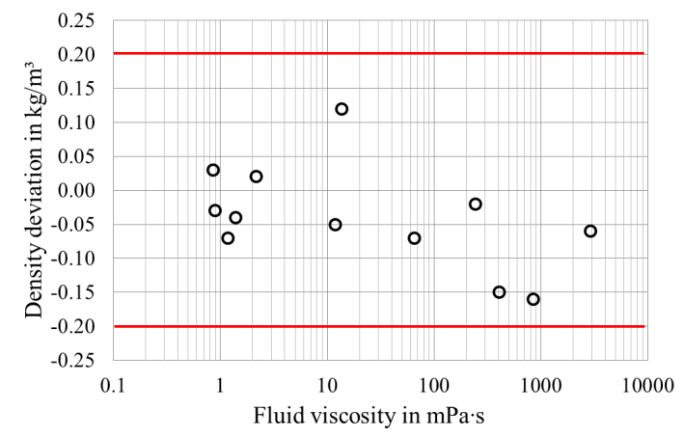
Figure 8: Measured density deviation across varying fluid viscosity at 25°C in accordance with H&D Fitzgerald Ltd. certificate number 15215 & nn15217R stays within ±0.2 kg/m³ [2].

3.2.3 Fluid compressibility and entrained gas
Liquids typically show rather small compressibility, hence speed of sound $c$ is high. If gas is entrained in liquid, compressibility of the mixture drops down significantly. Due to this compressibility effect fluid amplitude is higher than tube amplitude as a consequence, apparently fluid density seems to be higher. By simultaneously driving of a higher order tube resonance frequency sound velocity of the mixture can be estimated and the density deviation finally is eliminated completely. Details to this new and patented technology called MFT can be found in [3].

3.2.4 Corrosion, abrasion and coating
In some applications corrosion, abrasion and coating are issues. Due to this gradual effects with time density reading becomes permanently and systematically wrong, not noticed by the operator. The new diagnostic feature Heartbeat Technology™ allows to monitor and track these slow changes in meter integrity [4]. Within the scope of predictive maintenance if indicated the device can be cleaned or recalibrated to ensure credibility of density measurement. Using Heartbeat Technology™ finally the meter can be replaced in time before tube rupture or cleaning can be commissioned before clogging.

3.3 Environmental and installation effects

3.3.1 Environmental temperature and radiation
An additional challenge is that meter housing temperature $T_{h}$ in general is influenced by sun shine, ambient temperature and convection, therefore its distribution is seldom homogeneous. Furthermore measuring tube temperature $T_{m}$ and housing temperature $T_{h}$ often are different in real applications. These gradients imply thermal stress in the measuring tubes, which has been reduced by optimized tube shape. Residual effects are compensated by ideal placement of one RTD at the housing. FEM and CFD simulation in combination with experimental approach was key factor in this design phase. In Figure 9 ambient temperature $T_{a}$ changes between 10°C and 50°C. Density variation is negligible and within ±0.2 kg/m³. Similar results have been obtained with direct sun shine.
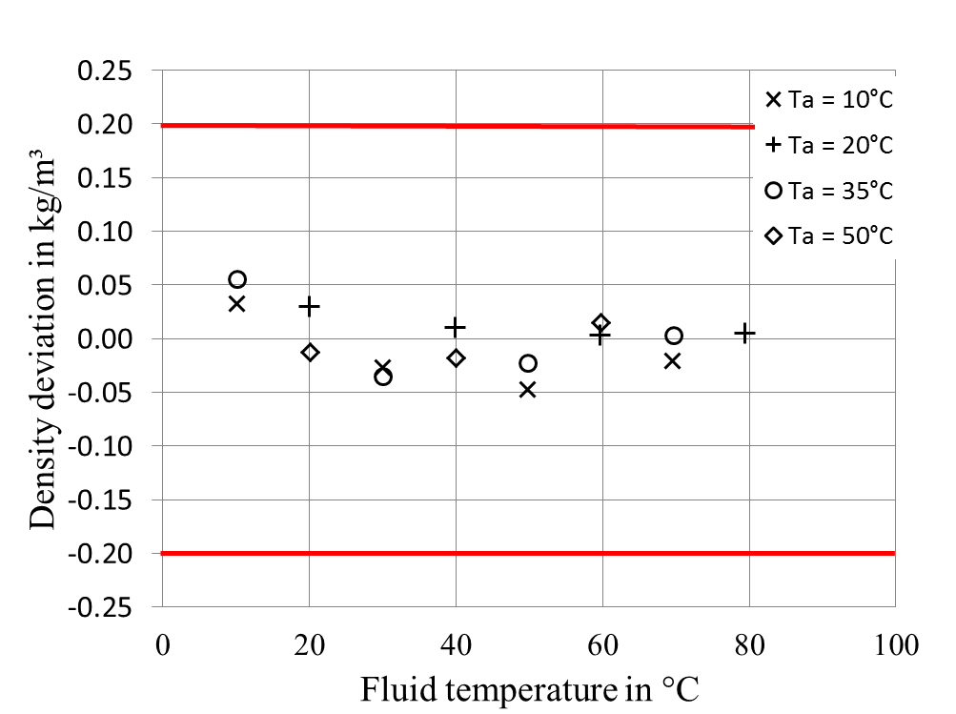
Figure 9: Measured density deviation across varying water temperature and ambient temperature as a parameter.

3.3.2 External forces and vibrations
Tube shape and housing stiffness has also been optimized so that the density measurement is insensitive to external installation stress while keeping the overall meter size and weight still comparatively compact and light. The moderate driving frequency resulted from the moderate tube height still offers great immunity against the influence of disturbing external vibrations which are typically at low frequencies.

3.3.3 Meter orientation
To a very small extent all bent tube Coriolis mass flow meters are prone to gravitational effects. Depending on meter orientation angle $γ$ with respect to the earth’s gravity, tube mass give rise to tension or compression along the tube, slightly changing resonance frequency and density reading. By giving this angle $γ$ after meter installation, this effect is corrected automatically by a patented algorithm.

4. Conclusion

A new type of Coriolis mass flow meter has been presented. Among other highlights it brings precise fluid density measurement which is desirable for many applications in process industry. It has been explained how all aspects of the meter design were optimized to ensure robust density performance in the field. During development process FEM and CFD simulation in symbiosis with experimental approach have been used. This results in a superior out of the box density measurement performance. Finally the meter was tested both internally as well as third party and verified to be within the stated ±0.2 kg/m³ specification across a broad range of process parameters, fluid properties as well as environmental and installation conditions.

References

- R. C. Baker, “Flow measurement handbook: industrial designs, operating principles, performance, and application”, Cambridge University Press, 2000.
- UKAS calibration certificate number 15215; Calibration certificate nn15217R, H&D Fitzgerald Ltd., St. Asaph UK, 2016, http://www.density.co. uk/
- H. Zhu, A. Rieder, Y. Lin, “An Innovative Technology for Coriolis Metering under Entrained Gas Condition” in Conference Proc. FLOMEKO 2016, Sydney AU, 2016. https://www.metrology. asn.au
- Endress+Hauser Flowtec AG, “Heartbeat Technology™ - Reliable and flexible proof testing”, http://www.endress.com/en

