IMPROVEMENTS OF THE DYNAMIC GRAVIMETRIC FLOW STANDARD (dGFS) BELOW 0.2 mg·s^{–1} N2 (10 sccm)

J. Barbe¹ , C. Rombouts²

¹LNE, 1 rue Gaston Boissier, 75724 Paris cedex 15, France
2.Fluke Calibration - Phoenix, Arizona, USA
E-mail (corresponding author): jean.barbe@lne.fr

Abstract

In 2011, Laboratoire National de Métrologie et d'Essais (LNE) installed a primary gas flow standard (dGFS) based on the dynamic gravimetric method. The dGFS developed by Fluke Calibration-Phoenix (FCP) was initially designed to calibrate molbloc laminar flow elements in the range from 0.2 mg·s^{–1} to 200 mg·s^{–1} of nitrogen (10 sccm to 10 slm) with a manufacturers expanded uncertainty (k = 2) on the order of ±0.06% of reading (variant with mass depleted). An LNE uncertainty analysis of the dGFS components using the GUM approach has given an expanded uncertainty (k = 2) on the reference mass flowrate of ± (0.06 % of reading + 3×10⁻⁴ mg·s^{–1}) in this flow range. This uncertainty has been validated through different international comparisons using commercial transfer standards such as molbloc LFE’s or portable volumetric devices.

LNE and FCP use the dGFS outside the working range to measure flows below 0.2 mg·s^{–1}. The system as delivered has issues with accurate and repeatable leak determinations and stable measurements in this lower flow range leading to results that are not as satisfactory and with higher uncertainties.

This paper presents the work being done to significantly reduce or reliably quantify the dGFS leakage and to measure stable and repeatable flows between 0.02 mg·s^{–1} and 0.2 mg·s^{–1} of nitrogen (1 sccm to 10 sccm) with an associated uncertainty never achieved with the dynamic gravimetric method.

An international low flow key comparison is in the early stages of development with NIST (USA), CMS (Taiwan), INRIM (Italy) and LNE (France), where improvements in the dynamic gravimetric method would be valuable to LNEs collection of data and the overall comparison.

1. Introduction

LNE developed primary gas flow standards based on the principle of the dynamic gravimetric method [1] it has used since the early 2000s to calibrate molbloc laminar flow elements [2]. The calibration uncertainty of the LNE gravimetric standards is between ±0.2 % and ±0.4 % (k = 2) in the range of flow from 0.03 mg·s^{–1} to 2200 mg·s^{–1}.
Currently, more efficient molbloc/molbox systems are distributed [3] allowing measurements with an uncertainty between 0.1% and 0.2%. Also the major NMI (NIST NMIJ, PTB or VSL) claim Calibration and Measurement Capabilities (CMC) equal to or better than ±0.1% (k = 2). In this context, the uncertainties of the LNE reference benches were no longer compatible with the calibration needs of the users of this new generation of flow meters.
LNE needed to improve its calibration facilities, but given the technical requirements and staff needed to modify the existing benches to reduce uncertainty by a factor of 2 to 3, LNE has renounced such work. Instead LNE preferred to acquire a new dynamic Gravimetric Flow Standard (dGFS) distributed by FCP. Operating on the same principle as the LNE benches, the dGFS is used in order to generate mass flows between 0.2 mg·s^{–1} and 200 mg·s^{–1} of nitrogen or dry air, with an expanded uncertainty better than ±0.1% of reading (k = 2).
LNE uses the dGFS for calibrating molblocs within the range of the system, but as this does not cover the entire range of available molblocs, LNE retained some of its original standards for calibrations between 200 mg·s^{–1} and 2200 mg·s^{–1}. The uncertainties of all the LNE flow standards are reported in the CMC of the CIPM-MRA (Mutual Recognition Arrangement CIPM) available on the website of the BIPM.
Based upon the components for the manufacturers uncertainty analysis of the dGFS [4], FCP and LNE knew the system should have been useful down to 0.02 mg·s^{–1} or less with up to 5 grams depleted. However, testing below 0.2 mg·s^{–1} had issues with performance and non-repeatability that were not expected, leading to less satisfactory results and uncertainties. This paper describes several issues that were encountered and the solutions that were developed.

2. Description of the dGFS

The dGFS periodically measures the mass depletion of a gas-filled, high-pressure carbon fiber wrapped aluminum cylinder while gas is withdrawn from the cylinder over a period of time (typically minutes to hours). The changes of the filled cylinder’s mass are independent of the thermodynamic conditions and of the chemical composition of the gas in the cylinder. Thus, the cylinder’s mass changes provide the mass flow from the fundamental SI units of mass (m) and time (t) as shown in Equation (1):

$\dot{m}=\frac{dm}{dt}≅\frac{m_{i+1}-m_{i}}{t_{i+1}-t_{i}}$ (1)

where the subscripts i and i+1 represent successive time steps.

A comprehensive description of the dGFS can be found in a paper presented at the 2006 ISFFM [5].

3. Uncertainty of the dGFS

Fluke offers a manufacturers measurement uncertainty analysis of the dGFS [4]. A separate LNE analysis of the mass flow measuring process leads to additional uncertainty components that need to be incorporated with Equation (1):
- the repeatability of the reference mass flow $c_{rep}$
- the time effect $c_{time}$
- the leak rate on the whole gas line including the catenary $c_{leak}$
These components associated with a zero correction do not change the value of the mass flow, but they increase its associated uncertainty. Taking into account all components gives the overall mass flow Equation (2):
$\dot{m}=\frac{dm}{dt}+c_{rep}+c_{time}+c_{leak}$ (2)
The standard uncertainty of the mass flow is estimated with the law of propagation of uncertainty [6] applied to Equation (2). As the sensitivity coefficients are equal to 1 for each of the correction factors and the uncertainty components are supposed to be independent, the uncertainty of $\dot{m}$ is obtained by Equation (3):
$u^{2}\left(\dot{m}\right)={\left(\frac{\dot{m} X u\left(dm\right)}{dm}\right)}^{2}+{\left(\frac{\dot{m} X u\left(dt\right)}{dt}\right)}^{2}$+
${u^{2}(c}_{rep})+{u^{2}(c}_{time})+{u^{2}(c}_{leak})$ (3)
LNE performed an uncertainty modeling versus flow applicable to the whole range. The regression line is estimated from 13 flow values between 0.2 mg·s^{–1} and 200 mg·s^{–1} and its coefficients were modified to include all the uncertainties associated with the set of points. The modified line with k = 2 is represented in Equation (4):
$U\left(\dot{m}\right)={3×10}^{-4}{mg.s}^{-1} + {6×10}^{-4}×\dot{m}$ (4)
Note that the uncorrected leak rate $c_{leak}$ measured by LNE reached maximum 1.1×10^{–4} mg·s^{–1} over a period of 8 hours and that its associated uncertainty ${u(c}_{leak})$ assuming a uniform law is estimated to 6.4×10^{–5} mg·s^{–1}. For example, the impact of the leak rate for a flow of 0.03 mg·s^{–1} is 0.21 %. A similar leak rate was already observed with the old benches of LNE and as the dGFS is based on the same principle, this allows to justify the use of the uncertainty reported in the LNE CMC between 0.03 mg·s^{–1} and 0.2 mg·s^{–1}. This approach while not completely satisfactory metrologically has been adopted while waiting to benefit from improvements on the dGFS in this flow range. A significant reduction of the current LNE uncertainty Equation (5) in this flow range should be obtained.

$U\left(\dot{m}\right)={3×10}^{-5}{mg.s}^{-1} + {4×10}^{-3}×\dot{m}$ (5)
The detailed uncertainty calculation by LNE of the reference mass flow is presented in a forthcoming publication [7]. The improvements of the dGFS undertaken by FCP between 0.02 mg·s^{–1} and 0.2 mg·s^{–1} are described beginning with Section 5 of this paper.

4. International comparison

To validate the new bench between 0.2 mg·s^{–1} and 200 mg·s^{–1}, LNE organized an international comparison. This comparison was conducted informally with participants very experienced and internationally recognized in the field: three NMI (NIST, PTB and CMI) and FCP who also provided the transfer standards and related equipment. Flow measurements were performed early 2011 to late 2012. This international comparison has been published [8].
The results of the comparison conducted by LNE show the equivalence of the four metrological laboratories with standardized degrees of equivalence within a range of ± 0.8 and an expanded uncertainty between 0.06 % and 0.2 %. This comparison has validated the uncertainty on the reference mass flow Equation (4) evaluated by LNE with the dGFS.

5. Improvements of the dGFS

5.1 Gas Cylinder Carbon Fiber issues
The dGFS is delivered with two different sized carbon fiber wrapped cylinders, a 1.1 liter as shown in Figure 1, and a 1.5 liter in a similar configuration.

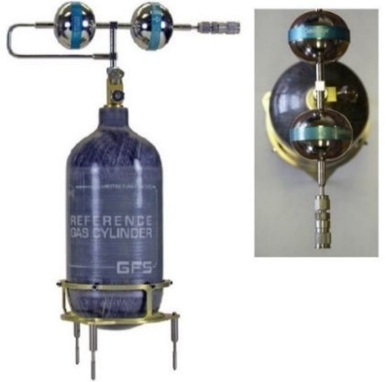
Figure 1: Gas Cylinder 1.1 liter assembly
An effect not previously considered is the possibility of a carbon fiber absorbing moisture. If the cylinder surface were to absorb moisture as relative humidity increased, or release moisture as it decreased, this could lead to mass errors that would impact data more at the low flows with long test times.

Initial testing seeking a correlation between cylinder mass and humidity using the software delivered with the dGFS were inconclusive and often counterintuitive, with mass changes appearing unsynchronized or in opposition with changes in humidity.

A spreadsheet with an RS232 remote communications add-on was created (see Section 5.4.1 Excel spreadsheet) to gain more control over the data collection method. Using the data collection spreadsheet, where the lines with a negative slope in Figure 2 and Figure 4 represent the mass change for a constant leak, it became very clear from Figure 2 and additional testing that some of the mass variation is correlated to the relative humidity, but there is a one to two hour delay between a variation in humidity and its impact on the mass measurements.

Figure 2: Humidity impact on carbon fiber cylinder leak measurement

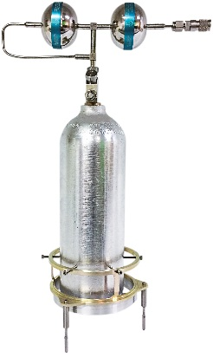
Figure 3: All-aluminium cylinder with offset cradle

Figure 4: Humidity impact on aluminium cylinder leak measurement
An adaptation by FCP to use an all-aluminum cylinder with no carbon fiber wrap in Figure 3 further proves out the moisture absorption theory as shown in Figure 4: a relatively stable and repeatable natural leak rate could be measured regardless of a similar change in humidity.

5.2 Eccentric comparator loading
It was noted that between the two cylinders, there was a repeatable difference of approximately 0.03% as measured at the same mass flow on a molbloc with good repeatability. The cylinders had been characterized by FCP for external volume changes due to pressure or thermal expansion. While both expansion factors are used by the software, the resulting impact on the air buoyancy corrections were insignificant, and no amount of adjustment of values related to the cylinders (mass, volume, buoyancy) within reasonable limits would correct for the difference.

The gas cylinders have a dual regulator assembly attached to them as shown in Figure 1 that counts as part of the assembled mass, as well as a three legged cylinder cradle for placement on the mass comparator. It was determined that the regulator assembly relative to the cradle legs placed more weight on one leg directly below the assembly than the other legs causing eccentric loading (also known as side loading) on the comparator. Counterweights were used temporarily to balance out the assemblies and resulted in the elimination of the difference between the cylinders at the same mass flows. A more permanent solution by FCP was an adaptation of the cradle that allowed the cylinder to be moved off center so the mass could be balanced between the three legs without the need for counterweights.

5.3 Catenary materials and tests
The catenary shape is a critical component of the dGFS that allows for a continuous dynamic flow connection to the gas cylinder while minimizing the impact on the mass measurements. Several modifications were made as summarized in Table 1 and shown in Figure 5, and tests were performed on all versions of the catenaries seeking the best configuration for the dGFS system.
Table 1: Catenary descriptions
Cat | Design | Len | OD | ID | Material
 |  | mm
1 | Original | 340 | 1.59 | 0.79 | PFA
2 | Fewer Connections | 340 | 1.59 | 0.79 | PFA
3 | High Flow, Fewer Connections | 390 | 1.92 | 1.02 | PFA
4 | Long Length | 480 | 1.59 | 0.79 | PFA
5 | Material & Length | 660 | 3.18 | 1.59 | PVDF
6 | Material & Length | 680 | 1.59 | 1.02 | ETFE

As any connection point could be a leak, attempts were made to reduce the number of connections through various means, but any potential benefit from this was not self-evident and could not be separated out from the leak test results.
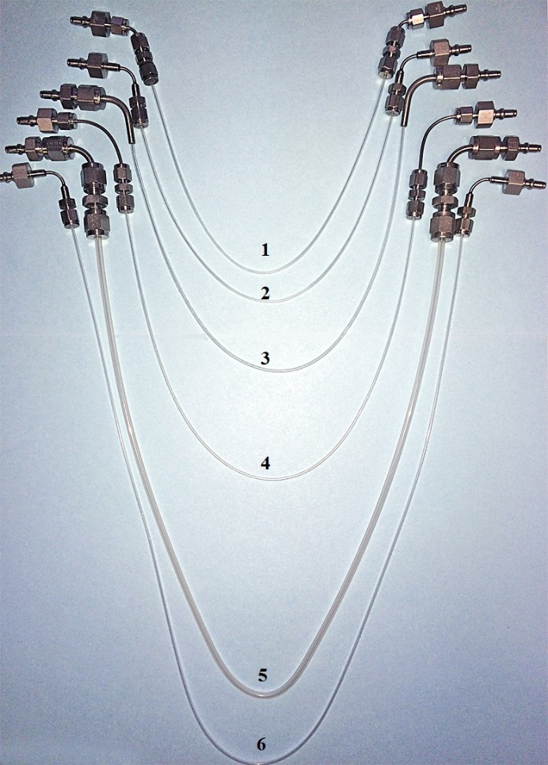
Figure 5: Various catenaries tested

5.3.1 Catenary Materials
The original catenary design was made of PFA, but that material has a higher permeability in certain gases (He, CO₂, H₂), and any permeation will present as a leak, so a low permeation material would be desirable.

When investigating alternative polymers such as those shown in Table 2, the ETFE polymer appears to be an excellent alternative and could be implemented in current and future dGFS systems: it is readily available, heat formable, an improvement in permeability by up to a factor of 10 over PFA for many gases, and capable of more than 0.7 MPa.

Table 2: Permeation rates of various polymers [9]
 | MATERIALS
GAS | PTFE | PFA | ETFE | PVDF
Air | 2000 | 1150 | 175 | 7
O₂ | 1500 | 6700* | 350 | 20
N₂ | 500 | 2000* | 120 | 30
He | 3500 | 17000 | 3700 | 600
CO₂ | 15000 | 14000* | 1300 | 100
Permeation rate cm³/(m².24 h.bar)
*DuPont Data not part of original data [10]

5.3.2 Catenary Leak testing
For a minimum target flow of 0.02 mg·s^{–1}, performing a leak test of the catenary installed in the dGFS system would take a significant amount of time to record sufficient data to have confidence in the results.

To establish the leak and/or permeation rate faster, a pressure decay rate was used instead. The equipment for pressurizing, isolating, and monitoring the pressure was estimated by dimensional calculation to have a volume of 1 cubic centimeter. A baseline test was run before and after testing the catenaries, substituting a stainless tube to establish the natural leak rate of the equipment. Each catenary was serialized 1 thru 6, and the volume of each was calculated using the length and inside diameter and added to the equipment volume. The catenaries were individually connected and pressurized to ~0.8 MPa and isolated, and after a short period of stabilization the pressure data was recorded every 30 seconds for several hours. After the data were collected for all of the catenaries, the tests were repeated including a second baseline.

The mass flow of the leak from each catenary was estimated with a rate-of-rise calculation using the change in density $(ρ)$ in a known volume (V) over a period of time (t) as shown in Equation (6):

$\dot{m}= \frac{\left(ρ_{start}- ρ_{end}\right) × V}{t}$ (6)

With a minimum desired mass flow of 0.02 mg·s^{–1}, the percent of reading impact of the leak rate at that flow was calculated for each catenary and is shown in Table 3.

Table 3: Catenary leak % impact on 0.02 mg·s^{–1}
Catenary | Material | Volume* | Test 1 % | Test 2 %
Baseline | Stainless | 1.21 cc | 0.015 | 0.001
1 | PFA | 1.17 cc | 0.054 | 0.064
2 | PFA | 1.17 cc | 0.037 | 0.014
3 | PFA | 1.34 cc | 0.067 | 0.040
4 | PFA | 1.24 cc | 0.027 | 0.032
5 | PVDF | 2.29 cc | 0.005 | 0.021
6 | ETFE | 1.56 cc | 0.039 | 0.026
*Volume values include the 1 cc of equipment volume.

Note that catenary #5 and #6 are significantly longer catenaries, approximately 67 cm versus 34 cm, with correspondingly larger volumes, but are made of lower permeability polymers and perform equal to or better than the shorter more permeable PFA.

5.3.3 Catenary Pressure Change Impact
The main purpose of the catenary connection is to reduce or eliminate any changing force on the mass comparator from the dynamic flow path connection. To investigate the effectiveness of the catenary design, a quick connect on a cylinder regulator assembly was plugged so it could not convey gas, which would allow each catenary to be pressurized from an outside source and the force on the mass measurement observed. The cylinder was installed in a complete GFS operational setup as if a flow test was to be performed.

A pressure controller was used to alternately set 120 psig and 60 psig of nitrogen on the catenary, covering 20 psig above and below the 80 and 100 psig output pressures of the dGFS cylinder regulator assemblies. The resolution of the mass comparator was precise enough that the change in gas density in the catenary could be observed between the two pressures, so the measurements were compensated to account for the mass change. A one minute delay was used between each pressure change, including the time to set the new pressure, for a total test time of approximately 30 minutes. Each catenary was connected sequentially and run through the process, and the results are shown in Figure 6.

Figure 6: Mass impact from extreme catenary pressure changes

It is noted that catenaries 1 and 2 are the original design length, but the current setup to accommodate the longer and larger catenary designs puts them at a flatter arc than was intended, possibly resulting in the less than ideal results. The large diameter PVDF catenary 5 had little reaction to the changes in pressure, but the most drift over the test time due to the rigidity of the larger diameter.

The longer catenaries 4 and 6 performed the best, with the ETFE catenary 6 having minimal reaction to the changes in pressure and the lowest drift over time.

This testing was valuable, but well outside of the normal operation mode of the dGFS. Under normal circumstances the dGFS would never experience such extreme pressure changes: there would be minor pressure changes as test flow points change, and significantly more stable pressures during the collection of data at a constant flow.

Based upon the results of testing the catenary materials, leak rates, and pressure change impact, the ETFE catenary #6 was chosen as the best configuration.

5.4 dGFS Software
Due to the typical length of time and quantity of data collected from 0.02 to 0.2 mg·s^{–1}, there was difficultly in troubleshooting the various impacts of improvements on the results. At a flow of ~0.02 mg·s^{–1} for nitrogen (1 sccm), the normal operation of the dGFS software was recording up to 10 readings per second, which for a 5 gram depletion taking approximately 67 hours the collection rate resulted in approximately 2.4 million discreet samples, far too much data to be easily analyzed or even parsed.

The software uses a comparator drift correction method called AutoZero, where an automated mass handler that is part of the dGFS system can exchange the gas cylinder assembly with a 2 kg reference mass at a predetermined interval to correct the mass values for drift over time. The default recommended AutoZero interval is 1 hour.

5.4.1 Excel spreadsheet
There being no option to easily change the dGFS software, a need to take tighter control of the drift correction and slow the data collection rate, and a desire to add the ability to automatically compensate data for a known natural leak rate, an Excel spreadsheet was created to duplicate the core data and calculation functions of the dGFS software but with added benefits.

The dGFS software has software components that can be used as add-on capabilities in Excel: a component that allows the use of RS232 communications with devices, and a component that can be used for unit of measure conversions and gas property data. These abilities along with the Visual Basic for Applications capabilities of Excel result in an exceptionally powerful tool well suited to the desired testing and can be easily modified when needed.

With the spreadsheet set up to collect the same critical remote device information as the software and calculate the buoyancy corrected cylinder mass, the first change was to slow the data collection rate to once every 600 seconds, or 6 samples per hour instead of 10 per second. This rate allows for a reliable data sample for both leak tests and low flow tests without an overwhelming amount of data, and the data is already in a form that can be quickly analyzed.

Another significant change was that having a large window of time between data samples, and access to the dGFS automated mass handler and 2 kg reference mass, it was decided to calibrate the mass comparator before each sample to further ensure the reliability of each data point rather than use the AutoZero drift correction.

Once a repeatable natural leak rate could be obtained, the spreadsheet also allows for that leak rate to be input to automatically correct the dGFS mass flow for real time comparison to the mass flow of the device under test.

6. Conclusion

At the time of this paper, LNE was considering a humidity sensitivity coefficient for the carbon fiber cylinders, but there is a clear advantage to the use of an all-aluminum cylinder. FCP is considering an upgrade kit for dGFS users that would include an all-aluminum cylinder.

Prior to the improvements in the dGFS, FCP had noted variations as high as ±2.2 % of reading at 0.02 mg·s^{–1}. Much of the data tended to be on the negative side, which may have been an indication of an uncompensated leak where more gas was depleting from the dGFS than was sensed by the molbloc under test.

In order to assist with validating the improvements to the dGFS system at low flows, FCP designed and implemented a small 9 liter Rate-of-Rise (ROR) system. A ROR measures flow by monitoring the rate of pressure rise in a known volume as gas is captured by the volume. With precision pressure, temperature, and time measurements the change in density can be used to calculate mass flow. This is the same method used for leak testing in Section 5.2.2 and using Equation (6). The use of the ROR by FCP for the evaluation offered a unique opportunity: to deplete gas from the dGFS, flow through the molbloc under test, and collect the gas with the ROR, a rare ability to use two completely different methods at the same time to calibrate a device under test.

The evaluation by FCP of the collective improvements discussed in this paper: all-aluminum cylinder, side load correction, catenary choice, slower data collection, comparator calibration before each data point collected, and compensation for the natural leak rate; have yielded a significant improvement in performance and repeatability in the range of 1 to 10 sccm (0.02 to 0.2 mg s ⁻¹), with satisfying results as shown in Figure 7 when considering the ±2.2 % FCP had previously observed.

Figure 7: Percent difference between two primary methods (dGFS and ROR) versus a calibrated laminar molbloc used as a flow reference

FCP is currently accredited by A2LA for a mass flow CMC of ± (0.1% of reading + 0.002 sccm) (k = 2) (0.002 sccm = 4.2×10⁻⁵ mg.s⁻¹) for nitrogen and dry air down to 0.02 mg·s^{–1}. The CMC for flows below 0.2 mg·s^{–1} was supported by means other than the dGFS. With some additional testing, FCP can make a strong case to drop or reduce the fixed uncertainty from that CMC using the dGFS.

FCP has recently provided LNE with a new ETFE catenary for their dGFS, but there was insufficient time for LNE to perform any testing that could have been used for this paper. However, LNE has an opportunity to study the new catenary and improvements in preparation for the international low flow key comparison that is developing with NIST (USA), CMS (Taiwan), INRIM (Italy) and LNE (France). These improvements in the dGFS method will be valuable to LNEs quest to reduce their CMC in the range of 0.03 mg·s^{–1} and 0.2 mg·s^{–1}, as well as for collection of data for the comparison which could be used to validate the new LNE CMC.

References

- Barbe, J., Couette, J., Picault, J-M., and Marschal, A., “Traceability of reference gas mixtures prepared by the dynamic gravimetric method”, Bulletin of BNM, 120, 2001, pp. 17-26.
- Delajoud, P., Girard, M., “A High Accuracy Portable Calibration Standard for Low Mass Flow”, XIII IMEKO, Torino, Italy, 1994, 7 p.
- Bair, M., “Uncertainty Analysis for flow measured by molbloc-L and molbloc-S mass flow transfer standards”, Fluke Calibration Technical Note 2011TN06B, 2009, 20 p.
- Bair, M., Rombouts, C., “Typical Measurement Uncertainty In Gas Flow Measured By GFS2102 Gravimetric Flow Standard”, Fluke Calibration Technical Note 6050TN09, 2006, 10 p.
- Delajoud, P., Bair, M., Rombouts, C. and Girard, M., “A Primary Calibration System for the Support of High Performance Gas Flow Standards”, Proceedings of International Symposium on Fluid Flow Measurement, Queretaro, Mexico, 2006, 6 p.
- ISO/CEI GUIDE 98-3:2008, Uncertainty of measurement – Part 3: guide to the expression of uncertainty in measurement (GUM:1995), 2008
- Barbe, J., Yardin, C. and Mace, T. “New national standard for the calibration of Molbloc laminar flowmeters from 0,2 mg·s^{–1} to 200 mg·s^{–1}”, Revue Française de Métrologie n° 42, Volume 2016-2 (to be published).
- Rombouts, C., Bair, M., Barbe, J., Wright J. D., Kramer R., and Krajicek Z., “A Comparison of Primary Gas flow standards Spanning the range from 10 sccm N₂ to 10 slm N₂”, NCSL International Measure, Vol. 9 No. 4, 2014, pp. 46-54
- Fitz, H., “Fluorocarbon Films - Present Situation and Future Outlook”, Kunststoffe with German Plastics, vol 70(1) English translation, 1980, pp. 11-16.
- DuPont Properties Bulletin, “DuPont PFA fluorocarbon film”, 225569C, 1996.

