NIM's Research Progress on Flue Gas Flowrate Measurement

L. Zhang¹, C. Wang¹, H. Li², X. Liu³

¹National Institute of Metrology, No.18, North Third Ring Road East, Chaoyang Dist, Beijing, P. R. China
²Shanghai Institute of Measurement and Testing Technology, Shanghai, P. R. China
³Chongqing Academy of Metrology & Quality Inspection , Chongqing, P. R. China
E-mail (corresponding author): zhangliang@nim.ac.cn

Abstract

The point source greenhouse gas emissions direct measurement approach is an effective complement to Chinese carbon trading market accounting methods. The main source of uncertainty in greenhouse gas emissions direct measurement is flue gas flowrate measurement. China does not have flue gas flowrate standard facility, moreover flue gas flowrate measurement methods need to be improved. In order to study flue gas flowrate accurate measurement methods and calibration methods, NIM built a Smoke Stack Simulator(SMSS). This facility can generate different swirls to simulate stack gas flow fields, which can be used to study flue gas flowrate measurement methods. This facility can also be used for standard pitot tubes calibration. Early in the design, Computational Fluid Dynamics (CFD) numerical simulation was used to evaluate the effect of environmental conditions on the performance of the SMSS. The structures and functions of main parts of SMSS were described in detail. NIM is also preparing to carry out field tests in a natural gas power plant and a coal-fired power plant, and verify flue gas flowrate measuring methods in real stack and duct. NIM will install 6-path ultrasonic flowmeters(USM) in two power plants and compare their performance with pitot tubes.

1. Introduction

Anthropogenic greenhouse gas emissions are the main cause of global warming. In order to alleviate and prevent global warming and the resulting natural disasters, most of the countries join Kyoto Protocol and Paris Agreement to collaboratively reduce greenhouse gas emissions. China, as the country with the largest greenhouse gas emissions[1], is actively promoting the greenhouse gas emission reduction. At present, China has carried out a pilot carbon trading in 7 provinces, and will be extended to the country's carbon trading market in 2017, trying to reduce greenhouse gas emissions. In order to guide China's carbon trading market, in 2013 National Development and Reform Commission issued first 10 industry sectors greenhouse gas emission accounting methods and reporting guidelines [2-11], including power generation, power grid, iron and steel production, chemical production, electrolytic aluminium production, magnesium smelting, flat glass production, cement production, ceramics production and civil aviation. Due to the lack of direct measurement data quality recognition, early in China's carbon trading market, greenhouse gas emissions accounting method is based on fuel calculation. However, due to the lack of Chinese enterprises emission factor data, fuel based method extensive use of the IPCC default emission factors. Zhu Liu et al. published an articles in Nature [12] showed that Chinese coal generally have low carbon content, due to the use of default emission factors, China's greenhouse gas emissions are overestimated. In the first phase of carbon trading, the accuracy of accounting data has become one of the main problems in China's carbon trading market. China is seeking to gradually improve the mechanism of carbon trading market.

European Union Emission Trading System (EU-ETS) is the world's most comprehensive greenhouse gas emission trading system, which has undergone the first phase (2005-2007), the second phase (2008-2012) and the third phase (2012-2020) of the progressive development and improvement process. In the first two phases, the monitoring and reporting guidelines (MRG) is mainly based on fuel calculation. If companies want to use direct measurement method require to receive approval from the competent authority and demonstrate that direct measurement will achieve greater accuracy. But in the third phase's MRG direct measurement method recognition increased significantly. The fuel based calculation method and direct measurement method were placed on a more equal status. As long as the direct measurement method can achieve uncertainty requirements, companies can choose this method. Moreover, for N₂O emissions measurement, MRG require to use direct measurement approach[13-14].

US EPA’s Greenhouse Gas Reporting Program (GHGRP) collects annual greenhouse gas information from the top emitting sectors of the U.S. economy. In 2014，8080 facilities in nine industry sectors reported direct emissions, totally 3.20 billion metric tons carbon dioxide equivalent, about half of total U.S. greenhouse gas emissions. Greenhouse gas emissions measurement methods are classified into four tiers. Tier 4 which have the highest accuracy is based on direct measurement. Tier 1-3 are based on fuel calculation. The largest emitting sector was the power plant Sector with 2.1 billion metric tons CO₂ equivalent. In this sector, most of power plants use direct measurement method [15].

Direct measurement is a potential high accuracy greenhouse gas emissions measurement method, particularly in the case which use non-uniform composition fuels, such as coal-fired power plants, waste incineration, its accuracy is superior to the fuel based calculation methods. When measuring stack greenhouse gas emissions, the greenhouse gas concentration and flue gas flowrate need to be measured simultaneously. The concentration measurement is relatively mature and can be calibrated by standard gas. However, due to the huge size of stack and the complex flue gas flow field, accurate measurement of flue gas flowrate has great challenge. Currently due to the lack of flue gas flowrate traceability system, flue gas flowmeters can not be calibrated, it is difficult to accurately assess the measurement accuracy of flue gas flowmeters. To solve this problem, NIM carry out research on flue gas flowrate high accuracy measurement methods and calibration methods by model experiments and field tests. Thereby increasing the accuracy of greenhouse gas emissions directly measurement method and establish data uncertainty assessment method. At present, NIM is working with National Institute of Standardization to develop new national greenhouse gas emission accounting methods and reporting guidelines for carbon trading.

NIM began to carry out flue gas flowrate measurement research from 2013. Currently NIM has built a smoke stack simulator (SMSS) to study the high accuracy measurement methods for flue gas flowmeters and to calibrate the standard pitot tubes which used as transfer standard in the field tests. In addition, NIM is installing pitot tube test platforms and 6-path ultrasonic flowmeters (USM) in a coal-fired power plant and a natural gas power plant to study direct measurement method and compare with fuel based calculation methods.

2. NIM's SMSS

NIM's SMSS is a scale model of real stacks and ducts. This system use swirl generators to generate different swirls to simulate flow fields in real stacks and ducts. Using this system, NIM will test the performance of the existing flue gas flowmeters in complex flow fields, improve the flowmeters and its measurement methods. At the same time, the SMSS also has the function of large diameter wind tunnel, which can be used to calibrate the field test standard flue gas flow meters (S, 2D, 3D pitot tubes) in different pitch and yaw angle.

2.1 Components and overall design of SMSS
As shown in Figure 1, the SMSS uses U-shape arrangement. It consists of inlet nozzle, reference section, expanding turning section, test section and outlet variable frequency fan. The facility uses ambient air as the flow medium, and the maximum flowrate can reach 100000m³/h. The inlet nozzle and the reference section provide a traceable standard flowrate for the facility. The reference section uses DN800 circular pipe. Since uniform axial velocity can be formed downstream of inlet nozzle, the reference section can also be used as a wind tunnel to calibrate pitot tubes. Wind tunnel velocity range is 0.2-55m/s. Because the facility use U-shape arrangement, expanding turning section is used to reduce the impact of turning on the flow field. The test section including DN1000, DN700 two circular pipeline and a 0.7m×1m rectangular pipeline to simulate the vertical circular stack and horizontal rectangular duct respectively. Two circular pipes with different diameters can study the scale effect of the flowmeters. The velocity range of test pipelines is 0.5-30m/s. In the test section, use replaceable swirl generators to generate complex flow fields to simulate the flow pattern in the real stacks and ducts. The performance of flue gas flowmeter in complex flow field can be evaluated. The flowrate of the whole facility is controlled by two frequency conversion axial flow fans. The inlet nozzle, reference section, test section and the outlet frequency conversion fan are all mounted on the sliding track and can slide along the axis direction, to facilitate the replacement of the pipelines. The facility photo is shown in Figure 2.

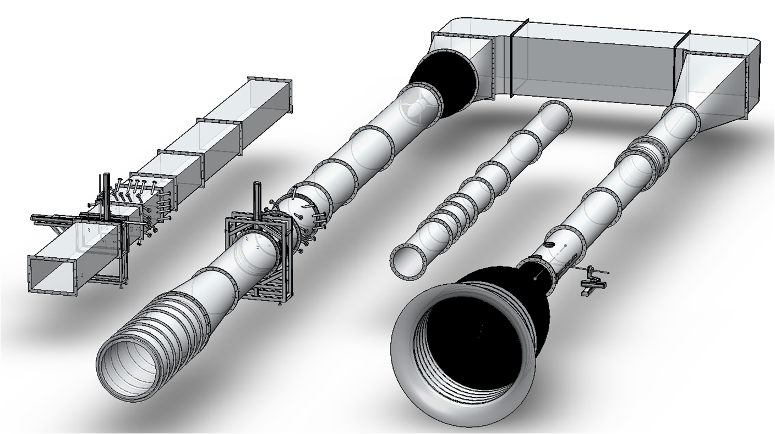
Reference Section
Test Section
Inlet Nozzle
Outlet Frequency Conversion Fan
Flow
1*0.7m Rectangular Pipe
DN1000 Circular Pipe
DN700 Circular Pipe
Expansion Turning Section
Swirl Generator
Wind Tunnel

Figure 1: SMSS components.
Early in the facility design, the influence of environmental conditions on the performance of the facility was evaluated using Computational Fluid Dynamics (CFD) simulation. The results showed that sunlight, ambient temperature, especially breeze at the inlet all affect temperature uniformity or flow field in the facility pipelines. Therefore, the facility needs to be placed in the laboratory environment to avoid the impact of the external environment. Due to the limitation of the laboratory space, the facility is designed in U-shape.
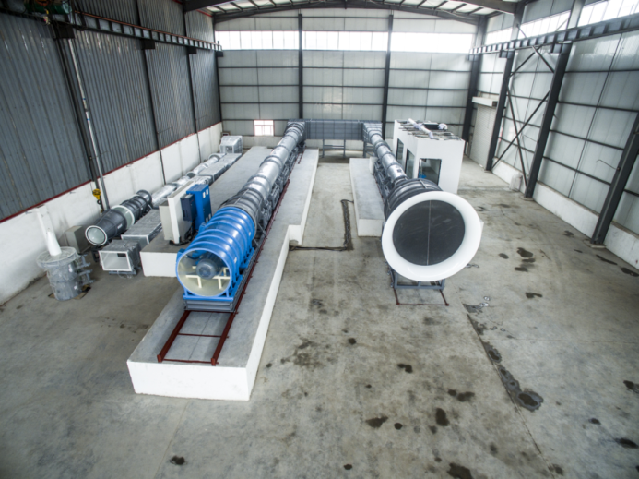

Figure 2: SMSS.

2.2 Design of inlet nozzle and reference section
The reference section of the SMSS can provide traceable standard flowrate data for the facility. The standard flowrate is used as the reference when calculate the measurement errors of flowmeters under test. As shown in Figure 3, the front portion of the reference section is the primary standard based on Laser Doppler Velocimetry (LDV) velocity area method. The primary standard can directly traceable to the spinning disk. The rear portion of the reference section is the working standard based on 8-path USM. The working standard is calibrated by the primary standard. Compare to the primary standard, working standard is more convenient to use. In addition, the axial velocity in the downstream of the inlet nozzle is very uniform, so the front portion of reference section can be used as a large diameter wind tunnel.

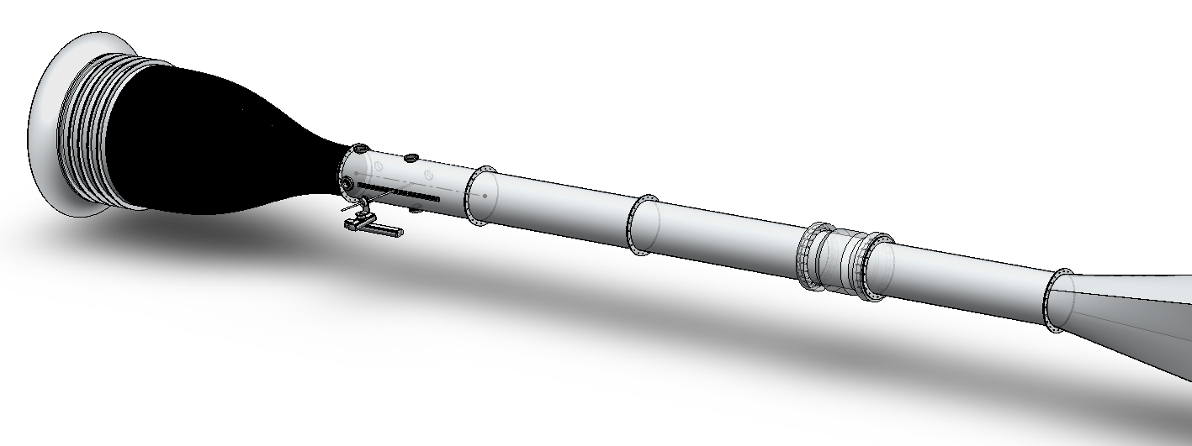
LDV Primary Standard
8-path USM Working Standard
Wind Tunnel
Nozzle

Figure 3: Design of inlet nozzle and reference section.

2.2.1 Inlet nozzle
As shown in Figure 4, the shape of inlet nozzle is specially designed to reach a very thin velocity boundary layer and uniform mainstream at the outlet of the nozzle. Multi layer flow conditioners are installed upstream of the contraction section. The grid size is gradually reduced, which is used to break the vortex of the inlet flow.

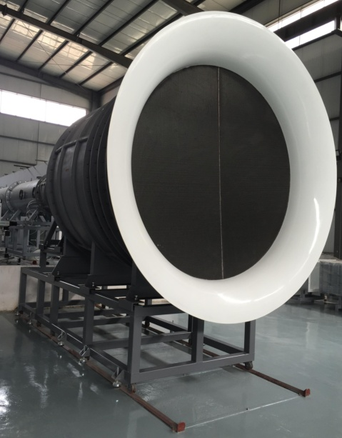

Figure 4: Inlet nozzle.

2.2.2 LDV primary standard
As shown in Figure 5, four quartz glass window was installed immediately adjacent to the outlet of the nozzle. These windows are used for LDV standard flowrate measurement. LDV have two standard flowrate measurement methods. One approach is scanning method, which use LDV to scan the velocity distribution along the diameters and integrate to obtain the flowrate. The other method is using a boundary layer LDV to measure the velocity distribution in the boundary layer, and use another LDV to measure the velocity in the mainstream. Because the axial velocity is very uniform in the main flow, the flowrate can be calculate by two LDV data. Specific measurement methods will be published in other papers.

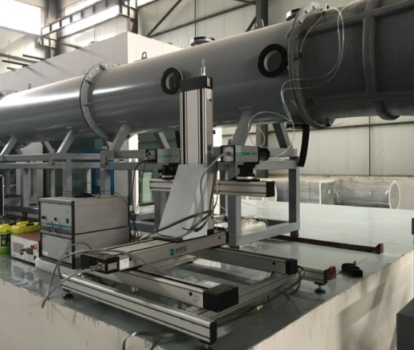

Figure 5: LDV primary flowrate standard.

2.2.3 8-path USM working standard
LDV primary standard at the time of measurement is more complex to operate, so this facility uses 8-path USM as the working standard, as shown in Figure 6. This USM can work under normal and negative pressure condition. The nominal uncertainty level is 0.5%. The installation position have long enough upstream and downstream straight pipe section to ensure reliable USM readings.

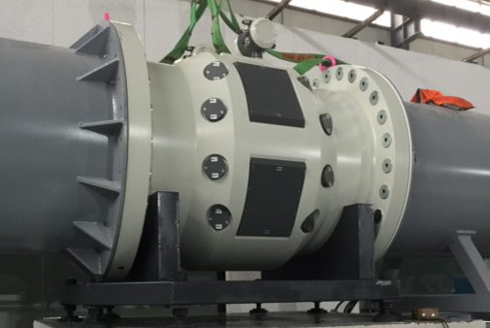

Figure 6: 8-path USM working standard.

2.2.4 Wind tunnel
Since the mainstream axial velocity is very uniform and the boundary layer is very thin, the reference section downstream of the nozzle can be used as a wind tunnel. As shown in Figure 7, a pitot tube inserting slot and 3 LDV window are arranged downstream of the primary standard LDV windows. When the pitot tube is inserted into the SMSS, pitot tubes head is right in the center of the slot. Through 3 windows, LDV can measure the flow fields around the pitot tube head. In order to facilitate the adjustment of the pitot tube pitch and yaw angle, pitot tube automatic positioning and calibration system is designed. This system can automatically change the pitch and yaw angle. When the angle changes, pipe tube head is always positioned in the middle of the slot, avoid uncertainty caused by velocity change in different position in the wind tunnel. When the wind tunnel is used to calibrate pitot tubes, a rubber strip is used to seal the slot, avoid a large amount of air flowing into the pipe to change the flow field in the wind tunnel. When the facility is not used as wind tunnel, a rubber band is used to seal the slot to prevent leakage. As shown in Figure 8, the facility use grids as turbulence generator. The grid will be installed between the nozzle and reference pipelines. Using different grid size can generate different turbulence intensity.

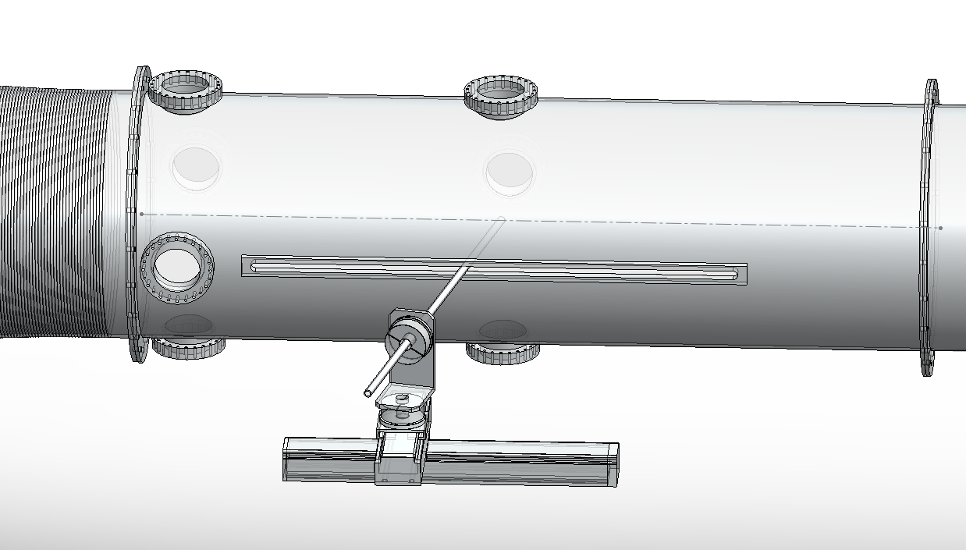
LDV Windows
Automatic Calibration System
Pitot Tube Insert Slot
Yaw Angle
Pitot Head Position Remains Unchanged
Pitch Angle

Figure 7: Wind tunnel.
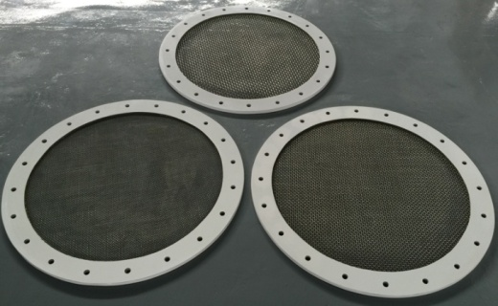

Figure 8: Turbulence generator.

2.2 Design of test section and outlet variable frequency fan
As shown in Figure 9, the SMSS test section is consist of three interchangeable pipelines, 1m×0.7m rectangular pipe, DN1000 and DN700 circular pipe. When testing, install one of these three pipelines in the SMSS. Each test pipeline has a contraction nozzle to reduce the flow field disturbance caused by the upstream expanding turning section. The swirl generator can be installed on the test pipeline to change the flow field in the test section. The swirl generator can be installed in any position of the test pipeline. The turbulence intensity can be changed by adjusting the length of the straight pipe between the swirl generator and the flowmeter under test. In the test section, multi-path USM and pitot tube automatic transverse system are installed downstream of the swirl generator.

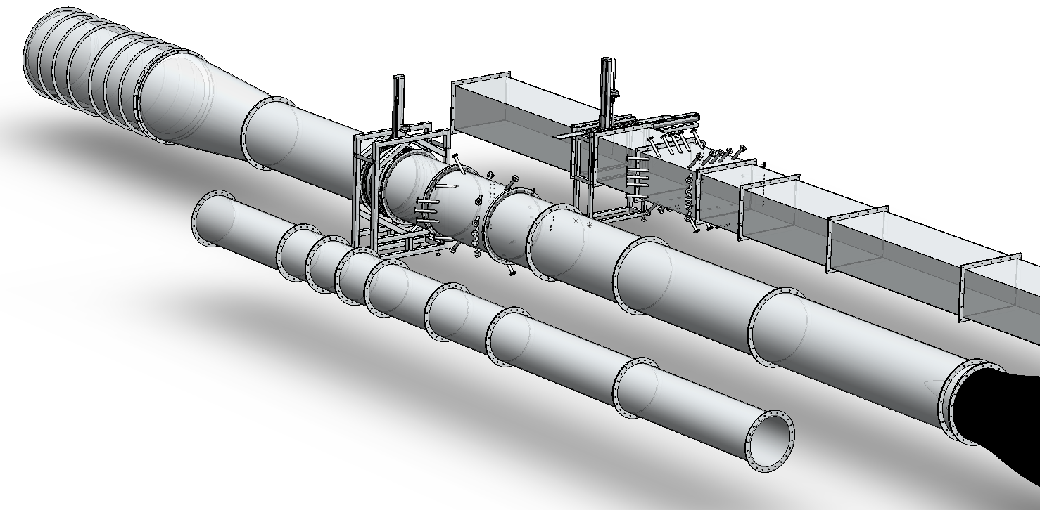
USM Under Test
Pitot Tube Automatic Transverse System
Swirl Generator
Frequency Conversion Fan

Figure 9: Design of test section and outlet variable frequency fan.

2.3.1 Swirl generator
Because the arrangement of the facility pipeline is fixed, the swirl in the flowmeter under test can not be changed by changing the upstream pipeline arrangement. Therefore, the facility is designed to generate different swirls using different swirl generators, which is used to study the performance of the flue gas flowmeters in different flow fields. Because the facility is a new design, in order to improve its performance step by step, current only a single swirl generator of DN1000 pipeline is made, as shown in figure 10. In the future, new swirl generator will be assessed by CFD simulation before manufacture. Usually this facility does not change the position of the flowmeters under test, but by changing the position of the swirl generator to change the swirl intensity at the position of flowmeter under test.

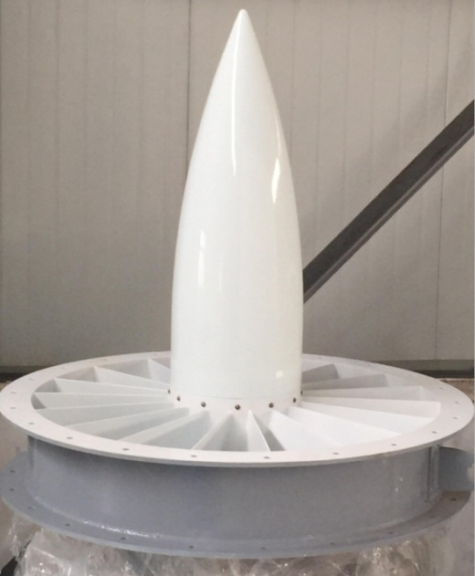

Figure 10: Single swirl generator.

(a) Circular Spool Piece
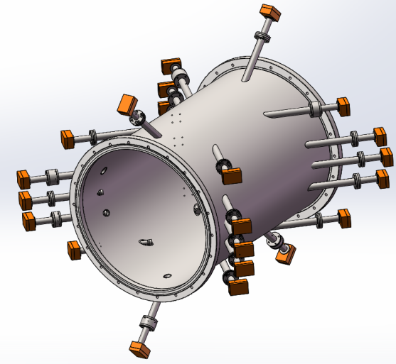

(b) Rectangular Spool Piece
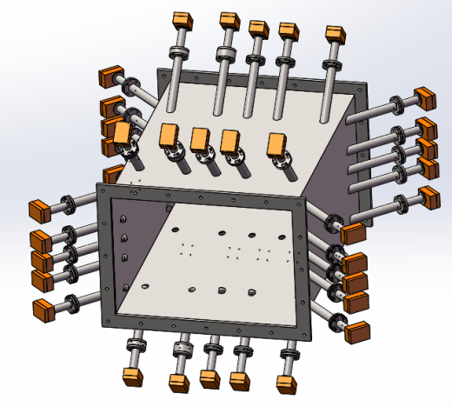

Figure 11: USM spool piece.

2.3.2 USM under test
USM is one of the main common flue gas flowmeters. In the United States, about 67% of the flue gas flowmeters is USM. But in most cases, the choice is single or dual path USMs. Because the stack flow field is very complex, path layout, integral method, path angle, installation angle all have great influence on the performance of USMs, therefore research on the performance of USMs will be carried out in SMSS. The USM under test is a 8-path USM. A DN1000 circular and a rectangular spool pieces are manufactured. As shown in Figure 11, the circular spool piece can install 8-path USM based on the OWICS[16] integration method and dual cross path diametric USM in perpendicular planes. In order to change the install angle, the circular conduit and both ends flanges can rotate relatively, which is convenient to adjust to different installation angle. Rectangular spool piece can install 8-path USMs based on the OWIRS[17] integration method and cross path USM in two perpendicular installation angle. By adding different thickness pad between the USM and the spool piece flanges can adjust the insert depth of the USM probes.

(a) Circular pipe
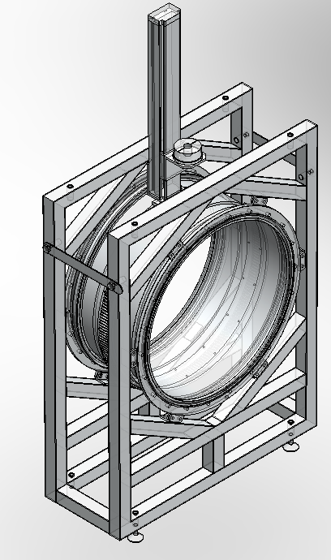
Yaw Angle
Insertion Depth
Pipe Rotation

(b) Circular Rectangular
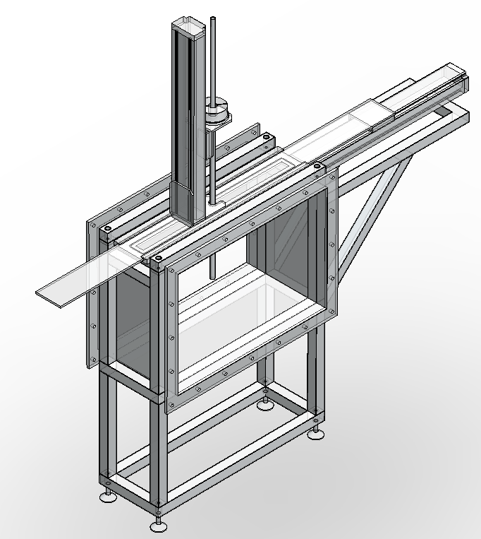
Yaw Angle
Insertion Depth
Change Position

Figure 12: Pitot tube automatic transverse system.

2.3.3 Pitot tube automatic transverse system
Pitot tube is a point velocity area method flue gas flowmeter. When measuring, it needs to measure point by point and integrate the velocity in the whole cross section. The point selection and integration method are related to the accuracy of the measurement results. In the test pipeline, installation of automatic transverse system can help to fast and accurate control of the pitot tube measurement position and yaw angle in circular and rectangular pipe. As shown in Figure 12, the circular pipe automatic transverse system has three degrees of freedom, along the axis of pitot tube can change the yaw angle, along the diameter direction to change the depth of insertion, the whole meter body can rotate around the axis to change the pipe diameter position. The rectangular pipe automatic transverse system also has three degrees of freedom, along the axis of pitot tube can change the yaw angle, along the vertical direction to change the depth of insertion, along the horizontal direction to change the insertion position.

2.3.3 Frequency conversion fan
Axial flow fan can provide very stable flow conditions, but usually axial flow fan pressure head is low, the maximum flowrate demand can not be achieved using one fan. So the facility use two axial fan in series, as shown in figure 13.

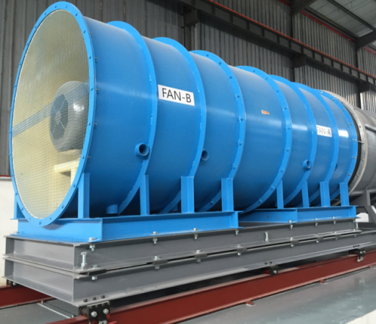

Figure 13: Frequency conversion fan.

3. Field tests in power plants

In order to verify the accuracy of measurement methods in real stack and duct, field tests will carry out in a coal-fired power plant and a natural gas power plant in Henan Province of China. The natural gas power plant uses gas turbine and waste heat boiler. The measurement position is selected on the circular stack as shown in Figure 14. The inner diameter of the stack is 6.9m. 6-path USM based on OWICS integration method is installed in the top two layer existing platforms. USM installation angle is 65º. Pitot tube measurement experiments will be carry out on the lower platform. The platform has two flange hole in two perpendicular diametric direction.

The measurement position of the coal-fired power plant is selected on the horizontal rectangular duct, as shown in figure 15. The cross section of the duct is 4.1m wide and 8.1m high. 3 layers of platforms are building in both sides of the horizontal duct. 6 holes (the number and position of holes are selected according to the EPA method 1 [18]) for pitot tubes transverse are placed in the upstream side of the platform. 6-path USM based on OWIRS integration method is placed in the downstream side of the platform. The path angle is 60º. By comparing different flue gas flowmeter in the field test, verify the high accuracy flue gas flowrate measurement method obtain in the SMSS. Using a fourier transform infrared spectroscopy gas analyser to measure the CO₂ concentration in the flue gas. Compare the accuracy of fuel based calculation methods and direct measurement method.

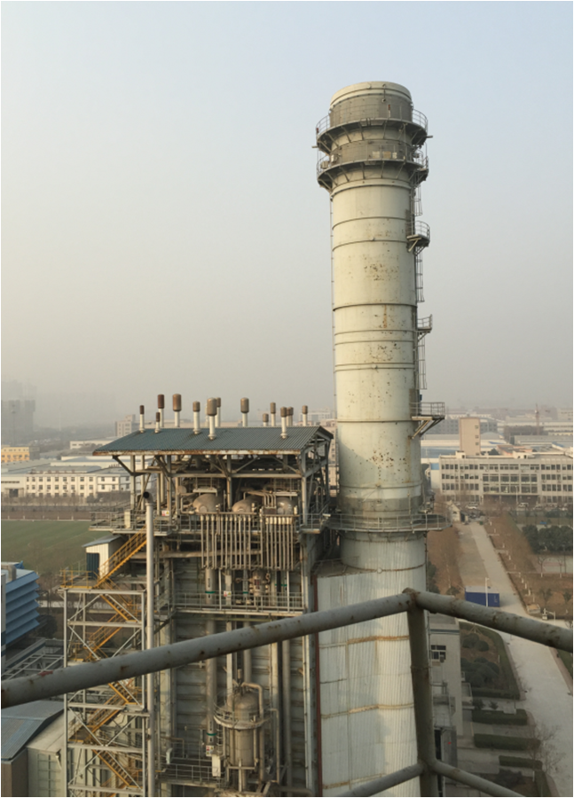
Install 6-Path USM
Pitot Tubes Test Platform

Figure 14: Flowmeters installation location of natural gas power plant.

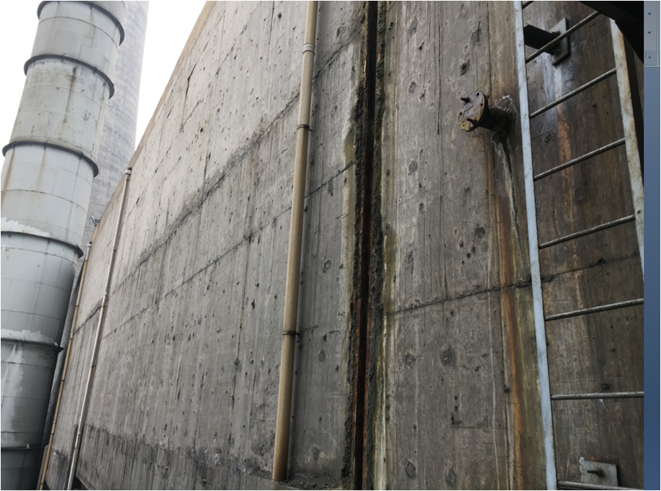
Install 6-Path USM
Build Pitot Tubes Test Platform

Figure 15: Flowmeters installation location of coal-fired power plant.

4. Conclusion

In order to study the point source greenhouse gas emission direct measurement method, improve the accuracy of the greenhouse gas emission data, support the development of carbon trading market of China, NIM is carrying out research on the flue gas flowrate high accuracy measurement method and calibration method. At present, NIM has set up the SMSS. In the early stage of the facility design, the influence of environmental conditions on the performance of the system was evaluated by CFD simulation. In this paper, component structures and functions of SMSS are introduced in detail. In order to verify the high accuracy flue gas flowrate measurement method in real stack and duct, NIM is preparing for the field test in a coal-fired power plant and a natural gas power plant. NIM will install 6-path USM in both power plants, and compare the performance of USMs and pitot tubes.

Acknowledgements

The authors gratefully acknowledge financial support from National Science and Technology Support Program Foundation (Grant No. 2013BAK12B01) and the Most Important Subject Open Fund of Zhejiang Province Instrumental Science and Technology (JL130109).

References

[1] Boden T A, Marland G, Andres R J, National CO₂ Emissions from Fossil-Fuel Burning, Cement Manufacture and Gas Flaring, Carbon Dioxide Information Analysis Center, Oak Ridge National Laboratory, U.S. Department of Energy, 2015.
[2] China Power Generation Enterprise Greenhouse gas Emission Accounting Methods and Reporting Guidelines, the National Development and Reform Commission Office, 2013.
[3] China Power Grid Enterprise Greenhouse Gas Emission Accounting Methods and Reporting Guidelines, the National Development and Reform Commission Office, 2013.
[4] China Iron and Steel Production Enterprise Greenhouse Gas Emission Accounting Methods and Reporting Guidelines, the National Development and Reform Commission Office, 2013.
[5] China Chemical Industry Production Enterprise Greenhouse Gas Emission Accounting Methods and Reporting Guidelines, the National Development and Reform Commission Office, 2013.
[6] China Electrolytic Aluminum Production Enterprise Greenhouse Gas Emission Accounting Methods and Reporting Guidelines, the National Development and Reform Commission Office, 2013.
[7] China Magnesium Smelting Enterprise Greenhouse Gas Emission Accounting Methods and Reporting Guidelines, the National Development and Reform Commission Office, 2013
[8] China Flat Glass Production Enterprise Greenhouse Gas Emission Accounting Methods and Reporting Guidelines, the National Development and Reform Commission Office, 2013
[9] China Cement Production Enterprise Greenhouse Gas Emission Accounting Methods and Report Guidelines, the National Development and Reform Commission Office, 2013
[10] China Ceramic Production Enterprise Greenhouse Gas Emission Accounting Methods and Report Guidelines, the National Development and Reform Commission Office, 2013
[11] China Civil Aviation Enterprise Greenhouse Gas Emission Accounting Methods and Reporting Guidelines, the National Development and Reform Commission Office, 2013
[12] Zhu L, Dabo G, Wei W, Reduced Carbon Emission Estimates from Fossil Fuel Combustion and Cement Production in China. Nature, Vol. 524, pp. 335-338, 2015
[13] Dimopoulos C, Process Industry Informer New monitoring and reporting guidelines for Phase III EU Emissions Trading Scheme, http://www.processindustryinformer.com/latest-news/analysers/new-monitoring-and-reporting-guidelines-for-phase-3-eu-emissions-trading-scheme.
[14] Bellassen V, Stephan N, Accounting for Carbon: Monitoring, Reporting and Verifying Emissions in the Climate Economy, 2015.
[15] GHGRP 2014: Reported Data, https://www.epa.gov/ghgreporting/ghgrp-2014-reported-data
[16] Thomas T, Peter G, Thomas S, Comparison of Integration Methods for Multipath Acoustic Discharge Measurements, International Conference on Innovation in Hydraulic Efficiency Measurements, 2006.
[17] Bruno L, Thomas S, Thomas T, Peter G, Optimizing the Acoustic Discharge Measurement for Rectangular Conduits, International Conference on Hydraulic Efficiency Measurements, 2008.
[18] EPA Method 1, Sample and Velocity Traverses for Stationary Sources, U.S. Environmental Protection Agency, 2000.

