**The influence of stagnation pressure on**

**Discharge coefficient of the sonic nozzle**

**Peijuan Cao1, 2, Chunhui Li2,Han Zhang2,3,Lishui Cui1**

*1 Tianjin University,* [*caopj@nim.ac.cn*](mailto:caopj@nim.ac.cn)*, Tianjin 300072, P. R. China*

*2 National Institute of Metrology (NIM), lich@nim.ac.cn, Beijing100029, P. R. China*

*3 Beijing Jiaotong University, zhanghan@nim.ac.cn, Beijing 100081, P. R. China*

*E-mail (corresponding author):lich@nim.ac.cn*

# Abstract

The discharge coefficient is the key parameter of the flow characteristic of the sonic nozzles, and it is measured at the pVTt facility. Within the stagnation pressure of (0.1~2.5) MPa, the discharge coefficients of 21 sonic nozzles with throat diameter of (1.921~12.444) mm were investigated. The 518 sets experimental results showed that: The discharge coefficient could be changed up to 2.3% for the same nozzle at different stagnation pressure; Unlike previous studies that the boundary layer transition taking place at the Reynolds number of (1E+06~2E+06), the experiment results show that boundary layer transition appears in advance that taking place at the Reynolds number of (4.8E+05~9.4E+05). We found it directly correlation with the throat diameter. The boundary layer transition occurred in the 4.8E+05 Reynolds number with throat diameter of 2.713 mm of the nozzle and occurred in the 9.4 E+ 05 Reynolds number with throat diameter of 12.444 mm. Except for the smallest sonic nozzle, the boundary layer transition from laminar to turbulent all regularly occurred. Based on NMIJ-2013 model proposed by Ishibashi to fit the experimental data and the results have good consistency. Besides, the empirical equations between the Reynolds number of boundary layer transition and throat diameter was presented, the formula is extended to the experimental dates of NMIJ by Ishibashi in Japan, and the calculated results by empirical equations are in good agreement with the experimental results.

# 1. Introduction

Due to the unique characteristics, such as, high accuracy, reasonable price, no moving parts, and many other features, venturi sonic nozzles (also known as sonic nozzle or nozzle) frequently used as master meters to calibrate other kinds of gas meters. More than 100 sets of the gas flow standard device based on sonic nozzle had been constructed in china, widely used for verification and calibration of flow meter in different medium, including natural gas, steam and air, and it directly serviced in various fields, like petroleum, chemical, energy saving, environmental protection, and aerospace.

On condition of assuming a one-dimensional isentropic flow of a ideal gas, the ideal mass flow rate through the sonic nozzle, can be expressed as [1],

 (1)

Where,  is the ideal mass flow rate through the sonic nozzle, kg/h; is the area of throat; m2,is the critical flow function;  is the stagnation pressure, Pa;  is the stagnation temperature, K; is the universal gas constant, J/kmol/K; is the molecular mass, kg/kmol.

The real mass flow rate, is not equal to the ideal mass flow rate, , on account of the viscous losses of the real gas and the three dimensional flow due to the nozzle geometry. The discharge coefficient, describes this difference between the real mass flow rate and the ideal mass flow rate,

 (2)

The discharge coefficient is the key parameter of sonic nozzle，it is measured at the pVTt facility or others[2~4]. The study of it can be traced back to Smit at the earliest 1962[5].

In 1964[6], the flow field through the sonic nozzle divided into two areas by Stratford: the area nearly wall and the multi-dimensional core area of nozzles. Furthermore, there is laminar boundary layer or turbulent boundary layer on are a nearly wall. The boundary layer transition from laminar to turbulent taking place at the Reynolds number of (1E+06 ~2E+06) through experimental study, and the discharge coefficient had a reduced "jump" with Reynolds number increasing in this transition.

In 2005[1], the latest version of ISO 9300 was published, two empirical equations between discharge coefficient of toroidal throat nozzles and their Reynolds number was presented : one is used of “normally machined nozzles” and allows a larger uncertainty to 0.3% (*k*=2) throughout the Reynolds number (2.1E+04~ 3.2E+07) range from laminar to turbulent boundary layer regimes; the other is used of “accurately machined nozzles” and allows a smaller uncertainty to 0.2% (*k*=2) in the Reynolds number range from (2.1E+04~1.4E+06) at laminar boundary layer regime.

In 2013[7], Ishibashi and others researched discharge coefficient of the sonic nozzles within the stagnation pressure of (0.1~0.8) MPa, throat diameter (9.7~18.4) mm, the experimental results present an empirical equations. The equations covered the whole Reynolds number range from laminar to turbulent boundary layer regimes and could be used instead of the two equations given in ISO 9300-2005, for shortly, NMIJ-2013,

（3）

The equation was suitable for accurately machined nozzles at the Reynolds number (2.1E+04~3.2E+07); in addition, the other experiment results were verified for normally machined nozzles within the stagnation pressure of (0.1~0.4) MPa, throat diameter (16.9~36.6) mm. The boundary layer transition of sonic nozzles takes place at the Reynolds number of (1E+06~2E+06) nearly.

Based on the high pressure pVTt primary gas flow standard facility in National Institute of Metrology (NIM), total of 21 nozzles were manufactured with throat diameter of (1.921~12.444) mm. Within (0.1~2.5) MPa stagnation pressure, the discharge coefficients of the sonic nozzles were investigated at the Reynolds number of between 2.4E+06 and 2.9E+06. The experimental results showed that: the boundary layer obviously advanced transition relate with the throat diameter, the boundary layer transition occurred in the Reynolds number 4.8E+05 for the nozzle with throat diameter of 2.713mm, it occurred in the Reynolds number 9.4 E+05 for the nozzle with throat diameter of 12.444mm. Based on the test results, the empirical formula of the relationship between the boundary layer transition Reynolds number and the throat diameter of the nozzle is presented in this paper.

# 2. The experimental system

*2.1 The experimental facility*

In 1986, the pVTt gas flow standard facility as standard facility for our country had been constructed in NIM, it calibrated the discharge coefficient of sonic nozzles with flow rates range from 1 m3/h to 1138 m3/h at 0.1 MPa for the stagnation pressure, and the expanded uncertainty of the discharge coefficient of sonic nozzles were 0.10%~0.20% (*k*=2).

At the end of 2014, another set of high pressure pVTt gas flow standard facility had been constructed in NIM shown in fig.1.The pVTt system was calibrated the discharge coefficient of nozzles cover a flow range extending from 0.016 m3/h to 46 m3/h, while the stagnation pressure ranged from 0.2 MPa to 2.5 MPa,. The expanded uncertainty of the high pressure pVTt gas flow standard facility could be 0.06% (*k*=2), while the expanded uncertainty of discharge coefficient of calibrated sonic nozzle was 0.08% (*k*=2). The measurement capability of the facility was verified by compared with the gas flow facilities in PTB with 3 sonic nozzles as transfer meters [8~9].

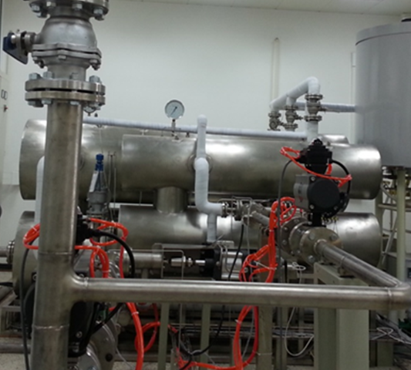

**Fig.1:** The high pressure pVTt gas flow standard facility

*2.2 The critical nozzles under test*

The 21 critical venturi nozzles under test were machined as toroidal nozzles according to the ISO 9300 with throat diameters between about 1.921 mm to 12.444mm, the information on the sonic nozzles are shown in table 1. The number of nozzles for HD17b, HD9b, and HD5b are designed and processed by PTB, and the others are designed and processed by NIM.

**Table 1:** Characteristic values of toroidal nozzles investigated

|  |  |  |  |  |
| --- | --- | --- | --- | --- |
| N | SN | Throat diameter | minimum Re | Maximum Re |
| [/] | [/] | [mm] | [/] | [/] |
| 1 | 201307127 | 1.921 | 2.39E+04 | 6.11E+05 |
| 2 | HD17b | 2.156 | 2.68E+04 | 7.05E+05 |
| 3 | 201307128 | 2.713 | 3.38E+04 | 8.63E+05 |
| 4 | 201307129 | 3.784 | 4.71E+04 | 1.22E+06 |
| 5 | HD9b | 4.9452 | 6.16E+04 | 1.59E+06 |
| 6 | 201307130 | 5.363 | 6.68E+04 | 1.71E+06 |
| 7 | HD5b | 6.98819 | 8.69E+04 | 2.21E+06 |
| 8 | 2013-05 | 7.463 | 9.58E+04 | 2.39E+06 |
| 9 | 2013-06 | 7.455 | 9.68E+04 | 2.37E+06 |
| 10 | 2013-07 | 7.466 | 9.75E+04 | 2.39E+06 |
| 11 | 2013-08 | 7.454 | 9.85E+04 | 2.39E+06 |
| 12 | 2013-09 | 7.454 | 9.61E+04 | 2.39E+06 |
| 13 | 2013-10 | 7.445 | 9.77E+04 | 2.38E+06 |
| 14 | 2013-11 | 7.444 | 9.61E+04 | 2.39E+06 |
| 15 | 2013-12 | 7.449 | 9.78E+04 | 2.40E+06 |
| 16 | 2013-13 | 7.437 | 9.62E+04 | 2.39E+06 |
| 17 | 2013-14 | 7.456 | 9.81E+04 | 2.41E+06 |
| 18 | 2013-15 | 7.452 | 9.33E+04 | 2.36E+06 |
| 19 | 2013-16 | 7.488 | 9.40E+04 | 2.39E+06 |
| 20 | 8605 | 9.086 | 1.18E+05 | 2.89E+06 |
| 21 | 8608 | 12.444 | 1.62E+05 | 1.63E+06 |

# 3. Experimental results and analysis

*3.1Experimental results*

The experiment results of the discharge coefficients of nozzles on the Reynolds number were conducted with atmospheric air and dry pressurized air at pVTt gas flow standard facility and high pressure pVTt gas flow standard facility as shown in fig.2, in which a total of 518 sets discharge coefficients of 21 sonic nozzles are plotted.

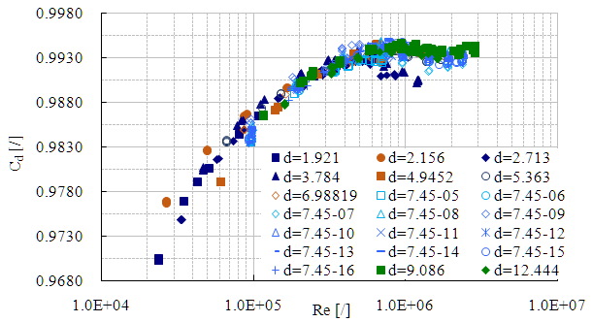

**Fig.2:** Discharge coefficients of 21 nozzles; 581 points in total.

As shown in fig.2, at different stagnation pressure, the discharge coefficient could be changed up to 2.3% for the same nozzle. Therefore, in order to get a higher accuracy of the discharge coefficient, it is necessary to carry out the actual measurement or accurate prediction of it under different stagnation pressure.

In this way, the relationship between discharge coefficient and the Reynolds number was different at different boundary layer conditions, in laminar boundary layer, the discharge coefficient significantly increased with Reynolds number increasing; in transition boundary layer, the discharge coefficient had a reduced "jump" with Reynolds number increasing; in turbulent boundary layer, the discharge coefficient slowly increased with Reynolds number increasing. In the studies of boundary layer transition are different with predecessors at a Reynolds number of 1 E+06 nearly, however, this study found that throat diameter is 7.488mm and below of the nozzles have obvious difference at the boundary layer transition position, those will advanced occur in the transition of the boundary layer, happened at that the Reynolds number of 4.8E+05.

*2.1Fitting of experimental results*

Based on the results, fitting of the experiment results of 21 nozzles was obtained the NIM-2016 empirical formula by reference formula (3). Table 2 gives the values of these coefficients for NIM-2016 and NMIJ-2013.

**Table 2:** Coefficients for NIM-2016 and NMIJ-2013

|  |  |  |
| --- | --- | --- |
| Parameter | NMIJ-2013 | NIM-2016 |
| a | 0.99845 | 0.99416 |
| b | -3.412 | -4.37783 |
| c | -0.00255 | -0.00162 |
| d | 0.692 | 5.14278 |
| e | 19.3 | 1.44875 |
| f | 70000 | 120000 |

The experimental results of 21 nozzles are analysed with the empirical formula of NIM-2016, NMIJ-2013 and ISO 9300 shown in fig.3 (a).Fig.3 (b) is the result of local amplification of Fig.3 (a),

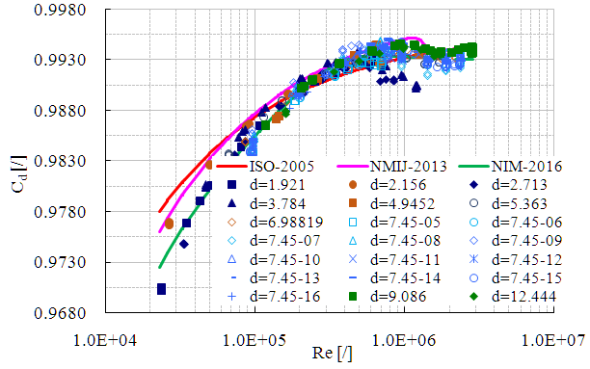

(a)

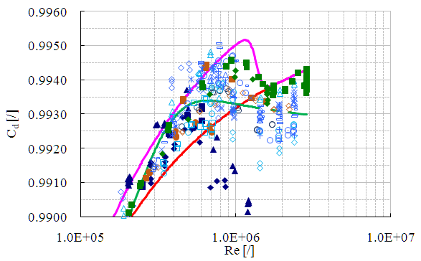

(b)

**Fig.3:** Three empirical formulas are compared with the experimental results

Besides, the difference between fitting results using NMIJ-2013 and NIM-2016 and the experimental results is shown in Figure.4.

 （4）

Where,  is the experimental result;  is the calculated result by empirical formula.

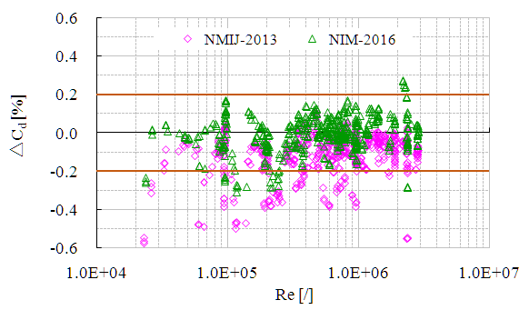

**Fig.4:** The deviation of the fitting results and the experimental data

As we can see from the figure 4 shows:

* The maximum deviation between the results of calculated using NIIJ-2013 empirical formula and experimental results up to 0.6%;
* The deviation between fitting results based on the NIM-2016 model and the experiment results are gathered in less than 0.3%.

*3.2 Analysis of the influence of throat diameter on the transition of boundary layer*

It is different from previous research results that the boundary layer transition from laminar to turbulent taking place at the Reynolds number of (1E+06~2E+06), the results show that boundary layer transition of the nozzle will happen in advance in this study, the earliest appeared in Reynolds number 4.8E+05. Furthermore, the position of the boundary layer transition obviously delays with the increase of the throat diameter, the experimental results of discharge coefficient of partly sonic nozzle as shown in figure 5.

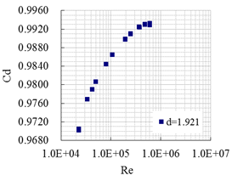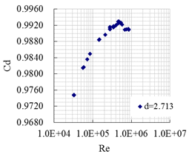

(a) (b)

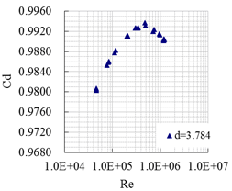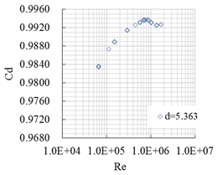

(c) (d)

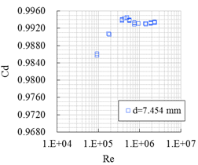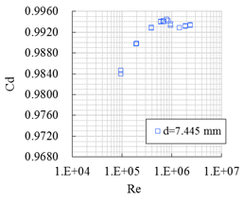

(e) (f)

**Fig.5:** Effect of the throat diameter

From the fig.5 shows that the position of the boundary layer transition appears obviously delays with the difference of the throat diameter in the range of pressure involved in the test. Figure 5 also can be seen,

* The throat diameter is 1.921 mm of sonic nozzle, without boundary layer transition;
* The throat diameter is 2.713 mm of sonic nozzle, which the boundary layer transition from laminar to turbulent at the Reynolds number of 4.8E+05.
* The throat diameter is 3.784 mm of sonic nozzle, which the boundary layer transition from laminar to turbulent at the Reynolds number of 4.9E+05.
* The throat diameter is 5.363 mm of sonic nozzle, which the boundary layer transition from laminar to turbulent at the Reynolds number of 7.9E+05.
* The throat diameter is 7.445 mm of sonic nozzle, which the position of the boundary layer transition appears at the Reynolds number of 7.1E+05.

The position of the transition of the boundary layer of the sonic nozzle appears as a sign that the discharge coefficient decreases with the increase of the Reynolds number. The position can be accurately determined by the function of the first derivative of the function is equal to zero,

* The first derivation of NMIJ-2013 and NIM-2016 are respectively obtained, and the function first equals zero that the position of the boundary layer transition is predicted by the two empirical equations.
* The position of the transition of the boundary layer of every nozzle is obtained based on the fitting formula of each nozzle, totally 21 scattered points.

The relationship between the Reynolds number of the boundary layer transition and the throat diameter of the 21 sonic nozzles is shown in figure6,

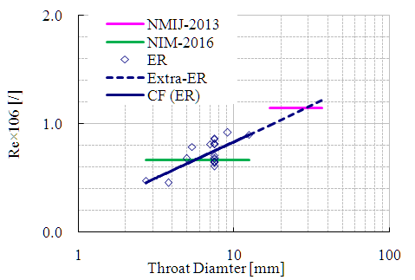

**Fig.6:** The relationship between Reynolds number of boundary layer transition and throat diameter

In the figure 6, the boundary layer transition of the same throat diameter of 12 nozzles appears to be dispersed, and the reason may be caused by the surface roughness during machining.

Through the analysis of these points, it is found that the throat diameter of the nozzle has a logarithmic relationship with the Reynolds number corresponding to the transition of the boundary layer, as shown in figure 6.This relationship can be described as follows:

 （5）

The empirical formula is obtained by fitting the experimental results of 21 normally manufactured nozzles with nominal diameters ranging from 1.921 mm to 12.444 mm in accordance with the provisions of ISO 9300.

The NMIJ-2013 is obtained by fitting the experimental results of precise manufactured nozzles with nominal diameters ranging from 9.7 mm to 18.4 mm in accordance with the requirements of ISO 9300. In order to verify the NMIJ-2013 by Ishibashi, he choose normally machined nozzles of satisfying ISO9300 requirements are tested within the stagnation pressure of (0.1~0.4) MPa, throat diameter (16.9~36.6) mm, the test results are in good agreement with the empirical formula (3). Thus, the NMIJ-2013 empirical formula predicts that the Reynolds number of the boundary layer transition Reynolds number can represent the Reynolds number of the boundary layer transition of normally manufactured nozzles in accordance with the provisions of ISO 9300. The formula (5) is extended to the experimental result of sonic nozzle by the NMIJ-2013 (as shown the dotted line in Figure 4), it can be found that the epitaxial results are in good agreement with the results of NMIJ-2013.

# 4. Conclusion

At the end of 2014, one set of high pressure pVTt gas flow standard facility had been constructed of the highest pressure 2.5 MPa in NIM. In order to evaluate the impact of facility system, three nozzles of manufactured in PTB to experiment, their experimental results of discharger coefficient are in good agreement with the results of the 18 nozzles designed and processed by NIM References.

21 normally manufactured nozzles with nominal diameters ranging from 1.921mm to 12.444mm were calibrated their discharge coefficient at the Reynolds number range from 2.4E+04 to 2.9E+06 of totally 518 sets in this facility. The calibration results show that the discharge coefficient could be changed up to 2.3% for the same nozzle at different stagnation pressure. Therefore, in order to get a higher accuracy of the discharge coefficient, it is necessary to calibrate the discharge coefficient at the Reynolds number in the actual use of the sonic nozzle. Based on the experimental results, the empirical formula of NIM-2016 is obtained by fitting the experiment results in this paper, and the measured discharge coefficients agreed with predicted values by this formula to better than 0.3% over a Reynolds number range extending from 2.4E+04 to 2.9E+06, the flow calibration results included data in the laminar, transition, and turbulent flow regimes.

In addition, the experimental results show that there is a close relationship between the transition position of the boundary layer and the throat diameter of the nozzle. The Reynolds number of boundary layer transition of the 21 nozzles was obtained based on the experimental results and the empirical equations between the Reynolds number of boundary layer transition and throat diameter was presented. The applicability of the formula is verified through the extension of the formula to experimental conditions by NMIJ-2013, the prediction results and experimental results showed good consistency.

# References

1. ISO 9300, Measurement of Gas Flow by Means of Critical Flow Venturi Nozzles[s]. 2005.
2. Vallet JP, Windenberger C. Improvement of thermodynamic calculations used for the flow rate of Sonic nozzles. 2000.
3. Mickan B, Kramer R, Dopheide D, et al. Comparisons by PTB, NIST and LNE-LADG in air and natural gas with critical Venturi nozzles agree within 0.05%. IMEKO World Congress 18th, 2006:16-18.
4. Johnson AN, Johansen B.U.S. National standards for High Pressure Natural Gas Flow Measurement. Proc.. Measurement Science Conference, 2008: 071202.1-071202.11.
5. Smith RE and Matz RJ, A theoretical method of determining discharge coefficients for Venturi operating at critical flow conditions, Journal of Basic Engineering, Transfer, ASME, 1962,84（4）:434-446
6. Stratford BS. The Calculation of the Discharge Coefficient of Profiled Choked Nozzles and the Optimum Profile for Absolute Air Flow Measurement. [J]. Journal of the Royal Aeronautical society, 237-244, 1964
7. Ishibashi M. Discharge coefficient equation for critical-flow toroidal-throat Venturi nozzle covering the boundary-layer transition regime [C]. Flomeko, 2013
8. Li CH, Cui LS, Wang C. The new pVTt facility in NIM[C]. FLOMEKO, Pair, France, 2013.
9. Cao PJ, Li CH, Cui LS, Zhang H. The Verification on the Capability of High Pressure pVTt Standard Facility [J]. Metrology journal, under review (in Chinese)